Supplementary Material 2: Data Extraction Supplement

Science Citation Knowledge Extractor
Heather Lent, Gustave Hahn-Powell, Asher Haug-Baltzell, Sean Davey, Mihai Surdeanu, Eric Lyons*
* Correspondence: Eric Lyons: ericlyons@email.arizona.edu

Data Extraction Workflow

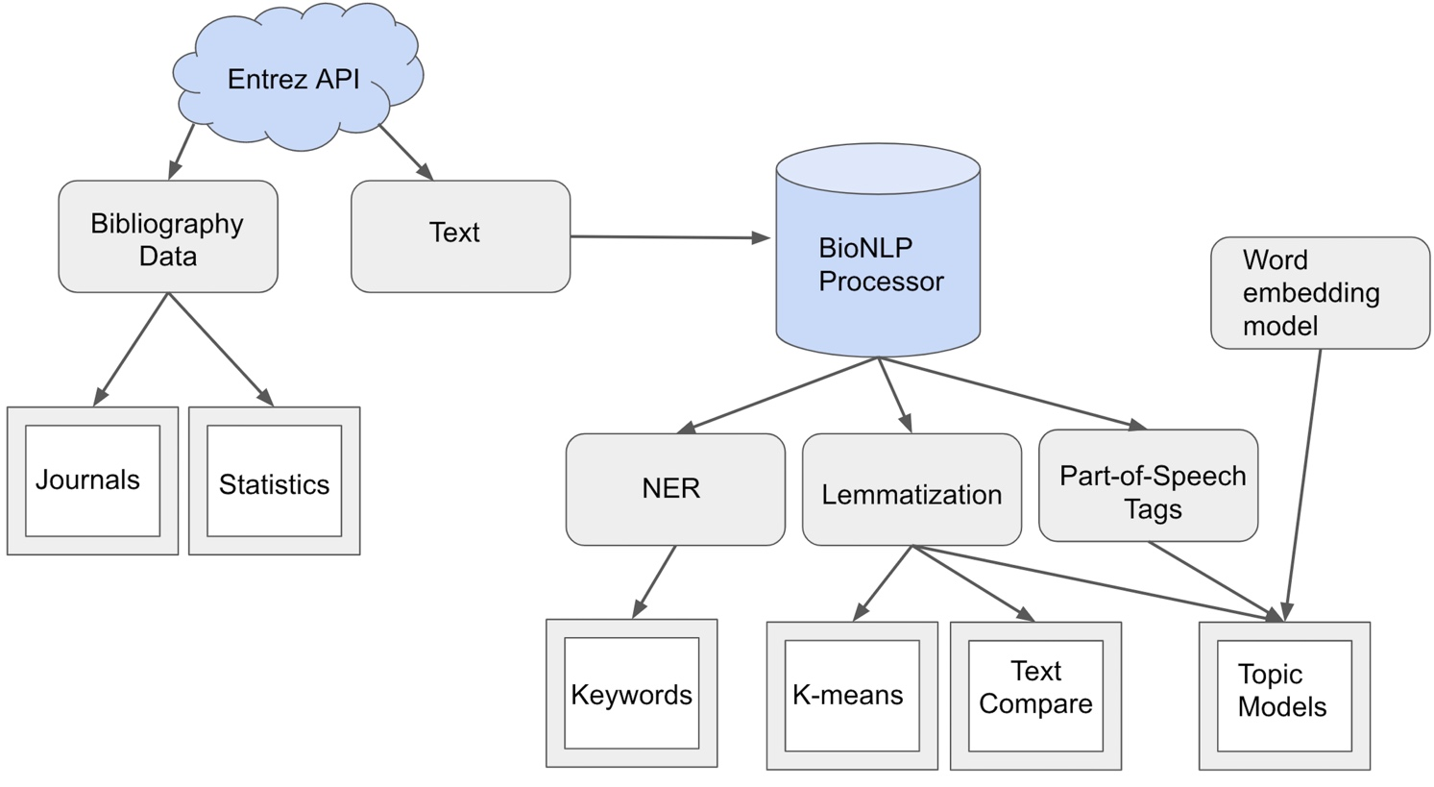

Supplemental Figure: Data Extraction Workflow. After a user submits a query (1 or more PubMed IDs to analyze), SCKE uses the Entrez API to obtain bibliographic data (e.g. citations, dates, etc.) and textual data (full text manuscripts and/or abstract). The BioNLP Processor annotates the text with features such as named entities (NER), part-of-speech tags, and lemmas. These annotations are used to generate the final datasets, which are presented through interactive visualizations.

Extracted Data Examples

The following tables illustrate the data that is collected and stored in the database. Each example corresponds to one row in a different table.

Input Table
post_id | 50
datestamp | 2018-11-12
pmid | 9108111
title | Motor-driven gene expression
author | Jarvis ED, Nottebohm F
journal | Proceedings of the National Academy of Sciences of the United States of America
pubdate | 1997 Apr 15
url | http://www.ncbi.nlm.nih.gov/pubmed/9108111
num_citations | 111
abstract | NA
whole_article | NA
pmcid | NA

Citations Table
post_id | 26538
datestamp | 2018-10-23
pmicd | 6152990
title | Vocal practice regulates singing activity–dependent genes underlying age-independent vocal learning in songbirds
author | Hayase S, Wang H, Ohgushi E, Kobayashi M, Mori C, Horita H, Mineta K, Liu WC, Wada K
journal | PLoS Biology
pubdate | 2018 Sep 12
citesPmid | 9108111
url | https://www.ncbi.nlm.nih.gov/pmc/articles/PMC6152990
abstract | yes
whole_article | yes
sents | 350
tokens | 11580
annotated | yes

Queries Table
post_id | 145
datestamp | 2018-04-18
query | 9108111
range_years | 1997+2018
total_pubs | 108
unique_pubs | 108
unique_journals | 55
num_abstracts | 107
num_whole_articles | 107
num_sents | 10391
num_tokens | 372182

