SUPPLEMENTARY MATERIAL

Interpreting non-coding genetic variation in multiple sclerosis
genome-wide associated regions

Elvezia Maria Paraboschi¹, Giulia Cardamone¹, Giulia Soldà^{1,2}, Stefano Duga^{1,2}, Rosanna Asselta^{1,2*}

¹Department of Biomedical Sciences, Humanitas University, Via Rita Levi Montalcini 4, 20090 Pieve Emanuele, Milan, Italy
²Humanitas Clinical and Research Center, Via Manzoni 56, 20089 Rozzano, Milan, Italy

Content
      - Supplementary Methods. Bioinformatic pipeline for enrichment analyses of disease-associated LD blocks.
- Supplementary Table 1. Susceptibility SNPs associated with MS
- Supplementary Table 2. Susceptibility SNPs associated with CAD
- Supplementary Table 4. Results of the analysis performed on the SLE-associated loci (upper part) and on 1,000 random sets (lower part)
- Supplementary Table 5. Results of the analysis performed on the RA-associated loci (upper part) and on 1,000 random sets (lower part)
- Supplementary Figure 1. Flowchart representing the pipeline steps.
- Supplementary Figure 2. Principal components of ancestry in Italians (our cohort) and Europeans (1000 Genome project subjects)
- Supplementary Figure 3. Distribution of circRNAs per gene
- References

Note
Supplementary Table 3 is contained in Excel file “Paraboschi et al - Supplementary table 3”

SUPPLEMENTARY METHODS

Bioinformatic pipeline for enrichment analyses of disease-associated LD blocks.

List of commands for the analysis of disease-associated LD blocks.

#script1: create random subsets of SNPs extracted from the annotation file

#!usr/bin/sh

for i in {1..1000}
do

gshuf -n xx list_SNP_bed_Intron > random_subset_$i
#xx: select the number of SNPs to extract

gshuf -n xx list_SNP_bed_nonIntron >> random_subset_$i

done

#script2: for each random subset (or disease-specific list) find the blocks in which each SNP lies

#!usr/bin/sh

for i in {1..1000}
do

perl block_finder.pl random_subset_$i random_subset_block_$i

done

#block_finder.pl

#!usr/bin/perl -w
use strict;

my @chr;
my @pos;
my @rs;

my $filename = $ARGV[0];
my $output = $ARGV[1];
#ARGV[0] is the list of SNPs (random_subset_$i); ARGV[1] is the output file (random_subset_block_$i)

open(SUBSET, "$filename") or die $!;
while (<SUBSET>) {
chomp;
my @col = split /\s/, $_;
push @chr, $col[0];
push @rs, $col[2];
push @pos, $col[1];
}
close SUBSET;

my @final;

open(OUT, ">$output") or die $!;

print OUT "chr(hg19)\tstart\tend\trs\tposizione_rs(hg19)\tSNPs\n";

#open the file containing the LD block structure
open(BLOCKS, "LD_structure.bed") or die $!;
while (<BLOCKS>) {
chomp;
my @col = split /\t/, $_;
for (my $i = 0; $i <= $#chr; $i++) {
if (("$col[0]" eq "$chr[$i]") and ($pos[$i] >= $col[1]) and ($pos[$i] <= $col[2])) {
push @final, "$chr[$i]\t$col[1]\t$col[2]\t$rs[$i]\t$pos[$i]\t$col[3]\n";
} else {}
}
}

close BLOCKS;

foreach (@final) {
print OUT;
}

#script3: for each block identified with the script2, find the overlapping non-coding features

#!usr/bin/sh

for i in $(seq 1 1000)
do

perl nc_blocks.pl random_subset_block_$i lnc_$i circ_$i mir_$i SE_$i

done

#nc_blocks.pl

#!usr/bin/perl -w
use strict;

my @chr;
my @start;
my @end;
my @finale;
my @circ;
my @mir;
my @sea;
my $filename = $ARGV[0];
my $output = $ARGV[1];
my $output2 = $ARGV[2];
my $output3 = $ARGV[3];
my $output4 = $ARGV[4];

#ARGV[0] is the output file from script2 (random_subset_block_$i), it contains the blocks in which SNPs lie; ARGV[1] is the output file produced by this script containing lncRNAs overlapping the blocks (lnc_$i); ARGV[2] is the output file produced by this script containing circRNAs overlapping the blocks (circ_$i); ARGV[3] is the output file produced by this script containing miRNAs overlapping the blocks (mir_$i); ARGV[4] is the output file produced by this script containing SEs overlapping the blocks (SE_$i)

#file LD blocks
open(BLOCKS, "$filename") or die $!;
while (<BLOCKS>) {
chomp;
my @col = split /\t/, $_;
push @chr, $col[0];
push @start, $col[1];
push @end, $col[2];
}
close BLOCKS;

open(GTF, "gunzip -c gencode.v25lift37.long_noncoding_RNAs.gtf.gz |") or die $!;
open(OUT, ">$output") or die $!;
open(OUT2, ">$output2") or die $!;
open(OUT3, ">$output3") or die $!;
open(OUT4, ">$output4") or die $!;

#file lncRNAs
while (<GTF>) {
chomp;
my @col = split /\t/, $_;
for (my $i = 0; $i <= $#chr; $i++) {
if ($_ =~ m/^##/){}
elsif (($col[2] eq "gene") and ($col[0] eq "$chr[$i]") and ($col[3] >= $start[$i]) and ($col[4] <= $end[$i])) {
push @finale, "$col[0]\t$col[2]\t$col[3]\t$col[4]\t$col[8]\n";
} elsif (($col[2] eq "gene") and ($col[0] eq "$chr[$i]") and ($col[3] <= $start[$i]) and ($col[4] >= $start[$i]) and ($col[4] <= $end[$i])) {
push @finale, "$col[0]\t$col[2]\t$col[3]\t$col[4]\t$col[8]\n";
} elsif (($col[2] eq "gene") and ($col[0] eq "$chr[$i]") and ($col[3] >= $start[$i]) and ($col[3] <= $end[$i]) and ($col[4] >= $end[$i])) {
push @finale, "$col[0]\t$col[2]\t$col[3]\t$col[4]\t$col[8]\n";
} elsif (($col[2] eq "gene") and ($col[0] eq "$chr[$i]") and ($col[3] <= $start[$i]) and ($col[4] >= $end[$i])) {
push @finale, "$col[0]\t$col[2]\t$col[3]\t$col[4]\t$col[8]\n";
} else {}
}
}

close GTF;

foreach (@finale) {
print OUT;
}

#file circRNAs
open(CIRC, "hsa_hg19_circRNA_human_download") or die $!;
while (<CIRC>) {
chomp;
my @col = split /\t/, $_;
for (my $i = 0; $i <= $#chr; $i++) {
if ($_ =~ m/^##/){}
elsif (($col[0] eq "$chr[$i]") and ($col[1] >= $start[$i]) and ($col[2] <= $end[$i])) {
push @circ, "$col[0]\t$col[1]\t$col[2]\t$col[4]\t$col[11]\n";
} elsif (($col[0] eq "$chr[$i]") and ($col[1] <= $start[$i]) and ($col[2] >= $start[$i]) and ($col[2] <= $end[$i])) {
push @circ, "$col[0]\t$col[1]\t$col[2]\t$col[4]\t$col[11]\n";
} elsif (($col[0] eq "$chr[$i]") and ($col[1] >= $start[$i]) and ($col[1] <= $end[$i]) and ($col[2] >= $end[$i])) {
push @circ, "$col[0]\t$col[1]\t$col[2]\t$col[4]\t$col[11]\n";
} elsif (($col[0] eq "$chr[$i]") and ($col[1] <= $start[$i]) and ($col[2] >= $end[$i])) {
push @circ, "$col[0]\t$col[1]\t$col[2]\t$col[4]\t$col[11]\n";
} else {}
}
}

close CIRC;

foreach (@circ) {
print OUT2;
}

#file miRNAs
open(MIR, "hsa_miRNA") or die $!;
while (<MIR>) {
chomp;
my @col = split /\t/, $_;
for (my $i = 0; $i <= $#chr; $i++) {
if ($_ =~ m/^#/){}
elsif (($col[0] eq "$chr[$i]") and ($col[3] >= $start[$i]) and ($col[4] <= $end[$i])) {
push @mir, "$col[0]\t$col[2]\t$col[3]\t$col[4]\t$col[8]\n";
} elsif (($col[0] eq "$chr[$i]") and ($col[3] <= $start[$i]) and ($col[4] >= $start[$i]) and ($col[4] <= $end[$i])) {
push @mir, "$col[0]\t$col[2]\t$col[3]\t$col[4]\t$col[8]\n";
} elsif (($col[0] eq "$chr[$i]") and ($col[3] >= $start[$i]) and ($col[3] <= $end[$i]) and ($col[4] >= $end[$i])) {
push @mir, "$col[0]\t$col[2]\t$col[3]\t$col[4]\t$col[8]\n";
} elsif (($col[0] eq "$chr[$i]") and ($col[3] <= $start[$i]) and ($col[4] >= $end[$i])) {
push @mir, "$col[0]\t$col[2]\t$col[3]\t$col[4]\t$col[8]\n";
} else {}
}
}

close MIR;

foreach (@mir) {
print OUT3;
}

#file SEs
open(SEA, "superenhancer.bed") or die $!;
while (<SEA>) {
chomp;
my @col = split /\t/, $_;
for (my $i = 0; $i <= $#chr; $i++) {
if ($_ =~ m/^#/){}
elsif (($col[1] eq "$chr[$i]") and ($col[2] >= $start[$i]) and ($col[3] <= $end[$i])) {
push @sea, "$col[1]\t$col[2]\t$col[3]\t$col[4]\t$col[5]\t$col[6]\n";
} elsif (($col[1] eq "$chr[$i]") and ($col[2] <= $start[$i]) and ($col[3] >= $start[$i]) and ($col[3] <= $end[$i])) {
push @sea, "$col[1]\t$col[2]\t$col[3]\t$col[4]\t$col[5]\t$col[6]\n";
} elsif (($col[1] eq "$chr[$i]") and ($col[2] >= $start[$i]) and ($col[2] <= $end[$i]) and ($col[3] >= $end[$i])) {
push @sea, "$col[1]\t$col[2]\t$col[3]\t$col[4]\t$col[5]\t$col[6]\n";
} elsif (($col[0] eq "$chr[$i]") and ($col[2] <= $start[$i]) and ($col[3] >= $end[$i])) {
push @sea, "$col[1]\t$col[2]\t$col[3]\t$col[4]\t$col[5]\t$col[6]\n";
} else {}
}
}

close SEA;

foreach (@sea) {
print OUT4;
}

#script4: Compute the statistics on the files produced
#!usr/bin/sh

for i in $(seq 1 1000)
do

awk -F'\t' '{print $5}' lnc_$i | awk -F';' '{print $1}' | sort | uniq | wc -l >> lnc_count
awk -F'\t' '{print $4}' circ_$i | sort | uniq | wc -l >> circ_count
grep -w miRNA mir_$i | awk -F'\t' '{print $5}' | awk -F';' '{print $3}' | sort | uniq | wc -l >> mir_count
wc -l block_$i >> blocks_count
awk -F'\t' '{print $1,$2,$3}' SE_$i | sort | uniq | wc -l >> SE_count

done

Supplementary Table 1. Susceptibility SNPs associated with MS.

Chromosome | SNP | Gene | p-value*
1 | rs3748817 | MMEL1 | 1.3×10⁻²⁶
1 | rs41286801 | EVI5 | 1.4×10⁻²⁶
1 | rs7552544 | VCAM1 | 1.9×10⁻¹⁶
1 | rs6677309 | CD58 | 5.4×10⁻⁴²
1 | rs1359062 | RGS1 | 4.8×10⁻²⁰
1 | rs55838263 | C1orf106 | 4.0×10⁻¹⁹
1 | rs3007421 | PLEKHG5 | 4.7×10⁻¹⁰
1 | rs12087340 | BCL10 | 1.1×10⁻²⁰
1 | rs11587876 | DDAH1 | 4.4×10⁻⁹
1 | rs666930 | PHGDH | 6.0×10⁻¹²
1 | rs2050568 | FCRL1 | 1.5×10⁻¹⁰
1 | rs35967351 | SLAMF7 | 4.4×10⁻¹¹
2 | rs2163226 | Intergenic | 2.1×10⁻¹⁶
2 | rs7595717 | PLEK | 1.2×10⁻¹³
2 | rs9989735 | SP140 | 4.2×10⁻²³
2 | rs4665719 | CENPO | 3.1×10⁻⁹
2 | rs842639 | FLJ16341 | 2.0×10⁻¹⁴
2 | rs9967792 | STAT4 | 3.5×10⁻¹²
3 | rs2371108 | EOMES | 1.5×10⁻¹⁵
3 | rs1813375 | Intergenic | 1.9×10⁻³²
3 | rs1131265 | TIMMDC1 | 1.4×10⁻²³
3 | rs1920296c | IQCB1 | 6.5×10⁻²²
3 | rs2255214c | CD86 | 1.2×10⁻²⁴
3 | rs1014486 | IL12A | 1.1×10⁻¹⁸
3 | rs11719975 | Intergenic | 1.1×10⁻⁸
3 | rs4679081 | CCR4 | 2.2×10⁻⁹
3 | rs9828629 | FOXP1 | 1.9×10⁻¹⁰
4 | rs7665090 | MANBA | 1.0×10⁻⁸
4 | rs2726518 | TET2 | 3.9×10⁻⁸
5 | rs6881706 | IL7R | 4.3×10⁻¹⁷
5 | rs6880778 | Intergenic | 8.1×10⁻²⁰
5 | rs71624119 | ANKRD55 | 3.4×10⁻¹³
5 | rs756699 | TCF7 | 8.8×10⁻¹¹
5 | None | NDFIP1 | 3.6×10⁻⁹
5 | rs4976646 | RGS14 | 4.4×10⁻¹⁸
6 | rs72928038 | BACH2 | 1.5×10⁻¹⁵
6 | rs11154801 | AHI1 | 1.8×10⁻²⁰
6 | rs17066096 | IL22RA2 | 1.6×10⁻²³
6 | rs67297943 | TNFAIP3 | 5.5×10⁻¹³
6 | rs212405 | TAGAP | 8.0×10⁻²¹
6 | rs17119 | Intergenic | 1.0×10⁻¹⁰
6 | rs941816 | PXT1 | 3.9×10⁻¹²
6 | rs7769192 | Intergenic | 3.3x10⁻⁹
7 | rs1843938 | CARD11 | 1.2×10⁻¹⁰
7 | rs706015 | Intergenic | 1.1×10⁻⁹
7 | rs917116 | JAZF1 | 3.3×10⁻⁹
7 | rs60600003 | ELMO1 | 6.0×10⁻¹⁴
7 | rs201847125 | IKZF1 | 1.2×10⁻¹¹
8 | rs1021156 | ZC2HC1A | 8.5×10⁻¹⁷
8 | rs4410871 | MIR1204 | 4.3×10⁻¹⁶
8 | rs759648 | MIR1208 | 5.0×10⁻¹⁰
8 | rs2456449 | Intergenic | 1.8×10⁻⁹
10 | rs2104286 | IL2RA | 2.3×10⁻⁴⁷
10 | rs1782645 | ZMIZ1 | 2.5×10⁻¹⁵
10 | rs7923837 | HHEX | 4.3×10⁻¹⁷
10 | rs793108 | Intergenic | 6.1×10⁻¹²
10 | rs2688608 | C10orf55 | 4.6×10⁻⁸
11 | rs34383631 | CD6 | 3.7×10⁻²³
11 | rs523604 | CXCR5 | 6.2×10⁻¹⁵
11 | rs7120737 | AGBL2 | 1.0×10⁻⁹
11 | rs694739 | PRDX5 | 2.0×10⁻⁹
11 | rs9736016 | CXCR5 | 3.0×10⁻¹⁵
11 | rs533646 | TREH | 7.6x10⁻¹¹
12 | rs1800693 | TNFRSF1A | 6.7×10⁻²⁸
12 | rs11052877 | CD69 | 5.6×10⁻¹³
12 | rs201202118 | TSFM | 9.0×10⁻²²
12 | rs7132277 | PITPNM2 | 1.9×10⁻¹³
12 | rs12296430 | LTBR | 7.2×10⁻¹⁴
13 | rs4772201 | MIR548AN | 1.3×10⁻¹⁰
14 | rs2236262 | ZFP36L1 | 2.5×10⁻¹²
14 | rs74796499 | GALC | 2.4×10⁻²⁰
14 | rs12148050 | TRAF3 | 5.1×10⁻¹³
15 | rs59772922 | CTSH | 1.2×10⁻⁸
15 | rs8042861 | IQGAP1 | 2.2×10⁻⁹
16 | rs12927355 | CLEC16A | 6.4×10⁻⁴⁶
16 | rs35929052 | IRF8 | 5.9×10⁻¹²
16 | rs6498184 | RMI2 | 7.4×10⁻¹⁸
16 | rs7204270 | MAPK3 | 1.6×10⁻¹¹
16 | rs1886700 | CDH3 | 1.3×10⁻⁸
16 | rs12149527 | WWOX | 3.3×10⁻¹¹
16 | rs7196953 | MAF | 1.0×10⁻¹⁰
16 | rs4780346 | CLEC16A | 4.4x10⁻¹⁰
17 | rs4796791 | STAT3 | 3.7×10⁻²⁰
17 | rs8070345 | VMP1 | 2.2×10⁻²³
17 | rs12946510 | IKZF3 | 2.9×10⁻⁹
17 | rs4794058 | NPEPPS | 1.0×10⁻¹³
19 | rs1077667 | TNFSF14 | 1.7×10⁻²⁴
19 | rs34536443 | TYK2 | 1.8×10⁻¹⁴
19 | rs11554159 | IFI30 | 1.9×10⁻²⁴
19 | rs8107548 | DKKL1 | 5.7×10⁻¹⁵
19 | rs2288904 | SLC44A2 | 1.6×10⁻¹¹
19 | rs1870071 | EPS15L1 | 2.0×10⁻¹⁵
20 | rs4810485 | CD40 | 7.7×10⁻¹⁶
20 | rs2248359 | CYP24A1 | 2.0×10⁻¹³
20 | rs17785991 | SLC9A8 | 4.2×10⁻⁸
20 | rs2256814 | SLC2A4RG | 3.5×10⁻⁹
22 | rs2283792 | MAPK1 | 5.5×10⁻¹⁶
Adapted from IMSGC et al. (2013)
* p-value is derived from the meta-analysis of discovery and replication phase.

Supplementary Table 2. Susceptibility SNPs associated with CAD.

Chromosome | SNP | Gene(s) | p-value*
1 | rs11206510 | PCSK9 | 2.34x10⁻⁰⁸
1 | rs17114036 | PPAP2B | 2.22x10⁻¹³
1 | rs646776 | SORT1 | 9.01x10⁻¹⁹
1 | rs4845625 | IL6R | 3.93x10⁻⁰⁸
1 | rs17464857 | MIA3 | 4.18x10⁻⁰⁵
1 | rs17465637 | MIA3 | 3.52x10⁻¹²
2 | rs16986953 | AK097927 | 1.45x10⁻⁰⁸
2 | rs515135 | APOB | 3.09x10⁻⁰⁸
2 | rs6544713 | ABCG5-ABCG8 | 8.88x10⁻⁰⁷
2 | rs1561198 | VAMP5-VAMP8-GGCX | 6.37x10⁻¹⁰
2 | rs2252641 | ZEB2-ACO74093.1 | 5.16x10⁻⁰⁴
2 | rs6725887 | WDR12 | 9.51x10⁻¹⁸
3 | rs9818870 | MRAS | 2.21x10⁻⁰⁶
4 | rs1878406 | EDNRA | 1.24x10⁻⁰⁶
4 | rs7692387 | GUCY1A3 | 7.35x10⁻⁰⁹
5 | rs273909 | SLC22A4-SLC22A5 | 1.24x10⁻⁰⁴
6 | rs6903956 | ADTRP-C6orf105 | 4.87×10⁻¹²
6 | rs12526453 | PHACTR1 | 2.14x10⁻²⁰
6 | rs17609940 | ANKS1A | 0.03
6 | rs10947789 | KCNK5 | 1.63x10⁻⁰⁶
6 | rs12190287 | TCF21 | 1.07x10⁻⁰³
6 | rs2048327 | SLC22A3-LPAL2-LPA | 2.46x10⁻⁰⁹
6 | rs3798220 | SLC22A3-LPAL2-LPA | 4.66x10⁻⁰⁹
6 | rs4252120 | PLG | 3.32x10⁻⁰³
7 | rs2023938 | HDAC9 | 1.36x10⁻⁰⁴
7 | rs10953541 | 7q22 | 1.02x10⁻⁰⁵
7 | rs11556924 | ZC3HC1 | 5.34x10⁻¹¹
8 | rs264 | LPL | 1.06x10⁻⁰⁵
8 | rs2954029 | TRIB1 | 2.61x10⁻⁰⁶
9 | rs3217992 | 9p21 | 1.03x10⁻⁴²
9 | rs4977574 | 9p21 | 6.35x10⁻⁹⁸
9 | rs579459 | ABO | 1.14x10⁻¹⁰
10 | rs2505083 | KIAA1462 | 1.57x10⁻¹⁰
10 | rs2047009 | CXCL12 | 2.75x10⁻¹¹
10 | rs501120 | CXCL12 | 1.39x10⁻¹¹
10 | rs11203042 | LIPA | 1.22x10⁻⁰⁴
10 | rs1412444 | LIPA | 5.15x10⁻¹²
10 | rs12413409 | CYP17A1-CNNM2-NT5C2 | 1.07x10⁻⁰⁷
11 | rs974819 | PDGFD | 2.44x10⁻¹⁰
11 | rs964184 | ZNF259-APOA5-APOA1 | 5.60x10⁻⁰⁵
12 | rs7136259 | ATP2B1 | 2.45x10⁻⁰⁵
12 | rs3184504 | SH2B3 | 1.03x10⁻⁰⁹
13 | rs9319428 | FLT1 | 7.13x10⁻⁰⁵
13 | rs4773144 | COL4A1/A2 | 3.87x10⁻⁰⁷
13 | rs9515203 | COL4A1/A2 | 9.33x10⁻¹⁰
14 | rs2895811 | HHIPL1 | 1.86x10⁻⁰⁵
15 | rs7173743 | ADAMTS7 | 5.55x10⁻¹⁶
15 | rs17514846 | FURIN-FES | 3.10x10⁻⁰⁷
17 | rs216172 | SMG6 | 5.07x10⁻⁰⁷
17 | rs12936587 | RAI1-PEMT-RASD1 | 8.24x10⁻⁰⁴
17 | rs46522 | UBE2Z | 1.84x10⁻⁰⁵
19 | rs1122608 | LDLR | 2.73x10⁻¹¹
19 | rs2075650 | APOE-APOC1 | 1.61x10⁻⁰⁶
19 | rs445925 | APOE-APOC1 | 4.23x10⁻⁰⁶
21 | rs9982601 | KCNE2 (gene desert) | 1.33x10⁻¹³
* The reported p-values refer to the meta-analysis work presented by Nikpay and colleagues (Nikpay et al., 2015).
** rs6903956 did not result significantly associated with CAD in the meta-analysis. The association p-value as calculated in the original paper is instead shown (Wang et al., 2011).

Supplementary Table 4. Results of the analysis performed on the SLE-associated loci (upper part) and on 1,000 random sets (lower part).

List | n blocks | n lncRNAs | n circRNAs | n miRNAs | n SEs
SLE set | 34 | 18 | 197 | 6 | 14
random sets* | 34.6 | 10.7 | 89.6 | 1 | 1.1
SD | 2.7 | 3.8 | 46.4 | 1.4 | 1.2
%** | - | 4.8 | 3.2 | 1.4 | 0
p-value | - | 0.05 | 0.03 | 0.01 | 9.9*10⁻⁴
* For the random sets analysis, the average values calculated on 1,000 iterations are indicated.
n, number; SD, standard deviation.
** % of times in which the same or a larger number of lncRNAs, circRNAs, miRNAs, or SEs was obtained in the 1,000 iterations as compared to the SLE dataset.
P values were calculated as described (Davison and Hinkley, 1997); in detail: p value = (1+sum(s >= s0))/(N+1), where s is the observed value of the random set, s0 is the value of the observed SLE-specific result, and N is the number of bootstraps.

Supplementary Table 5. Results of the analysis performed on the RA-associated loci (upper part) and on 1,000 random sets (lower part).

List | n blocks | n lncRNAs | n circRNAs | n miRNAs | n SEs
RA set | 58 | 28 | 145 | 0 | 9
random sets* | 58.2 | 17.8 | 148.3 | 1.8 | 1.8
SD | 3.6 | 4.9 | 59.5 | 2.1 | 1.5
%** | - | 3.5 | 46.3 | 100 | 1.1
p-value | - | 0.04 | 0.46 | 1.00 | 0.01
* For the random sets analysis, the average values calculated on 1,000 iterations are indicated.
n, number; SD, standard deviation.
** % of times in which the same or a larger number of lncRNAs, circRNAs, miRNAs, or SEs was obtained in the 1,000 iterations as compared to the RA dataset.
P values were calculated as described (Davison and Hinkley, 1997); in detail: p value = (1+sum(s >= s0))/(N+1), where s is the observed value of the random set, s0 is the value of the observed RA-specific result, and N is the number of bootstraps.

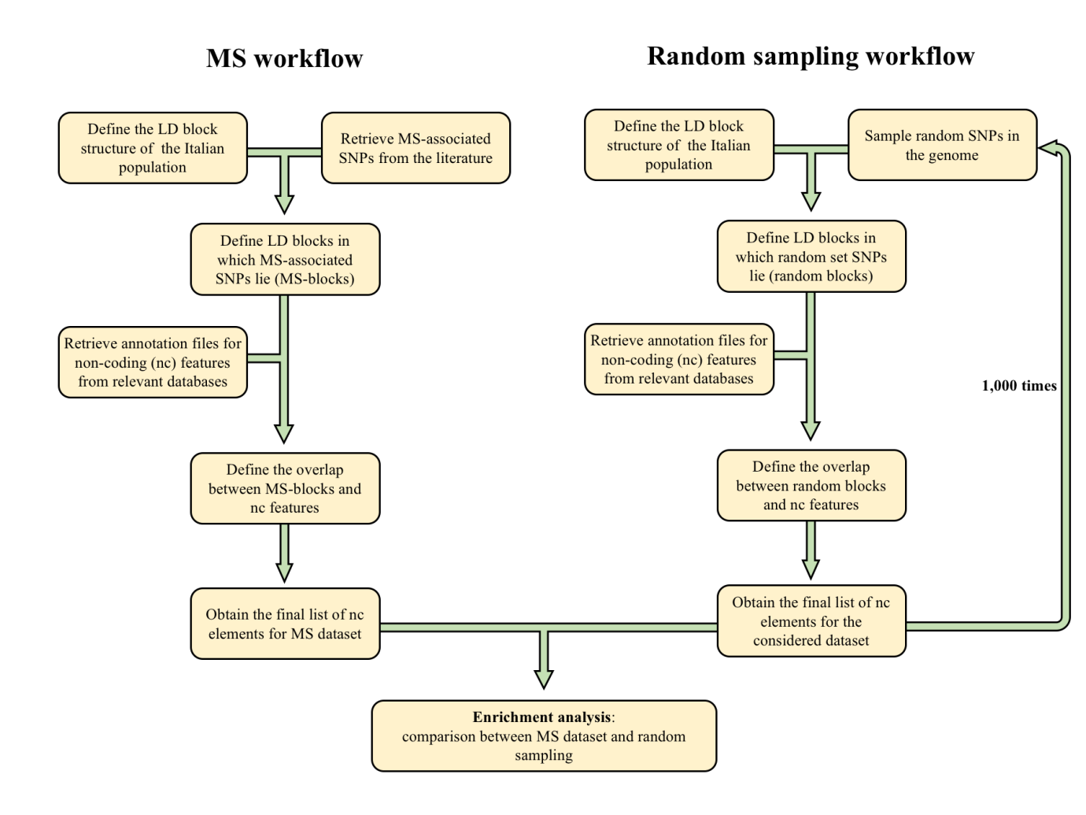

Supplementary Figure 1. Flowchart representing the pipeline steps.

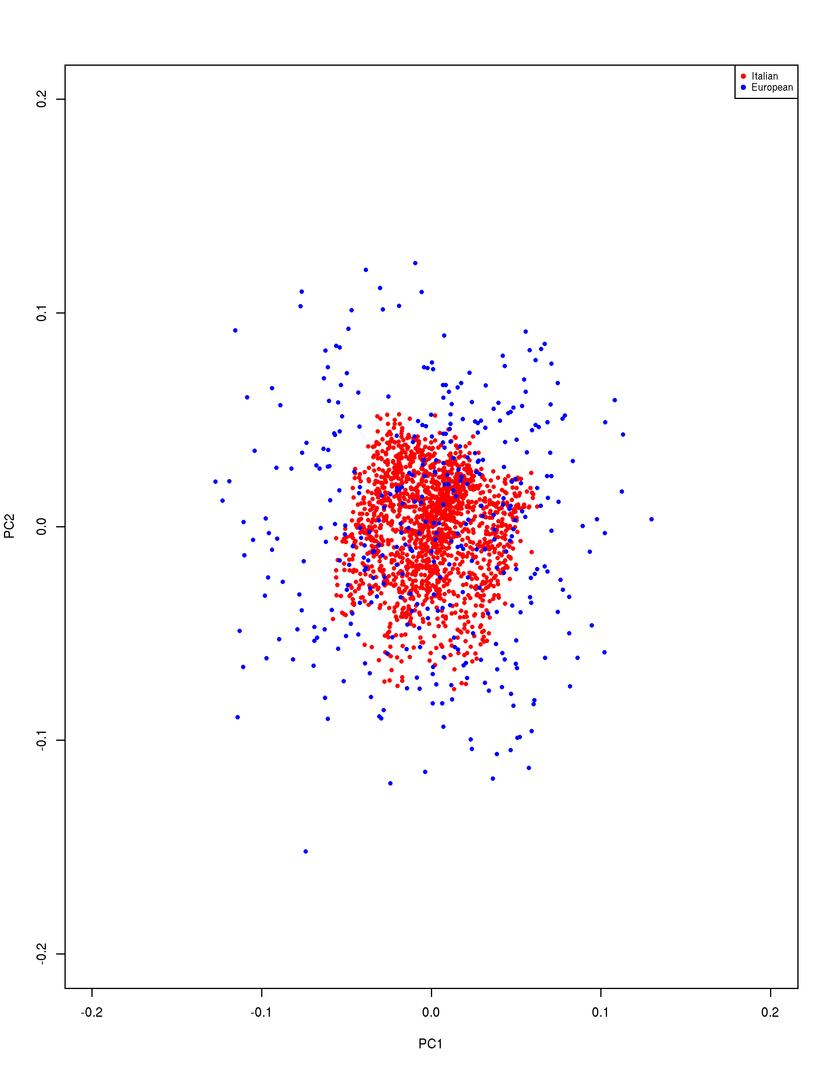

Supplementary Figure 2. Principal components of ancestry in Italians (our cohort) and Europeans (1000 Genome project subjects).
Principal component (PC) analysis of 1,668 healthy unrelated individuals of self-reported Italian origin (red dots) and of 503 individuals of European origin (from the 1000 Genome project, phase 3; blue dots). The two PCs are shown (PC1 and PC2), demonstrating a substantial overlap between the two populations. PC analysis was preformed using SmartPCA software contained in the EIGENSOFT package (Patterson et al., 2006; Price et al., 2006).

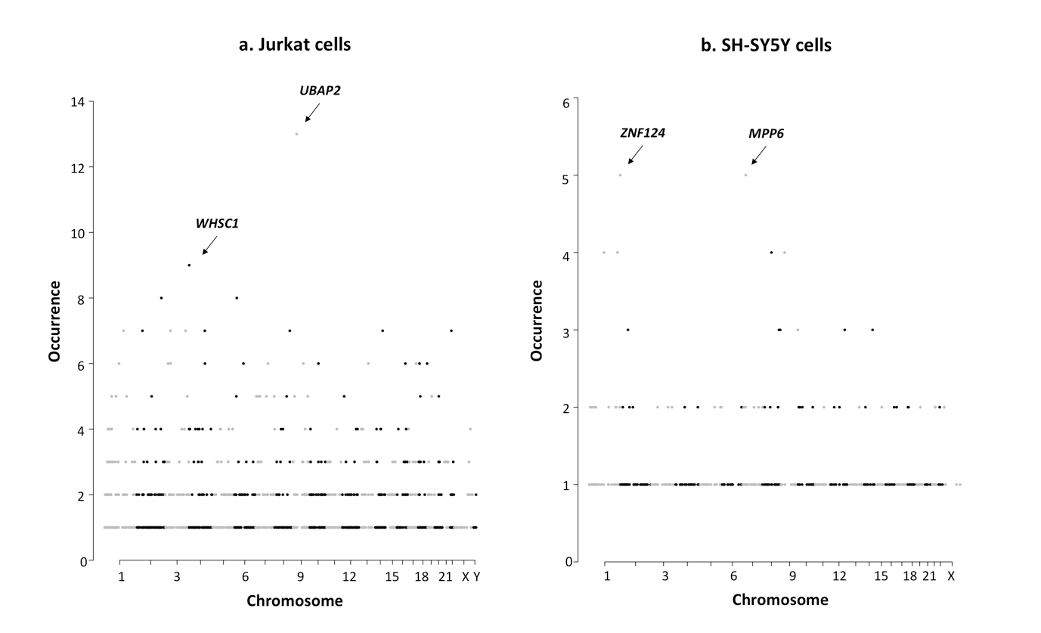

Supplementary Figure 3. Distribution of circRNAs per gene.
The figure shows the number of different species of circRNAs (supported by at least 5 reads) carried by each gene for Jurkat cells (panel a) and SH-SY5Y cells (panel b). Genes are separated according to their position on chromosomes (X axis) and represented as dots. The number of different circRNAs is reported on Y axis. Arrows indicate the genes characterized by the highest number of circRNAs, and their names are also shown.

References

Davison, A.C., Hinkley, D.V. (1997). Bootstrap methods and their application. New York: Cambridge University Press

International Multiple Sclerosis Genetics Consortium (IMSGC), Beecham, A.H., Patsopoulos, N.A., Xifara, D.K., Davis, M.F., Kemppinen, A., et al. (2013). Analysis of immune-related loci identifies 48 new susceptibility variants for multiple sclerosis. Nat Genet. 45, 1353-1360. doi: 10.1038/ng.2770

Nikpay, M., Goel, A., Won, H.H., Hall, L.M., Willenborg C., Kanoni S., et al. (2015). A comprehensive 1,000 Genomes-based genome-wide association meta-analysis of coronary artery disease. Nat Genet. 47, 1121-1130. doi: 10.1038/ng.3396

Patterson, N., Price, A.L. and Reich, D. (2006) Population structure and eigenanalysis. PLoS Genet., 2, e190. doi: 10.1371/journal.pgen.0020190

Price, A.L., Patterson, N.J., Plenge, R.M., Weinblatt, M.E., Shadick, N.A. and Reich, D. (2006). Principal components analysis corrects for stratification in genome-wide associa- tion studies. Nat. Genet., 38, 904-909. doi: 10.1038/ng1847

Wang, F., Xu, C.Q., He, Q., Cai, J.P., Li, X.C., Wang, D., et al. (2011). Genome-wide association identifies a susceptibility locus for coronary artery disease in the Chinese Han population. Nat Genet. 43, 345-349. doi: 10.1038/ng.783

