Supplementary Material

Elevated temperature does not substantially modify the interactive effects between elevated CO₂ and diel CO₂ cycles on the survival, growth and behaviour of a coral reef fish
Michael D. Jarrold* and Philip L. Munday

* Correspondence: michael.jarrold@my.jcu.edu.au

Supplementary Figure 1. Mean daily pCO₂ profiles at 29 and 31°C.

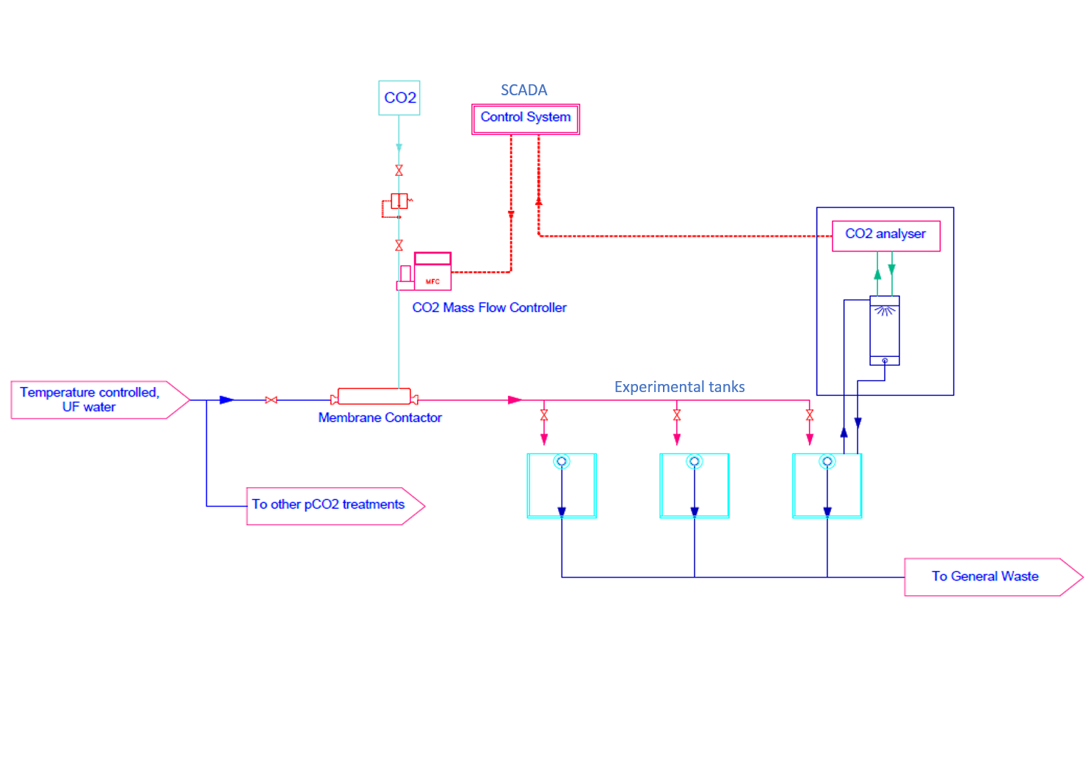
Supplementary Figure 2. Schematic diagram of one individual system. The experimental setup was comprised of 16 systems.

Supplementary Table 1. Comparison between the present study and two previous studies (Jarrold et al., 2017; Jarrold and Munday, 2018) of the effects that stable elevated, diel-cycling elevated CO₂ and elevated temperature had on the survival, growth and behaviour of the spiny damselfish, Acanthochromis polyacanthus. NA is used to show that a trait was not measured in a study. – represents no significant effects or apparent response. Arrows represent the direction of a response, while the colours represent the following: Red = significant negative effect; Green = significant positive effect and orange represents a non-significant trend. The responses of traits to stable-elevated CO₂ are relative to the control treatment, while the responses to diel-cycling elevated CO₂ are relative to stable elevated CO₂.
 | Jarrold et al., 2017 |  | Jarrold and Munday 2018 |  | Present study
Trait | Stable-elevated CO₂ | Diel cycling-elevated CO₂ | Stable-elevated CO₂ | Diel cycling-elevated CO₂ | Stable-elevated CO₂ | Diel cycling-elevated CO₂ | Elevated temperature
Survival | NA | NA | − | − | − | − | ↓
Growth | NA | NA | ↓ | ↑ | ↓ | ↑ | ↓
Absolute lateralization | ↓ | ↑ | NA | NA | ↓ | ↑ | −
Relative lateralization | − | − | NA | NA | − | − | −
Routine activity | NA | NA | NA | NA | − | ↓ | ↓
Boldness | NA | NA | NA | NA | − | − | ↓
Fast starts | NA | NA | NA | NA | − | − | ↑

References
Jarrold, M. D., Humphrey, C., McCormick, M. I., and Munday, P. L. (2017). Diel CO₂ cycles reduce severity of behavioural abnormalities in coral reef fish under ocean acidification. Sci. Rep. 7, 10153. doi:10.1038/s41598-017-10378-y.
Jarrold, M. D., and Munday, P. L. (2018). Diel CO₂ cycles do not modify juvenile growth, survival and otolith development in two coral reef fish under ocean acidification. Mar. Biol. 165. doi:10.1007/s00227-018-3311-5.

