Supplementary Material

# Bioassay-Guided Isolation of Anti-Candida Biofilm compounds From Methanol Extracts of the Aerial Parts of *Salvia officinalis* (Annaba, Algeria)

Neila Kerkoub1¥*, Sujogya Kumar Panda2¥*, Ming-Rong Yang3, Jing-Guang Lu3, Zhi-Hong Jiang3, Hichem Nasri1, Walter Luyten2

**\* Correspondence**

Neila kerkoub (neilaker23@gmail.com ), Sujogya Kumar Panda (sujogyapanda@gmail.com)

# Supplementary Data (HRMS and NMR spectrum)

|  |
| --- |
|  |
|  |

**Figure 1.** HRMS spectrum and data of **WL-04**

|  |  |  |  |  |  |
| --- | --- | --- | --- | --- | --- |
| Formula | Score | *m/z* (Calc) | Diff(ppm) | Ion Formula | *m/z* |
| C20H26O4 | 100 | 331.1904 | -1.1 | C20H26O4 | 331.1908 |
| C20H26O4 | 57.38 | 329.1758 | -2.8 | C20H26O4 | 329.1768 |

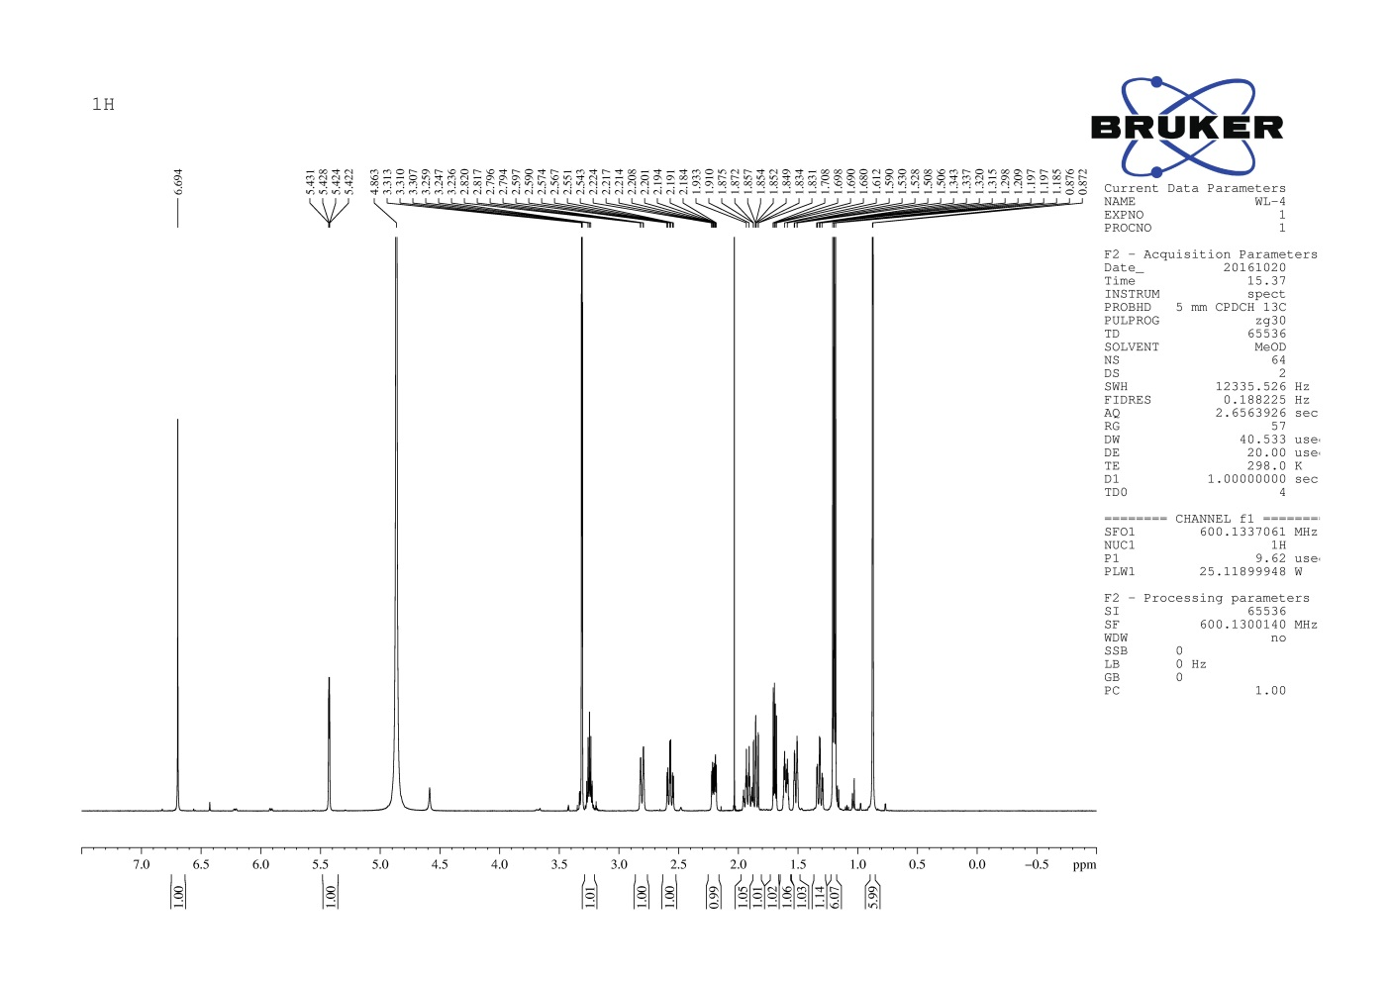

**Figure 2.** 1H-NMR spectrum of **WL-04**

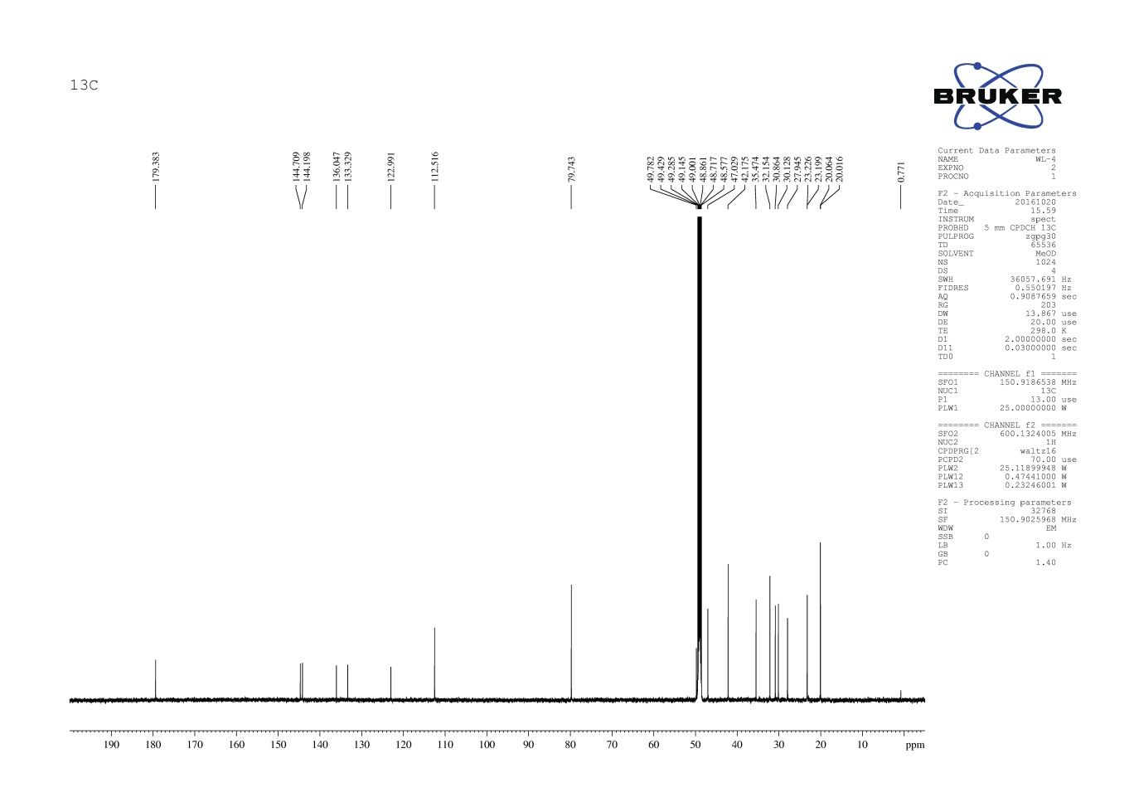

**Figure 3.** 13C-NMR spectrum of **WL-04**

|  |
| --- |
|  |
|  |

|  |  |  |  |  |  |
| --- | --- | --- | --- | --- | --- |
| Formula | Score | *m/z* (Calc) | Diff(ppm) | Ion Formula | *m/z* |
| C21H30O4 | 100 | 347.2217 | -0.2 | C21H30O4 | 347.2218 |
| C21H30O4 | 100 | 345.2071 | -3.4 | C21H30O4 | 345.2083 |

**Figure 4.** HRMS spectrum and data of **WL-12**

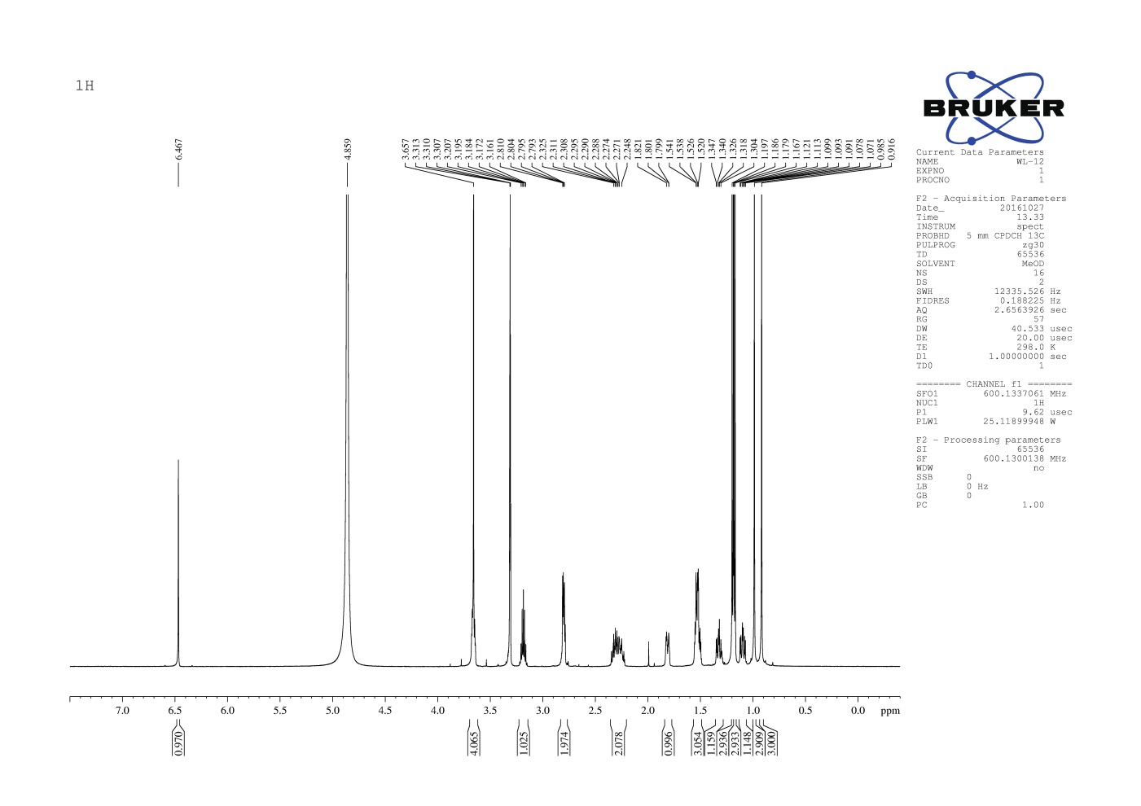

**Figure 5.** 1H-NMR spectrum of **WL-12**

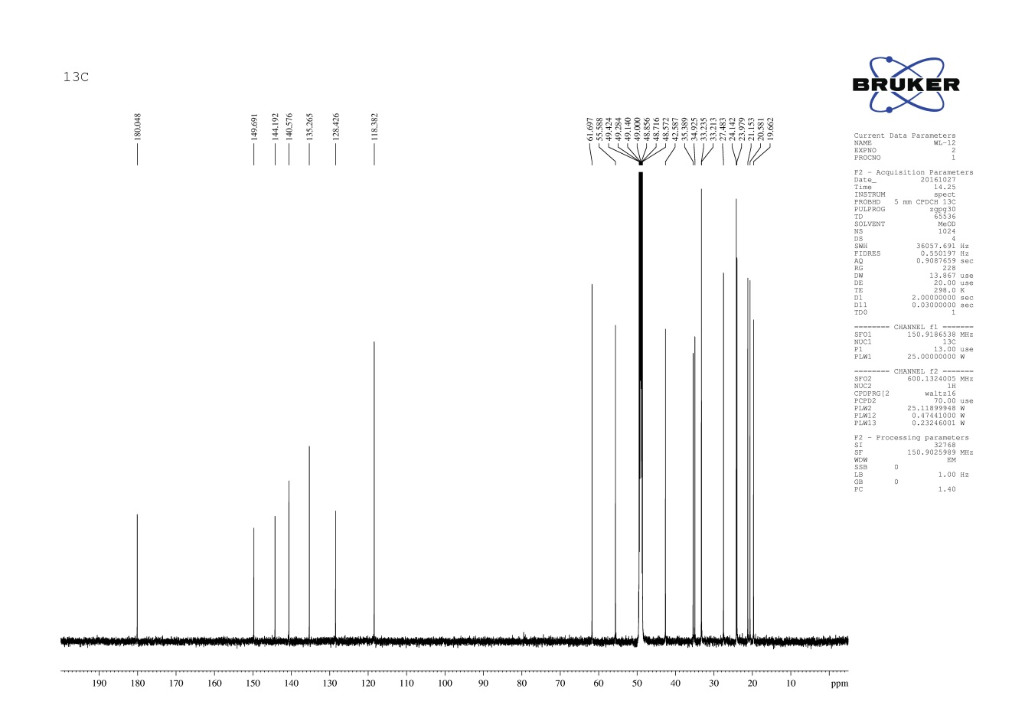

**Figure 6.** 13C-NMR spectrum of **WL-12**

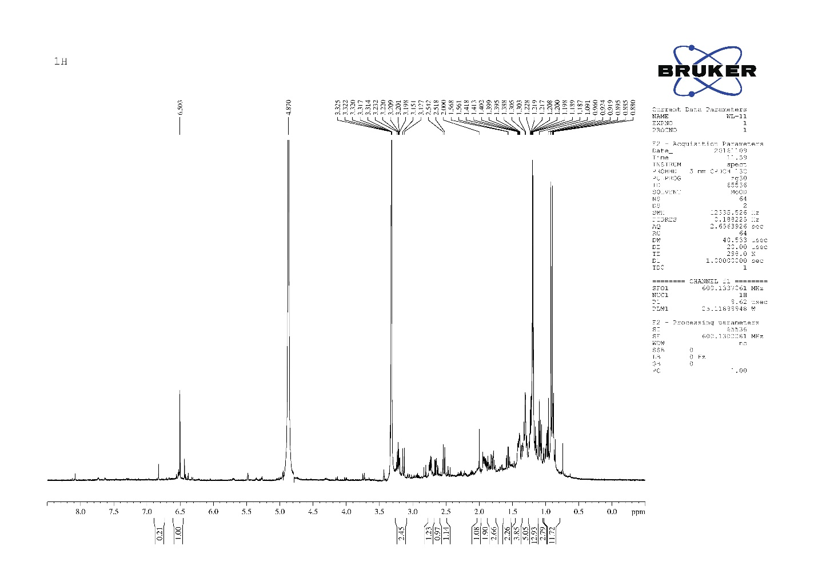

**Figure 7.** 1H-NMR spectrum of **WL-11**

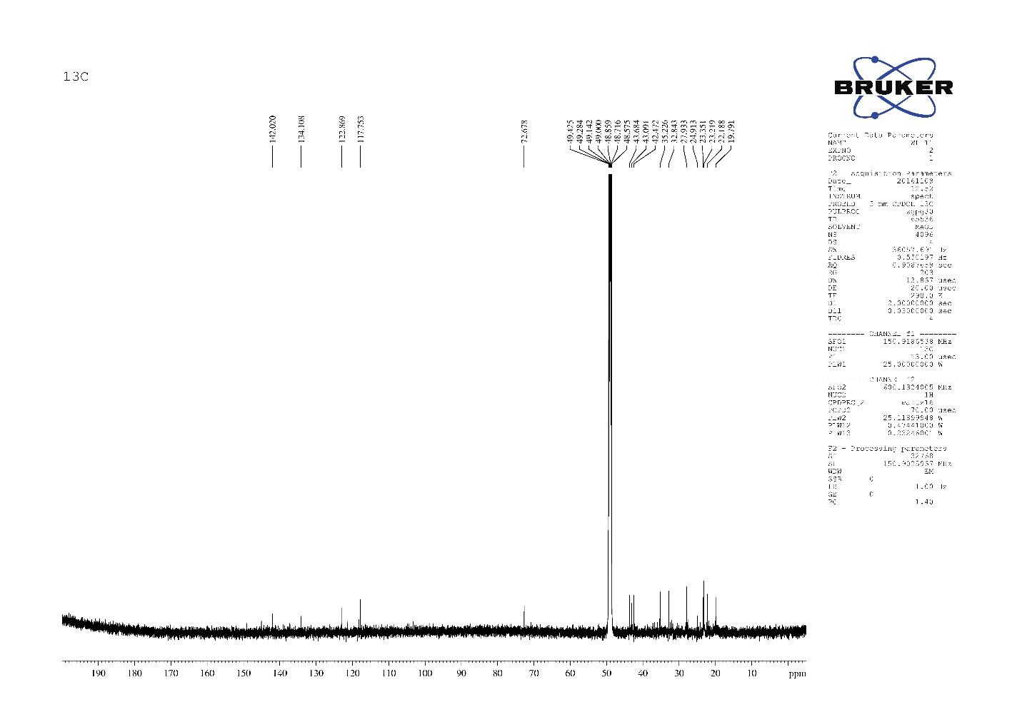

**Figure 8.** 13C-NMR spectrum of **WL-11**



**Figure 9.** HRMS spectrum and data of **WL-11;** [Formula: C16H26N6O([M-H]-= 317.2095, -4.9ppm)