Supplementary Material
Genome-Wide Association Study of Growth-Associated Genetic Markers in a New Fast-Growing Carp Strain Using 2b-RAD Method
Shengyan Su, Hengde Li, Fukuan Du , Chengfeng Zhang, Xinyuan Li, Xiaojun Jing, Liyue Liu, Zhixun Li, Xingli Yang, Pao Xu *, Xinhua Yuan*, Jian Zhu *, Raouf Bouzoualegh

* Corresponding author:
Dr. Pao Xu
xup@ffrc.cn

Dr. Xinhua Yuan
E-mail: yuanxh@ffrc.cn

Dr. Jian Zhu
E-mail: zhuj@ffrc.cn

Supplementary Figures
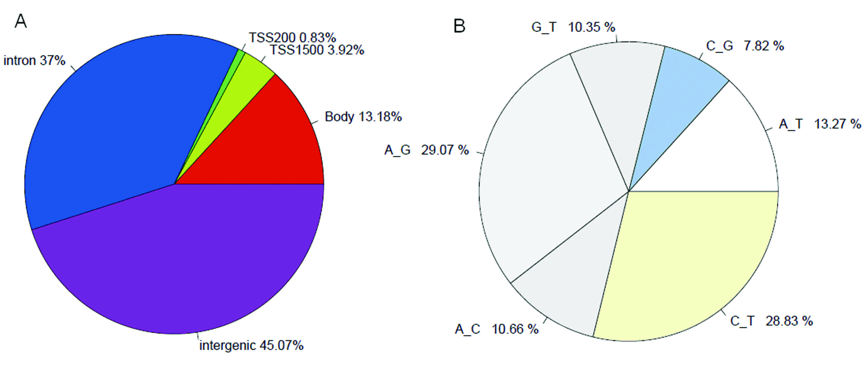
Supplementary Figure 1. Genome-wide features of the SNPs captured by 2b-RAD. a. Genomic distribution of the captured SNPs; b. Number of different nucleotide base mutations on the genome-wide level.
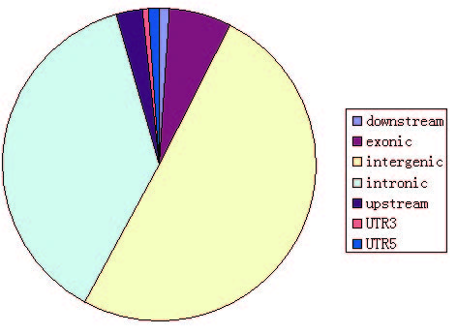
Supplementary Figure 2. Distribution of SNPs observed on genome functional regions.

