Supplementary Table S4. ¹H- and ¹³C-NMR data of 4-amino-3-(4-(methylsulfinyl)butyl)-2-thioxothiazolidine-4-carboxylic acid (4MSOB-ITC-Cyclic-Cys conjugate B) isolated from feces of P. chrysocephala.
Position | δ_{H} (mult.) | δ_{C} | Structure
1 | 2.82/2.88 (m/m) | 54.1 | 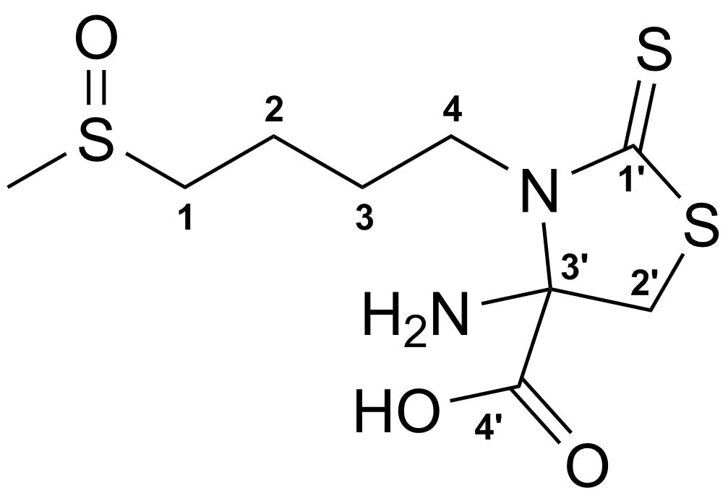
2 | 1.94 (m) | 27.3
3 | 1.76 (m) | 21.0
4 | 3.58/3.74 (m/m) | 46.7
1' | - | 199.0
2' | 3.22/3.99 (d, J=11.5 Hz) | 39.7
3' | - | 89.6
4' | - | 174.8
-SCH₃ | 2.63 (s) | 37.8

