Supplementary Table S3. ¹H- and ¹³C-NMR data of 4MSOB-acetamide isolated from feces of P. chrysocephala.
Position | δ_{H} (mult.) | δ_{C} | Structure
1 | 2.80/2.88 (m/m) | 52.9 | 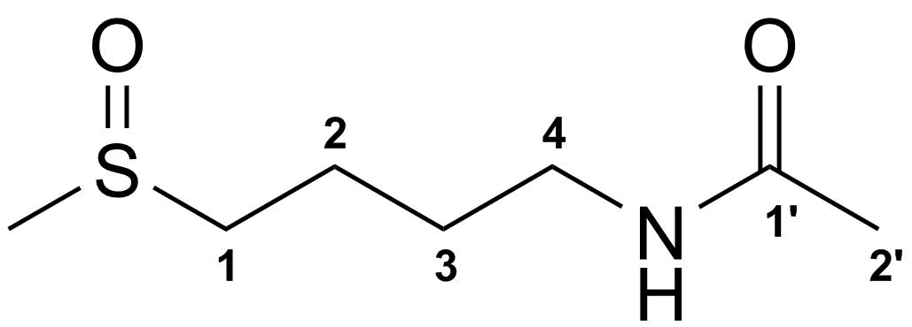
2 | 1.80 (m) | 19.7
3 | 1.68 (m) | 28.0
4 | 3.24 (m) | 38.4
1' | - | 172.2
2' | 1.96 (s) | 21.3
-SCH₃ | 2.66 (s) | 36.7

