§Primers designed in this study
PCR methods
ESBL qPCR and Melting Curve analysis
Primers
FWD_SHVu 5’-GCAAAACGCCGGGTTATTC-3’
§R_SHVin 5’-GCCGGCGTATCCCGCAGATAA-3’
FWD_CTX-Mu 5’-CGCTTTGCGATGTGCAG-3’
REV_CTX-Mu 5’-ACCGCGATATCGTTGGT-3’
§F_Tem_in 5’-TGCTCACCCAGAAACGCTGGT-3’
§R_Tem_in 5’-TGCTGCAGGCATCGTGGTGT-3’
Reaction mix
qPCR Master Mix (Promega) 1X, , forward and reverse blaSHV primers 300 nM each, forward and reverse blaCTX-M primers 150 nM, forward and reverse blaTEM primers 250 nM, 1µL of template DNA, Water molecular grade reagent up to 25 µL
Amplification protocol
95°C for 2 min, followed by 40 cycles composed of denaturation at 95°C for 20 s, annealing at 60°C for 30s and extension at 72°C for 1.30 min followed by melt curve analysis.
blaSHV family: T_{m} ≈ 90°C
blaCTX-M family: T_{m} ≈ 89°C
blaTEM family: T_{m} ≈ 84°C
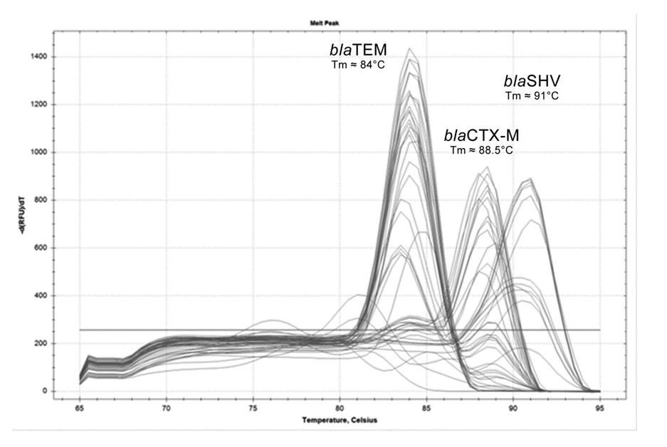
L1
Primers (Primer Express software v2.0, Thermo Fisher Scientific)
§F_sm_L1 5’-GGCGACGGCATCACCTAT-3’
§Rev__bis_L1_sm 5’-CTTGCCATCGCGGGTATCGG-3’
Reaction mix
Phusion (Thermo Scientific) 0.4u, HF buffer 1X, dNTPs 200 µM each, additional Mg 0.25mM, forward and reverse primers 400 nM each, 1µL of template DNA, Water molecular grade reagent up to 25 µL
Amplification protocol
98°C for 30 s, followed by 40 cycles composed of denaturation at 98°C for 10 s, annealing at 69°C for 10s and extension at 72°C for 10 s.

AmpR-L2
Primers (Primer Express software v2.0, Thermo Fisher Scientific)
§F_sm_AmpR_L2_good 5’-CGGGTGAAGTTCTGGTGGCG-3’
§R_sm_AmpR_L2_best 5’-CTGCAGGAATCGGCGACGG-3’
Reaction mix
Phusion (Thermo Scientific) 0.4u, HF buffer 1X, dNTPs 200 µM each, additional Mg 0.5mM, forward and reverse primers 400 nM each, 1µL of template DNA, Water molecular grade reagent up to 25 µL
Amplification protocol
98°C for 30 s, followed by 40 cycles composed of denaturation at 98°C for 10 s, annealing at 71.6 °C for 10 s and extension at 72°C for 10s.

SXT resistance in S. maltophilia
Class 1 integrase
Temperature of annealing: 59.3°C
intI1-R 5’-CAGTGGACATAAGCCTGTTC-3’
intI1-F 5’-CCCGAGGCATAGACTGTA-3’
Class 1 integron
Temperature of annealing: 54.1°C
In1-R 5’-AAGCAGACTTGACCTGA-3’
In1-F 5’-GGCATCCAAGCAGCAAG-3’
Class 2 integron
Temperature of annealing: 65.7°C
hep74 5’-CGGGATCCCGGACGGCATGCAC-3’
hep51 5’-GATGCCATCGCAAGTACGAG-3’
Class 3 integrase
Temperature of annealing: 64.0°C
int3-R 5’-TGTTCTTGTATCGGCAGGTG-3’
int3-F 5’-AGTGGGTGGCGAATGAGTG-3’
sul1
Temperature of annealing: 59.3°C
sul1-R 5’-ATTCAGAATGCCGAACACCG-3’
sul1-F 5’-TAGCGAGGGCTTTACTAAGC-3’
sul2
Temperature of annealing: 66.6°C
sul2-R 5’-GAAGCGCAGCCGCAATTCAT-3’
sul2-F 5’-CCTGTTTCGTCCGACACAGA-3’
dfrA1
Temperature of annealing: 61.0°C
dfrA1-R 5’-TTGTGAAACTATCACTAATGGTAG-3’
dfrA1-F 5’-CTTGTTAACCCTTTTGCCAGA-3’
dfrA5
Temperature of annealing: 61.0°C
dfrA5-R 5’-TCCACACATACCCTGGTCCG-3’
dfrA5-F 5’-ATCGTCGATATATGGAGCGTA-3’
dfrA12
Temperature of annealing: 63.8°C
dfrA12-R 5’-ATGAACTCGGAATCAGTACGC-3’
dfrA12-F 5’-TTAGCCGTTTCGACGCGCAT-3’
dfrA13
Temperature of annealing: 58.6°C
dfrA13-R 5’-GAAACTATCACTAATGGCAGC-3’
dfrA13-F 5’-CTCATCTGCTGGCTATCTCA-3’
dfrA17
Temperature of annealing: 65.9°C
dfrA17-R 5’-TTGAAAATATTATTGATTTCTGCAGTG-3’
dfrA17-F 5’-GTTAGCCTTTTTTCCAAATCTGGTATG-3’
Reaction mix
Phusion (Thermo Scientific) 0.3u, HF buffer 1X, dNTPs 200 µM each, additional Mg 0.25mM, forward and reverse primers 500 nM each, 1µL of template DNA, Water molecular grade reagent up to 25 µL
Amplification protocol
98°C for 30 s, followed by 40 cycles composed of denaturation at 98°C for 10 s, annealing specific for each primer pair (listed above) °C for 15 s and extension at 72°C for 20 s.

Transposon Tn125
5’-terminus
Primers (Primer3Plus, http://www.bioinformatics.nl/cgi-bin/primer3plus/primer3plus.cgi)
§Fwd_ISAba125 5’-GGCAGAATCAGTGCGCAAGGC-3’
§NDM-reverse 5’-GTGCTCAGCTTCGCGACC-3’
3’-terminus (Primer3Plus, http://www.bioinformatics.nl/cgi-bin/primer3plus/prmer3plus.cgi)
§F_∆pac 5’-TGACTGAACCAACTGTGAGTCCT-3’
§rev_ISAba125 5’-TTGAACTTCGGCTGGGCGCT-3’
Reaction mix
Hot Start GoTaq (Promega) 1 u, buffer 1X, dNTPs 200 µM each, Mg 2 mM, forward and reverse primers 400 nM each, 1µL of template DNA, Water molecular grade reagent up to 25 µL
Amplification protocol
95°C for 2 min, followed by 40 cycles composed of denaturation at 94°C for 30 s, annealing at 58°C for 30s and extension at 72°C for 1 min.

blaOxa-23
Primers (Primer Express software v2.0, Thermo Fisher Scientific)
§F_Oxa-23 5’-GGAGAACCAGAAAACGGAT-3’
§R_Oxa-23 5’-ATGGTCCTACCAACCAGA-3’
Reaction mix
GoTaq® qPCR Master Mix with CXR reference dye (Promega) 1 X, forward and reverse primers 400 nM each, 1µL of template DNA, Water molecular grade reagent brought to 20 µL
Amplification protocol
95°C for 2 min, followed by 40 cycles composed of denaturation at 95°C for 15 s, annealing and extension at 60°C for 1 min. followed by Melt curve analysis.

OprD
Primers (Primer3Plus, http://www.bioinformatics.nl/cgi-bin/primer3plus/prmer3plus.cgi)
§F_5_oprD 5’-ACTAGCCGTCACTGCGGCAC-3’
§R_3_oprD 5’-CGCGTTGCCGCCGAGAAGAA-3’

Reaction mix
Hot Start GoTaq (Promega) 1 u, buffer 1X, dNTPs 200 µM each, Mg 2 mM, forward and reverse primers 300 nM each, 1µL of template DNA, Water molecular grade reagent up to 25 µL
Amplification protocol
95°C for 2 min, followed by 40 cycles composed of denaturation at 94°C for 20 s, annealing at 58°C for 20s and extension at 72°C for 2 min.
§R_5_oprD 5’-CGGCGAAGACCGGAGCGG-3’
§F_3_oprD 5’-GGTCCATGGCGATCAGCCGTTT-3’
§F_OprD_seq_a 5’-CGAAGGCAAGCAGGGCACCA-3’
§F_OprD_seq_b 5’-TCAGCGCCTCCCTGTACGGT-3’
§F_OprD_seq_c 5’-AGGCCGGCGACATCAGCAAC-3’
§F_5'rev_OprD 5’-CCGCTCCGGTCTTCGCCG-3’

