**Appendix 1. Means, SDs and Correlations of all variables**

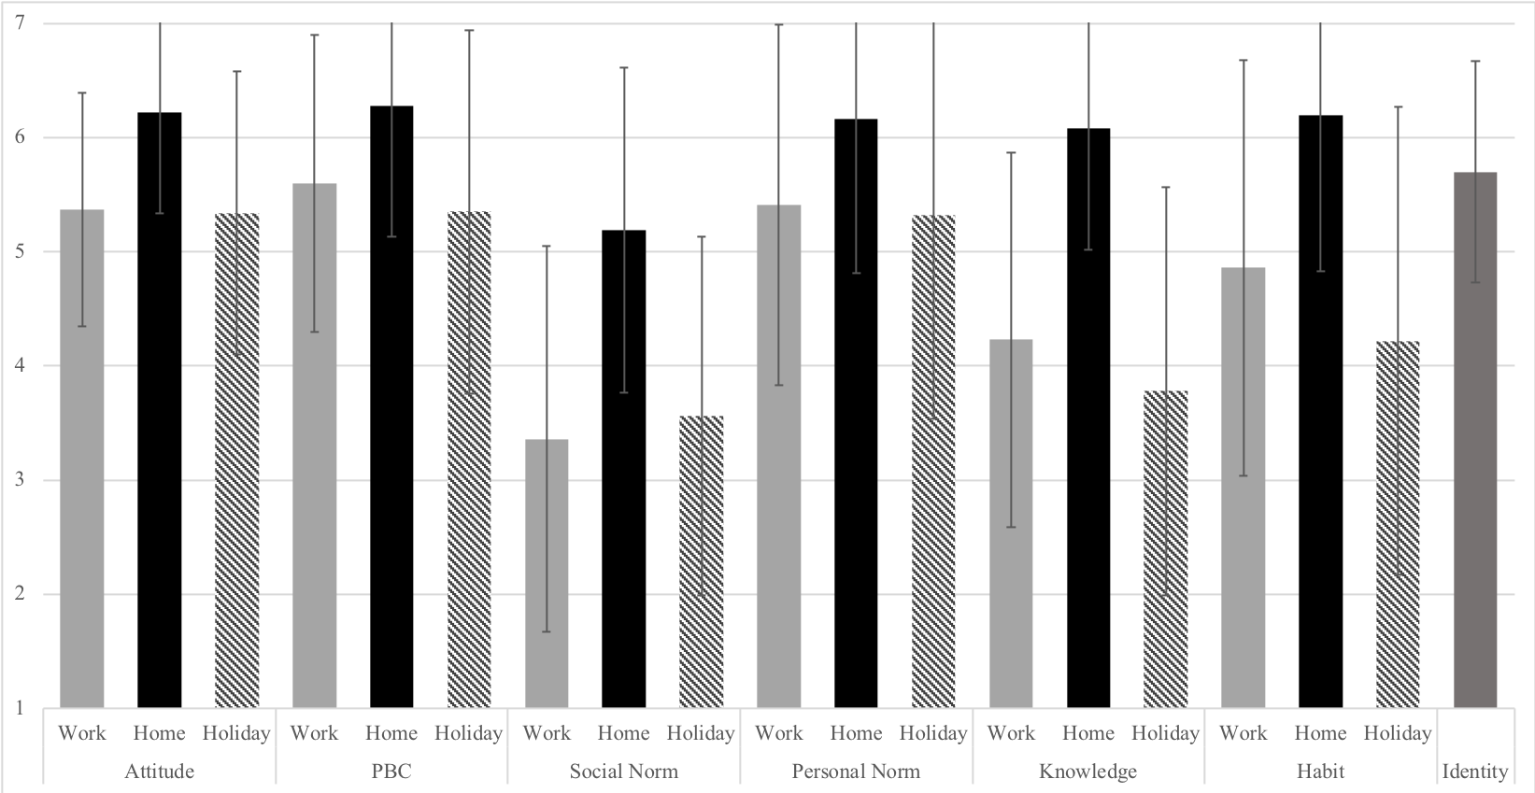

*Figure A1. Means and SDs of psychological variables*

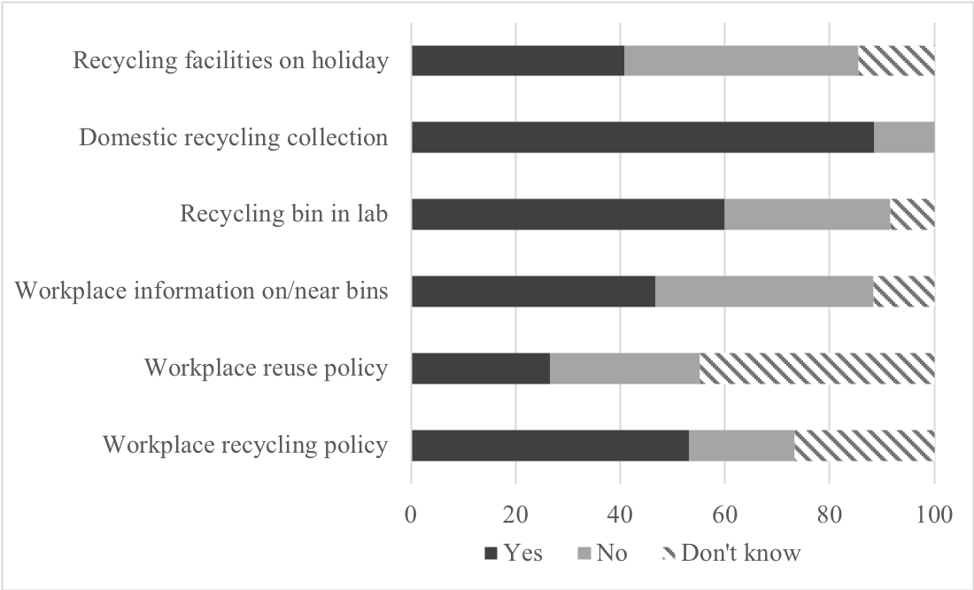

*Figure A2. Contextual variables (% of respondents)*

