Supplementary Materials
Urban-Rural Disparity in Cancer Incidence, Mortality, and Survivals in Shanghai, China, During 2002 and 2015
Xiaopan Li †, Yang Deng †, Weina Tang †, Qiao Sun, Yichen Chen, Chen Yang, Bei Yan, Yingying Wang, Jing Wang, Shuo Wang, Fan Yang, Yibo Ding, Genming Zhao*, Guangwen Cao*
* Correspondence: Guangwen Cao: gcao@smmu.edu.cn.
Genming Zhao: gmzhao@shmu.edu.cn.

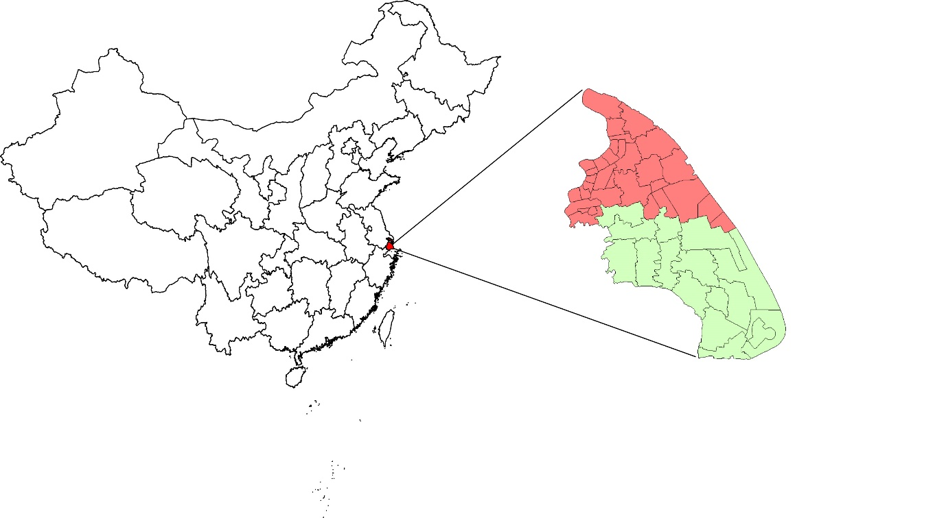
Supplementary Figure 1 | The geographic location of Pudong New Area in China.
Urban areas are presented in red color; rural areas are presented in green color.
Supplementary Table 1 | The three main measures of data quality for cancer registry in Pudong new district, Shanghai, China, 2002-2015
Type | ICD-10 | MV%ª | DCO%^{b} | M/I^{c}
Lip, oral cavity, & pharynx (except nasopharynx) | C00-C10, C12-C14 | 88.47 | 1.86 | 0.44
Nasopharynx | C11 | 82.38 | 1.99 | 0.47
Esophagus | C15 | 67.16 | 6.46 | 0.82
Stomach | C16 | 75.59 | 3.38 | 0.68
Colon & rectum | C18-C20 | 81.73 | 1.75 | 0.50
Liver | C22 | 55.38 | 6.86 | 0.86
Gallbladder | C23-C24 | 42.37 | 4.76 | 0.87
Pancreas | C25 | 56.62 | 6.08 | 0.92
Larynx | C32 | 89.50 | 2.33 | 0.43
Lung & bronchus | C33-C34 | 51.41 | 4.80 | 0.77
Other thoracic organs | C37-C38 | 53.08 | 3.58 | 0.58
Bone | C40-C41 | 49.28 | 12.05 | 0.68
Melanoma of the skin | C43 | 84.36 | 2.47 | 0.60
Breast in female | C50 | 92.36 | 0.71 | 0.19
Cervix | C53 | 94.25 | 0.45 | 0.14
Uterus | C54-C55 | 90.68 | 1.53 | 0.22
Ovary | C56 | 80.89 | 1.62 | 0.47
Prostate | C61 | 77.79 | 1.31 | 0.42
Testis | C62 | 85.16 | 1.10 | 0.20
Kidney | C64-C66, C68 | 77.19 | 1.66 | 0.34
Bladder | C67 | 82.78 | 1.98 | 0.41
Brain & CNS^{d} | C70-C72 | 57.88 | 4.04 | 0.47
Thyroid | C73 | 95.44 | 0.24 | 0.04
Lymphoma | C81-C85, C88, C90, C96 | 71.11 | 3.31 | 0.61
Leukemia | C91-C95 | 39.94 | 4.98 | 0.71
All other sites and unspecified | A_O | 60.91 | 4.31 | 0.52
All types | ALL | 70.40 | 3.42 | 0.56
ªMV, morphological verification.
^{b}DCO, Death certification only.
^{c}M/I, mortality to incidence ratio.
^{d}CNS, central nervous system.

