Supplementary Material
Understanding the mechanisms behind the response of environmental perturbation in microbial mats: a metagenomic-network approach
Valerie De Anda¹, Icoquih Zapata-Peñasco ², Jazmín Blaz³, Augusto Cesar Poot-Hernández⁴, Bruno Contreras Moreira^{5,6}, Marcos González Laffitte⁷, Niza Gámez Tamariz¹, Maribel Hernández Rosales^{7,} Luis E. Eguiarte¹ and Valeria Souza*
* Correspondence: Corresponding Author: souza@unam.mx

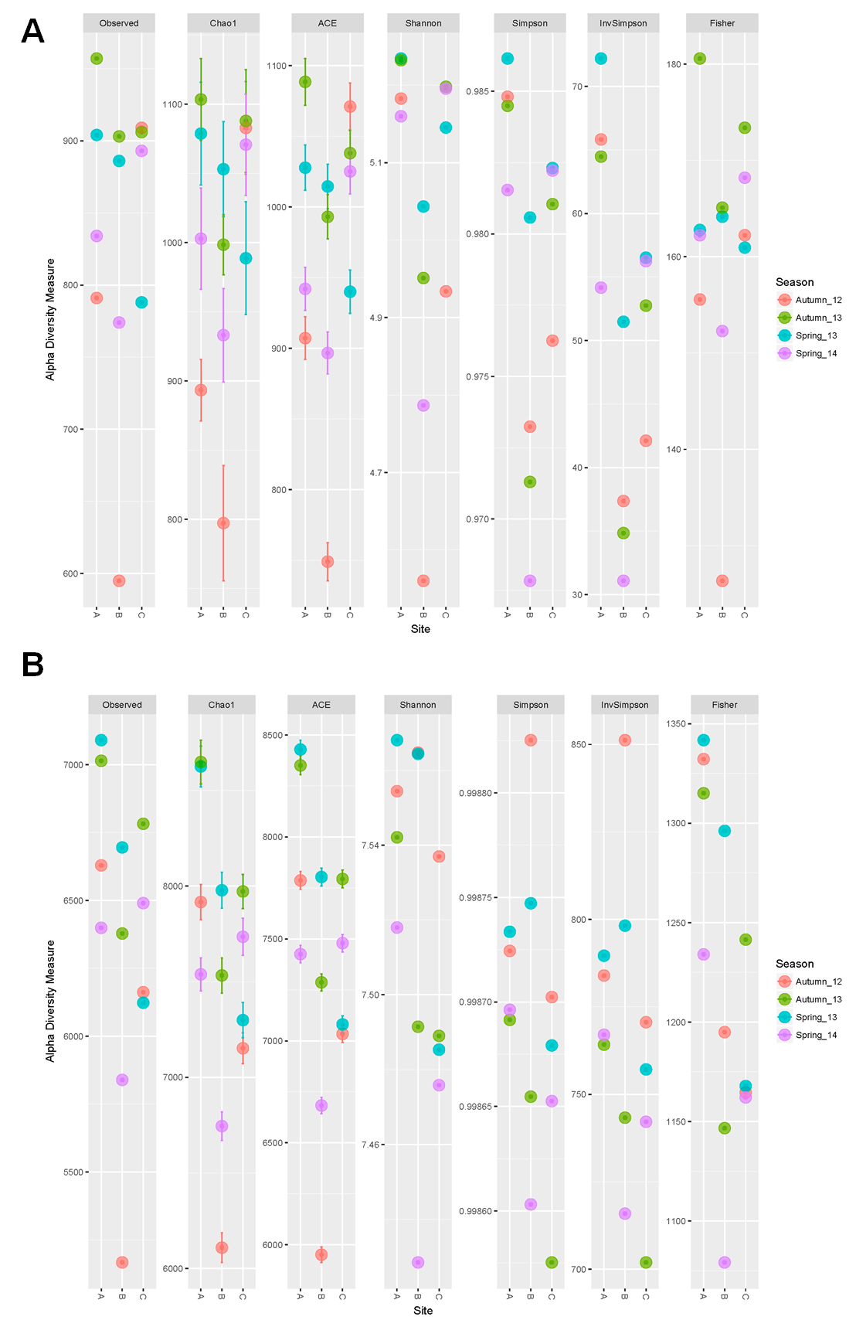
Supplementary Figure 1. Several estimators of Alpha-richness in the microbial mats samples at taxonomic (panel A), and metabolic level (panel B).

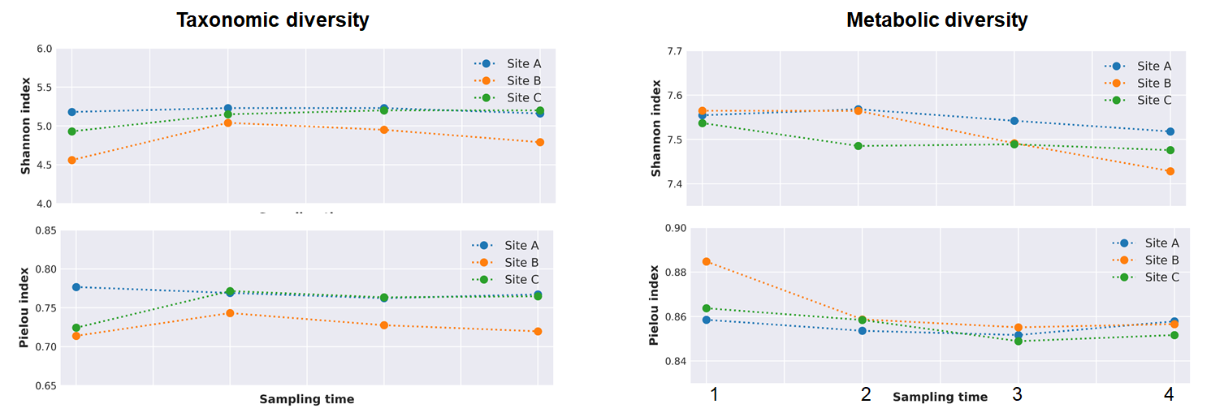Supplementary Figure 2. Variation through time of Shannon and Pielou diversity across sites at taxonomic (A) and metabolic (B), level.

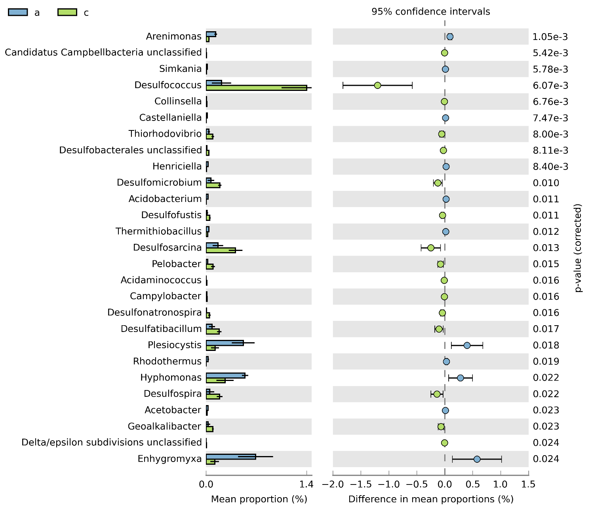

Supplementary Figure 3. Extender error bar indicating all genera where Welch’s t-test with confidence interval method DP welch’ inverted of 0.95 produces a p-value (>0.025). The difference in mean proportion between the microbial mats from site A and C are shown in blue and green colors respectively.
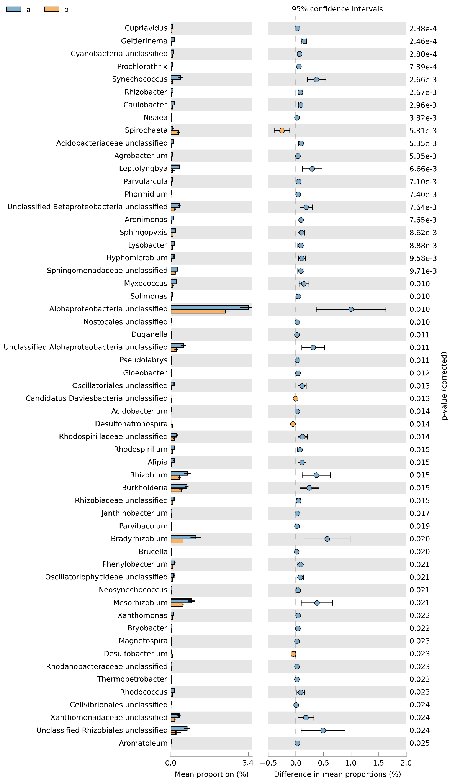
Supplementary figure 4. Extender error bar indicating all genera where Welch’s t-test with confidence interval method DP welch’ inverted of 0.95 produces a p-value (>0.025). The difference in mean proportion between the microbial mats from site A and B are shown in blue and orange colors respectively.

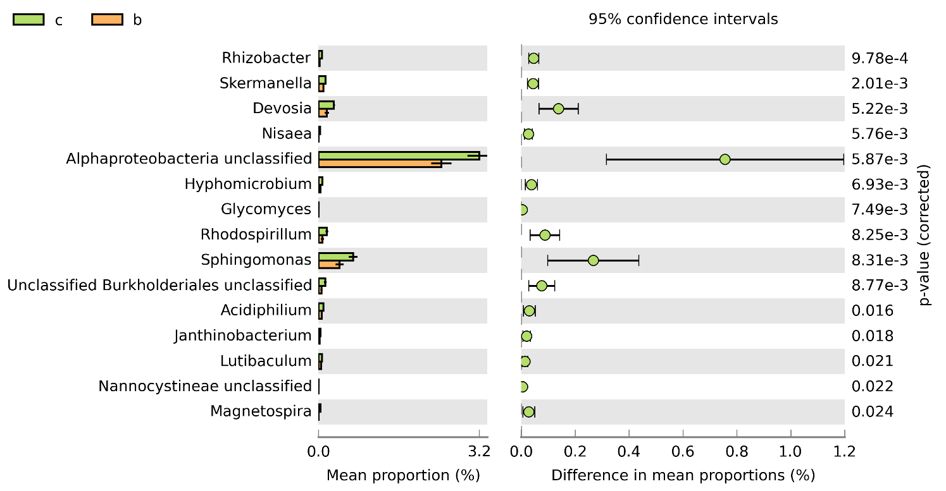

Supplementary figure 5. Extender error bar indicating all genera where Welch’s t-test with confidence interval method DP welch’ inverted of 0.95 produces a p-value (>0.025). The difference in mean proportion between the microbial mats from site B and C are shown in orange and green colors respectively.

