Supplementary Material
This SN atlas used in present study was developed by the Functional Imaging in Neuropsychiatric Disorders (FIND) lab at Stanford University (Table S1 and Figure S1).

Table S1.
The 19 salience network subregions.
SN | Brain Region | Centre MNI coordinates |  |  | Voxels
SN | Brain Region | x | y | z | Voxels
Anterior 1 | L MFG | -29 | 47 | 20 | 651
Anterior 2 | L insula | -43 | 14 | -5 | 305
Anterior 3 | L&R dACC | ±7 | 32 | 22 | 2877
Anterior 4 | R MFG | 28 | 47 | 21 | 470
Anterior 5 | R insula | 43 | 14 | -5 | 319
Anterior 6 | L cerebellum_Crus1 | -33 | -58 | -33 | 95
Anterior 7 | R cerebellum_Crus1 | 33 | -58 | -33 | 139
post 1 | L MFG | -38 | 36 | 29 | 93
Post 2 | L supramarginal gyrus | -58 | -38 | 36 | 1205
Post 3 | L precuneus | -8 | -53 | 61 | 98
Post 4 | R MCC | 13 | -30 | 42 | 56
Post 5 | R SPL | 16 | -55 | 66 | 133
Post 6 | R supramarginal gyrus | 58 | -38 | 36 | 1002
Post 7 | L thalamus | -10 | -19 | 6 | 142
Post 8 | L cerebellum_6 | -32 | -43 | -37 | 102
Post 9 | L insula | -37 | -14 | -3 | 114
Post 10 | R thalamus | 13 | -15 | 7 | 63
Post 11 | R cerebellum_6 | 33 | -43 | -39 | 13
Post 12 | R insula | 40 | -7 | -9 | 134
SN, salience network; MNI, Montreal Neurological Institute; MFG, middle frontal gyrus; dACC, dorsal anterior cingulated cortex; MCC, middle cingulate cortex; SPL, superior parietal lobe; L, left; R, right.

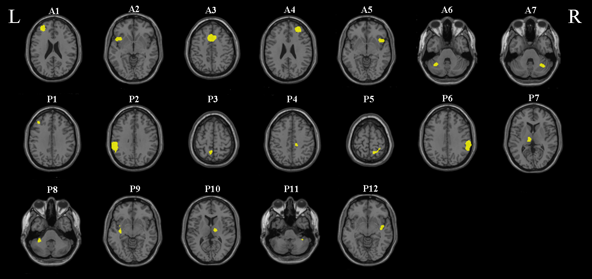
Supplementary figure S1. The 19 salience network subregions. L, left side; R, right side. A1, left middle frontal gyrus; A2, left insula; A3, left and right dorsal anterior cingulated cortex; A4, right middle frontal gyrus; A5, right insula; A6, left cerebellum_Crus1; A7, right cerebellum_Crus1; P1, left middle frontal gyrus; P2, left supramarginal gyrus; P3, left precuneus; P4, right middle cingulate cortex; P5, right superior parietal lobe; P6, right supramarginal gyrus; P7, left thalamus; P8, left cerebellum_6; P9, left insula; P10, right thalamus; P11, right cerebellum_6; P12, right insula.

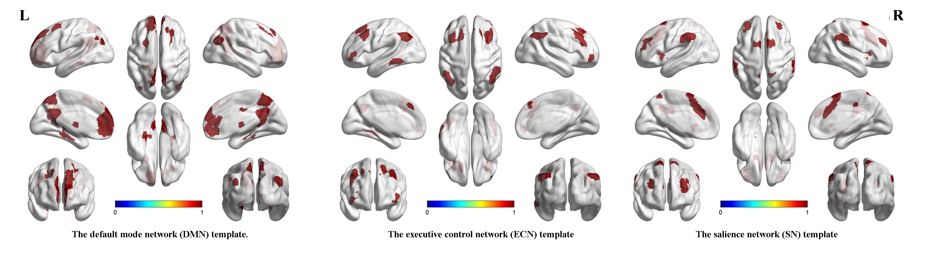
Supplementary figure S2. The default mode network (DMN), executive control network (ECN), and salience network (SN) template.

