Supplementary Material
Visualization of Alzheimer’s disease related α-/β-/γ-secretase ternary complex by bimolecular fluorescence complementation based fluorescence resonance energy transfer

Xin Wang, Gang Pei*
* Correspondence: Gang Pei: gpei@sibs.ac.cn

Supplementary Figures
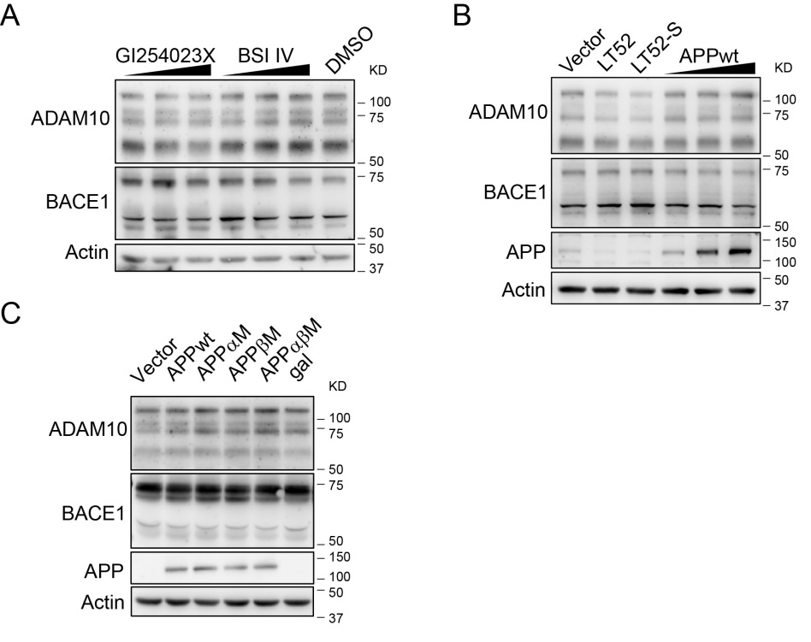
Supplementary Figure 1 BiFC signal of α-/β-secretase complex. (A) ADAM10 and BACE1 BiFC probes possess secretase activities in HEK 293 cells stably expressing APPswe-HA. Expression of ADAM10-CV or ADAM10-NV increased the production of sAPPα, while expression of BACE1-CV or BACE1-NV enhanced the generation of sAPPβ. (B) BiFC signal between BACE1-CV and ADAM10-NV. HEK 293 cells were transfected with designated plasmids and fixed 16 hours later. The signals of bimolecular fluorescent Venus were examined by confocal imaging under 20X objective. Scale bar: 100 μm. (C) Western blots show the expression of BACE1-CV and ADAM10-NV in (B). (D) Quantification analysis of fluorescence intensity of BiFC signals in (B). Images under 20X objective were evaluated, N = 8-12 per condition. A one-way ANOVA with Bonferroni’s multiple comparisons was used. *** p < 0.001. (E) BiFC signal between BACE1-CV and ADAM10-NV with mCherry expression control. The signals of bimolecular fluorescent Venus and mCherry were examined by confocal imaging under 20X objective. Scale bar: 100 μm. (F) Quantification analysis of BiFC efficiency in (E). Images under 20X objective were evaluated, N = 13-14 per condition. A one-way ANOVA with Bonferroni’s multiple comparisons was used. *** p < 0.001. (G) The amino acid sequences of LT52 and LT52-S. (H) Western blots show the expression of BACE1-CV and ADAM10-NV in Figure 1E.

Supplementary Figure 2 Western blots show the expression of ADAM10 and BACE1 BiFC probes. (A) Western blots show the expression of ADAM10-CV and BACE1-NV when treated with GI254023X or BSI-IV in Figure 2A. (B) Western blots show the expression of ADAM10-CV, BACE1-NV and APPwt in Figure 2C. (C) Western blots show the expression of ADAM10-CV, BACE1-NV and APP in Figure 2E.
Supplementary Figure 3 Representative images of FRET analysis between APP and ADAM10 (A), and between APP and BACE1 (B) in Figure 3D.

