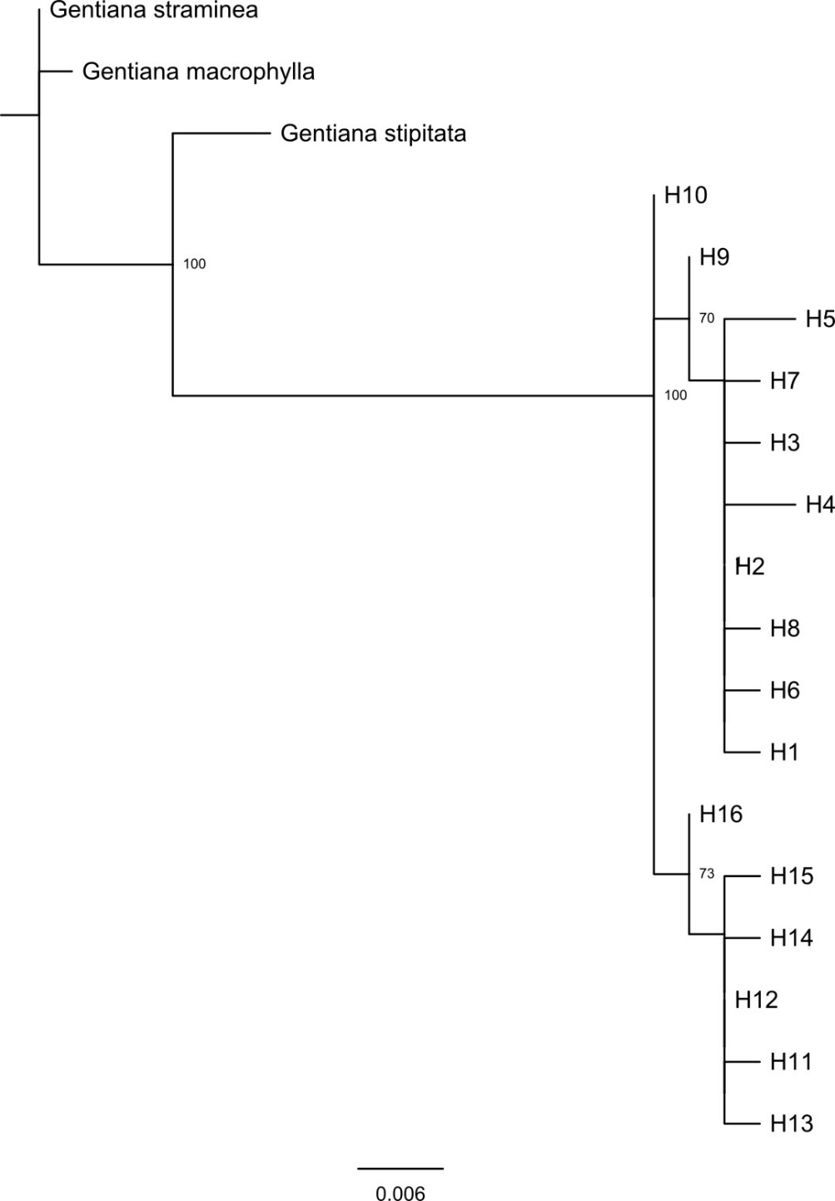

Fig. S1 The ML tree of the 16 chloroplast haplotypes detected in G. lawrencei var. farreri.

