Supplementary Material

Dynamics of Sediment Microbial Functional Capacity and Community Interaction Networks in an Urbanized Coastal Estuary

Tianjiao Dai¹, Yan Zhang², Daliang Ning^{3, 4, 5}, Zhiguo Su¹, Yushi Tang¹, Bei Huang⁶, Qinglin Mu⁶, Donghui Wen^{1,} *

* Correspondence:
Dr. Donghui Wen
dhwen@pku.edu.cn
Table S1 Environmental factors at sampling sites
Samples | 2012S2 | 2012Z1 | 2012Z2 | 2012Z3 | 2012Z4 | 2012Z5 | 2014S2 | 2014Z1 | 2014Z2 | 2014Z3 | 2014Z4 | 2014Z5
Geographic location
Longitude (E) | 120.85 | 121.04 | 121.36 | 122.07 | 122.75 | 123.16 | 120.85 | 121.04 | 121.36 | 122.07 | 122.75 | 123.16
Latitude (N) | 30.21 | 30.43 | 30.62 | 30.85 | 30.75 | 30.17 | 30.21 | 30.43 | 30.62 | 30.85 | 30.75 | 30.17
Depth (m) | 3 | 8 | 9 | 10 | 27 | 60 | 3 | 11 | 12 | 9 | 26 | 52
Seawater quality
pH | 7.65 | 8.22 | 8.42 | 8.34 | 8.29 | 8.38 | 7.91 | 8.00 | 8.04 | 7.98 | 8.05 | 8.31
DO (mg/L) | 4.35 | 8.10 | 8.39 | 8.20 | 7.03 | 6.02 | 5.28 | 8.17 | 8.26 | 8.12 | 5.78 | 5.43
Salinity (‰) | 1.97 | 3.81 | 4.06 | 13.42 | 24.40 | 20.60 | 3.87 | 9.14 | 11.26 | 13.05 | 18.92 | 22.80
COD (mg/L) | 3.07 | 2.21 | 1.58 | 2.59 | 0.98 | 2.67 | 1.68 | 2.44 | 2.36 | 2.32 | 1.12 | 0.96
Ammonia (mg/L) | 0.32 | 0.07 | 0.06 | 0.04 | 0.01 | 0.03 | 0.35 | 0.04 | 0.00 | 0.03 | 0.01 | 0.02
Nitrate ( mg/L) | 4.14 | 1.34 | 1.41 | 0.68 | 0.39 | 0.18 | 2.72 | 1.39 | 1.35 | 0.79 | 0.37 | 0.09
DIN (mg/L) | 4.47 | 1.42 | 1.47 | 0.72 | 0.4 | 0.21 | 3.07 | 1.43 | 1.35 | 0.82 | 0.38 | 0.12
TP (mg/L) | 0.07 | 0.04 | 0.05 | 0.03 | 0.03 | 0.00 | 0.09 | 0.08 | 0.07 | 0.06 | 0.02 | 0.03
Sediment physicochemical properties
TP (%) | 0.05 | 0.06 | 0.06 | 0.05 | 0.06 | 0.05 | 0.07 | 0.05 | 0.06 | 0.05 | 0.05 | 0.05
TN (%) | 0.06 | 0.07 | 0.09 | 0.05 | 0.07 | 0.07 | 0.02 | 0.05 | 0.09 | 0.04 | 0.07 | 0.07
Nitrate (mg/kg) | 19.6 | 15.1 | 18.7 | 19.8 | 9.4 | 15.7 | 14.0 | 26.8 | 37.5 | 55.4 | 31.4 | 29.0
Sulfate (mg/kg) | 59 | 391 | 524 | 495 | 1150 | 1060 | 142 | 420 | 905 | 565 | 1230 | 1260
OM (g/kg) | 4.5 | 11.0 | 14.1 | 8.4 | 13.2 | 10.6 | 4.7 | 10.1 | 14.4 | 7.1 | 11.9 | 11.0
Cr (μg/g) | 46.63 | 72.55 | 89.14 | 82.34 | 72.35 | 53.13 | 57.97 | 72.29 | 77.57 | 66.86 | 79.14 | 58.26
Cu (μg/g) | 14.62 | 17.44 | 39.77 | 35.11 | 21.6 | 13.34 | 12.53 | 31.52 | 30.93 | 18.57 | 26.93 | 12.99
Zn (μg/g) | 45.4 | 55.22 | 103.3 | 84.7 | 70.9 | 59.66 | 44.24 | 78.23 | 85.48 | 61.59 | 85.33 | 65.87
As (μg/g) | 6.17 | 6.98 | 14.37 | 12.61 | 10.3 | 5.96 | 5.32 | 9.78 | 11.97 | 8.97 | 12.17 | 6.11
Cd (μg/g) | 0.12 | 0.18 | 0.24 | 0.20 | 0.16 | 0.11 | 0.17 | 0.20 | 0.20 | 0.14 | 0.16 | 0.10
Pb (μg/g) | 13.99 | 15.73 | 32.24 | 25.67 | 20.80 | 18.89 | 13.42 | 23.01 | 24.73 | 17.96 | 27.83 | 18.57
Abbreviations: COD, chemical oxygen demand; DIN, dissolved inorganic nitrogen; TP, total phosphorus; TN, total nitrogen; OM, organic matter.
Table S2 Overview of the metagenomic sequences and annotations
Sample | Upload |  |  |  | Sequence Breakdown |  |  |  | Predicted Features
 | # of Sequence | Mean Sequence Length (bp) | Mean GC Content (%) |  | Failed QC (%) | Predicted Feature (%) | Unknown (%) |  | Unknown Protein (%) | Annotated Protein (%) | Ribosomal RNA (%)
2012S2 | 88,500,106 | 128 ± 14 | 53 ± 13 |  | 13.27 | 83.57 | 3.17 |  | 66.36 | 24.20 | 9.45
2012Z1 | 84,861,585 | 129 ± 16 | 55 ± 12 |  | 12.55 | 85.25 | 2.20 |  | 66.01 | 24.95 | 9.04
2012Z2 | 87,818,029 | 128 ± 15 | 48 ± 13 |  | 16.49 | 75.07 | 8.45 |  | 66.84 | 23.41 | 9.75
2012Z3 | 90,675,697 | 129 ± 18 | 51 ± 12 |  | 11.75 | 85.40 | 2.84 |  | 67.90 | 23.11 | 8.99
2012Z4 | 106,501,580 | 129 ± 18 | 49 ± 12 |  | 18.81 | 74.56 | 6.63 |  | 66.53 | 22.81 | 10.66
2014Z1 | 89,469,355 | 127 ± 12 | 54 ± 13 |  | 13.63 | 82.76 | 3.61 |  | 67.06 | 23.42 | 9.52
2014Z2 | 94,381,961 | 127 ± 11 | 57 ± 12 |  | 11.78 | 87.31 | 0.91 |  | 67.95 | 23.24 | 8.08
2014Z3 | 102,303,143 | 130 ± 20 | 54 ± 12 |  | 11.40 | 86.84 | 1.77 |  | 68.10 | 22.94 | 8.96
2014Z4 | 103,789,327 | 129 ± 17 | 54 ± 12 |  | 10.86 | 88.02 | 1.09 |  | 69.10 | 22.38 | 8.52
2014Z5 | 92,701,406 | 128 ± 14 | 52 ± 12 |  | 12.26 | 85.09 | 2.65 |  | 68.96 | 22.50 | 8.54

Table S3 The relationship of a microbial community to environmental factors (env) and geographic distance (geo) revealed by Mantel tests and Partial Mantel tests.
 |  | taxonomic structure |  |  | phylogenetic structure |  |  | functional structure
 |  | R | P |  | R | P |  | R | P
Mantel test | env | 0.56 | 0.001*** |  | 0.59 | 0.001*** |  | 0.09 | 0.282
 | geo | 0.41 | 0.024* |  | 0.35 | 0.062 |  | 0.30 | 0.132
partial Mantel test | env (geo) | 0.45 | 0.002** |  | 0.51 | 0.001*** |  | -0.13 | 0.764
 | geo (env) | 0.17 | 0.147 |  | 0.06 | 0.312 |  | 0.31 | 0.127
* P <0.05, ** P <0.01, and *** P <0.001

Table S4 Topological properties of the network for sediment bacterial communities and its associated random networks
Experimental Network
Number of OTUs used for network construction | 246
Network size (n)ª | 162
Number of links | 390
Percentage of positive links (%) | 89.0
Modularity (number of modules) | 0.635 (13)
R² of power-law | 0.94
Average connectivity (avgK) | 4.815
Average clustering coefficient (avgCC) | 0.258
Average path distance (GD)^{b} | 4.574
Harmonic geodesic distance (HD) | 3.498
Centralization of degree (CD) | 0.234
Centralization of betweenness (CB) | 0.458
Centralization of stress centrality (CS) | 2.136
100 Random Networks
Modularity | 0.388 ± 0.008
Average clustering coefficient (avgCC) | 0.101 ± 0.011
Average path distance (GD) | 3.157 ± 0.054
Harmonic geodesic distance (HD) | 2.804 ± 0.034
Centralization of betweenness (CB) | 0.263 ± 0.024
Centralization of stress centrality (CS) | 0.850 ± 0.073
ªThe number of OTUs (i.e., nodes) in the network
^{b}GD, geodesic distance.

Table S5 Taxonomic information for keystone OTUs (i.e., module hubs, connectors, and OTUs with top 10 degree).
OTU ID | Node degree | No. of modules | Phylum | Class | Order | Topological role
OTU519 | 42 | 4 | Proteobacteria | Gammaproteobacteria | Xanthomonadales | module hub
OTU981 | 28 | 4 | Proteobacteria | Gammaproteobacteria | Xanthomonadales | module hub
OTU238 | 19 | 3 | Firmicutes | Bacilli | Bacillales
OTU464 | 18 | 3 | Proteobacteria | Gammaproteobacteria | Pseudomonadales
OTU448 | 17 | 3 | Firmicutes | Bacilli | Bacillales
OTU649 | 17 | 3 | Firmicutes | Bacilli | Bacillales
OTU1061 | 17 | 4 | Proteobacteria | Gammaproteobacteria | Chromatiales
OTU684 | 16 | 1 | Bacteroidetes | Flavobacteria | Flavobacteriales | module hub
OTU10 | 16 | 3 | Firmicutes | Bacilli | Bacillales
OTU410 | 16 | 3 | Firmicutes | Bacilli | Bacillales
OTU642 | 9 | 8 | Acidobacteria | Acidobacteria | Subgroup_10 | module hub
OTU166 | 7 | 8 | Verrucomicrobia | Verrucomicrobiae | Verrucomicrobiales | connector
OTU1073 | 6 | 5 | Bacteroidetes | BD2-2 | norank | connector

Figure S1 Microbial functional profile at level 1 gene category of SEED hierarchy

Figure S2 Pearson correlation of environmental factors with functional genes. Each diamond represents an environmental factor, each circle represents a level 3 functional gene category of SEED hiearchy. Colors of circles indicate gene categories at level 1. Solid and dashed lines indicate significant (p<0.05) positive or negetive correlations, respectively. Correlation p-values were adjusted using fdr method.
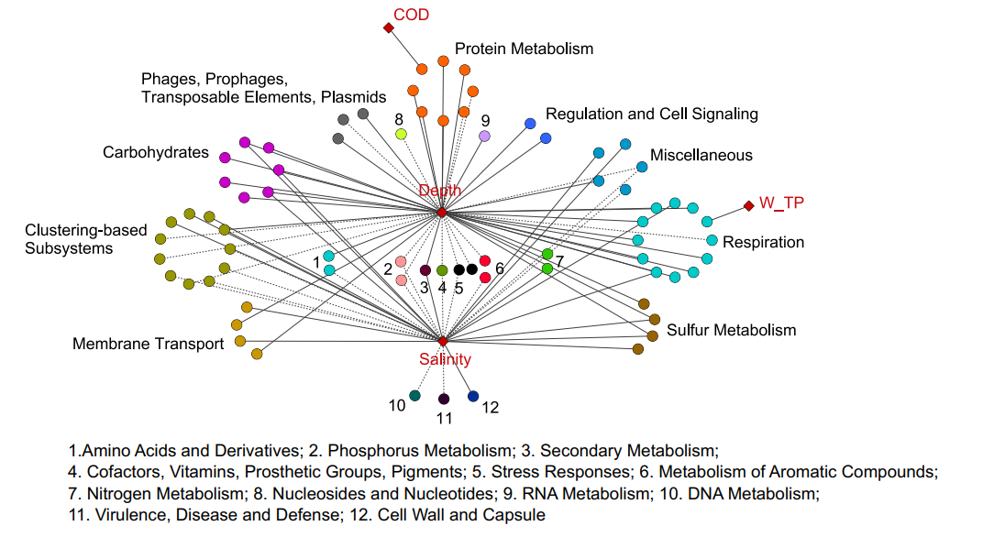
Figure S3 Pearson correlation of environmental factors and the gene abundance at level 1 for the 6 selected gene categories.
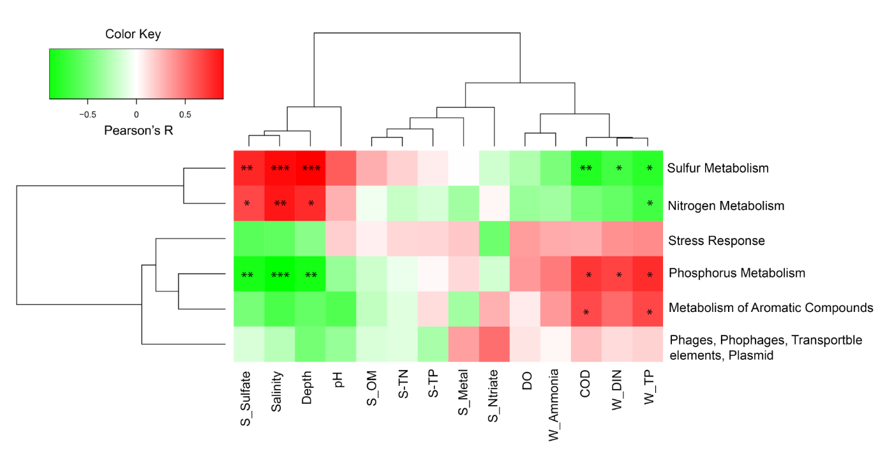
* P <0.05, ** P <0.01, and *** P <0.001

Figure S4 Z-P plot exhibiting the distribution of OTUs based on their topological roles. Pi represents the degree of connections between OTUs from different modules, whereas Zi represent connections between OTUs from same module.
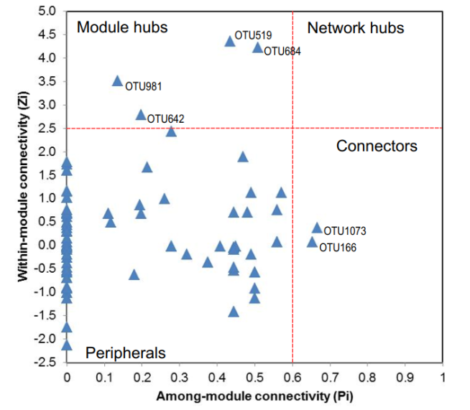

Figure S5 The relationship between the network keystone OTUs (i.e., module hubs, connectors, and with top 10 node degree) and environmental factors.
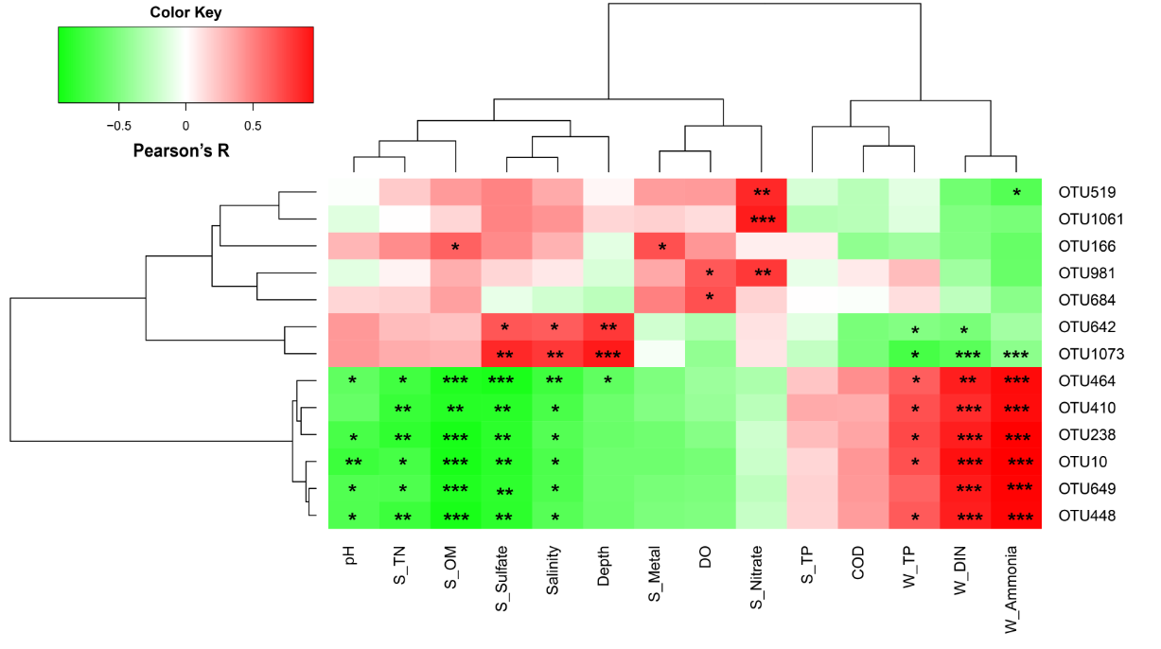
* P <0.05, ** P <0.01, and *** P <0.001

