Supplementary Material

Soil Bacteria Isolated from Tunisian Arid Areas Show Promising Antimicrobial Activities against Gram-Negatives
Zina Nasfi^{1,2,3}, Henrik Busch⁴, Stefan Kehraus⁴, Luis Linares-Otoya², Gabriele M. König⁴, Till F. Schäberle^{2,5*}, Rafik Bachoual¹
¹Laboratory of Plant Improvement and Valorization of Agroresources, National School of Engineering of Sfax, Sfax, Tunisia
²Institute for Insect Biotechnology, Justus-Liebig-University Giessen, Giessen, Germany
³Faculty of Sciences of Gabès, University of Gabès, Tunisia
⁴Institute for Pharmaceutical Biology, University of Bonn, Bonn, Germany
⁵Department of Bioresources of the Fraunhofer Institute for Molecular Biology and Applied Ecology, Giessen, Germany

* Correspondence:
till.f.schaeberle@agrar.uni-giessen.de

Supplementary Figures and Tables
  - Supplementary Figures
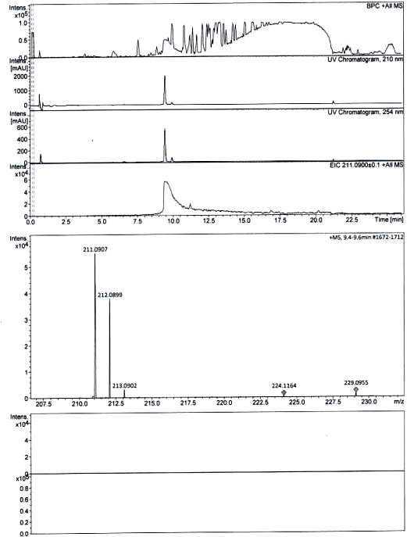

Supplementary Figure 1. LC-MS mass spectrum of the bioactive compound 1-acetyl-β-carboline produced by Bacillus sp. M21a.

(A)
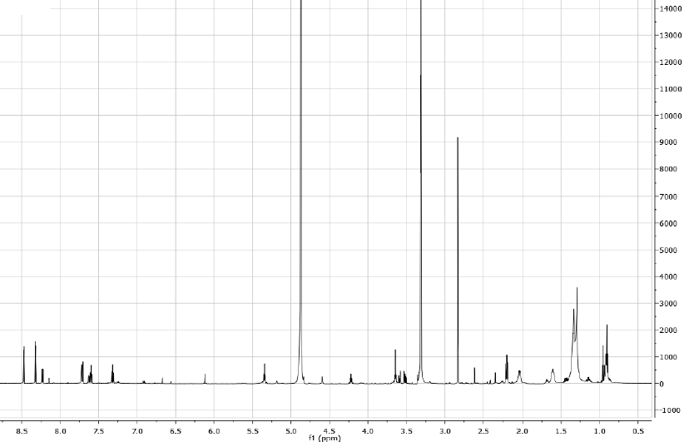

(B)
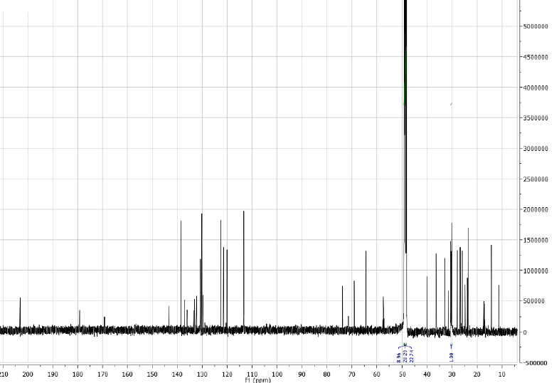

(C)

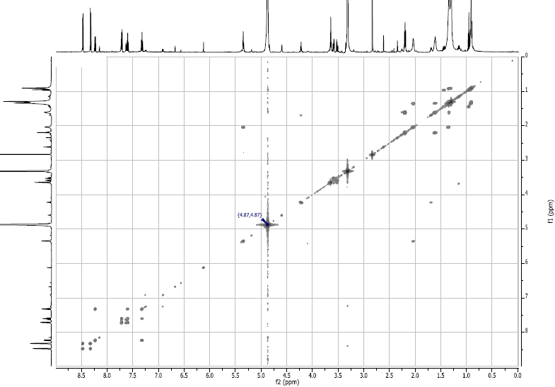

(D)
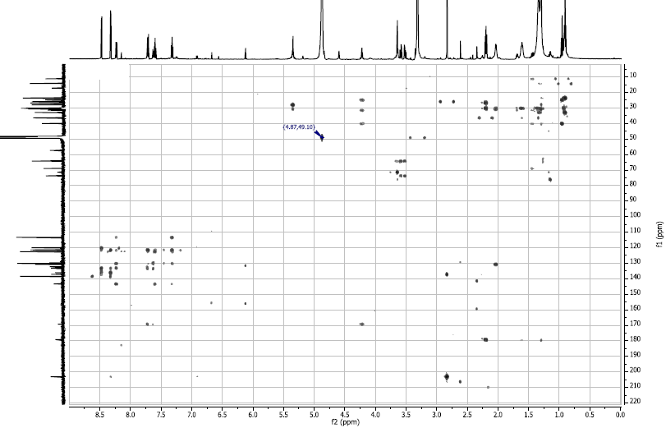
Supplementary Figure 2. NMR data of the bioactive compound 1-acetyl-β-carboline produced by Bacillus sp. M21a. (A) ¹H-NMR spectrum, (B) ¹³C-NMR spectrum, (C) ¹H-¹H COSY spectrum, (D)¹H-¹³C HMBC spectrum.

(A)
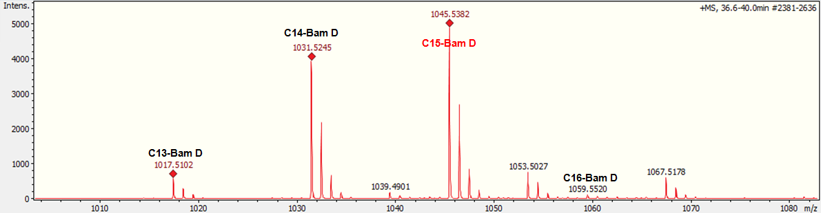
(B)
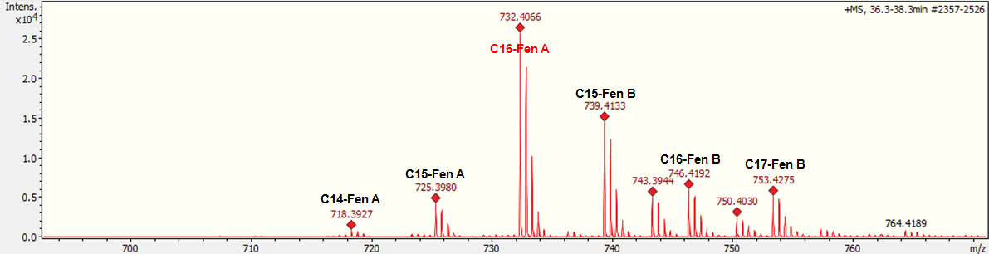
(C)
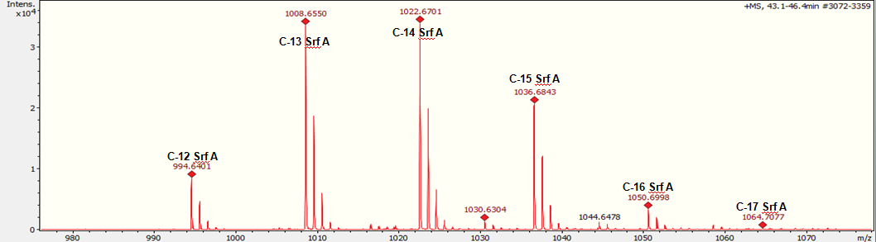
Supplementary Figure 3. LC-MS spectra of bioactive lipopetides from the methanolic extract from a solid cultivation of Bacillus sp. M21a. (A) Mass spectra corresponding to the bacillomycin D homolog, (B) Mass spectra corresponding to the fengycin homolog, (C) Mass spectra corresponding to the surfactin homolog.

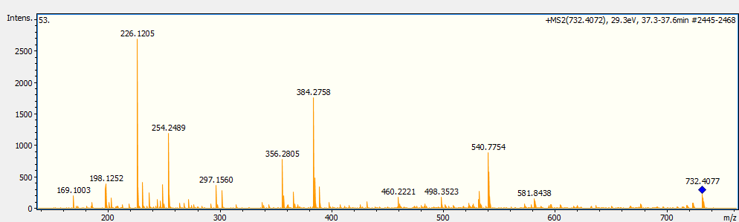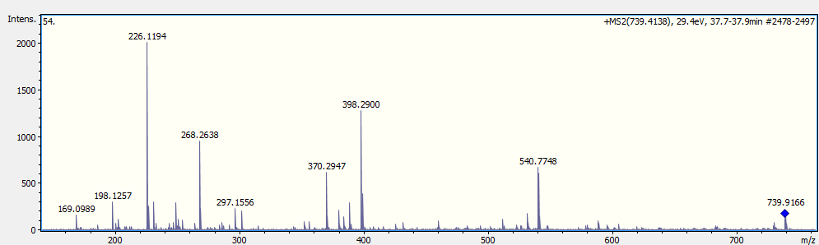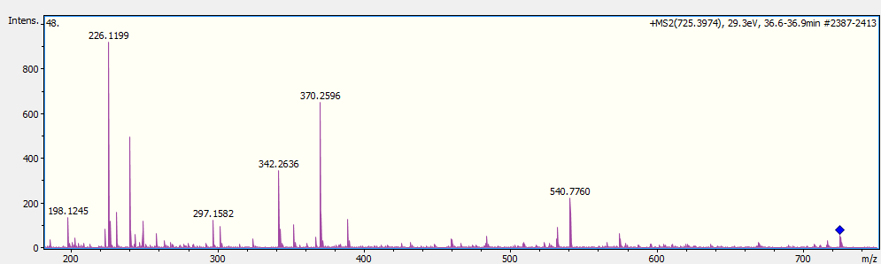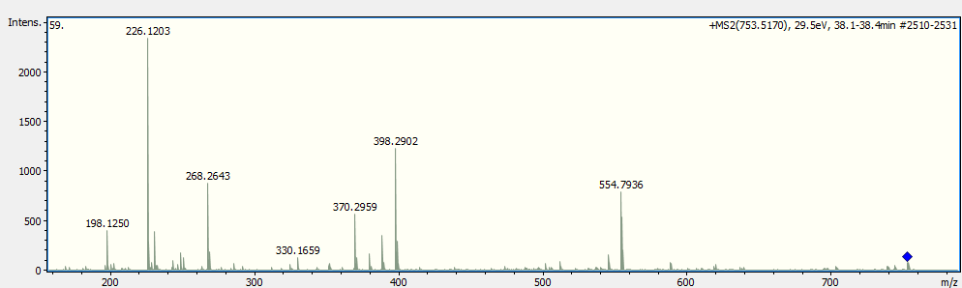
Supplementary Figure 4. MS/MS spectrum of the fengycin precursors, A C15-Fen A precursor ion [M + 2H]²⁺ at m/z 725.3974, B C16-Fen A precursor ion [M + 2H]²⁺ at m/z 732.4072, C C15-Fen B precursor ion [M + 2H]²⁺ at m/z 739.4138, D C17-Fen B precursor ion [M + 2H]²⁺ at m/z 753.5170

(A)
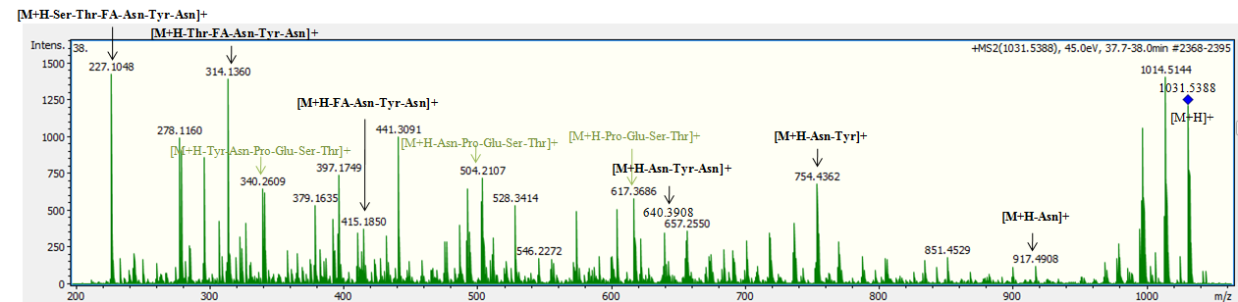
(B)
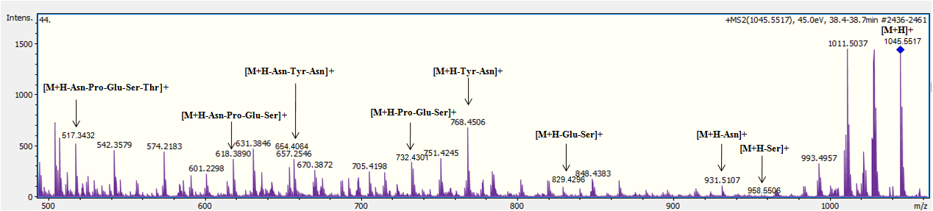
(C)
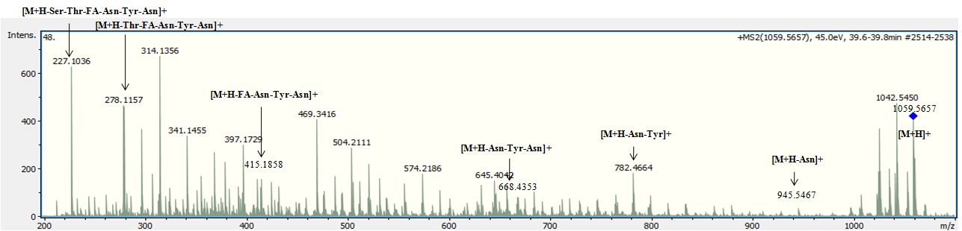
Supplementary Figure 5. MS/MS spectrum of the bacillomycin D precursors, A Bam D precursor ion [M + H]⁺ at m/z 1031 for C14-Bam D, B Bam D precursor ion [M + H]⁺ at m/z 1045 for C15-Bam D, C Bam D precursor ion [M + H]⁺ at m/z 1059 for C16-Bam D.
(A)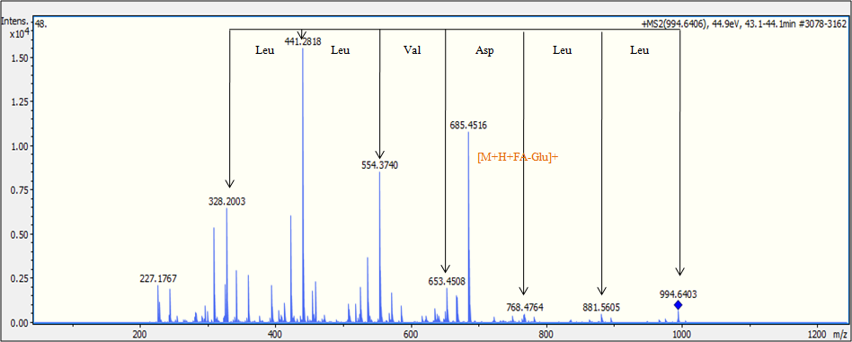
(B)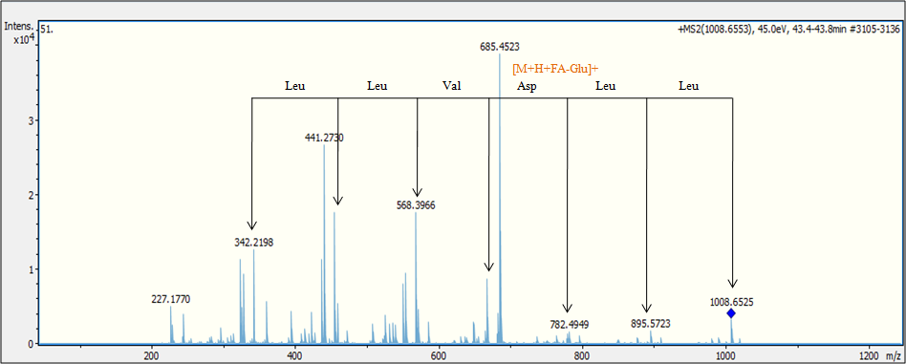
(C)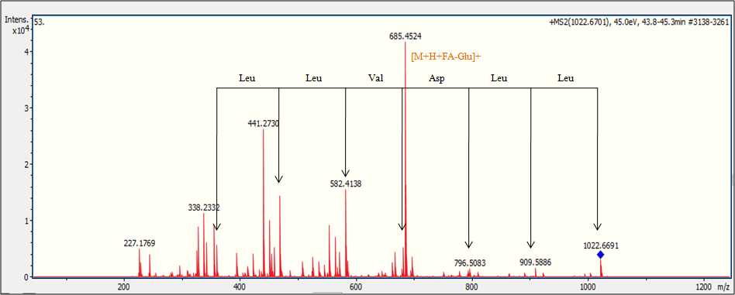

(D)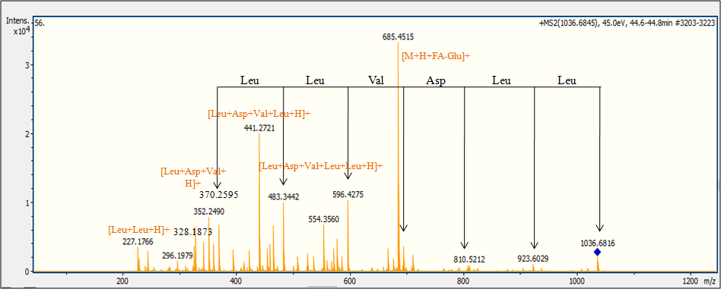
(E)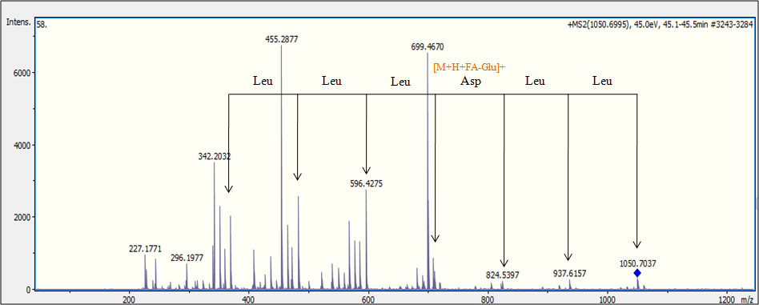
(F)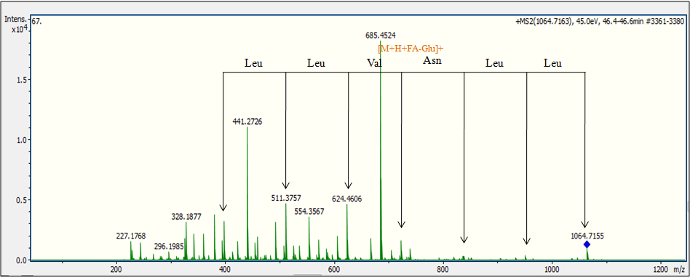
Supplementary Figure 6. MS/MS spectrum of the surfactin precursors and fragmentation proposal, A Surfactin precursor ion [M + H]⁺ at m/z 994 for C12-Srf A, B Surfactin precursor ion [M + H]⁺ at m/z 1008 for C13-Srf A, C Surfactin precursors ion [M + H]⁺ at m/z 1022 for C14-Srf A, D Surfactin precursor ion [M + H]⁺ at m/z 1036 for C15-Srf A, E Surfactin precursor ion [M + H]⁺ at m/z 1050 for C16-Srf A, and F Surfactin precursor ion [M + H]⁺ at m/z 1064 for C17-Srf A

Supplementary Tables
Supplementary Table1. Antibacterial activity of the selected soil isolates against several test bacteria.

 | Gram Negative Bacteria |  |  |  |  |  |  |  |  |  |  |  |  |  |  | Gram Positive Bacteria
Strain | E. coli ATCC25922 | E. coli ATCC35218 | E. coli KL.16 | E. coli KL16.2a |  | E. coli MA isolate |  | E. coli isolate |  | S. typhiisolate |  | S. typhiisolate |  | S aureus ATCC29213 |  |  | S. epidermidis |  | S. saprophyticus |  | S. aureus isolate
B1 | 13,33 ± 1,15 | 14 ± 0 | 12,33 ± 0,57 | 11,66 ± 0,57 |  | 10 ± 0 |  | - |  | ND |  | ND |  | 19,66 ± 2,08 |  |  | 19 ± 1 |  | 15,33 ± 0,57 |  | -
C2 | - | - | - | - |  | - |  | - |  | - |  | - |  | 9 ± 0 |  |  | 8,33 ± 0,57 |  | - |  | -
C5 | 13 ± 0,57 | 12,66 ± 1,52 | 11,66 ± 0,57 | 11,66 ± 1,15 |  | 9 ± 0 |  | - |  | 16,33 ± 0,57 |  | 16 ± 0 |  | 12,66 ± 0,57 |  |  | 12,66 ± 1,52 |  | 13,66 ± 1,52 |  | -
C6 | 14,33 ± 0,57 | 15,33 ± 0,57 | 15 ± 0 | 14 ± 0 |  | 12,33 ± 0,57 |  | - |  | 17 ± 1,73 |  | 16,33 ± 1,15 |  | 12,66 ± 1,52 |  |  | 11 ± 1 |  | 12,33 ± 1,15 |  | -
C7 | 11,66 ± 1,52 | 12,66 ± 1,15 | 10,66 ± 0,57 | 10,66 ± 0,57 |  | 9,33 ± 1,15 |  | - |  | 14,33 ± 1,52 |  | 14,66 ± 0,57 |  | 13,33 ± 0,57 |  |  | 12,33 ± 1,15 |  | 13 ± 1 |  | -
C11 | 10,66 ± 1,52 | 12,33 ± 1,52 | 11 ± 0 | 10 ± 0 |  | 9 ± 0 |  | - |  | 13,66 ± 1,52 |  | 14 ± 0 |  | 14 ± 0 |  |  | 13,66 ± 1,15 |  | 14,66 ± 1,52 |  | -
C14 | 10,66 ± 0,57 | - | 9,66 ± 0,57 | 9 ± 0 |  | 8 ± 1 |  | - |  | - |  | - |  | 9,66 ± 0,57 |  |  | 8,66 ± 0,57 |  | - |  | -
C17 | 13 ± 0 | - | 11,66 ± 1,52 | 12 ± 1 |  | 10,66 ± 0,57 |  | - |  | - |  | - |  | 13,33 ± 0,57 |  |  | 14 ± 0 |  | 11 ± 1 |  | -
C18 | 14,33 ± 1,15 | 12,66 ± 1,15 | 12,33 ± 1,15 | 12,66 ± 1,15 |  | 10,33 ± 1,15 |  | - |  | - |  | - |  | 17,33 ± 1,15 |  |  | 15,66 ± 0,57 |  | 15,66 ± 0,57 |  | -
C20 | 13,33 ± 1,15 | 14 ± 1 | 12,33 ± 0,57 | 12 ± 0 |  | 10,33 ± 0,57 |  | - |  | - |  | - |  | 15,33 ± 0,57 |  |  | 13,33 ± 0,57 |  | 17,66 ± 0,57 |  | -
C21 | 14,33 ± 0,57 | 15,33 ± 0,57 | 13,66 ± 1,15 | 12,66 ± 1,52 |  | 10 ± 0 |  | - |  | - |  | - |  | 16 ± 1,73 |  |  | 14 ± 1 |  | 17,66 ± 1,52 |  | -
C22 | 15,33 ± 0,57 | 16 ± 0 | 14,33 ± 1,52 | 13,66 ± 0,57 |  | 11,33 ± 0,57 |  | - |  | - |  | - |  | 15,66 ± 0,57 |  |  | 13,66 ± 1,15 |  | 17,33 ± 1,52 |  | -
C23 | 14,66 ± 1,52 | 15,66 ± 1,15 | 14 ± 1 | 13 ± 0 |  | 11,66 ± 0,57 |  | - |  | - |  | - |  | 17,66 ± 0,57 |  |  | 16 ± 1 |  | 16,66 ± 1,15 |  | -
C24 | 15 ± 0 | 16,66 ± 0,57 | 12,66 ± 1,15 | 12,33 ± 0,57 |  | 11 ± 1 |  | - |  | - |  | - |  | 16 ± 0 |  |  | 15,66 ± 1,52 |  | 16,66 ± 1,52 |  | -
C25 | 15,66 ± 0,57 | 16,33 ± 0,57 | 14 ± 0 | 13,33 ± 0,57 |  | 10,66 ± 1,15 |  | - |  | - |  | - |  | 16,66 ± 0,57 |  |  | 15 ± 1,73 |  | 15,66 ± 1,52 |  | -
C26 | 14,66 ± 0,57 | 15 ± 1 | 13,66 ± 0,57 | 13,66 ± 0,57 |  | 10,66 ± 1,52 |  | - |  | - |  | - |  | 17,33 ± 2,08 |  |  | 15,66 ± 1,52 |  | 17,33 ± 1,52 |  | -
 | Gram Negative Bacteria |  |  |  |  |  |  |  |  |  |  |  |  |  |  | Gram Positive Bacteria
 | E. coli ATCC25922 | E. coli ATCC35218 | E. coli KL.16 |  | E. coli KL16.2a |  | E. coli MA isolate |  | E. coli isolate |  | S. typhiisolate |  | S. typhiisolate |  | S aureus ATCC29213 |  |  | S. epidermidis |  | S. saprophyticus |  | S. aureus isolate
M2 | 12 ± 2 | - | 10,66 ± 0,57 |  | 11 ± 1 |  | 9,33 ± 0,57 |  | - |  | 12 ± 1 |  | 11,33 ± 0,57 |  | 14,66 ± 1,15 |  |  | 14 ± 0 |  | 17,66 ± 1,52 |  | -
M21a | 17,66 ± 1,52 | 12 ± 1 | 15,33 ± 0,57 |  | 16,33 ± 1,52 |  | 13,33 ± 1,52 |  | - |  | 12,66 ± 0,57 |  | 11 ± 0 |  | 22,66 ± 1,15 |  |  | 19,66 ± 2,08 |  | 18,33 ± 2,08 |  | -
M22 | 13,66 ± 1,52 | - | 12 ± 0 |  | 12,66 ± 1,15 |  | 10 ± 1,73 |  | - |  | - |  | - |  | 13,66 ± 1,15 |  |  | 11,66 ± 1,15 |  | 14 ± 0 |  | -
M27 | 12 ± 1 | - | 10 ± 0 |  | 10,66 ± 1,15 |  | 8,33 ± 0,57 |  | - |  | - |  | - |  | 12 ± 0 |  |  | 11,33 ± 1,52 |  | - |  | -
M28 | 11 ± 1,73 | - | 10,66 ± 0,57 |  | 10,33 ± 0,57 |  | 9 ± 0 |  | - |  | - |  | - |  | 11,66 ± 0,57 |  |  | 10,66 ± 2,08 |  | - |  | -
M32 | 8,33 ± 0,57 | 10,66 ± 1,15 | 8 ± 0 |  | 8 ± 0 |  | 7,33 ± 0,57 |  | - |  | 14 ± 1 |  | 13,33 ± 0,57 |  | 12 ± 1,73 |  |  | 14 ± 0 |  | 12,33 ± 0,57 |  | -
M77 | 14,33 ± 1,52 | 14 ± 1 | 14,66 ± 0,57 |  | 15 ± 1 |  | 12,66 ± 0,57 |  | - |  | 15,33 ± 1,15 |  | 14,66 ± 0,57 |  | 16 ± 2,64 |  |  | 19 ± 1 |  | 14,66 ± 0,57 |  | -
M79 | 14,66 ± 0,57 | 14 ± 1,73 | 15 ± 1 |  | 14,66 ± 0,57 |  | 12 ± 1 |  | - |  | 15,33 ± 0,57 |  | 15,33 ± 1,15 |  | 14 ± 0 |  |  | 17,33 ± 1,15 |  | 14,66 ± 1,52 |  | -
M98 | 11,66 ± 2,3 | - | 11,66 ± 0,57 |  | 12,33 ± 0,57 |  | 7 ± 0 |  | - |  | - |  | - |  | 12,33 ± 0,57 |  |  | 10,33 ± 0,57 |  | - |  | -
M101 | 13 ± 1 | - | 12,33 ± 0,57 |  | 12,66 ± 0,57 |  | 10,33 ± 0,57 |  | - |  | - |  | - |  | 10,33 ± 0,57 |  |  | 10 ± 0 |  | - |  | -
M117 | 14,66 ± 0,57 | - | 14 ± 1 |  | 13,33 ± 1,52 |  | 12 ± 0 |  | - |  | - |  | - |  | 11,33 ± 0,57 |  |  | 10,33 ± 1,15 |  | - |  | -
M124 | 16,33 ± 1,52 | 15,33 ± 1,15 | 15,66 ± 1,15 |  | 16,66 ± 1,52 |  | 14,66 ± 0,57 |  | - |  | 15,66 ± 0,57 |  | 15,66 ± 1,15 |  | 22,33 ± 0,57 |  |  | 18,33 ± 1,52 |  | 17 ± 1 |  | -

Supplementary Table 2. Characteristics of the bioactive bacterial isolates.
 | Morphology | Motility | Arrangement | Spores | Gram reaction
B1, C5, C7, C11, M21a, M77, M79, M124 | Dry creamy irregular colonies with undulate edges | + | Pairs or chains | Terminal | +
C2 | Slimy white circular colonies with entire edges | - | Long chains | Terminal | +
C6 | Yellow to brown dry and adherent colonies with elevated ridges | + | Singles | - | -
C14 | Creamy large irregular colonies | + | Singles or pairs | Central | +
C17, C18, C21, C22, C23, C24, C25, C26 | Slightly yellowish, smooth and irregular colonies | + | Singles or pairs | Terminal | +
C20 | White with irregular margins | - | Long chains | - | +
M2, M27, M28, M98 | Mucoid creamy colonies with irregular borders | - | Very long chains | Central or terminal | +
M21, M22, M101, M117 | White irregular colonies with undulate edges | - | Pairs or chains | Terminal | +
M32 | White irregular colonies with a characteristic odor | - | Singles or pairs | - | +

Supplementary Table 3.Composition of culture media tested for antibiotic production by Bacillus sp. M21a against B. megaterium and E. coli.
Culture medium | Medium composition (g/L) |  | Reference | B. megateriumª | E. coliª
LB | Peptone | 10 | Liu et al., 2015 | + | +
 | Yeast extract | 5
 | NaCl | 10
M1 | Glucose | 2.5 | Liu et al., 2015 | + | -
 | Tryptone | 17
 | Phytone | 3
 | NaCl | 5
M2 | Glucose | 1 | Liu et al., 2015 | + | -
 | Peptone | 1.5
 | Yeast extract | 3
 | NaCl | 6
M3 | Tryptone | 6 | Liu et al., 2015 | + | -
 | Yeast extract | 3
 | CaCl₂ | 0.38
M4 | Glucose | 0.5 | Gulhane et al., 2014 | + | -
 | citric acid | 1
 | MgSO₄ | 0.2
 | MnSO₄ | 0.01
 | KH₂PO₄ | 0.5
 | K₂HPO₄ | 0.5
 | FeSO₄ | 0.01
M5 | Chitin | 0.1 | Gomashe et al., 2014 | + | -
(Minimal medium) | KH₂PO₄ | 0.01
 | MgSO₄.7H₂O | 0.005
M6
 | Peptone | 5 | Uddin et al., 2013 | + | -
 | Meat extract | 3
 | NaCl | 5
M7 | Glucose | 0.1 | Uddin et al., 2013 | + | -
 | Yeast extract | 0.02
 | NaCl | 0.05
M8 | Peptone | 0.025 | Uddin et al., 2013 | - | -
 | Meat extract | 0.075
 | NaCl | 0.15
 | KCl | 0.1
 | MgCl₂ | 0.1
 | FeSO₄ | 0.1
M9 | Glucose | 0.1 | Uddin et al., 2013 | + | -
 | NaCl | 0.05
M10 | Sucrose | 10 | Beric et al., 2012 | + | -
 | Peptone | 10
M11 | Glucose | 10 | Vijayalakshmi et al., 2011 | + | -
 | Triammonium citrate | 2.5
 | MgSO₄ | 0.2
 | MnSO₄ | 0.2
M12 | Glucose | 20 | Youcef Ali et al., 2004 | + | -
 | Peptone | 10
 | Yeast extract | 10
M13 | Sucrose | 20 | Jacques et al., 1999 | + | -
 | Peptone | 30
 | Yeast extract | 7
 | KH₂PO₄ | 1.9
 | Trace element solution | 1 mL/L
ªA (+) indicates if activity of the crude extract was observed against the test strain, (-): no activity.

Supplementary Table 4.¹H and ¹³C NMR data, ¹H–¹H COSY, and HMBC correlations for the antibacterial compound of Bacillus sp. M21a.
Position | δ_{H} [ppm], J | mult. | δ_{C} [ppm] | ¹H - ¹H COSY | ¹H - ¹³C HMBC
1 | 7.32 (ddd, J = 7.9, 7.1, 1.0 Hz, 2H) | CH | 129.78 | 2;6 | 2; 3; 5
2 | 7.61 (m, 2H) | CH | 130.162 | 1;3 | 4; 6
3 | 7.71 (m, 2H) | CH | 113.355 | 2 | 1; 5
4 |  | C | 143.329 |  | 2; 6
5 |  | C | 121.466 |  | 11
6 | 8.23 (dt, J = 7.9, 1.0 Hz, 1H) | CH | 122.528 | 1 | 2;4
7 |  | C | 132.264 |  | 11
8 |  | C | 130.738 |  | 6
9 |  | C | 137.133 | 11 | 10
10 | 8.47 (d, J = 4.9 Hz, 1H) | CH | 138.474 | 10 | 8;9
11 | 8.32 (d, J = 5.0 Hz, 1H) | CH | 120.12 |  | 5;7
12 |  | C | 203.078
13 | 2.83 (s) | CH₃ | 25.946 |  | 9

References
Berić, T., Kojić, M., Stanković, S., Topisirović, L., Degrassi, G., Myers, M., ...and Fira, D. (2012). Antimicrobial activity of Bacillus sp. natural isolates and their potential use in the biocontrol of phytopathogenic bacteria. Food Technology and Biotechnology, 50(1), 25-31.
Gomashe, A. V., Sharma, A. A., and Wankhede, M. A. (2014). Screening and Evaluation of Antibacterial Activity of Bacteriocin Producing LAB against some Selected Bacteria Causing Food Spoilage. Int. J. Curr. Microbiol. App. Sci, 3(8), 658-665.
Gulhane, P. A., Gomashe, A. V., and Lade, S. (2014). Optimization of Bacitracin Production from Bacillus licheniformis NCIM 2536. Int. J. Curr. Microbiol. App. Sci, 3(9), 819-829.
Jacques, P., Hbid, C., Destain, J., Razafindralambo, H., Paquot, M., De Pauw, E., &Thonart, P. (1999). Optimization of biosurfactant lipopeptide production from Bacillus subtilis S499 by Plackett-Burman design. In Twentieth Symposium on Biotechnology for Fuels and Chemicals (pp. 223-233). Humana Press, Totowa, NJ.
Liu, C., Sheng, J., Chen, L., Zheng, Y., Lee, D. Y. W., Yang, Y., ...and Shen, L. (2015). Biocontrol activity of Bacillus subtilis isolated from Agaricusbisporus mushroom compost against pathogenic fungi. Journal of agricultural and food chemistry, 63(26), 6009-6018.
Uddin, M., Mahmud, N., Anwar, N. and Manchur, M. A. (2013). Bioactive metabolite production by Streptomyces albolongus in favourable environment. Journal of Microbiology and Infectious Diseases, 3(02).
Vijayalakshmi, S., Kumar, V. and Thankamani, V. (2013). Optimization and cultural characterization of Bacillus RV. B2. 90 producing alkalophilic thermophilic protease. Research Journal of Biotechnology, 8(5), 37-43.
Youcef-Ali, M., Chaouche, N. K., Dehimat, L., Bataiche, I., Mounira, K. A. R. A., Cawoy, H. E., and Thonart, P. (2014). Antifungal activity and bioactive compounds produced by Bacillus mojavensis and Bacillus subtilis. African Journal of Microbiology Research, 8(6), 476-484.

