Supplementary Material
Enhancing the electricity generation and nitrate removal of microbial fuel cell with a novel denitrifying exoelectrogenic strain EB-1
Xiaojun Jin ^{1, 2}, Fei Guo ¹, Zhimei Liu ^{1, 2}, Yuan Liu ^{1 *}, Hong Liu ^{1, 3 *}
* Correspondence: Yuan Liu: liuyuan@cigit.ac.cn; Hong Liu: liuhong@cigit.ac.cn

Supplementary Figures

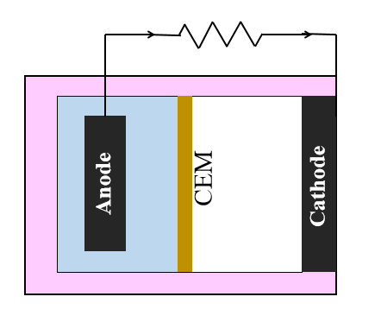
Supplementary Figure S1. The schematic of the air-cathode MFC

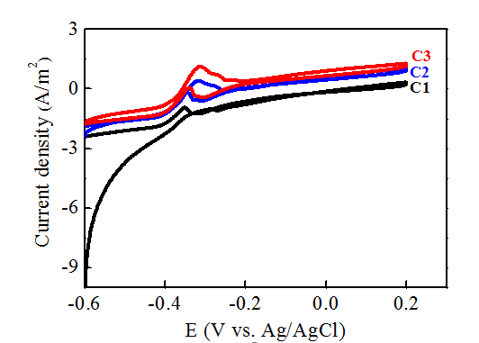
Supplementary Figure S2. Three circles of CV at initial voltage increasing stage when the anolyte was replaced with fresh medium in few minutes.

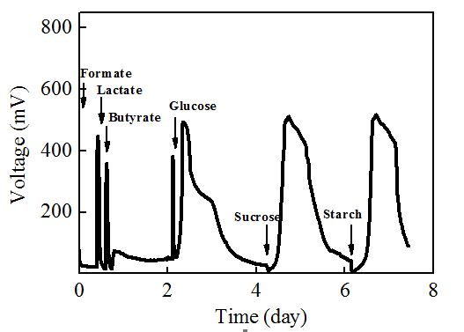
Supplementary Figure S3. Voltage outputs of MFCs by strain EB-1with different carbon sources (COD=500 mg/L).

Supplementary Tables
Supplementary Table S1. Nitrogen detection of the end-products of MFCs with different initial NO₃⁻-N concentrations.
Initial NO₃⁻-N concentrations  (mg L⁻¹) | Residual NO₃⁻-N  (mg L⁻¹) | Product NO₂⁻-N  (mg L⁻¹) | Product NH₄⁺-N  (mg L⁻¹)
22.3±0.5 | 1.27±0.31 | 0.07±0.01 | ND
52.5±1.3 | 1.15±0.16 | 0.07±0.01 | ND
105.4±3.5 | 2.08±0.54 | 0.40±0.02 | ND
222.5±5.1 | 41.34±4.34 | 0.81±0.04 | ND

ND: the concentration of samples under the limit of detection

