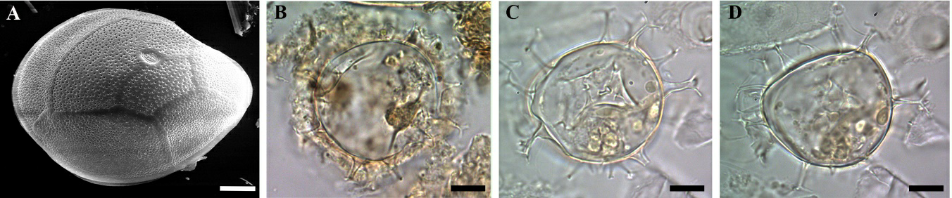

Figure S2. (A) Gambierdiscus sp. found in King Fish, Caribbean coast of Guatemala; and some dinoflagellate cysts found in Punta Caracol, Caribbean coast of Mexico: Spiniferites spp. (B), Spiniferites hyperacanthus (C and D). Scale: 10 µm.

