Supplementary Material
Molecular Mass and Localization of α-1,3-Glucan in Cell Wall Control the Degree of Hyphal Aggregation in Liquid Culture of Aspergillus nidulans
Ken Miyazawa, Akira Yoshimi, Shin Kasahara, Asumi Sugahara, Ami Koizumi, Shigekazu Yano, Satoshi Kimura, Tadahisa Iwata, Motoaki Sano, and Keietsu Abe*
* Correspondence: Keietsu Abe: kabe@niche.tohoku.ac.jp

TABLE S1. Strains used in this study.
Strain | Genotype | Reference
ABPU1 | biA1, pyrG89, wA3, argB2, pyroA4, veA1 | (Motoyama et al. 1996)
ABPU1 (ΔligD) | biA1, pyrG89, wA3, argB2, pyroA4, veA1, ligD::ptrA | (Yoshimi et al. 2013)
ABPU1 (ligD^{+,} argB⁺; wild-type) | biA1, pyrG89, wA3, argB2, pyroA4, veA1, ligD::ptrA, ligD+::pyrG, AoargB⁺ | This study
ΔagsA | biA1, pyrG89, wA3, argB2, pyroA4, veA1, ligD::ptrA, agsA::loxP, ligD⁺::pyrG, AoargB⁺ | This study
ΔagsB | biA1, pyrG89, wA3, argB2, pyroA4, veA1, ligD::ptrA, agsB::argB, ligD⁺::pyrG | This study
ΔagsAΔagsB | biA1, pyrG89, wA3, argB2, pyroA4, veA1, ligD::ptrA, agsA::loxP, agsB::argB, ligD⁺::pyrG, AoargB⁺ | This study
agsA^{OE} | biA1, pyrG89, wA3, argB2, pyroA4, veA1, ligD::ptrA, agsB::argB, ligD⁺::pyrG, Ptef1-agsA::pyroA | This study
agsB^{OE} | biA1, pyrG89, wA3, argB2, pyroA4, veA1, ligD::ptrA, agsA::loxP, ligD⁺::pyrG, AoargB⁺, Ptef1-agsB::pyroA | This study
BPU1 | biA1, pyrG89, wA3, argB2, pyroA4, veA1, AoargB⁺ | (Hagiwara et al. 2007)
PagsA-EGFP | biA1, pyrG89, wA3, argB2, pyroA4, veA1, PagsA-EGFP::argB | This study
PagsB-EGFP | biA1, pyrG89, wA3, argB2, pyroA4, veA1, PagsB-EGFP::argB | This study
ΔamyG | biA1, pyrG89, wA3, argB2, pyroA4, veA1, ligD::ptrA, amyG::pyrG | This study
ΔagsAΔagsB (ΔligD) | biA1, pyrG89, wA3, argB2, pyroA4, veA1, ligD::ptrA, agsB::argB | (Yoshimi et al. 2013)

TABLE S2. Primers used in this study
Purpose | Primer name | Sequence (5' to 3')
Construction of the agsA gene disruption strain
 | PxynG2-cre-F | GGTACCCGGGGATCGCGGCCGCTACCGTTCGTATAGCATACA
 | PxynG2-cre-R | GGGTACGTCTGTTGTCCTCGTACTCGATGACGGCT
 | AopyrG-PU1 | ACAACAGACGTACCCTGTGATGTTC
 | AopyrG-PL1-lox66 | CGACTCTAGAGGATCGCGGCCGCTACCGTTCGTATAATGTATGCTATACGAAGTTATAACTGCACCTCAGAAGAA
 | ANagsA-LU1 | CGACTCTAGAGGATCCAGTGGAGGAGTTAGGGAGTGAT
 | ANagsA-LL1 | CGTAATAATCTGCTGAAAGAGTAAGGTAGAAGCCCC
 | ANagsA-RU1 | CAGCAGATTATTACGCACCGGA
 | ANagsA-RL1 | CGGTACCCGGGGATCCAACCGTGGTTTTGGTGGCAAAG
 | ANagsALR-F | TAAATTTCGCGGCCGCCAGCAGATTATTACGCACCGGAATG
 | ANagsALR-R | TAAATTTCGCGGCCGCAAAGAGTAAGGTAGAAGCCCC
Construction of the agsA^{OE} and agsB^{OE} strains
 | ANagsA-tef-LU2 | CGACTCTAGAGGATCCGCGGCCGCGACTAGTTAGCAACCAGCAAC
 | ANagsA-tef-LL2 | AACCCGTATACTCCTCGACTACTAGACGCTGGTTC
 | ANagsA-tef-RU2 | CGCACCACCTTCAAAATGAGGTGGAGGCCTTTAAACC
 | ANagsA-tef-RL2 | CGGTACCCGGGGATCCGCGGCCGCCTGGCCAACGAAAAACATCC
 | ANpyroA-PU | TGGCGCCTGTCTGGTTTGGGAAGCGCAGTTGAGCCTGAGA
 | ANpyroA-PL | AGGAGTATACGGGTTTTTGGCATTG
 | ANPtef-TU | AACTGCGCTTCCCAAACCAGACAGGCGCCACTC
 | ANPtef-TL | tttgaaggtggtgcgaacttt
 | ANagsB-tef-LU | CGACTCTAGAGGATCCGCGGCCGCGCTTCACCAACAATCCTTCCACCTG
 | ANagsB-tef-LL | AACCCGTATACTCCTGTGAGGCGTACCATGGGTACTG
 | ANagsB-tef-RU | CGCACCACCTTCAAAATGGGGAGGCTCCAGCTCTCA
 | ANagsB-tef-RL | CGGTACCCGGGGATCCGCGGCCGCTGGCGTTAATCAGGTCGTTGG
Construction of the argB complementation strain
 | ANargB-LU | CGACTCTAGAGGATCCGCGGCCGCACAGTTCGCTGTAAGCTCATCGGA
 | ANargB-LL | CAGCGGATGGAATTCAGCAGGAGCTTCCGATCATTG
 | ANargB-RU | TACTCCGTCGGTACCAGTCGTCCTAGCCAAGGTAGATC
 | ANargB-RL | CGGTACCCGGGGATCCGCGGCCGCGCACTGAAAGATCATGTGCTTGCCA
 | AoargB-F | CGGTACCCGGGGATCGGTACCGACGGAGTAACT
 | AoargB-R | GAATTCCATCCGCTGTGG
Construction of the ligD complementation strain
 | ANamdS-LU | CGACTCTAGAGGATCCGCGGCCGCCTACAACATGAGGTGTTGCCTCCTG
 | ANamdS-LL | GATACAATACGGATCCCGGAGGCCTCTGTGATCTTCAGTTC
 | ANamdS-RU | GGGTACGTCTGTTGTTAACGATAGCTCAGCCTTGCAGGTG
 | ANamdS-RL | CGGTACCCGGGGATCCGCGGCCGCTGTCGCCAGAGTGCTTCACTTGAAC
 | AopyrG-PU2 | GGGTCTCATCGGATCCAACTGCACCTCAGAAGAAAAGGATG
 | AopyrG-PL2 | ACAACAGACGTACCCTGTGATGTTC
 | ANligD-F | CATTCATGCAGGATCCGTATTGTATC
 | ANligD-R | ATAGAAGAGATGGATCCGATGAGACC
Quantitative PCR
 | ANagsA-RT-F | GCTTTCCAAATCCCACAGTTGG
 | ANagsA-RT-R | GTGAAGCAGATATGCATCCGTG
 | ANagsB-RT-F | ATCGGACACTACCTTCCCTG
 | ANagsB-RT-R | GACTTGGCTGACGATCAACG
 | ANHistone-RT-F | CACCCGGACACTGGTATCTC
 | ANHistone-RT-R | GAATACTTCGTAACGGCCTTGG

TABLE S2. Primers used in this study (continued)
Purpose | Primer name |  | Sequence (5' to 3')
Construction of the PagsA- and PagsB-EGFP strains
 |  | IF_PagsA-F |  | CAGCGGATGGAATTCAGTGGAGGAGTTAGGGAGTG
 |  | IF_PagsA-R |  | GCCCTTGCTCACCATGGTCGATTTTTCCGGATGTC
 |  | IF_EGFP-F |  | ATGGTGAGCAAGGGCGAG
 |  | IF_EGFP-TagdA-R |  | CGACTCTAGAGGATCAGGCCTGCAGGAGATCCC
 |  | IF_PagsB-F |  | CAGCGGATGGAATTCCAATGAGAGCTGGAATCAGTG
 |  | IF_PagsB-R |  | GCCCTTGCTCACCATAGTAACTGATGAAGCGAGAAC
Construction of the amyG gene disruption strain
 |  | ANamyG-LU |  | TCCCTCCTGCCTGTTAGCTC
 |  | ANamyG -LL |  | CACAGGGTACGTCTGTTGTTGTGCTTTGCGGCATCTAGTC
 |  | ANamyG -RU |  | TTCTTCTGAGGTGCAGTTATGCAGTATACGGTCTTGG
 |  | ANamyG -RL |  | CGTTGCTCATTATTCTACTAGG
 |  | ANamyG -PU |  | TAGATGCCGCAAAGCACAACAACAGACGTACCCTGTGATGTTC
 |  | ANamyG -PL |  | CCAAGACCGTATACTGCATAACTGCACCTCAGAAGAAAAGGATG
 |  | ANamyG-F |  | GATGTCACCACCCTCGTATC
 |  | ANamyG-R |  | AACGTCCTTGACAATCTAGTTGCTC

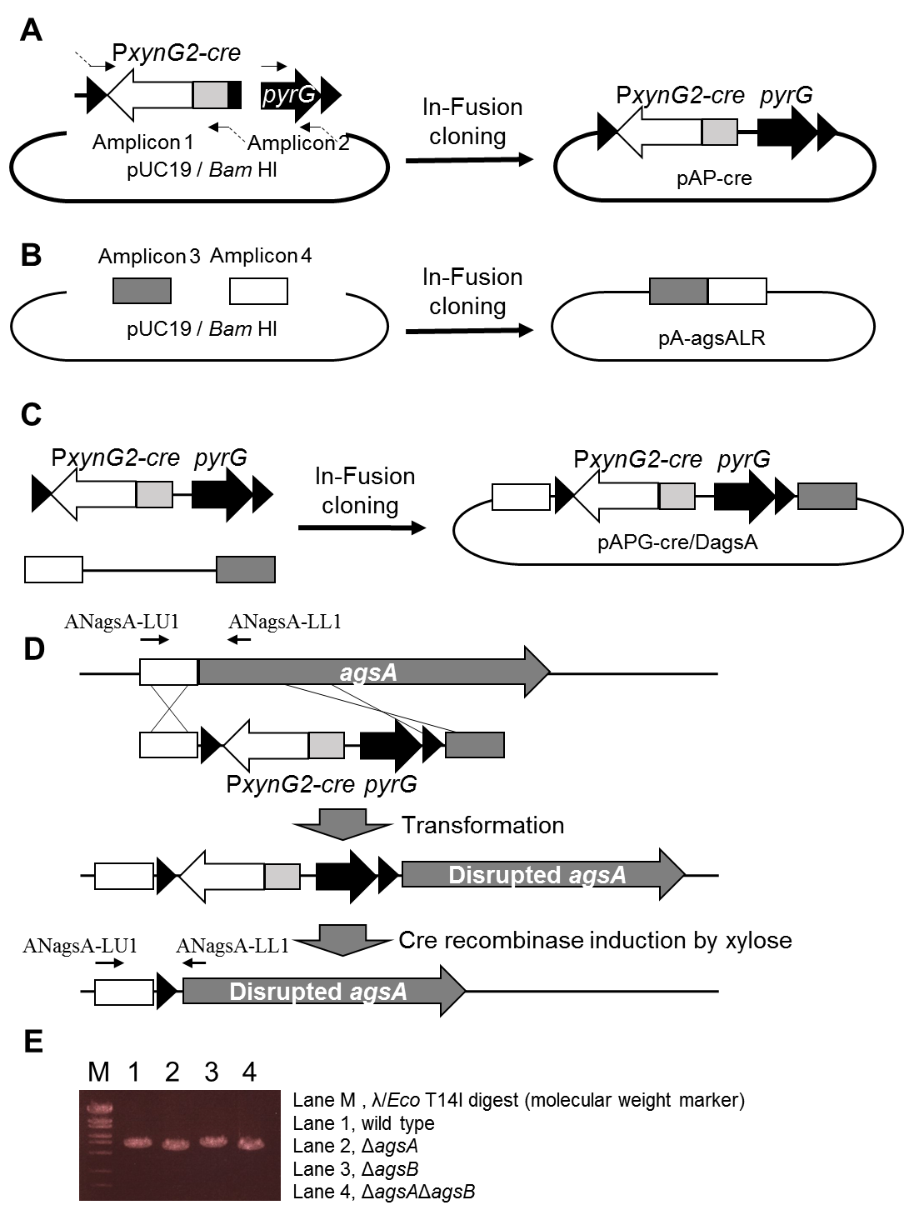
FIGURE S1. Construction of the agsA disruption strain of Aspergillus nidulans using the Cre/mutant loxP marker recycling system. (A) Construction of the pAP-cre plasmid. Fragments containing PxynG2 and Cre, and the pyrG marker were amplified and then fused to BamHI-digested pUC19 by using In-Fusion cloning. (B) Construction of the pA-agsALR plasmid. Fragments containing the right and left arms of agsA for agsA disruption were amplified and then fused to BamHI-digested pUC19. (C) Construction of the pAPG-cre/DagsA plasmid. (D) Strategy for gene replacement to disrupt agsA. EcoRI-digested pAPG-cre/DagsA was used to transform the wild-type and ΔagsB strains. Candidate strains were isolated based on uridine and uracil requirement. Then the Cre gene was induced by culture on CD medium containing 1% xylose, resulting in marker cassette excision. (E) PCR analysis of agsA gene disruption.

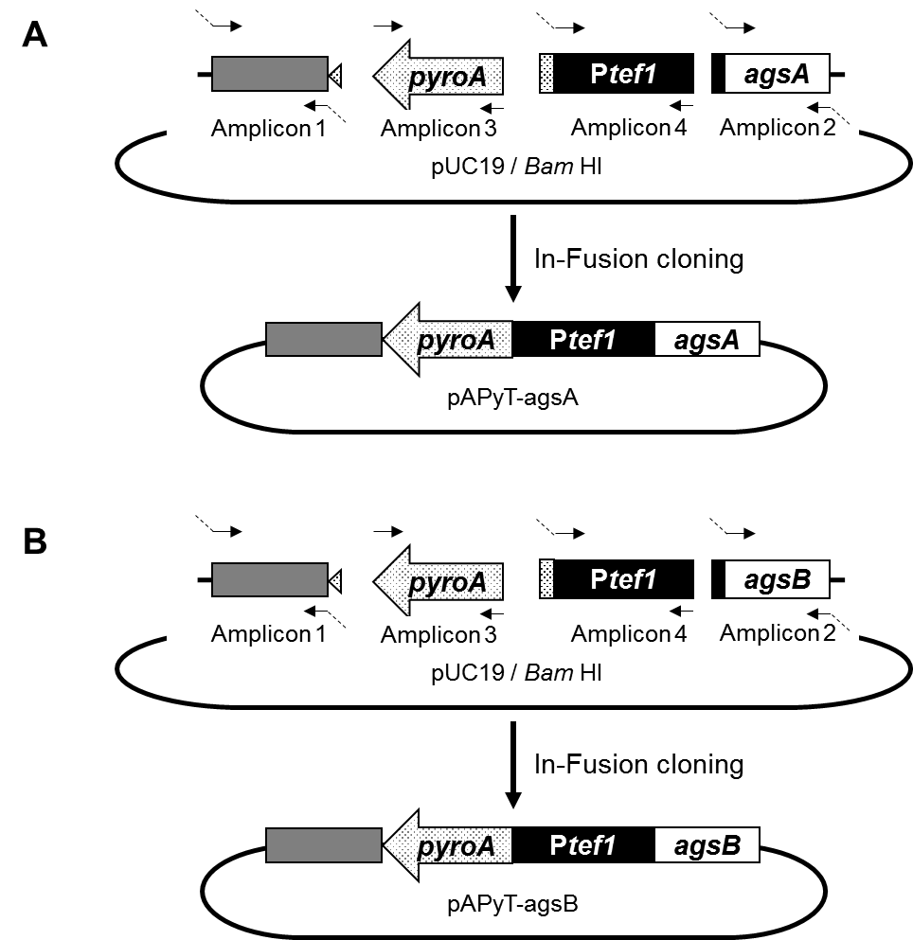
FIGURE S2. Construction of the plasmids (A) pAPyT-agsA and (B) pAPyT-agsB for agsA or agsB overexpression. Fragments containing the right and left arms of agsA or agsB for agsA or agsB gene replacement, the pyroA marker, and the tef1 promoter (Ptef1) for gene overexpression were amplified and then fused to BamHI-digested pUC19.

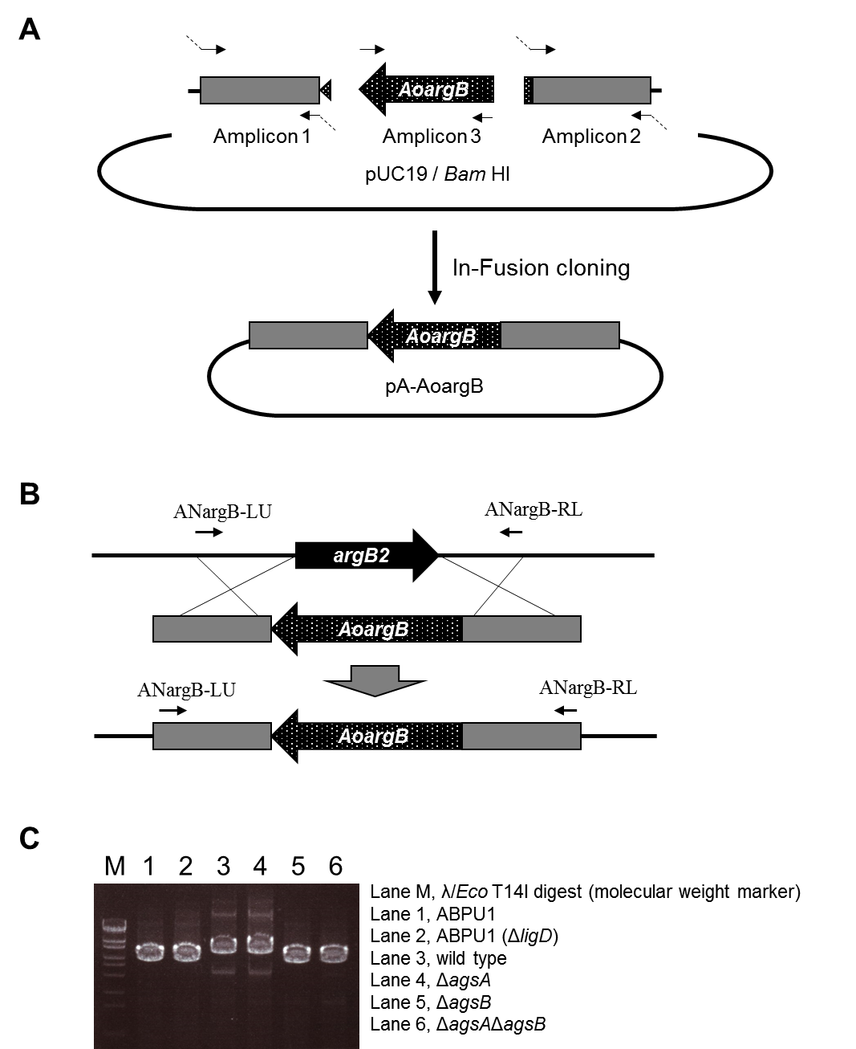
FIGURE S3. Construction of the argB complementation strains of A. nidulans. (A) Construction of the pA-AoargB plasmid. Fragments containing the right and left arms of the A. nidulans argB gene and the argB marker derived from A. oryzae were amplified and then fused to BamHI-digested pUC19. (B) Strategy for replacement of the A. nidulans argB gene. NotI-digested pA-AoargB was used to transform strains requiring arginine. Candidate strains were isolated based on arginine requirement. (C) PCR analysis of argB gene complementation at the argB locus in A. nidulans.

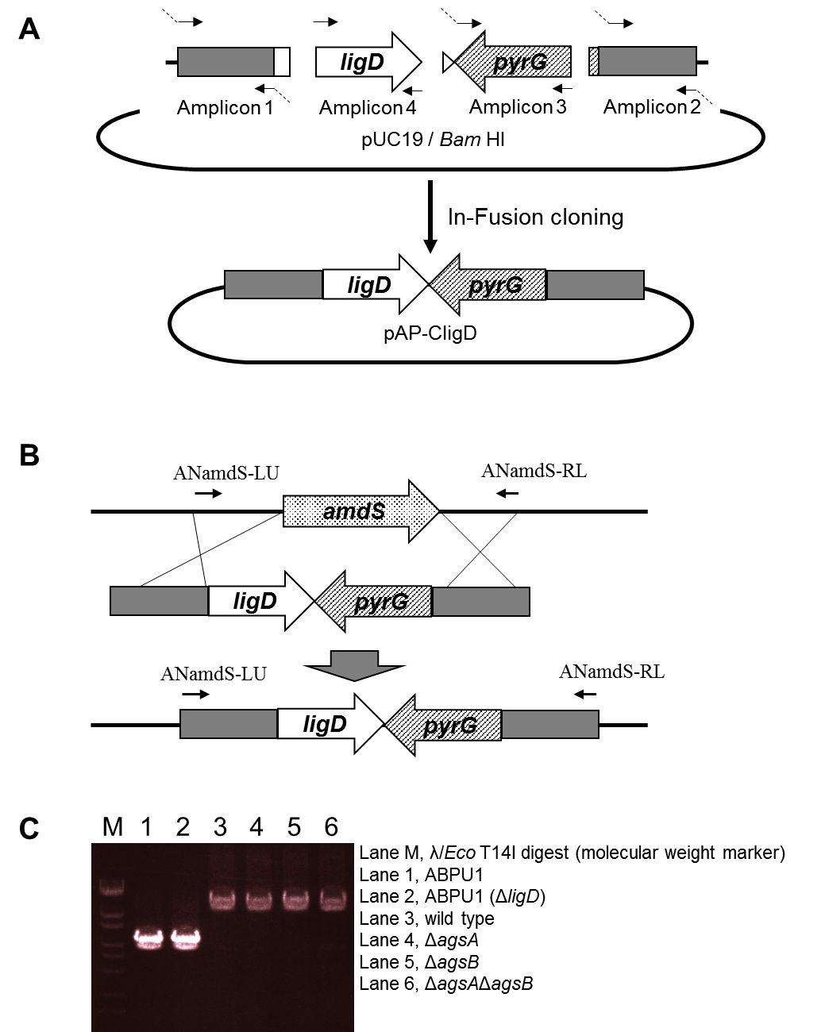
FIGURE S4. Construction of the ligD complementation strains. (A) Construction of the pAP-CligD plasmid. Fragments containing the right and left arms of the A. nidulans amdS gene, the full-length ligD gene, and the pyrG marker derived from A. oryzae were amplified and fused to BamHI-digested pUC19. (B) Strategy for complementation of the ligD gene. NotI-digested pAP-CligD was used to transform A. nidulans. Candidate strains were isolated based on uridine and uracil requirement. (C) PCR analysis of ligD gene complementation at the amdS locus in A. nidulans.

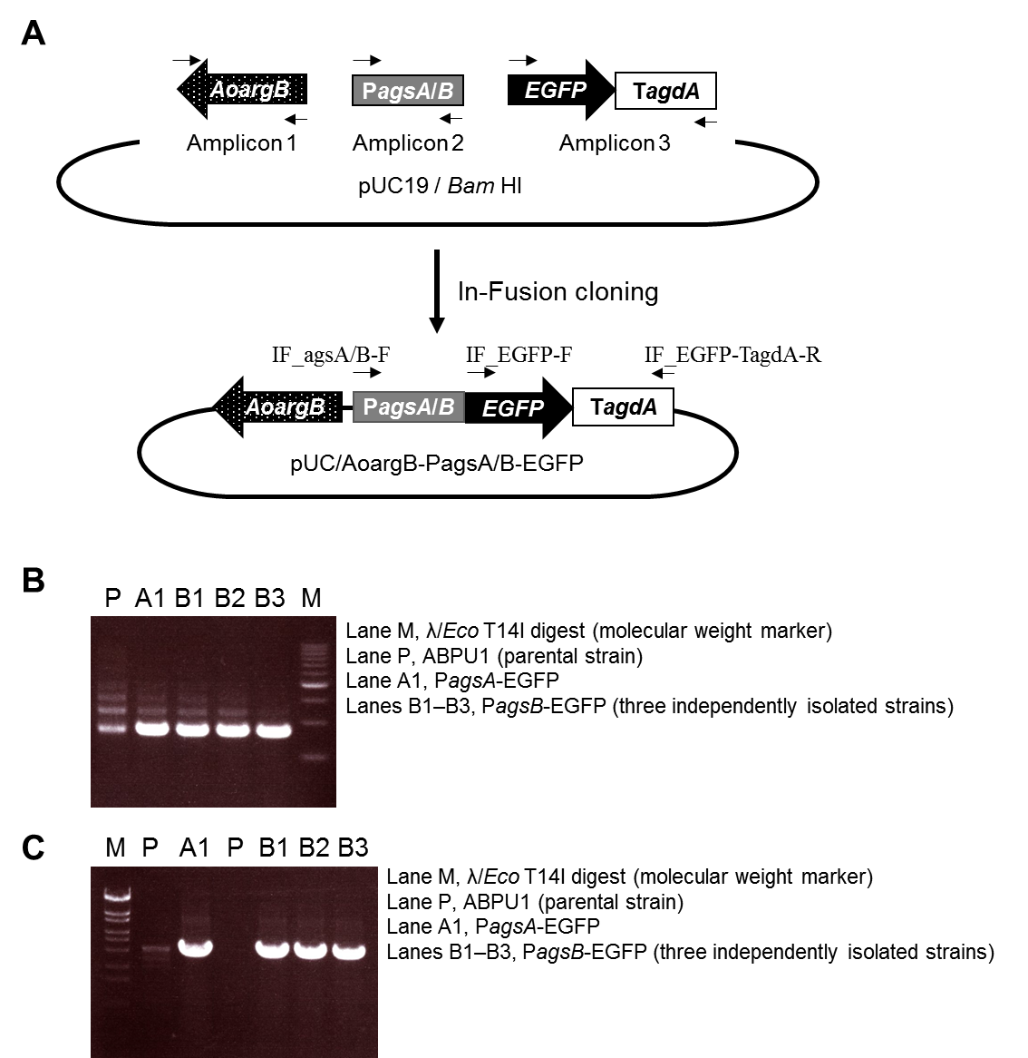
FIGURE S5. Construction of the PagsA-EGFP and PagsB-EGFP strains of A. nidulans. (A) Construction of the plasmid pUC/AoargB-PagsA/B-EGFP. Fragments containing the argB marker gene derived from A. oryzae, the promoter regions of agsA or agsB, and EGFP and the terminator region of agdA were amplified and fused to BamHI-digested pUC19. (B) PCR analysis of the introduction of the EGFP gene into the genome. Primers IF_EGFP-F and IF_EGFP-TagdA-R were used. (C) PCR analysis for confirmation of the fusion of the agsA or agsB promoter region with the EGFP gene in the genome. Primers IF_agsA-F or IF_agsB-F and IF_EGFP-TagdA-R were used. Lane designations are as in (B).

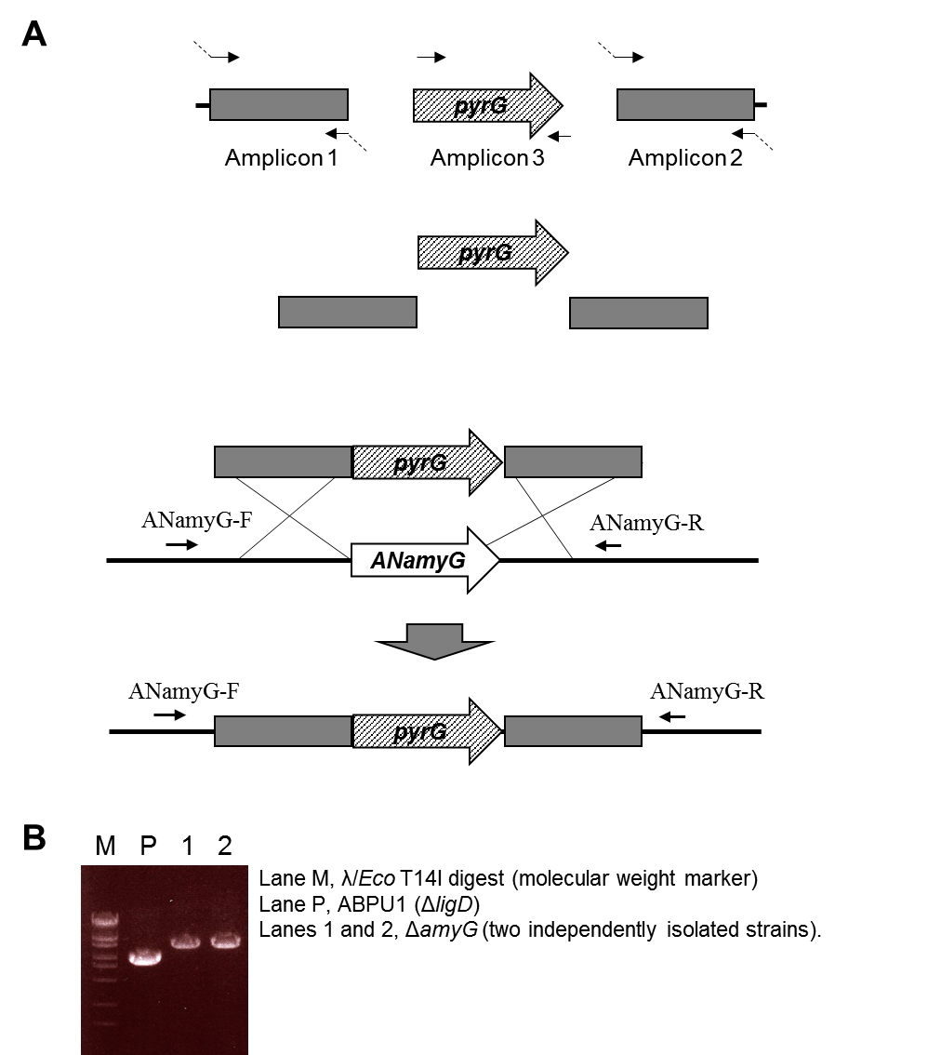
FIGURE S6. Construction of the amyG disruption strain of A. nidulans. (A) Disruption of the amyG gene. The first round of PCR was done to amplify the fragments containing the right and left arms of amyG, and the pyrG marker. The second round of PCR was done to fuse the three fragments from the first round. (B) PCR analysis of amyG gene disruption.

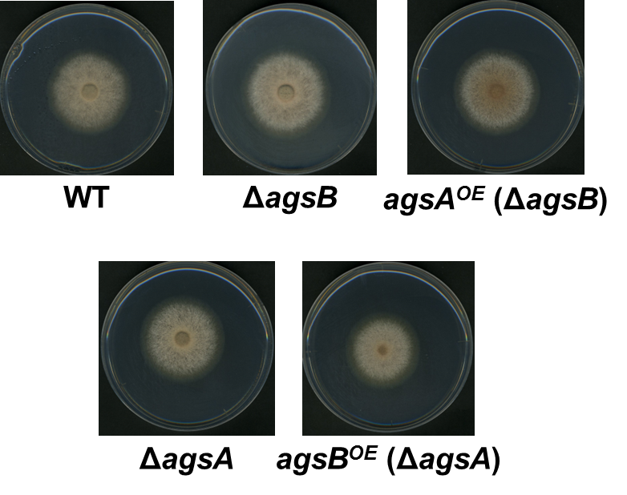
FIGURE S7. Mycelial growth of the agsA^{OE} and agsB^{OE} strains on agar plates. Conidia (1 × 10⁴) were inoculated onto CD agar medium and cultured at 37°C for 4 days.

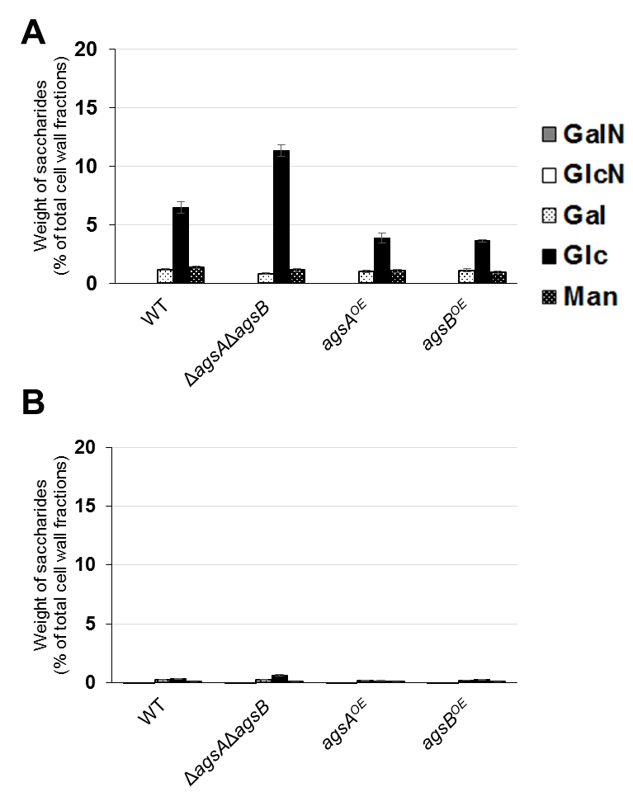
FIGURE S8. Monosaccharide composition of the hot-water soluble (HW) and AS1 fractions from the wild-type (WT), ΔagsAΔagsB, agsA^{OE}, and agsB^{OE} strains. The strains were cultured in CD medium (160 rpm, 37°C, 24 h). The cell wall of each strain was fractionated into four fractions according to solubility in hot water at neutral pH and alkali. Monosaccharide composition of (A) HW and (B) AS1 is shown. Error bars represent the standard error of the mean calculated from three replicates. GalN, galactosamine; GlcN, glucosamine; Gal, galactose; Glc, glucose; Man, mannose.

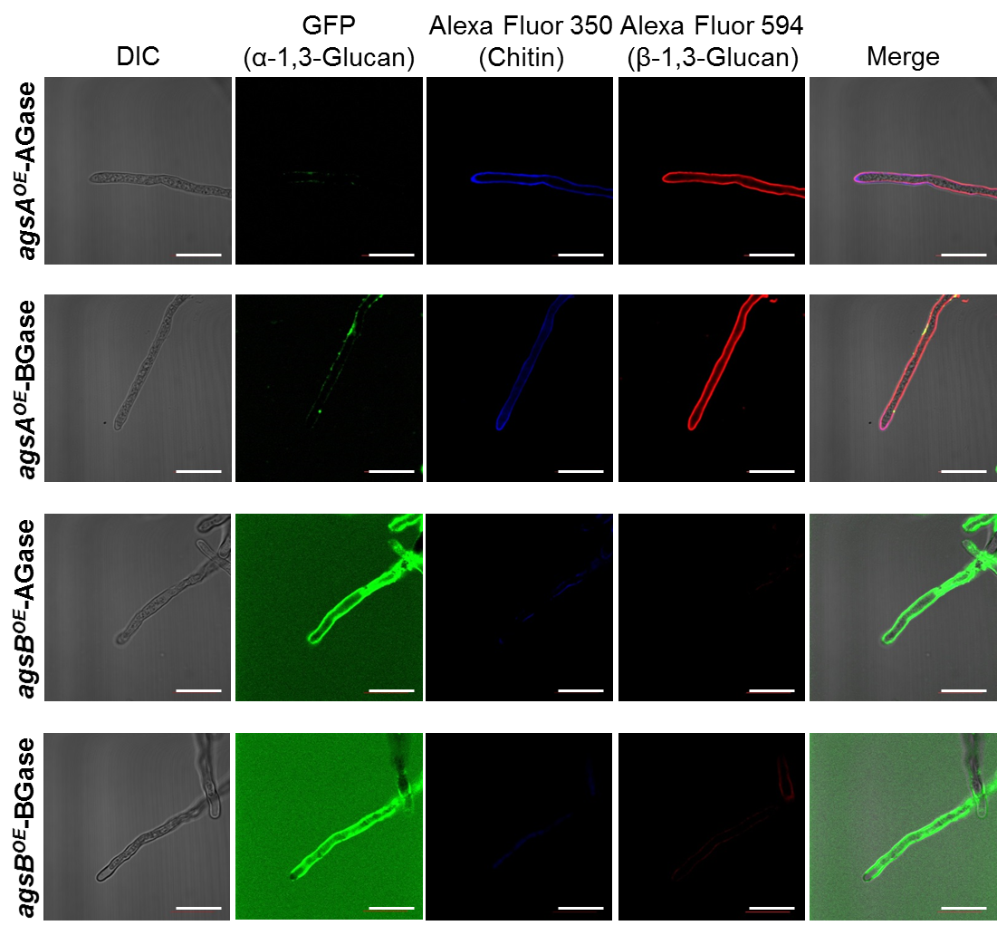
FIGURE S9. Localization of cell wall polysaccharides without α-1,3-glucanase or β-1,3-glucanase treatment. Vegetative hyphae cultured for 12 h were fixed and incubated for 6 h at 37°C (control for α-1,3-glucanase treatment) or 55°C (control for β-1,3-glucanase treatment). The hyphae were stained with AGBD-GFP for α-1,3-glucan, fluorophore-labeled antibody for β-1,3-glucan, and fluorophore-labeled lectin for chitin. Scale bars are 10 µm.

