Supplementary Material
Contraction Dynamics and Respiration of Small Single-Osculum Explants of the Demosponge Halichondria panicea
Lars Kumala^{1,2,3,4}* and Donald Eugene Canfield⁴
¹Marine Biological Research Centre, University of Southern Denmark, Kerteminde, Denmark
²Max-Planck Odense Center on the Biodemography of Aging, Department of Biology, University of Southern Denmark, Odense, Denmark
³Max Planck Institute for Demographic Research, Rostock, Germany
⁴Nordcee, Department of Biology, University of Southern Denmark, Odense, Denmark

* Correspondence: Lars Kumala: kumala@biology.sdu.dk

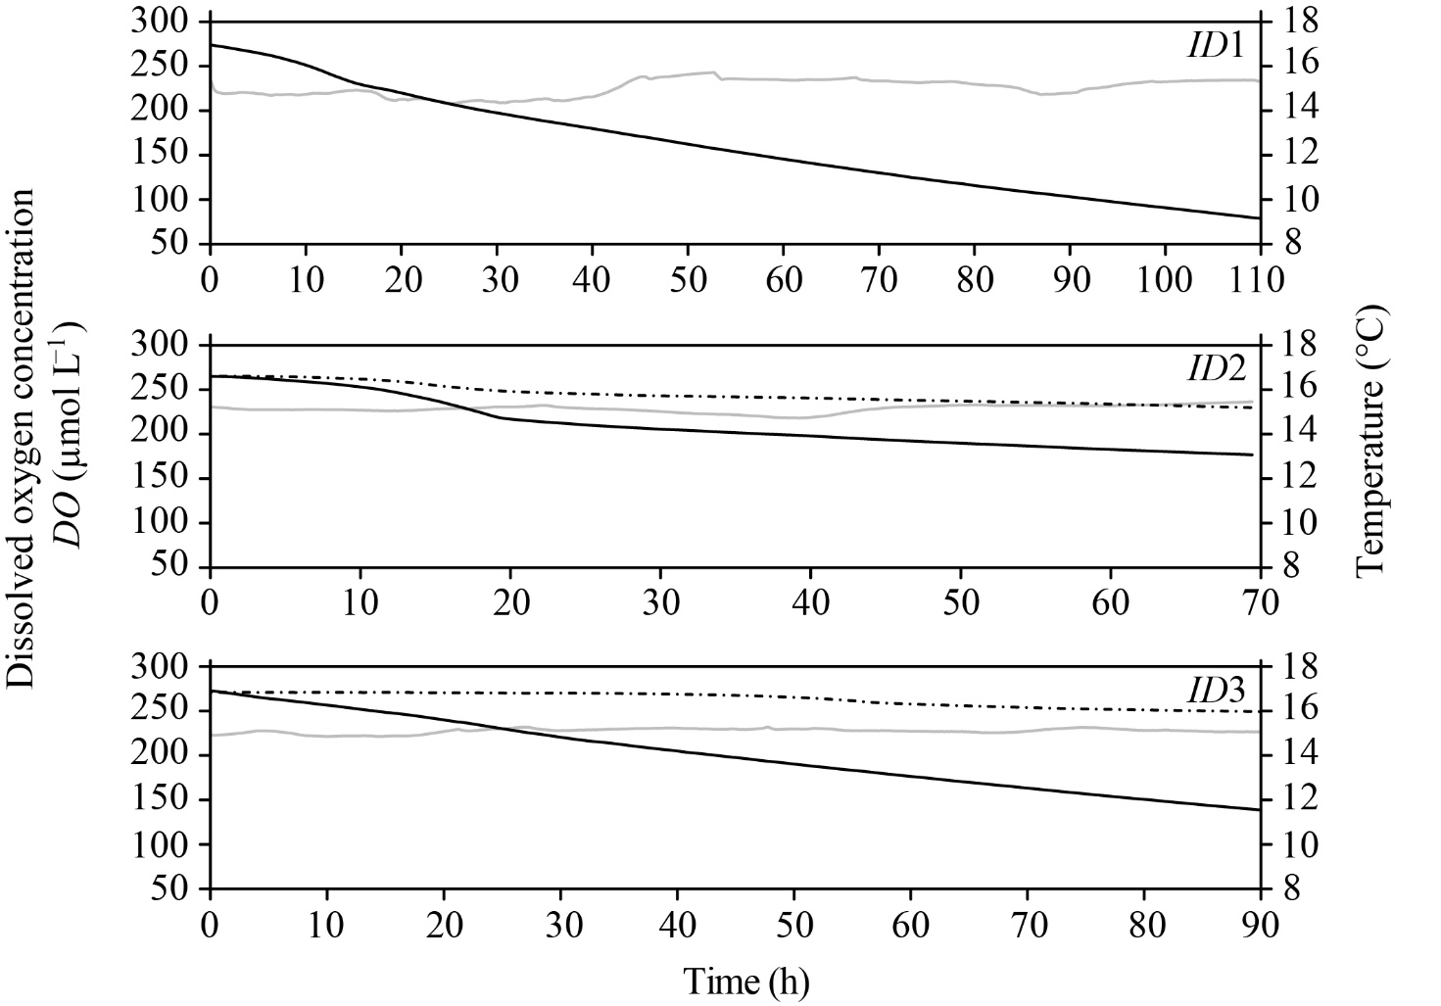
Figure S1. Halichondria panicea. Dissolved oxygen concentration (DO, µmol L⁻¹; dark line) as a function of time in respiration experiments with single-osculum explants (identification number = ID1 to ID3) in experimental chamber (V = 29.4 ml) with well-mixed (0.2 µm) filtered seawater (20 PSU). The dashed lines show the DO in the control chamber (i.e. with glass slide without sponge explant). Both the temperature (grey line) and DO was recorded every 5 s (ID2) or 10 s (ID1 and ID3).

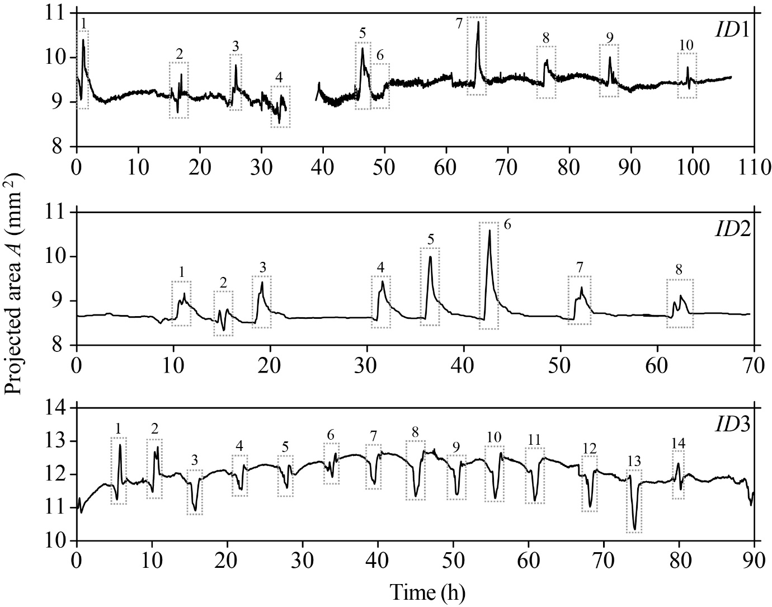
Figure S2. Halichondria panicea. Measurement of the projected area (A, mm²) of sponge explants (ID1 to ID3) as a function of time during respiration experiments with combined time-lapse observations of the explant osculum and body (Figure 1). Numbered boxes indicate contraction-expansion events (Table 1). Corresponding temporal changes in osculum cross-sectional area (OSA) and respiration rate (R) are given in Figure 2.
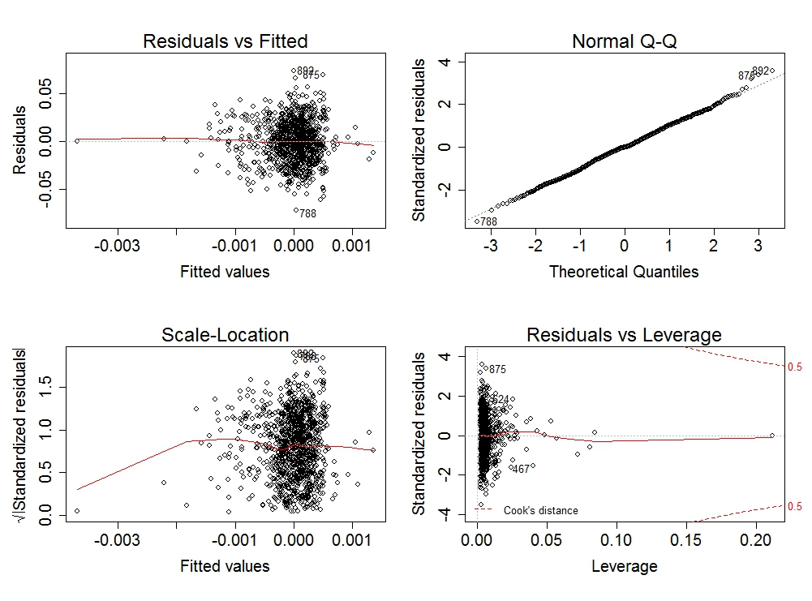
Figure S3. Halichondria panicea. Diagnostic plots of the relationship between temporal changes of respiration rate R (µmol O₂ h⁻¹) and state of the osculum cross-sectional area (OSA, mm²) when considering individual variation (ID).
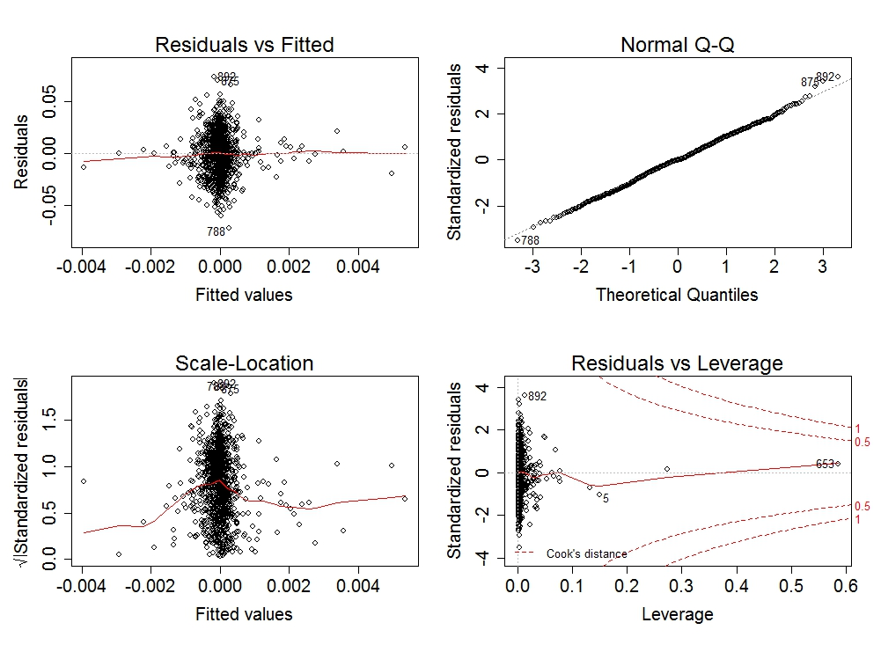
Figure S4. Halichondria panicea. Diagnostic plots of the relationship between temporal changes of explant respiration rate R (µmol O₂ h⁻¹) and temporal changes in osculum cross-sectional area (OSA, mm²) when considering individual variation (ID).

