Supplementary Material
Frontiers in Microbiology
Characteristics comparison of bacterial community composition between two estuarine reservoirs from a tropical and sub-tropical region
Zheng Xu ª, Shu Harn Te ^{b}, Yiliang He ^{a,} *, Karina Yew-Hoong Gin ^{b, c,} *

ª School of Environmental Science and Engineering, Shanghai Jiao Tong University, Shanghai 200240, PR China
^{b} NUS Environmental Research Institute (NERI), National University of Singapore, Singapore 138602
^{c} Department of Civil and Environmental Engineering, National University of Singapore, Singapore 138602

* Corresponding author. Tel.: +86 21 54744008; E-mail address: ylhe@sjtu.edu.cn

Supplementary Material
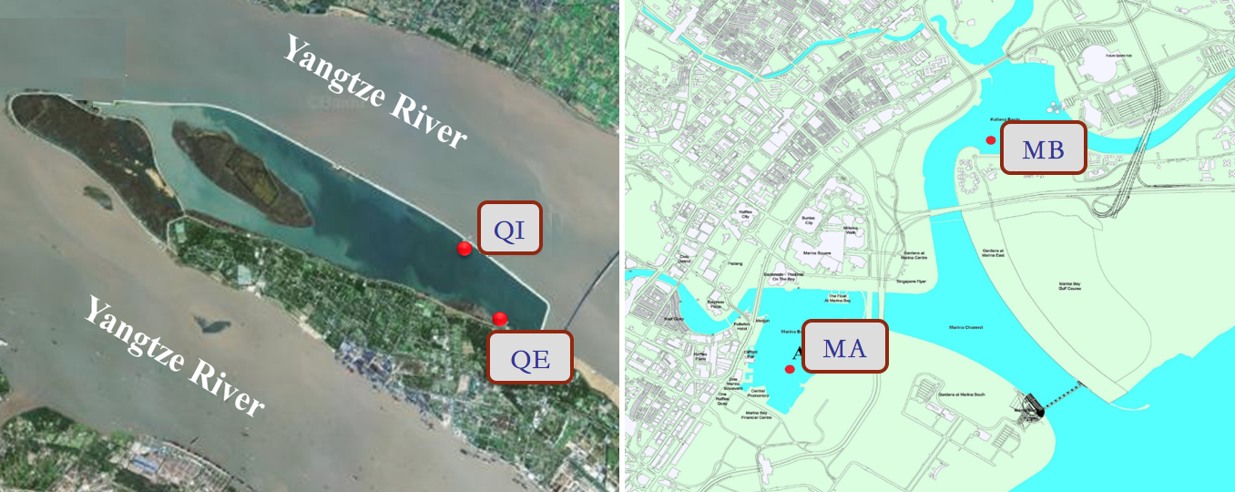
Fig. S1 Aerial schematic of two different estuarine reservoirs and annotated sampling
(reservoir A: Qingcaosha Reservoir in Shanghai, China (left); reservoir B: Marina Reservoir in Singapore (right))
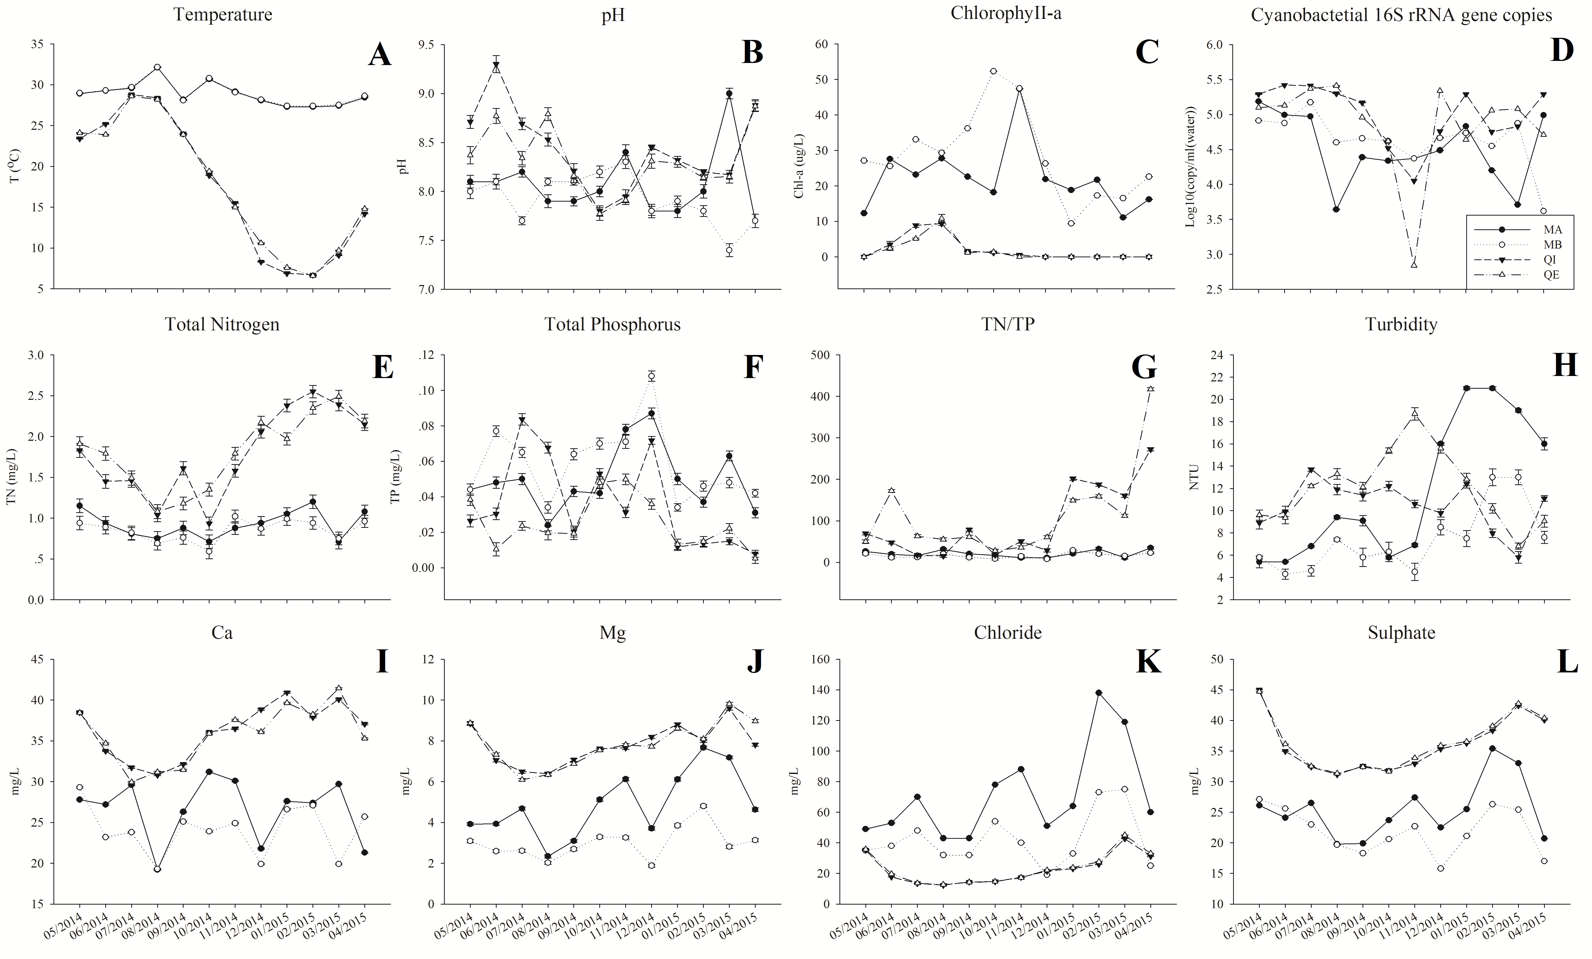
Fig. S2 Water chemistry and environmental parameters in reservoir A and B (A: Temperature, B: pH, C: Chlorophyll-a, D: Cyanobacterial 16S rRNA gene copies, E: Total Nitrogen, F: Total Phosphorus, G: TN/TP, H: Turbidity, I: Ca, J: Mg, K: Chloride, L: Sulphate)
Table S1 Supplemental water chemistry and environmental parameters in Reservoir A
reservoir A | Rainfall (1d) | Rainfall (5d) | Rainfall (30d)
QI_2014_05 | 0 | 1.9 | 61.5
QI_2014_06 | 0 | 33.2 | 175.9
QI_2014_07 | 0 | 0 | 192.2
QI_2014_08 | 0.01 | 43.7 | 229.3
QI_2014_09 | 3.68 | 42.9 | 196
QI_2014_10 | 0 | 0 | 37.3
QI_2014_11 | 0.15 | 11.7 | 34.6
QI_2014_12 | 0 | 0 | 5.8
QI_2015_01 | 0.46 | 4.6 | 61.1
QI_2015_02 | 0 | 1.2 | 81.1
QI_2015_03 | 0.08 | 31.2 | 96.4
QI_2015_04 | 0 | 59.5 | 108.9
QE_2014_05 | 0 | 1.9 | 61.5
QE_2014_06 | 0 | 33.2 | 175.9
QE_2014_07 | 0 | 0 | 192.2
QE_2014_08 | 0.01 | 43.7 | 229.3
QE_2014_09 | 3.68 | 42.9 | 196
QE_2014_10 | 0 | 0 | 37.3
QE_2014_11 | 0.15 | 11.7 | 34.6
QE_2014_12 | 0 | 0 | 5.8
QE_2015_01 | 0.46 | 4.6 | 61.1
QE_2015_03 | 0.08 | 31.2 | 96.4
QE_2015_04 | 0 | 59.5 | 108.9

Table S2 Supplemental water chemistry and environmental parameters in Reservoir B
reservoir B | Rain (1d) | Rain (5d) | Rain (30d)
MA_2014_05 | 0 | 2 | 242.7
MA_2014_06 | 10.8 | 16.4 | 100.5
MA_2014_07 | 8.8 | 14.6 | 62.7
MA_2014_08 | 11.8 | 46.8 | 209.79
MA_2014_09 | 0.2 | 32.6 | 155.7
MA_2014_10 | 0 | 0 | 111.6
MA_2014_11 | 6.8 | 6.8 | 104.1
MA_2014_12 | 0.6 | 58.8 | 282
MA_2015_01 | 0 | 0.8 | 400.5
MA_2015_02 | 0 | 0.2 | 83.7
MA_2015_03 | 0 | 0 | 49.5
MA_2015_04 | 32.79 | 78.4 | 135.9
MB_2014_05 | 0 | 2 | 242.7
MB_2014_06 | 10.8 | 16.4 | 100.5
MB_2014_07 | 8.8 | 14.6 | 62.7
MB_2014_08 | 11.8 | 46.8 | 209.79
MB_2014_09 | 0.2 | 32.6 | 155.7
MB_2014_10 | 0 | 0 | 111.6
MB_2014_11 | 6.8 | 6.8 | 104.1
MB_2014_12 | 0.6 | 58.8 | 282
MB_2015_01 | 0 | 0.8 | 400.5
MB_2015_02 | 0 | 0.2 | 83.7
MB_2015_03 | 0 | 0 | 49.5
MB_2015_04 | 32.79 | 78.4 | 135.9
Table S3. PERMANOVA analysis of the Bray-Curtis dissimilarities for bacterial community composition in reservoir A. Df = degrees of freedom; SS = sum of squares; MS = mean sum of squares; Pseudo-F = F value by permutation, P(perm) = P-values based on 9999 permutations.
Bacterial community Source | df | SS | MS | Pseudo-F | P(perm)
Site | 1 | 657.32 | 657.32 | 1.1147 | 0.3775
Time | 11 | 30085 | 2735 | 4.6382 | 0.0001
Res | 10 | 5896.7 | 589.67
Total | 22 | 36712

Table S4. PERMANOVA analysis of the Bray-Curtis dissimilarities for bacterial community composition in reservoir B. Df = degrees of freedom; SS = sum of squares; MS = mean sum of squares; Pseudo-F = F value by permutation, P(perm) = P-values based on 9999 permutations.
Bacterial community Source | df | SS | MS | Pseudo-F | P(perm)
Site | 1 | 2970.5 | 2970.5 | 2.2211 | 0.0057
Time | 11 | 30935 | 2812.2 | 2.1027 | 0.0001
Res | 11 | 14712 | 1337.4
Total | 23 | 48617

Table S5. Multiple linear correlations by rcor.test in ltm package (R language).

A | B | R
Otu000012 | Otu000003 | 0.72
Otu000018 | Otu000017 | 0.88
Otu000022 | Otu000012 | 0.73
Otu000030 | Otu000012 | 0.73
Otu000030 | Otu000022 | 0.92
Otu000031 | Otu000005 | 0.91
Otu000035 | Otu000003 | 0.73
Otu000038 | Otu000035 | 0.81
Otu000044 | Otu000036 | 0.72
Otu000046 | Otu000017 | 0.77
Otu000048 | Otu000036 | 0.84
Otu000050 | Otu000036 | 0.83
Otu000050 | Otu000044 | 0.78
Otu000050 | Otu000048 | 0.81
Otu000052 | Otu000029 | 0.87
Otu000053 | Otu000005 | 0.74
Otu000058 | Otu000015 | 0.84
Otu000058 | Otu000036 | 0.72
Otu000059 | Otu000029 | 0.88
Otu000059 | Otu000052 | 0.86
Otu000062 | Otu000036 | 0.86
Otu000062 | Otu000040 | 0.77
Otu000062 | Otu000044 | 0.86
Otu000062 | Otu000048 | 0.8
Otu000062 | Otu000050 | 0.78
Otu000064 | Otu000038 | 0.75
Otu000066 | Otu000017 | 0.91
Otu000066 | Otu000018 | 0.88
Otu000067 | Otu000036 | 0.85
Otu000067 | Otu000044 | 0.76
Otu000067 | Otu000048 | 0.78
Otu000067 | Otu000050 | 0.74
Otu000067 | Otu000062 | 0.88
Otu000070 | Otu000022 | 0.81
Otu000070 | Otu000030 | 0.77
Otu000073 | Otu000007 | 0.71
Otu000073 | Otu000015 | 0.85
Otu000073 | Otu000058 | 0.86
Otu000074 | Otu000007 | 0.74
Otu000074 | Otu000015 | 0.84
Otu000074 | Otu000032 | 0.78
Otu000074 | Otu000058 | 0.85
Otu000074 | Otu000073 | 0.83
Otu000076 | Otu000007 | 0.75
Otu000076 | Otu000015 | 0.78
Otu000076 | Otu000058 | 0.86
Otu000076 | Otu000073 | 0.92
Otu000076 | Otu000074 | 0.82
Otu000077 | Otu000052 | 0.82
Otu000079 | Otu000029 | 0.93
Otu000079 | Otu000052 | 0.75
Otu000079 | Otu000059 | 0.75
Otu000081 | Otu000015 | 0.82
Otu000081 | Otu000036 | 0.77
Otu000081 | Otu000058 | 0.96
Otu000081 | Otu000073 | 0.86
Otu000081 | Otu000074 | 0.8
Otu000081 | Otu000076 | 0.86
Otu000085 | Otu000007 | 0.77
Otu000096 | Otu000029 | 0.79
Otu000096 | Otu000052 | 0.74
Otu000096 | Otu000059 | 0.74
Otu000096 | Otu000077 | 0.89
Otu000096 | Otu000079 | 0.72
Otu000102 | Otu000006 | 0.72
Otu000102 | Otu000064 | 0.74
Otu000102 | Otu000080 | 0.75
Otu000105 | Otu000007 | 0.75
Otu000105 | Otu000015 | 0.79
Otu000105 | Otu000036 | 0.82
Otu000105 | Otu000058 | 0.88
Otu000105 | Otu000073 | 0.8
Otu000105 | Otu000074 | 0.76
Otu000105 | Otu000076 | 0.83
Otu000105 | Otu000081 | 0.93
Otu000106 | Otu000012 | 0.74
Otu000106 | Otu000022 | 0.82
Otu000106 | Otu000030 | 0.79
Otu000106 | Otu000070 | 0.85
Otu000107 | Otu000018 | 0.77
Otu000107 | Otu000040 | 0.73
Otu000107 | Otu000044 | 0.71
Otu000107 | Otu000062 | 0.77
Otu000107 | Otu000075 | 0.75
Otu000107 | Otu000085 | 0.88
Otu000108 | Otu000038 | 0.84
Otu000108 | Otu000047 | 0.77
Otu000108 | Otu000064 | 0.81
Otu000108 | Otu000080 | 0.79
Otu000108 | Otu000102 | 0.78
Otu000109 | Otu000068 | 0.79
Otu000113 | Otu000014 | 0.76
Otu000113 | Otu000047 | 0.74
Otu000113 | Otu000080 | 0.77
Otu000113 | Otu000108 | 0.75
Otu000117 | Otu000005 | 0.95
Otu000117 | Otu000031 | 0.89
Otu000120 | Otu000029 | 0.78
Otu000120 | Otu000052 | 0.89
Otu000120 | Otu000059 | 0.79
Otu000120 | Otu000077 | 0.84
Otu000120 | Otu000096 | 0.75
Otu000121 | Otu000022 | 0.77
Otu000121 | Otu000030 | 0.77
Otu000121 | Otu000070 | 0.74
Otu000126 | Otu000022 | 0.83
Otu000126 | Otu000030 | 0.92
Otu000126 | Otu000070 | 0.75
Otu000137 | Otu000029 | 0.8
Otu000137 | Otu000052 | 0.91
Otu000137 | Otu000059 | 0.81
Otu000137 | Otu000077 | 0.8
Otu000137 | Otu000079 | 0.75
Otu000137 | Otu000096 | 0.76
Otu000137 | Otu000120 | 0.93
Otu000138 | Otu000029 | 0.86
Otu000138 | Otu000052 | 0.96
Otu000138 | Otu000059 | 0.86
Otu000138 | Otu000077 | 0.81
Otu000138 | Otu000079 | 0.75
Otu000138 | Otu000096 | 0.76
Otu000138 | Otu000120 | 0.87
Otu000138 | Otu000137 | 0.93
Otu000146 | Otu000005 | 0.9
Otu000146 | Otu000031 | 0.88
Otu000146 | Otu000117 | 0.88
Otu000147 | Otu000015 | 0.75
Otu000147 | Otu000058 | 0.88
Otu000147 | Otu000073 | 0.78
Otu000147 | Otu000076 | 0.81
Otu000147 | Otu000081 | 0.9
Otu000147 | Otu000105 | 0.83
Otu000150 | Otu000015 | 0.74
Otu000150 | Otu000058 | 0.83
Otu000150 | Otu000073 | 0.74
Otu000150 | Otu000076 | 0.79
Otu000150 | Otu000081 | 0.87
Otu000150 | Otu000105 | 0.81
Otu000150 | Otu000147 | 0.98
Otu000151 | Otu000005 | 0.93
Otu000151 | Otu000031 | 0.9
Otu000151 | Otu000117 | 0.92
Otu000151 | Otu000146 | 0.92
Otu000154 | Otu000102 | 0.72
Otu000154 | Otu000108 | 0.74
Otu000154 | Otu000113 | 0.78
Otu000163 | Otu000030 | 0.73
Otu000163 | Otu000126 | 0.76
Otu000195 | Otu000038 | 0.72
Otu000195 | Otu000047 | 0.78
Otu000195 | Otu000080 | 0.82
Otu000195 | Otu000102 | 0.8
Otu000195 | Otu000108 | 0.93
Otu000195 | Otu000113 | 0.85
Otu000195 | Otu000154 | 0.84
Otu000213 | Otu000047 | 0.76
Otu000213 | Otu000080 | 0.79
Otu000213 | Otu000102 | 0.72
Otu000213 | Otu000108 | 0.88
Otu000213 | Otu000113 | 0.83
Otu000213 | Otu000154 | 0.83
Otu000213 | Otu000195 | 0.99
Otu000219 | Otu000038 | 0.77
Otu000219 | Otu000047 | 0.8
Otu000219 | Otu000064 | 0.72
Otu000219 | Otu000080 | 0.84
Otu000219 | Otu000102 | 0.77
Otu000219 | Otu000108 | 0.95
Otu000219 | Otu000113 | 0.84
Otu000219 | Otu000154 | 0.79
Otu000219 | Otu000195 | 0.97
Otu000219 | Otu000213 | 0.94
Chla | Otu000006 | 0.76
Chla | Otu000102 | 0.81
pH | Otu000151 | 0.75
TN.TP | TP | -0.84
Chloride | Otu000014 | 0.72
Mg | Chloride | 0.88
Sulphate | Chloride | 0.85
Sulphate | Mg | 0.78
Otu000007 | Otu000004 | 0.7
Otu000015 | Otu000014 | 0.7
Otu000016 | Otu000008 | 0.71
Otu000036 | Otu000007 | 0.71
Otu000077 | Otu000029 | 0.71
Otu000080 | Otu000038 | 0.7
Otu000081 | Otu000007 | 0.7
Otu000085 | Otu000075 | 0.7
Otu000097 | Otu000004 | 0.71
Otu000113 | Otu000102 | 0.71
Otu000121 | Otu000012 | 0.7
Otu000154 | Otu000080 | 0.7
Otu000195 | Otu000035 | 0.7
TP | Otu000096 | 0.7
Chloride | Otu000150 | 0.7
Rain..5d. | Otu000079 | 0.7
Otu000022 | Otu000003 | 0.69
Otu000034 | Otu000014 | 0.68
Otu000038 | Otu000008 | 0.69
Otu000047 | Otu000038 | 0.69
Otu000068 | Otu000056 | 0.7
Otu000080 | Otu000047 | 0.68
Otu000107 | Otu000048 | 0.68
Otu000108 | Otu000008 | 0.69
Otu000120 | Otu000079 | 0.68
Otu000121 | Otu000003 | 0.69
Otu000213 | Otu000038 | 0.68
Otu000219 | Otu000035 | 0.69
Temperature | Otu000018 | 0.69
Chloride | Otu000105 | 0.69
Rain..5d. | Rain..1d. | 0.7
Otu000008 | Otu000003 | 0.67
Otu000032 | Otu000007 | 0.67
Otu000044 | Otu000040 | 0.68
Otu000046 | Otu000006 | 0.67
Otu000048 | Otu000044 | 0.67
Otu000055 | Otu000044 | 0.68
Otu000058 | Otu000007 | 0.67
Otu000064 | Otu000047 | 0.67
Otu000073 | Otu000032 | 0.68
Otu000075 | Otu000019 | 0.68
Otu000077 | Otu000059 | 0.67
Otu000104 | Otu000064 | 0.68
Otu000105 | Otu000067 | 0.67
Otu000108 | Otu000035 | 0.68
Otu000121 | Otu000106 | 0.67
Otu000126 | Otu000106 | 0.68
Otu000146 | Otu000053 | 0.67
Otu000147 | Otu000074 | 0.68
Otu000156 | Otu000020 | 0.68
Otu000213 | Otu000035 | 0.68
pH | Otu000146 | 0.67
TN | Otu000066 | -0.67
Otu000044 | Otu000018 | 0.67
Otu000053 | Otu000031 | 0.67
Otu000105 | Otu000014 | 0.66
Otu000105 | Otu000048 | 0.66
Otu000117 | Otu000053 | 0.67
Otu000126 | Otu000121 | 0.66
Chla | Otu000064 | 0.67
Mg | Ca | 0.66
Otu000017 | Otu000006 | 0.66
Otu000034 | Otu000015 | 0.66
Otu000066 | Otu000046 | 0.66
Otu000195 | Otu000064 | 0.66
pH | Otu000005 | 0.66
TP | Otu000077 | 0.66
Sulphate | Otu000014 | 0.66
Rain..5d. | Sulphate | -0.66
Otu000151 | Otu000053 | 0.65
pH | Otu000031 | 0.65
Otu000050 | Otu000018 | 0.64
Chloride | Otu000081 | 0.64
Mg | Turbidity | 0.64
Otu000032 | Otu000004 | 0.64
Otu000037 | Otu000019 | 0.64
Otu000085 | Otu000018 | 0.64
Otu000150 | Otu000074 | 0.64
Otu000154 | Otu000047 | 0.64
Otu000050 | Otu000007 | 0.63
Otu000066 | Otu000040 | 0.63
Otu000080 | Otu000064 | 0.63
Otu000107 | Otu000007 | 0.63
Otu000156 | Otu000053 | 0.63
TP | Otu000120 | 0.63
Otu000047 | Otu000035 | 0.63
Otu000053 | Otu000040 | 0.63
Otu000058 | Otu000014 | 0.63
Otu000076 | Otu000032 | 0.63
Otu000079 | Otu000026 | 0.63
Otu000095 | Otu000031 | 0.63
Otu000102 | Otu000047 | 0.63
Otu000109 | Otu000029 | 0.63
Otu000154 | Otu000014 | 0.63
Otu000016 | Otu000014 | 0.63
Otu000067 | Otu000040 | 0.63
Otu000070 | Otu000012 | 0.63
Otu000097 | Otu000046 | 0.63
Otu000107 | Otu000067 | 0.63
pH | Otu000117 | 0.63
TN | Otu000017 | -0.63
Chloride | Otu000015 | 0.63
Chloride | Otu000147 | 0.62
Chloride | Turbidity | 0.62
Otu000076 | Otu000036 | 0.62
Otu000163 | Otu000022 | 0.62
TN | Otu000053 | -0.62
Otu000032 | Otu000026 | 0.62
Otu000062 | Otu000018 | 0.62
Otu000073 | Otu000036 | 0.62
Otu000107 | Otu000066 | 0.62
Otu000150 | Otu000007 | 0.62
Rain..30d. | Otu000042 | 0.62
Sulphate | Otu000150 | 0.62
Otu000048 | Otu000007 | 0.61
Otu000074 | Otu000023 | 0.61
Otu000075 | Otu000018 | 0.61
Otu000040 | Otu000018 | 0.61
Otu000073 | Otu000014 | 0.61
Sulphate | Otu000015 | 0.61
Otu000014 | Otu000001 | -0.6
Otu000050 | Otu000017 | 0.6
Otu000147 | Otu000007 | 0.6
Temperature | Otu000066 | 0.6
Otu000079 | Otu000077 | 0.6
Otu000074 | Otu000026 | 0.6
Otu000107 | Otu000036 | 0.6
TP | Otu000137 | 0.6
Otu000035 | Otu000008 | 0.59
Otu000107 | Otu000050 | 0.59
Rain..5d. | Otu000029 | 0.59
Otu000074 | Otu000036 | 0.59
Otu000066 | Otu000053 | 0.59
Otu000074 | Otu000004 | 0.59
Otu000213 | Otu000064 | 0.59
Otu000023 | Otu000017 | 0.59
Otu000107 | Otu000095 | 0.59
Temperature | Otu000017 | 0.59
Mg | Otu000014 | 0.59
Otu000044 | Otu000007 | 0.58
Chloride | Otu000058 | 0.58
Otu000023 | Otu000018 | 0.58
Otu000081 | Otu000014 | 0.58
Otu000085 | Otu000044 | 0.58
Otu000109 | Otu000059 | 0.58
Otu000126 | Otu000012 | 0.58
Turbidity | Otu000032 | 0.58
CYAN | Otu000107 | -0.58
pH | Otu000056 | -0.58
CYAN | Otu000007 | -0.58
Rain..5d. | Ca | -0.58
Otu000076 | Otu000014 | 0.58
Otu000034 | Otu000016 | 0.58
Mg | Otu000150 | 0.58
Otu000081 | Otu000067 | 0.58

