Figure S1: Time dependent analysis of the effect of NTM on survival of COPD patients. At time zero, patients were diagnosed with COPD, and at that time about 73% also had NTM. Our sample included those patients diagnosed with NTM after a year of diagnosis of COPD (as demarcated by the red line).
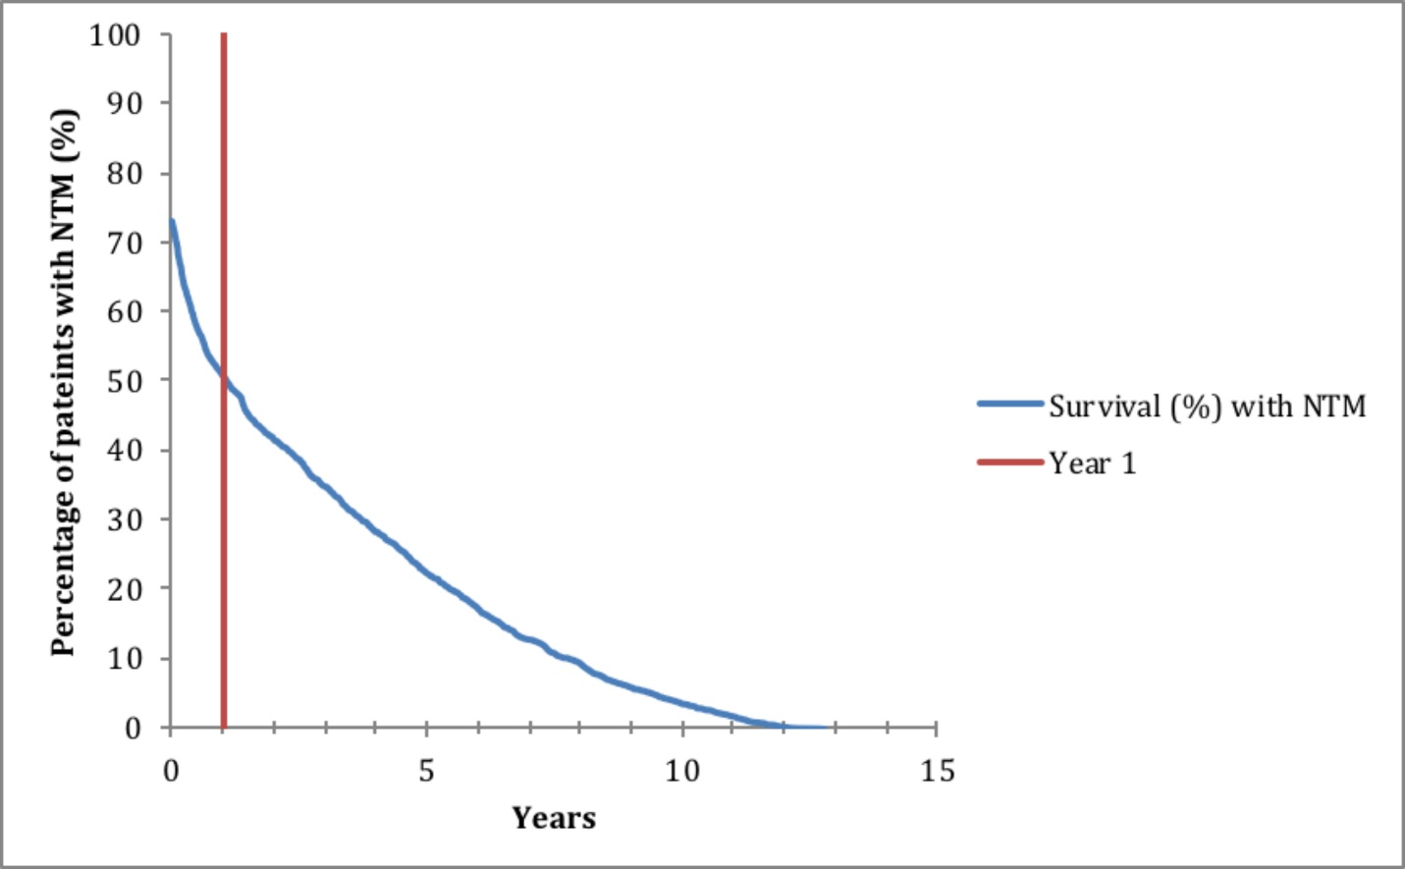

Table S1: List of International Classification of Diseases Codes Used to Identify Patients with COPD, NTM, and other Comorbidities
Disease | ICD-9 | ICD-10
COPD | 491 | J.44.0, J44.1, J44.9
Pulmonary NTM | 031 | A31.9
Bronchiectasis | 494.0, 494.1 | J47
CHF | 428.0 | 150.0, 150.1,150.9
DM | 250.00, 250.01,250.02, 250.03, 250.09 | E10, E11, E12, E13, E14, E14.0, E14.1, E14.3, E14.4, E14.5, E14.6
ESRD | 585.6 | N18.6
HIV | 042 | B20, B21, B22, B23, B24
ILD | 518.89, 508.1, 515, 516.3, 714.81, 770.7 | J84, J84.8, J84.9
Lung Cancer | 162.0, 162.2, 162.3, 162.4,162.5, 162.8, 162.9 | C33, C34.00, C34.01, C34.02, C34.10, C34.11, C34.12, C34.2, C34.30, C34.31, C34.32, C34.80, C34.81, C34.82, C34.90, C34.91, C34.92, C38.4, C45.0
Pneumonia | 480.0, 480.1, 480.2, 480.3, 480.8, 480.9, 481, 482.0, 482.32,482.4, 482.42, 482.49, 482.8, 482.9, 483.0,483.1, 483.8, 484.1, 484.3, 484.5, 484.6, 484.7, 484.8, 485, 487.0, 487.1, 487.8 | J15, J15.8, J17.0, J12, J12.11, J12.2, J12.8, J17.1, J18.9
Aspergillosis | 117.3 | B44.9
Asthma | 493.92 | J45.901, J45.909
Atherosclerosis | 440.0, 440.1, 440.2, 440.21- 440.24, 440.29, 440.30, 440.31, 440.32, 440.4, 440.8, 440.9 | I70.0-I70.9
Cystic Fibrosis | 277.0 | E84.0
Depression | 311 | F32.9
Hyperlipidemia | 272.4 | E78.4, E78.5
GERD | 530.81 | K21.9
HTN | 401 | I10
TB | 011.9 | A15.0
Obesity | 278.00, 278.01, 278.02, 278.0 | - E66.0, E66.1, E66.2,  - E66.3, E66.8, E66.9
Tobacco use | 305.1 | F17.210, F17.211, F17.220
Pectus excavatum | 754.81 | Q67.6
CAD | 414.00, 414.01, 414.02, 414.03, 414.04, 414.05, 414.06, 414.07, 414.4, | I25.10, I25.11, I25.83, I25.84
Organ Transplant | V42.0, V42.1, V42.2, V42.3, V42.3, V42.4, V42.5, V42.6, V42.7, V42.81, V42.82, V42.83, V42.84, V42.89, V42.9 | Z94.0, Z94.1, Z942, Z94.3, Z94.4, Z94.5, Z94.6, Z94.7, Z94.8, Z94.81, Z94.82, Z94.83, Z94.84, Z94.89, Z94.9
Mental disorder | 290 to 319 | F01 to F99
Immune system disorder | 287.31, 279.0, 279.01, 279.02, 279.03, 279.05, 279.1, 279.12, 279.19, 279.3 | D80-D89
Metastasis | 198.0-198.8, 198.81, 198.82, 198.89 | C76-C80
Cancer | 190-208, 209.00-209.03, 209.10-209.17, 209.30 | C00 to C96
Rheumatoid disorder | 714.0, 714.1, 714.2, | M06.9
Liver disease | 571.0-771.9 | K70-K77

Table S2: Average Age at NTM Diagnosis Over Time
Year | Average Age at Diagnosis
2001 | 66.1
2002 | 67.5
2003 | 67.9
2004 | 68.0
2005 | 68.0
2006 | 66.2
2007 | 67.9
2008 | 69.0
2009 | 66.6
2010 | 67.9
2011 | 68.5
2012 | 67.8
2013 | 67.6
2014 | 68.3
2015 | 67.5

Table S3: Percentage Change in Prevalence and Incidence Rates Over 5 Year Intervals
Interval | %Change in incidence rate over period | %Change in Prevalence rate over period
2001-2005 | -27.5% | 30.4%
2006-2010 | 29.3% | 21.7%
2011-2015 | 151.1% | 81.5%

Table S4. Age groups at time of diagnosis with NTM

Age at time of  Diagnosis with NTM | N  (%)
<45 | 9 (0.87%)
45-50 | 16 (1.54%)
50-55 | 67 (6.47%)
55-60 | 132 (12.74%)
60-65 | 184(17.76%)
65-70 | 238 (22.97%)
70-75 | 110 (10.62%)
75+ | 280 (27.03%)
Total | 1036 (100%)

