Phone Interview
I’m going to start off with a few questions about your life.

What do you consider your race to be? (White, Black, Asian or Pacific Islander, Other) ______________
What do you consider your ethnicity to be? (Hispanic, non-Hispanic) ______________
What level of education did you complete? (Did not graduate high school, high school degree, college degree, masters/PhD/other advanced degree) ______________
Prior to your stroke, had you ever been diagnosed or treated for a psychiatric disease? (yes/no) ______________
If yes, what psychiatric disease? (Free text) ______________
Were you working prior to your stroke? (yes/no) ______________
Are you working now? (yes/no) ______________
If not, what is the limitation to returning to work? (Free text) ______________
Counting yourself, how many members currently make up your household? (Integer) ______________
Are you now married, widowed, divorced, separated, never married, or living with a partner? (married, widowed, divorced, separated, never married, living with partner, refused) ______________
Did you go to inpatient rehabilitation after your stroke? (yes/no) _______________
If so, how long were you in inpatient rehabilitation? (in days, integer) _______________

Next, I will ask you a few questions about how often you have received medical attention in the past 6 months. Do NOT count your initial stroke hospitalization or rehab stay:

Stanford Healthcare Utilization Survey
- In the past 6 months, how many times did you visit a physician? Do not include visits while in the hospital or to a hospital emergency room. Fill in with “0” or another number.
- In the past 6 months, how many times did you go to a hospital emergency room? Fill in with “0” or another number.
- How many different times did you stay in a hospital overnight or longer in the past 6 months? Fill in with “0” or another number.
- How many total nights did you spend in the hospital in the past 6 months? Fill in with “0” or another number.
Have you been told by a doctor that you had a second stroke separate from your first stroke? ________

Next, I would like to ask you some questions about how you have been feeling during the past week. It is best not to think too hard about your response, but to give the answer that first comes to mind.

Hospital Anxiety and Depression Scale

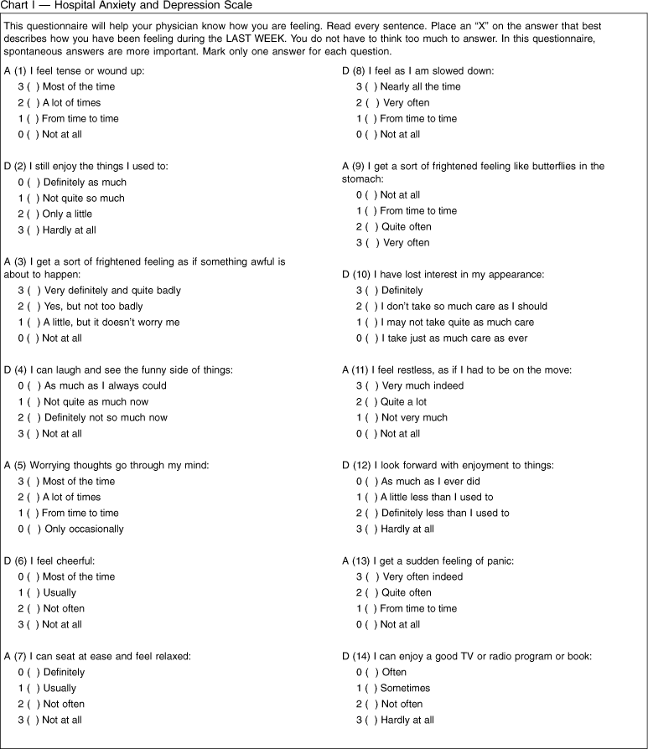

We will now read you a list of problems and complaints that some people sometimes have in response to stressful life experiences, like a stroke. Please indicate how much you have been bothered by that problem in the last month by giving a number on a scale of 1-5 where 1 is not at all, 2 is a little bit, 3 is moderately, 4 is quite a bit, and 5 is extremely.
PTSD CheckList- Stressor Specific Version (PCL-5)
The event you experienced was: ___________________ on: ____________________
Positive/Negative: ________ Score: _________

I would also like to know how you are functioning after your stroke. Please let me know which of the following scenarios best describes your level of function at this point.

The Modified Rankin Scale & Corresponding Sections of Structured Interview
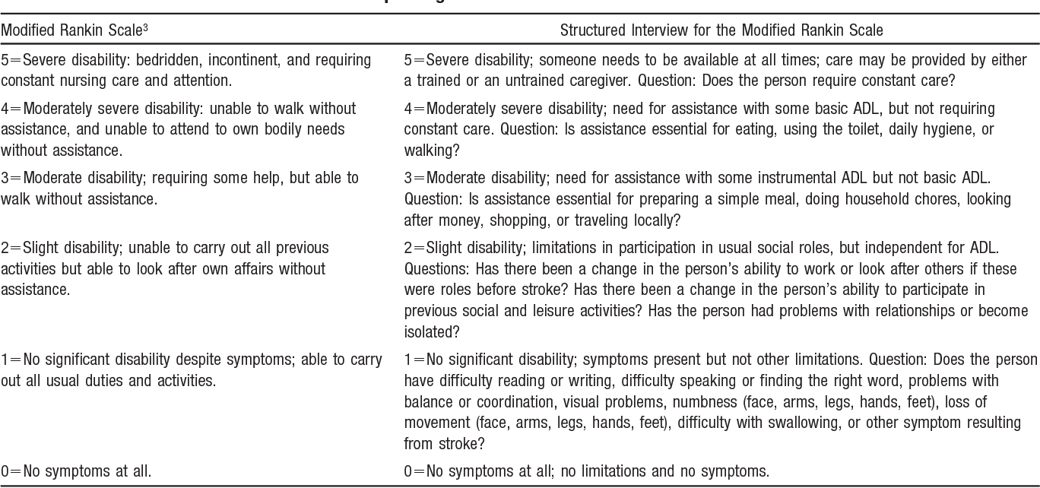

Please indicate which statements best describe your own health state today.
Euro QOL
Mobility
___ I have no problems in walking about
___ I have some problems in walking about
___ I am confined to bed

Self-Care
___ I have no problems with self-care
___ I have some problems washing or dressing myself
___ I am unable to was or dress myself

Usual Activities (e.g. work, study, housework, family or leisure activities)
___ I have no problems with performing my usual activities
___ I have some problems with performing my usual activities
___ I am unable to perform my usual activities

Pain/Discomfort
___ I have no pain or discomfort
___ I have moderate pain or discomfort
___ I have extreme pain or discomfort

Anxiety/Depression
___ I am not anxious or depressed
___ I am moderately anxious or depressed
___ I am extremely anxious or depressed

To help people say how good or bad a health state is, we have produced a scale (rather like a thermometer) on which the best state you can imagine is marked 100 and the worst state you can imagine is marked 0.
We would like you to indicate on this scale how good or bad your own health is today, in your opinion. Please pick a number between 0 and 100 that best describes your health state.
Health state: ____________

