SUPPLEMENTARY Figure 1

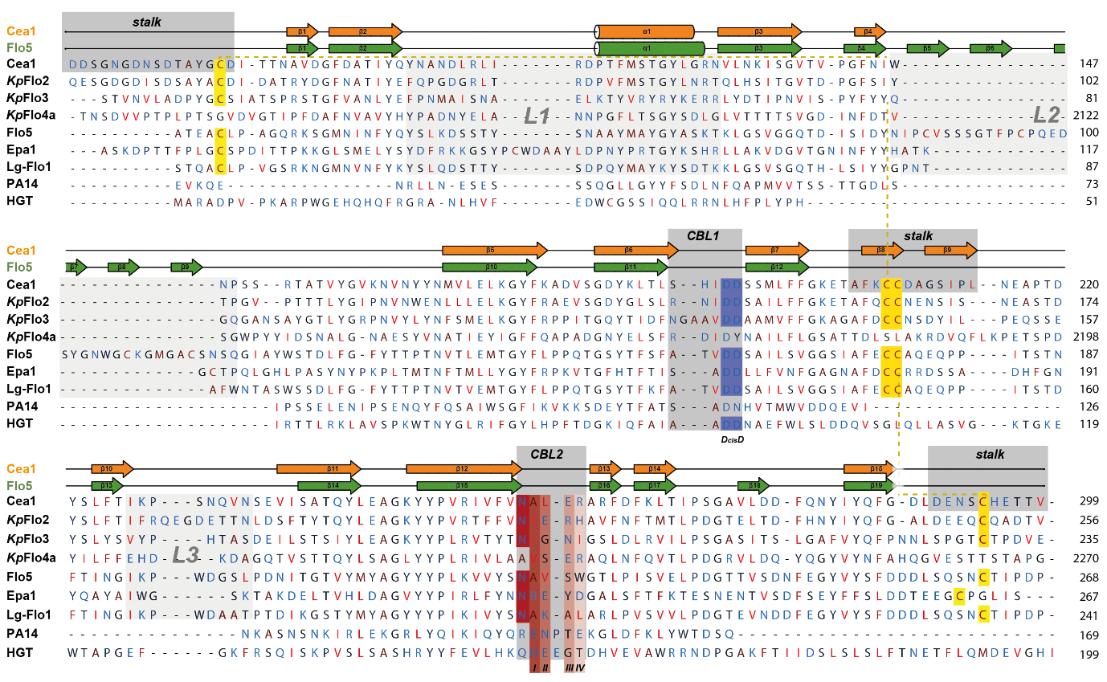

FIGURE S1. Alignment of KpFlo A domain sequences with other PA14/Flo5-like domains. An alignment of KpFlo1A-KpFlo3A as well as of KpFlo4aA and representatives of the PA14/Flo5-like family (Uniprot-entries: ScFlo5, P38894; Epa1 adhesin from C. glabrata, Q6VBJ0; LgFlo1, B3IUA8; PA-14, P13423; human galactosaminyl transferase HGT, Q8N9V0) was generated using the T-Coffee-algorithm (20) and combined with the structural annotation of the secondary structure of Cea1A and ScFlo5A. Regions forming the stalk, CBL1 or CBL2 are highlighted in grey. The stalk region is formed mainly by a small β-sheet (β8, β9) and the N- and C-terminus of the A domain. Positions I-IV of CBL2, that are central constituents of the binding pocket, are indicated. The highly conserved DcisD motif is marked in blue and the conserved disulfide-bonds in yellow.

SUPPLEMENTARY Figure 2

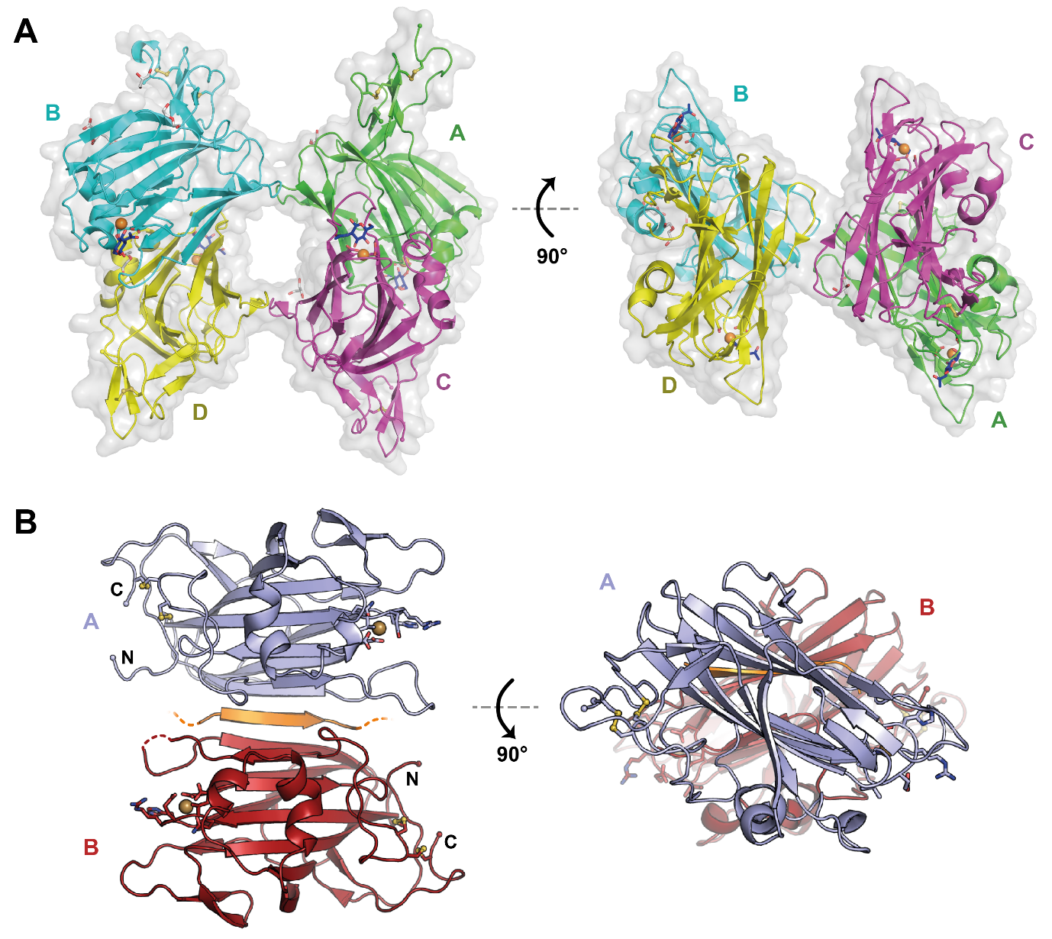

FIGURE S2. Crystal packing of KpFlo A domains. A. The four molecules (A, B, C, D) of the orthorhombic crystal form of Cea1A are arranged in an antiparallel manner and form with their β-sandwiches a continuous 10-pleaded β-sheet by edge-to-edge packing. The chains are shown with Ca²⁺ (orange) and bound GlcNAc ligands (blue). Molecules A-D are almost identical with a maximum r.m.s.d. of 0.22 Å between two Cea1A molecules. Due to crystal packing, two Cea1A molecules show pairwise a higher structural similarity to each other. B. Dimer of the KpFlo2A domain as present in the asymmetric symmetry unit. The molecules A (blue) and B (red) form a continuous β-sheet via parts of an His₆-affinity tag (orange).

SUPPLEMENTARY fIGURE 3

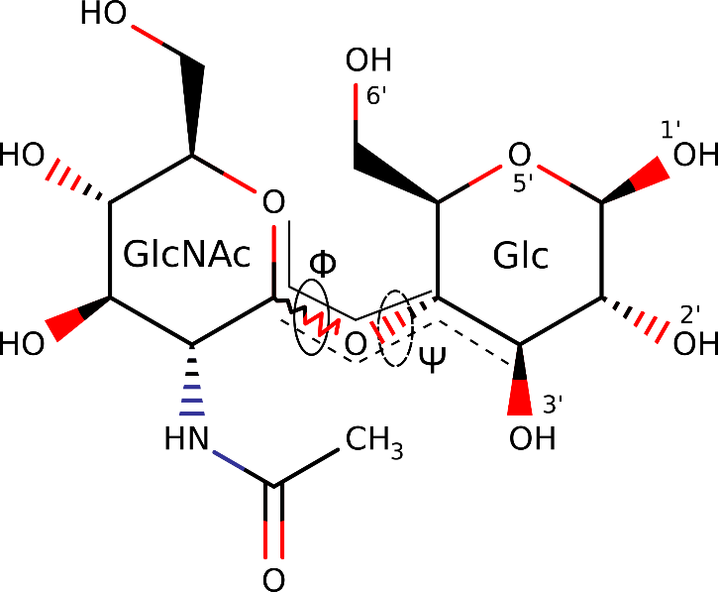

Figure S3 Definition of the Φ-Ψ angles, as well as of the glucosyl positions for all simulations.

supplementary figure 4

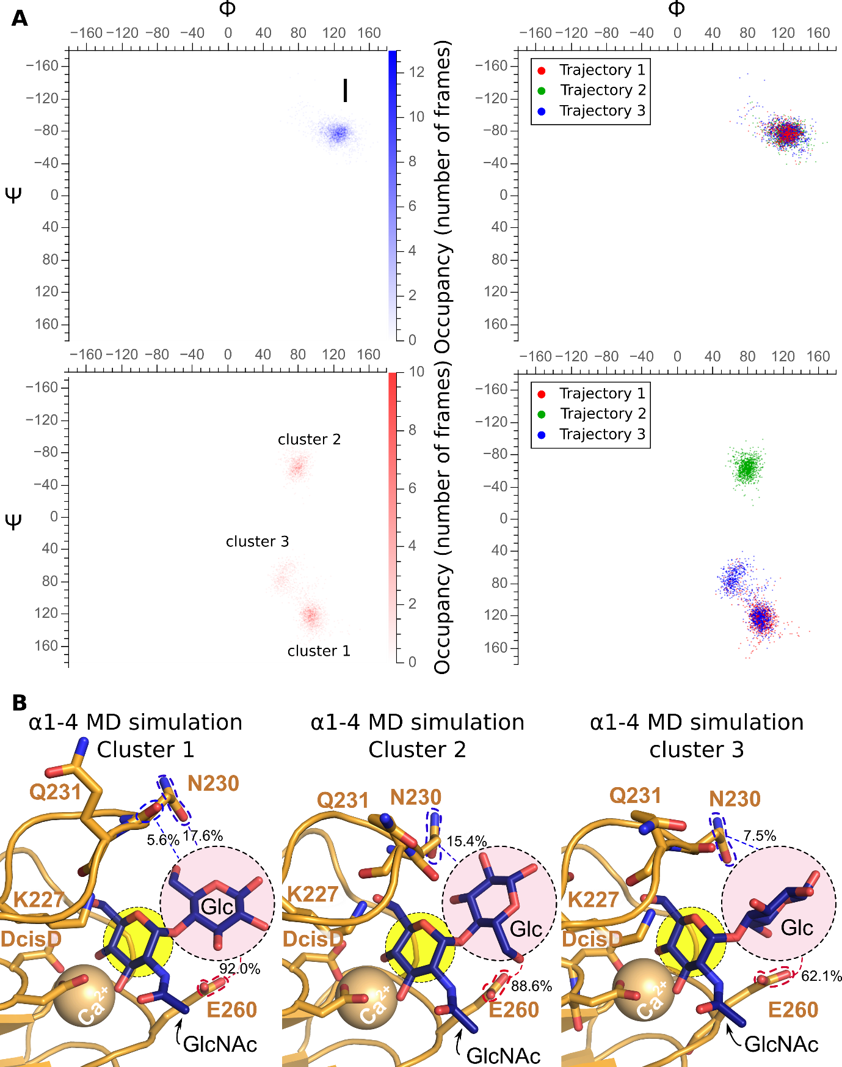
Figure S4 Clustering analysis of α1-4 and β1-4 MDS. A. 2D Φ-Ψ plots for β1-4 MDS (top) and α1-4 MDS (bottom) showing the population density for each cluster (left) or the value distribution by trajectory replica (right). Note that β1-4 MDS presents a single, clearly defined cluster with highly overlapping values throughout the overall simulation, on which all three trajectory replicas converge (Table S1). On the other hand, α1-4 MDS shows a total of three clusters, resulting in a high degree of discrepancy between the overall Φ and Ψ values for the entire simulation and those of the individual clusters (Tables S1,S2). Furthermore, trajectory replicas do not converge, as clusters 1 and 3 are populated exclusively by trajectories 1 and 3, while cluster 2 only by trajectory 2. B. detailed, per-cluster description of the glucosyl hydrogen bonding network with nearby interaction partners in α1-4 MDS. Here, the glycan ligand (blue) is bound by Cea1A and Ca²⁺ (golden). Waters have been stripped for clarity. Glucosyl interaction partners are highlighted via colored dashed lines, with the cumulative overall hydrogen bond occupancy shown as a percentage, as well as by the color of the dashed highlights.

SUPPLEMENTARY Figure 5
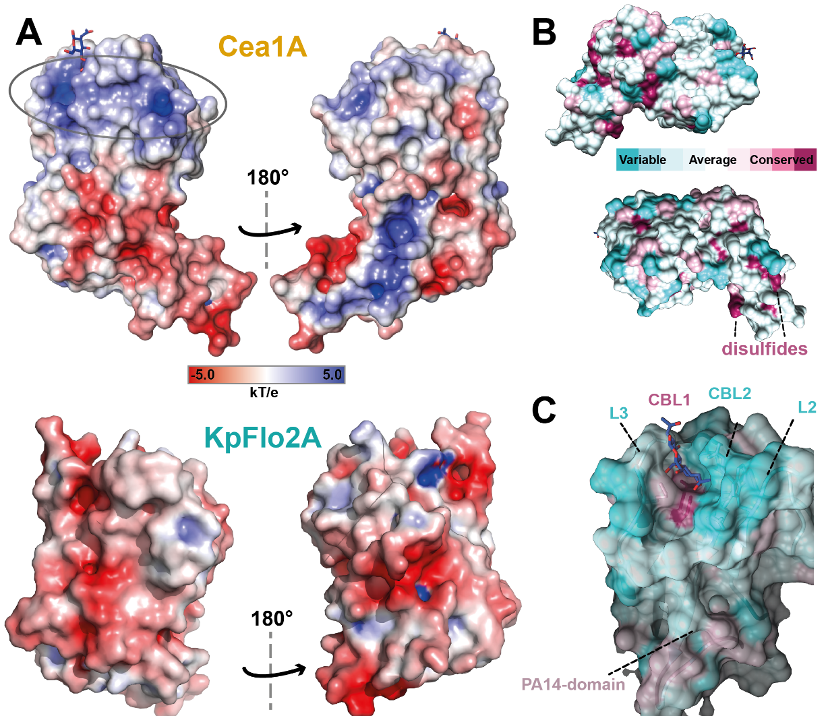

FIGURE S5. Surface properties of KpFlo A domains. A. The electrostatic surface of Cea1A (top) and KpFlo2A (bottom) was generated by APBS at 0.15 M NaCl concentration (20). In Cea1A, a patch of positively charged residues (blue) enclose the binding pocket (grey circle), whereas KpFlo2A carries a negatively charged surface near the binding pocket like other fungal PA14/Flo5-like A domains. B. Conservation of surface properties of Cea1A. Structural models of Cea1A and the binding pocket (C.) depict conserved and variable surface residues according to ConSurf analysis. The highest conservation is found for the DcisD-motif and the two disulfide bridges.

SUPPLEMENTARY Figure 6

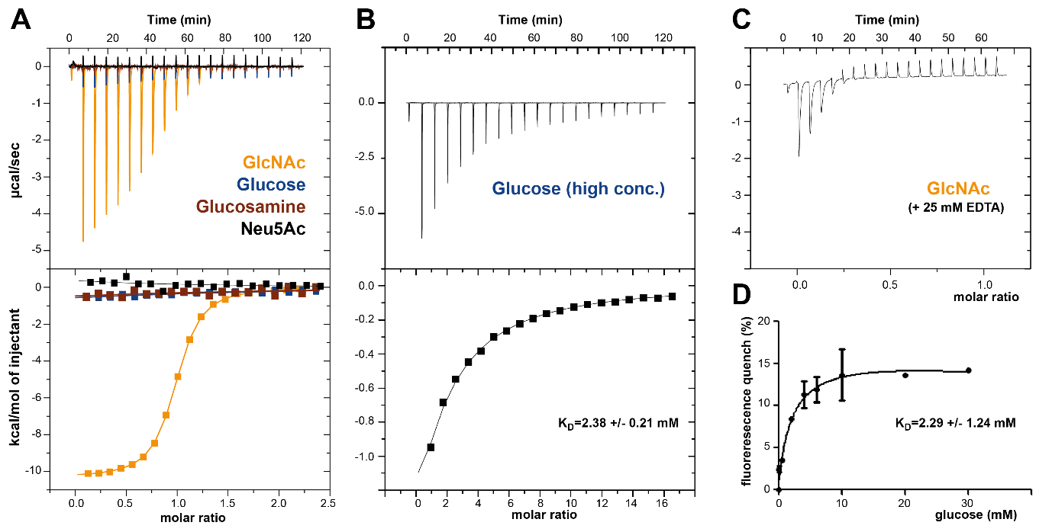
FIGURE S6. Binding of GlcNAc by Cea1A is specific and depends on Ca²⁺. A. Unlike GlcNAc, glucose, glucosamine and N-acetylneuraminic acid (Neu5Ac) fail to bind to Cea1A under ITC conditions when using stock concentrations of 5 mM. The upper part shows the values of the heats released in response to single injections, while integration of each peak and corresponding fits to a one-site binding model are depicted as curves in the diagram below. B. Titration of 500 µM Cea1A/Δ291-299 using a 40 mM stock of glucose for injections. C. Titration of 450 µM Cea1A using 5 mM EDTA as added stock effectively ablates binding to GlcNAc in isothermal titration calorimetry (ITC) analysis. Small peaks visible for the first three injections may indicate that Ca²⁺ removal from the binding pocket is incomplete. D. Fluorescence titration of 11.5 µM Cea1A/Δ291-299 with glucose using λ_{exc}=280 nm and λ_{em}=295 nm for recording of triplicates.

