Supplementary Material

Math Self-Efficacy and STEM Intentions: A Person-Centered Approach
Li Lin, Taehun Lee*, Lori Anderson Snyder
* Correspondence:
Taehun Lee
lee.taehun@gmail.com

Supplementary Tables and Figures

Tables
 | M | SD | Range | Gender | ITMA | MEIM | OGO | Interest in STEM subjects
Gender | 1.60 | 0.50 | 1.00
ITMA | 2.79 | 0.98 | 5.00 | 0.06
MEIM | 2.80 | 0.59 | 3.00 | 0.00 | -0.07
OGO | 3.30 | 0.48 | 2.33 | 0.13** | -0.21** | 0.13**
Interest in STEM subjects | 3.10 | 0.85 | 4.00 | -0.27** | -0.35** | -0.01 | 0.03
Interest in STEM activities | 3.27 | 0.91 | 4.00 | -0.26** | -0.31** | 0.01 | 0.08* | 0.82**

Table 1. Descriptive statistics and correlations among all predictor variables. Gender was coded as 1 = male, 2 = female. *p < .05; ** p < .01

 | M | SD | I1 | I2 | I3 | I4 | I5 | I6 | I7 | I8 | I9 | I10 | I11 | I12 | I13 | I14 | I15 | I16 | I17
I1 | 4.16 | 1.37 | 1.00
I2 | 4.13 | 1.50 | 0.81 | 1.00
I3 | 2.56 | 1.50 | -0.65 | -0.64 | 1.00
I4 | 4.37 | 1.52 | 0.66 | 0.60 | -0.49 | 1.00
I5 | 4.54 | 1.25 | 0.75 | 0.73 | -0.58 | 0.65 | 1.00
I6 | 3.85 | 1.45 | 0.74 | 0.72 | -0.57 | 0.58 | 0.79 | 1.00
I7 | 3.88 | 1.53 | 0.68 | 0.71 | -0.53 | 0.50 | 0.67 | 0.74 | 1.00
I8 | 3.71 | 1.68 | 0.65 | 0.73 | -0.52 | 0.44 | 0.61 | 0.67 | 0.80 | 1.00
I9 | 3.77 | 1.71 | 0.67 | 0.73 | -0.55 | 0.45 | 0.63 | 0.66 | 0.76 | 0.88 | 1.00
I10 | 3.77 | 1.69 | 0.69 | 0.75 | -0.56 | 0.45 | 0.65 | 0.68 | 0.76 | 0.87 | 0.89 | 1.00
I11 | 3.80 | 1.69 | 0.71 | 0.75 | -0.56 | 0.49 | 0.65 | 0.68 | 0.77 | 0.86 | 0.84 | 0.89 | 1.00
I12 | 3.78 | 1.66 | 0.72 | 0.73 | -0.57 | 0.48 | 0.64 | 0.68 | 0.72 | 0.79 | 0.79 | 0.85 | 0.89 | 1.00
I13 | 3.04 | 1.65 | -0.58 | -0.58 | 0.66 | -0.43 | -0.56 | -0.55 | -0.52 | -0.50 | -0.50 | -0.51 | -0.52 | -0.50 | 1.00
I14 | 3.27 | 1.55 | -0.52 | -0.56 | 0.60 | -0.40 | -0.50 | -0.49 | -0.49 | -0.50 | -0.49 | -0.49 | -0.50 | -0.46 | 0.76 | 1.00
I15 | 2.97 | 1.60 | -0.60 | -0.62 | 0.67 | -0.48 | -0.57 | -0.53 | -0.50 | -0.51 | -0.51 | -0.51 | -0.53 | -0.50 | 0.82 | 0.84 | 1.00
I16 | 2.70 | 1.56 | -0.60 | -0.60 | 0.67 | -0.50 | -0.56 | -0.53 | -0.50 | -0.47 | -0.47 | -0.50 | -0.51 | -0.47 | 0.76 | 0.75 | 0.85 | 1.00
I17 | 2.49 | 1.54 | -0.58 | -0.58 | 0.66 | -0.46 | -0.56 | -0.50 | -0.46 | -0.44 | -0.48 | -0.49 | -0.51 | -0.47 | 0.71 | 0.69 | 0.78 | 0.80 | 1.00
I18 | 2.42 | 1.53 | -0.56 | -0.58 | 0.64 | -0.44 | -0.58 | -0.50 | -0.47 | -0.44 | -0.46 | -0.47 | -0.48 | -0.45 | 0.72 | 0.71 | 0.81 | 0.82 | 0.85

Table 2. Inter-item correlations of Sources of Math Self-Efficacy. All coefficients are significant at p < .01
Number of groups | Number of free parameters | Log Likelihood | Akaike Information Criterion | Bayesian Information  Criterion | Sample-size Adjusted BIC | Entropy | pLMR | Smallest class frequency (Relative frequency)
1 | 36 | -21925 | 43922 | 44083 | 43969 | - | - | 658 (1.00)
2 | 73 | -18360 | 36867 | 37195 | 36963 | 0.970 | 0.000 | 320 (0.49)
3 | 110 | -17143 | 34505 | 34999 | 34650 | 0.971 | 0.001 | 104 (0.16)
4 | 147 | -17129 | 34553 | 35213 | 34746 | 0.970 | 0.500 | 0 (0.00)

Table 3. Model Information for Models with One to Four Classes. pLMR = p-values for the Lo-Mendell-Rubin likelihood ratio test for K versus K-1 classes. Smallest class frequency = size of the smallest latent class and the relative proportion. N = 658.

 | Unconfident vs. Moderate | Mastery vs. Moderate | Unconfident vs. Mastery
Intercepts
β₀’s | -1.746* | -0.099 | -1.647*
Odds Ratio | 0.174* | 0.906 | 0.193*
Native
β₁’s | 0.948* | -0.091 | 1.039*
Odds Ratio | 2.581* | 0.913 | 2.826*
OGO
β₂’s | 0.306 | 0.284* | 0.021
Odds Ratio | 1.358 | 1.328* | 1.021
ITMA
β₃’s | 0.934* | -0.296* | 1.229*
Odds Ratio | 2.545* | 0.744* | 3.418*
OGO*ITMA
β₄’s | 0.089 | 0.288* | -0.199
Odds Ratio | 1.093 | 1.334* | 0.820

Table 4. Predictors of the Latent Class Variable. Odds coefficient and odds ratio of each covariate are reported. The Moderate group was used as the reference for “Unconfident” and “Mastery.” The last column presents information with regard to being in the Unconfident group when the Mastery group was used as the reference group. N = 633. *p < .01.

 |  | Unconfident |  |  |  | Mastery
 | Intercepts |  | β’s | Odds Ratio | β’s |  | Odds Ratio
Interest in STEM Subjects | 3.079* |  | -0.872* | - | 0.419* |  | -
Interest in STEM Activities | 3.225* |  | -0.820* | - | 0.415* |  | -
Retention GPA | 3.173* |  | -0.170** | - | 0.289* |  | -
STEM | 1.016* |  | -1.288* | 0.276* | 0.705* |  | 2.023*
Non-STEM | 0.294 |  | 0.375 | 1.455 | 0.304 |  | 1.355

Table 5. Outcomes of the Latent Class Variable. Table reports the unstandardized intercepts, coefficients, and odds ratios by regressing outcomes of interest on the dummy-coded latent class variable. The Moderate group and STEM code = 2 were used as the reference.
*p < .01 ** p = .059

Figures
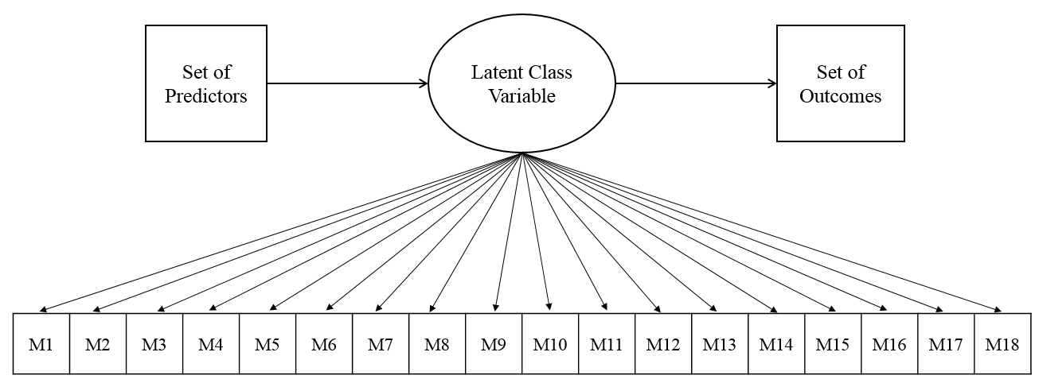

Figure 1. Latent profile analysis model with covariates and outcomes.

Figure 2. Latent profile analysis model that contains the final list of predictors and outcomes.

Figure 3. Three-class model estimations for the sources of math self-efficacy measure.

Figure 4. The effects of Native, OGO, ITMA, and OGO by ITMA. The Moderate group is used as the reference in this figure. The odds of class membership in the Unconfident group relative to the Mastery group is not presented.

Figure 5. The effect of ITMA as a function of OGO. The Moderate group is used as the reference in this figure. The odds of class membership in the Unconfident group relative to the Mastery group is not presented.

