Supplemental Information

Figure S1. Gel image showing the presence of Cas9 in CR-rpk1 (T1) and CR-bnaarf2 (T0).
Figure S2. Gel image showing the presence of GFP, Cas9, NPTII and U6-26 in different progeny of CR-rpk1 and CR-bnaarf2.
Figure S3. Genotypes of the CR-bnaarf2 mutants.
Figure S4. Expression of RPK1 and BnaARF2s in the CRISPR/Cas9 mutants obtained by qRT-PCR.
Figure S5. Phylogenetic analysis of the ARF2 homologs in Arabidopsis and B. napus, B. rapa, and B. oleracea.
Figure S6. Genotypes of strawberry fruit transiently transformed with CR-FveMyb10.
Figure S7. Number of nodules induced in soybean roots transiently transformed with CR-GmNFR1a.
Figure S8. Genotypes of soybean roots transiently transformed with CR-GmNFR1a.
Table S1. Percentage of CR-rpk1 (T2) or CR-banarf2 (T1) with or without Cas9.
Table S2. Segregation patterns of Cas9-free mutants in the T2 generation in Arabidopsis.
Table S3. Segregation patterns of Cas9-free mutants in the T3 generation in Arabidopsis.
Table S4. Segregation patterns of Cas9-free mutants in the T1 generation in B. napus.
Table S5. Segregation patterns of Cas9-free mutants in the T2 generation in B. napus.
Table S6. The list of primers used in this study.
Table S7. Summary of the sgRNAs sequence (%GC contents and mutation rates). The PAM motif (NGG) is marked by a grey box.

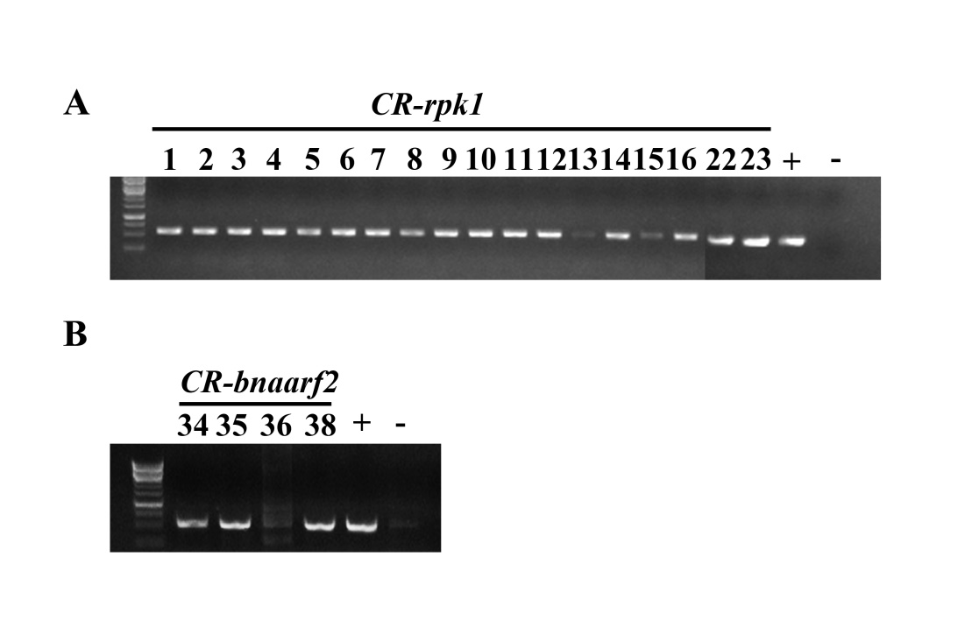
Figure S1. Gel image showing the presence of Cas9 in CR-rpk1 (T1) and CR-bnaarf2 (T0).
(A) The Cas9 fragment was amplified by Cas9 primers in CR- rpk1 (L1-L23; T1 generation). (B) The Cas9 fragment was amplified by Cas9 primers in CR-bnaarf2 (L34, L35, L36 and L38). +: The vector pKSE401 was used as the positive control; -: gDNA of WT was used as the negative control.

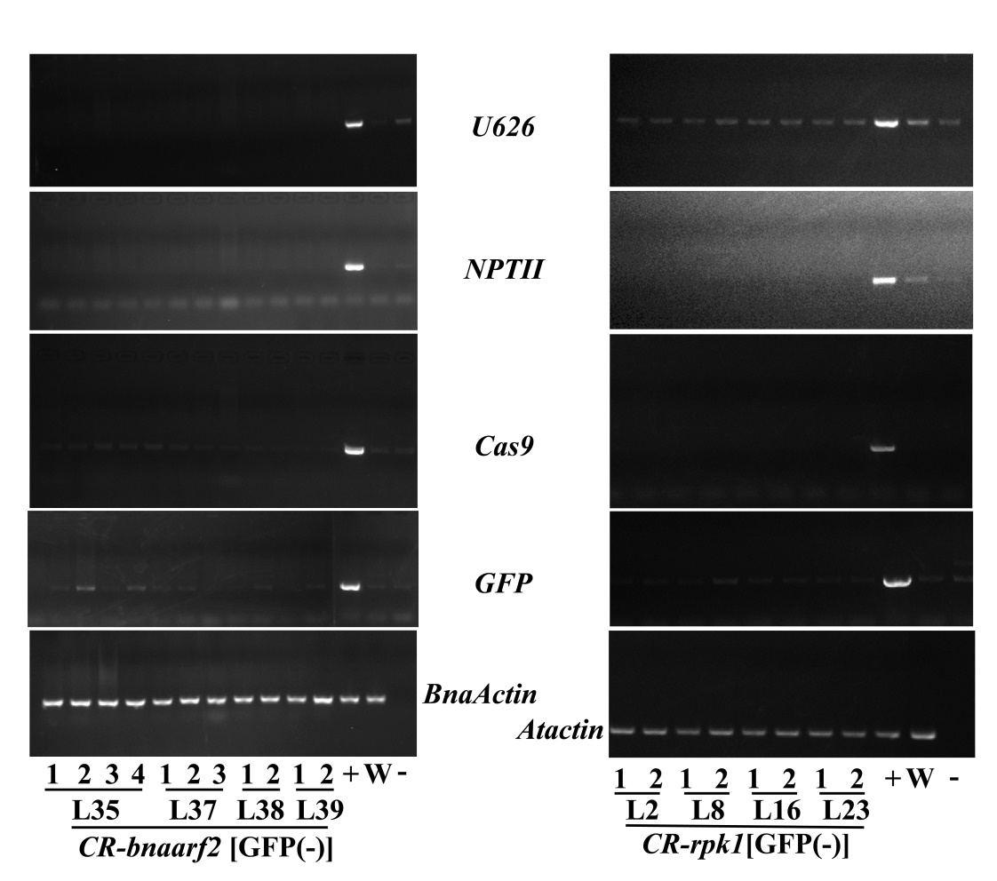

Figure S2. Gel image showing the presence of GFP, Cas9, NPTII and U6-26 in different progeny of CR-rpk1 and CR-bnaarf2.
+: pKSE401 was used as the positive control for Cas9, NPTII and U626. -: gDNA from Westar or Col were used as the negative control for Cas9, NPTII and U626. ddH₂O was used as the negative control for BnaActin1 or Atactin. The B. napus or Arabidopsis actin genes were used as the PCR internal control.
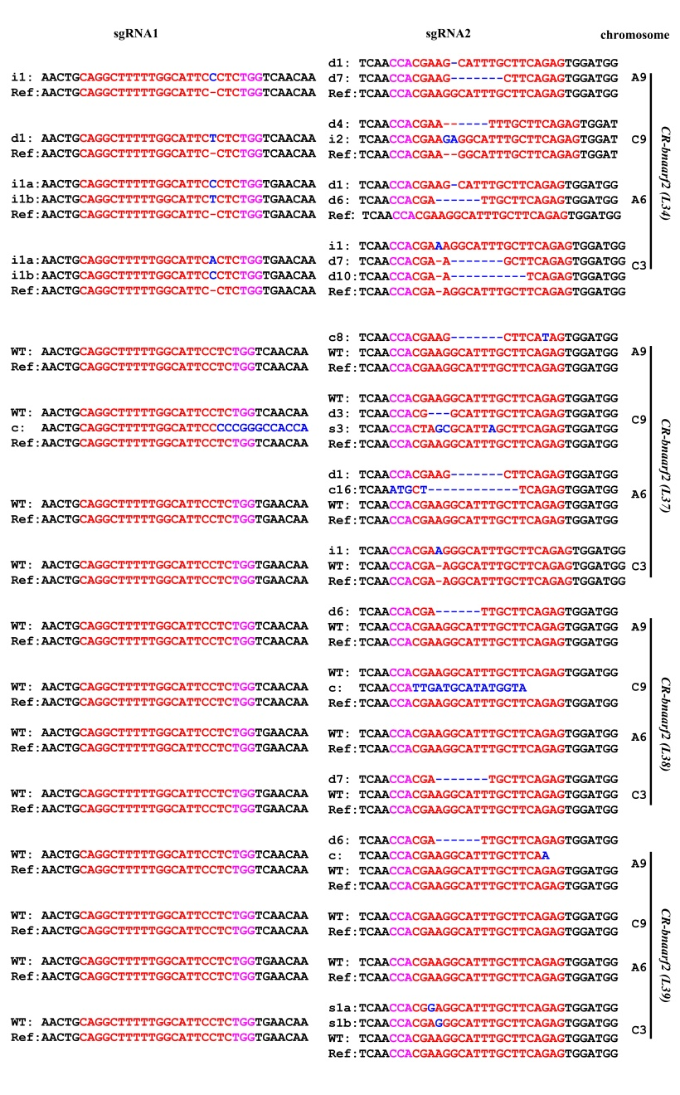
Figure S3. Genotypes of the CR-bnaarf2 mutants.
The PAM sequence is indicated with magenta. The sgRNA is indicated with red. The mutation sites are indicated with blue. i: insertion; d: deletion; c: combined. d#, # of base pair (bp) deleted from target site; i#, # of bp inserted at target site, c#, combined mutations. L34, L37, L38 and L39 indicated individual T0 transgenic plants.

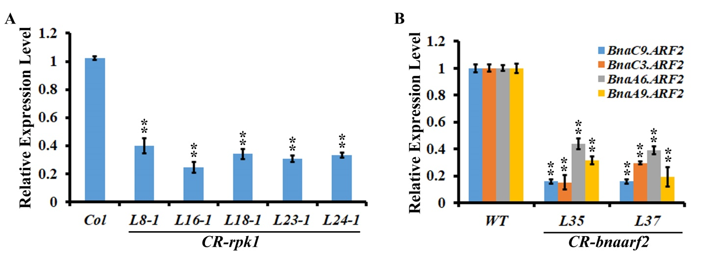

Figure S4. Expression of RPK1 and BnaARF2s in the CRISPR/Cas9 mutants obtained by qRT-PCR.
(A) qRT-PCR analysis revealed the suppressed expression of RPK1 in CR-rpk1 mutant plants. The Arabidopsis GAPDH gene was amplified and used as an internal control. (B) qRT-PCR analysis revealed the suppressed expression of BnaARF2 paralogues in CR-bnaarf2 quadruple mutant plants (L35 and L37). The B.napus GAPDH gene was amplified and used as an internal control. In A and B, data are means ± SD obtained from three biological replicates; **, P < 0.01, Student’s t-test.

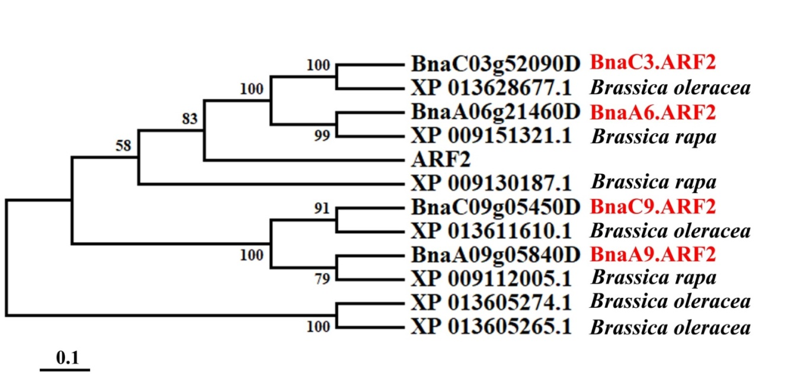

Figure S5. Phylogenetic analysis of the ARF2 homologs in Arabidopsis and B. napus, B. rapa, and B. oleracea.

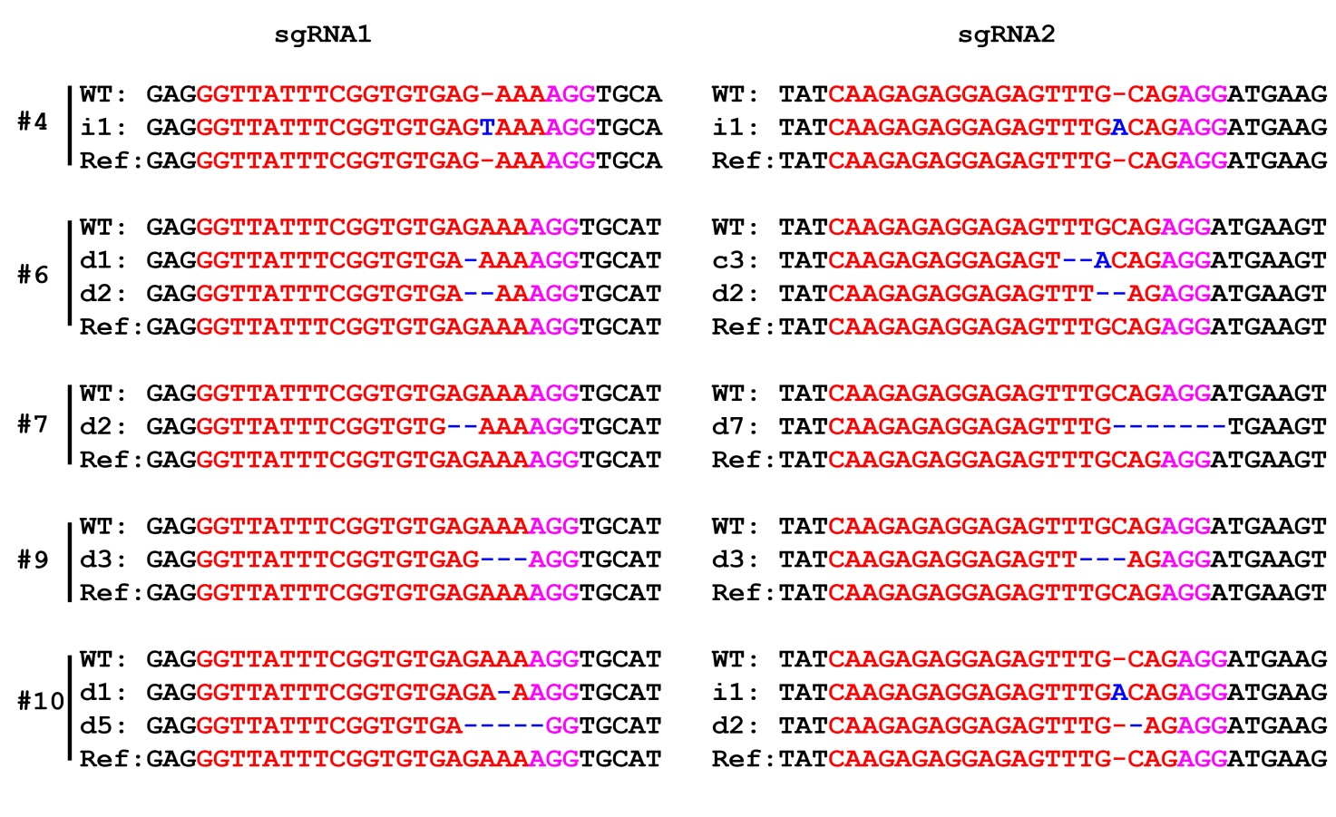
Figure S6. Genotypes of strawberry fruit transiently transformed with CR-FveMyb10.
The PAM sequence is indicated with magenta. The sgRNA is indicated with red. The mutation sites are indicated with blue. i: insertion; d: deletion; c: combined. d#, # of base pair (bp) deleted from target site; i#, # of bp inserted at target site, c#, combined mutations. #4, #6, #7, #9, and #10 indicated individual transgenic fruit.
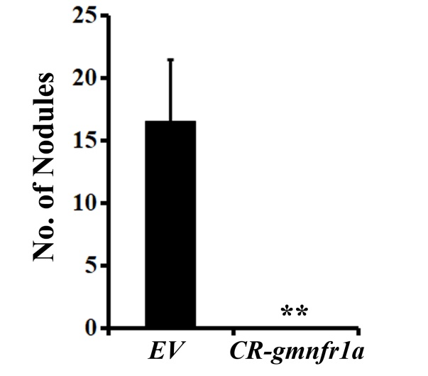

Figure S7. Number of nodules induced in soybean roots transiently transformed with CR-GmNFR1a.
Bar graph shows the nodule number of mutated roots induced by CR-gmnfr1a and control roots four weeks after infection. Error bars represent SD (n=6). **, P < 0.01, Student’s t-test.
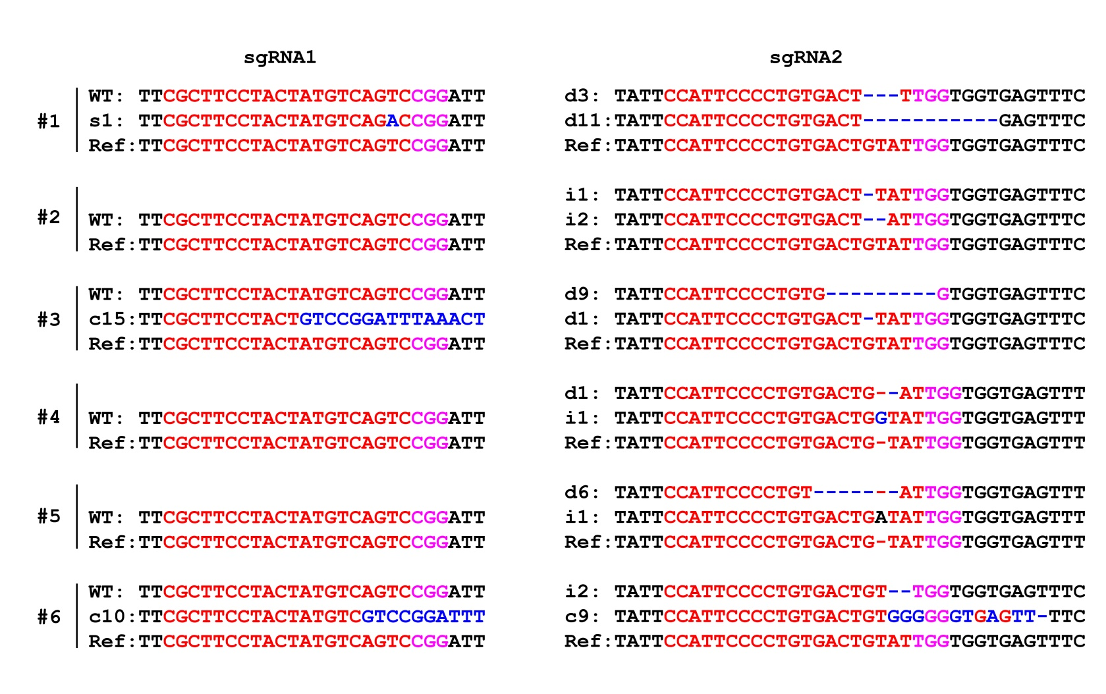
Figure S8. Genotypes of soybean roots transiently transformed with CR-GmNFR1a.
The PAM sequence is indicated with magenta. The sgRNA is indicated with red. The mutation sites are indicated with blue. i: insertion; d: deletion; c: combined. d#, # of base pair (bp) deleted from target site; i#, # of bp inserted at target site, c#, combined mutations. #1 to #6 indicated individual transgenic root.
Table S1. Percentage of CR-rpk1 (T2) or CR-banarf2 (T1) with or without Cas9.

Target Gene | Line | No. of plants examined | GFP positive plants | GFP positive rate | GFP negative plants | GFP negative rate | Cas9 negative plants (total examined plant) | Cas9 negative rate
RPK1 (T2) | L2 | 25 | 18 | 72% | 7 | 28% | 6 (6) | 100.0%
 | L6 | 14 | 14 | 100% | 0 | 0
 | L6 | 12 | 9 | 75% | 3 | 25% | 3 (3) | 100.0%
 | L7 | 10 | 7 | 70% | 3 | 30% | 3 (3) | 100.0%
 | L8 | 47 | 34 | 72.34% | 13 | 27.66% | 9 (9) | 100.0%
 | L16 | 19 | 19 | 100% | 0 | 0
 | L17 | 33 | 24 | 72.73% | 9 | 27.27% | 8 (8) | 100.0%
 | L18 | 29 | 28 | 96.56% | 1 | 3.44% | 8 (8) | 100.0%
 | L23 | 62 | 53 | 85.48% | 9 | 14.52% | 0 (1) | 0
Total (average) |  | 251 | 206 | (82.1%) | 45 | (17.3%) | 37 | (85.7%)
BnaARF2 (T1) | L35 | 32 | 22 | 68.75% | 10 | 31.25% | 10 (10) | 100.0%
 | L37 | 34 | 27 | 79.41% | 7 | 20.59% | 7 (7) | 100.0%
 | L38 | 17 | 14 | 82.35% | 3 | 17.65% | 3(3) | 100.0%
 | L39 | 12 | 12 | 66.67% | 4 | 33.33% | 4 (4) | 100.0%
Total (average) |  | 95 | 71 | (74.7%) | 24 | (25.7%) | 24 | (100.0%)

Table S2: Segregation patterns of Cas9-free mutants in the Arabidopsis T2 generation.
 |  |  | T1 |  |  |  | T2
Target gene | sgRNA | Line | Zygosity ◐ | Genotype | Cas9§ |  | Genotype | Cas9§
RPK1 | sgRNA1 | L2 | Bi-allelic | i1a:i1b | Yes |  | 4i1ai1a:2i1ai1b | No
RPK1 | sgRNA1 | L6 | Heterozygous | i1:WT | Yes |  | 3i1WT | No
RPK1 | sgRNA1 | L7 | Heterozygous | i1:WT | Yes |  | 2i1i1:1i1WT | No
RPK1 | sgRNA1 | L8 | Bi-allelic | i1a:i1b | Yes |  | 3i1ai1a:3i1ai1b:3i1bi1b | No
RPK1 | sgRNA1 | L17 | Bi-allelic | i1a:i1b | Yes |  | 5i1ai1a:3i1ai1b | No
RPK1 | sgRNA1 | L18 | Heterozygous | i1:WT | Yes |  | 4i1i1:2i1WT:2WTWT | No

i#, # of bp inserted at target site; i#a, same number of insertion at one site; i#b, same number of insertion of different nucleotide at the same site.
◐: the zygosity of homozygote, bi-allele, and heterozygote in T1and T2 plants. §: presence of Cas9 sequence: Yes, Cas9 positive; No, Cas9 negative.

Table S3. Segregation patterns of Cas9-free mutants in the T3 generation in Arabidopsis.
 |  |  | T2 |  |  |  | T3
Target gene | sgRNA | Line | Zygosity ◐ | Genotype | Cas9§ |  | Genotype | Cas9§
RPK1 | sgRNA1 | L8-3 | Homozygous | i1i1 | No |  | 10i1i1 | No
RPK1 | sgRNA1 | L18-1 | Homozygous | i1i1 | No |  | 10i1i1 | No

d#b, same number of deletion at other sites; i#, # of bp inserted at target site.
◐: the zygosity of homozygote, bi-allele, and heterozygote in T2 and T3 plants. §: presence of Cas9 sequence: Yes, Cas9 positive; No, Cas9 negative.

Table S4. Segregation patterns of Cas9-free mutants in the T1 generation in B. napus.
 |  |  | T0 |  |  |  | T1
Target gene | sgRNA | Line | Zygosity ◐ | Genotype | Cas9§ |  | Genotype | Cas9§
BnaA9.ARF2 | sgRNA2 | L35 | Chimera | d9:d10:s3 | Yes |  | 5d9d10:5h | No
BnaC9.ARF2 | sgRNA2 | L35 | Bi-allelic | d8:s1 | Yes |  | 3d8d8:4d8s1:3s1s1 | No
BnaA6.ARF2 | sgRNA2 | L35 | Heterozygous | i1:WT | Yes |  | 4i1i1:5i1WT:1WTWT | No
BnaC3.ARF2 | sgRNA2 | L35 | Heterozygous | d1:WT | Yes |  | 3d2d2:4d2WT:3WTWT | No
BnaC3.ARF2 | sgRNA2 | L37 | Heterozygous | i1:WT | Yes |  | 5i1i1:2i1WT | No
BnaC9.ARF2 | sgRNA2 | L37 | Chimera | d3:s3:WT | Yes |  | 7h | No
BnaA9.ARF2 | sgRNA2 | L38 | Heterozygous | d6:WT | Yes |  | 3d6WT | No
BnaC3.ARF2 | sgRNA2 | L38 | Heterozygous | d7:WT | Yes |  | 3d7WT | No

d#, # of bp deleted from target site; i#, # of bp inserted at target site; s#, # of bp substituted of the target site; h, heterogeneous, more than one sequence detected in the sample.
◐: the zygosity of homozygote, bi-allele, and heterozygote in T0 and T1 plants. §: presence of Cas9 sequence: Yes, Cas9 positive; No, Cas9 negative.

Table S5. Segregation patterns of Cas9-free mutants in the T2 generation in B. napus.
 |  |  | T1 |  |  |  | T2
Target gene | sgRNA | Line | Zygosity ◐ | Genotype | Cas9§ |  | Genotype | Cas9§
BnaA9.ARF2 | sgRNA2 | L35-1 | Bi-allelic | d9:d10 | No |  | 3d9d9:5d9d10:2d10d10 | No
BnaC9.ARF2 | sgRNA2 | L35-1 | Homozygous | d8d8 | No |  | 10d8d8 | No
BnaA6.ARF2 | sgRNA2 | L35-1 | Homozygous | d1d1 | No |  | 10d1d1 | No
BnaC3.ARF2 | sgRNA2 | L35-1 | Homozygous | d2d2 | No |  | 10d2d2 | No

d#, # of bp deleted from target site.
◐: the zygosity of homozygote, bi-allele, and heterozygote in T1 and T2 plants. §: presence of Cas9 sequence: Yes, Cas9 positive; No, Cas9 negative.

Table S6. The list of primers used in this study.
Primer name | Primer sequence (5’ to 3’) | Purpose of the primers
RPK1-DT1-BsF | ATATATGGTCTCGATTGCTAACTGTATCGGTCACGGGTT | Making RPK1 CRISPR construct
RPK1-DT1-F0 | TGCTAACTGTATCGGTCACGGGTTTTAGAGCTAGAAATAGC | Making RPK1 CRISPR construct
RPK1-DT2-R0 | AACAAGGAGATTTGGGGGTTGGCAATCTCTTAGTCGACTCTAC | Making RPK1 CRISPR construct
RPK1-DT2-BsR | ATTATTGGTCTCGAAACAAGGAGATTTGGGGGTTGGCAA | Making RPK1 CRISPR construct
BnaARF2-DT1-BsF | ATATATGGTCTCGATTGAGGCTTTTTGGCATTCCTCGTT | Making BnaARF2 CRISPR construct
BnaARF2-DT1-F0 | TGAGGCTTTTTGGCATTCCTCGTTTTAGAGCTAGAAATAGC | Making BnaARF2 CRISPR construct
BnaARF2-DT2-R0 | AACCGAAGGCATTTGCTTCAGACAATCTCTTAGTCGACTCTAC | Making BnaARF2 CRISPR construct
BnaARF2-DT2-BsR | ATTATTGGTCTCGAAACCGAAGGCATTTGCTTCAGACAA | Making BnaARF2 CRISPR construct
FvMyb10-DT1-BsF | ATATATGGTCTCGATTGGTTATTTCGGTGTGAGAAAGTT | Making FvMyb10 CRISPR construct
FvMyb10-DT1-F0 | TGGTTATTTCGGTGTGAGAAAGTTTTAGAGCTAGAAATAGC | Making FvMyb10 CRISPR construct
FvMyb10-DT2-R0 | AACCTGCAAACTCTCCTCTCTTCAATCTCTTAGTCGACTCTAC | Making FvMyb10 CRISPR construct
FvMyb10-DT2-BsR | ATTATTGGTCTCGAAACCTGCAAACTCTCCTCTCTTCAA | Making FvMyb10 CRISPR construct
GmNFR1a-DT1-BsF | ATATATGGTCTCGATTGGCTTCCTACTATGTCAGTCGTT | Making GmNFR1a CRISPR construct
GmNFR1a -DT1-F0 | TGGCTTCCTACTATGTCAGTCGTTTTAGAGCTAGAAATAGC | Making GmNFR1a CRISPR construct
GmNFR1a -DT2-R0 | AACATACAGTCACAGGGGAATGCAATCTCTTAGTCGACTCTAC | Making GmNFR1a CRISPR construct
GmNFR1a -DT2-BsR | ATTATTGGTCTCGAAACATACAGTCACAGGGGAATGCAA | Making GmNFR1a CRISPR construct
GmNFR1a–checking-F | ACCCTGTATAGAAAGTCCTAG | Checking GmNFR1a gene editing
GmNFR1a–checking-R | CATTAACCCTGGCATTTGCAG | Checking GmNFR1a gene editing
AtRPK1-DS1_sgR1-F | CTAACTGTATCGGTCACGG | Checking RPK1-sgRNA1 gene editing
AtRPK1-DS1_sgR1-R | TCTCGGTTTCGCTCGCATGGTAAC | Checking RPK1-sgRNA1 gene editing
AtRPK1-DS2_sgR2-F | CGAGAGTGGTGGTGGTCTCCACG | Checking RPK1-sgRNA2 gene editing
AtRPK1-DS2_sgR2-R | AACCCCCAAATCTCCTTTGG | Checking RPK1-sgRNA2 gene editing
FvMyb10-checking-F | TTCTCTTTCGTAAAGTAATTAATG | Checking FvMyb10 gene editing
FvMyb10-checking-R | TAGCTTTGGAATTCCAGAAG | Checking FvMyb10gene editing
BnaC9.ARF2-sgRNA1-F | CTTCTAACCCATTTTCCTGAGTTTTGG | Checking BnaC9.ARF2-sgRNA1 gene editing
BnaC3.ARF2-sgRNA1-F | CTGTTTTTGTTAGATCATACTATTATTCAAGAAGCC | Checking BnaC3.ARF2-sgRNA1 gene editing
BnaA9.ARF2-sgRNA1-F | CACTTGCTTCTTATTTGTATTGAAACATATTTGAC | Checking BnaA9.ARF2-sgRNA1 gene editing
BnaA6.ARF2-sgRNA1-F | GCAGAGTATAACAGGTTGATCATATTATTCAAG | Checking BnaA6.ARF2-sgRNA1 gene editing
BnaARF2-sgRNA1-R | GCCTTACACCCACACGTAATTC | Conserved primer for BnaARF2-sgRNA1 site
BnaARF2-sgRNA2-F | AACTGGCCAATACGTCCAC | Conserved primer for BnaARF2-sgRNA2 site
BnaC9.ARF2-sgRNA2-R | AAGTTATTAATTCAGAAGAACACACAAGTATAA | Checking BnaC9.ARF2-sgRNA2 gene editing
BnaC3.ARF2-sgRNA2-R | CTCTGCGTTACAAAAGTCTCGTTAGT | Checking BnaC3.ARF2-sgRNA2 gene editing
BnaA9.ARF2-sgRNA2-R | CTCTCTAGTAACCTGTGAACACATATGTA | Checking BnaA9.ARF2-sgRNA2 gene editing
Primer name | Primer sequence (5’ to 3’) | Purpose of the primers
BnaA6.ARF2-sgRNA2-R | AACACCCAAGTCTCATTTGTCTGTAAT | Checking BnaA6.ARF2-sgRNA2 gene editing
35S-GFP-Ter-F | CTGTCAAACACTGATAGTTTTGCATGCCTGCAGGTCAAC | Amplify 35S-GFP-Terminator cassette
35S-GFP-Ter-R | TCGTTTCCCGCCTTCAGTTTTCGACCATATGGGAGAGCTC | Amplify 35S-GFP-Terminator cassette
Cas9-s | AGACCGTGAAGGTTGTGGAC | Cas9 gene checking primer
Cas9-r | TAGTGATCTGCCGTGTCTCG | Cas9 gene checking primer
NPTII-s | ATGGGGATTGAACAAGATGGAT | NPTII gene checking primer
NPTII-r | CAGAAGAACTCGTCAAGAAGGCG | NPTII gene checking primer
U626-s | TGTCCCAGGATTAGAATGATTAGGC | pKSE401 fragment checking primer
U629-r | GTCAGGCTGCAGTAGTTTCCATTAA | pKSE401 fragment checking primer
GFP-s | ATGGTGAGCAAGGGCGAGGAGC | GFP gene checking primer
GFP-r | TTACTTGTACAGCTCGTCCATGC | GFP gene checking primer
BnaActin-s | ATGTGATGTGGATATCAGGAAGGAT | qPCR primer of B.napus internal control gene
BnaActin-r | ACGGTCCAGATTCGTCATACTCA | qPCR primer of B.napus internal control gene
Atactin2-s | GTTCCAGCCCTCGTTTGTG | qPCR primer of Arabidopsis internal control gene
Atactin2-r | CAAGTGCTGTGATTTCTTTGCTC | qPCR primer of Arabidopsis internal control gene
RPK1-sgRNA2-off--F1 | GAAAAGTTGGAAGTAACTTATCCG | Checking RPK1 sgRNA2 off-targeted site
RPK1-sgRNA2-off-R1 | ACCTTCAGTTTGTATATCATTATTCATT | Checking RPK1 sgRNA2 off-targeted site
RPK1-sgRNA2-off-F2 | CAAGAAATAGATAAACTGTGTTCAAG | Checking RPK1 sgRNA2 off-targeted site
RPK1-sgRNA2-off-R2 | GACAGCCTATATTACTCCATTCATC | Checking RPK1 sgRNA2 off-targeted site
ARF2-sgRNA1-off-F1 | ATCTATGGTATTGGCAGGATAACG | Checking BnaARF2 sgRNA1 off-targeted site1
ARF2-sgRNA1-off-R1 | GTTAAAGCTTCATTCTCATAATATTTCATC | Checking BnaARF2 sgRNA1 off-targeted site1
ARF2-sgRNA1-off-F2 | GATCTTCCAAAAAGGTATTAAACAACGGAAGAG | Checking BnaARF2 sgRNA1 off-targeted site2
ARF2-sgRNA1-off-R2 | CTCACCGTAGTGTCATTCCAAGAGAATG | Checking BnaARF2 sgRNA1 off-targeted site2
ARF2-sgRNA1-off-F3 | GGTTTTACACACACTAAGACTCGCCAC | Checking BnaARF2 sgRNA1 off-targeted site3
ARF2-sgRNA1-off-R3 | TAAAGCTCGAGCACAGCTTCCAAATC | Checking BnaARF2 sgRNA1 off-targeted site3
ARF2-sgRNA2-off-F1 | AGGATATGTCACGTCAGCCTCCT | Checking BnaARF2 sgRNA2 off-targeted site1
ARF2-sgRNA2-off-R1 | TAATTCTCCATTCTCACCCCTACGCAA | Checking BnaARF2 sgRNA2 off-targeted site1
ARF2-sgRNA2-off-F2 | CAGGATCTCCGGTCAATCTCCCTA | Checking BnaARF2 sgRNA2 off-targeted site2
ARF2-sgRNA2-off-R2 | CAAAAATATCAAGCTCCTCCCCTGTTCATG | Checking BnaARF2 sgRNA2 off-targeted site2
ARF2-sgRNA2-off-F3 | CCTGGGATTCCGTGGCATTACTTT | Checking BnaARF2 sgRNA2 off-targeted site3
ARF2-sgRNA2-off-R3 | AAACTGGAGATACTCAGCAGAGGGATC | Checking BnaARF2 sgRNA2 off-targeted site3
ARF2-A6-qPCR-R | CTACTATCCTCGGACTAGGCGA | qT-PCR primer for BnaA6.ARF2
ARF2-A6-qPCR-F | TATGGTTCATACGTACAAATGCTGC | qT-PCR primer for BnaA6.ARF2
ARF2-A9-qPCR-R | AGATTCATGTAACGTCAGGGAAAGGC | qT-PCR primer for BnaA9.ARF2
Primer name | Primer sequence (5’ to 3’) | Purpose of the primers
ARF2-A9-qPCR-F | TGATGTGGTTTCGGCTTCAGCTTC | qT-PCR primer for BnaA9.ARF2
ARF2-C3-qPCR-F | TTTGAGCTCTCTCGCATAGTAG | qT-PCR primer for BnaC3.ARF2
ARF2-C3-qPCR-R | TGGTTCATTTTAGGGTGCTAGT | qT-PCR primer for BnaC3.ARF2
ARF2-C9-qPCR-F | CAGACATGAATCTGCTTACACGGA | qT-PCR primer for BnaC9.ARF2
ARF2-C9-qPCR-R | CGGCCACAGAAGGTAGTGATG | qT-PCR primer for BnaC9.ARF2
ATRPK1-qPCR-F | CTCTTGGACAACAACTACAACG | qT-PCR primer for RPK1
ATRPK1-qPCR-R | TACTCTGGAGCTACATATCCGA | qT-PCR primer for RPK1
GAPDH-s | TTTGCATCAGAAGGACCACTTAGGG | qPCR primer of Arabidopsis internal control gene
GAPDH-r | CGTTGGCGGGATATGGTTTTAGC | qPCR primer of Arabidopsis internal control gene
BnaGAPDH-s | TGCTAAGGTGGTGCATGAGG | qPCR primer of B.napus internal control gene
BnaGAPDH-r | GTGTTGGAACACGGAAAGCC | qPCR primer of B.napus internal control gene

Table S7. Summary of the sgRNAs sequence (%GC contents and mutation rates). The PAM motif (NGG) is marked by a grey box.
Target genes | Target sequence (PAM in gray) | GC content | Mutation rate
RPK1 | sgRNA1: CTAACTGTATCGGTCACGGCGG | 50% | 33.3%
 | sgRNA2: TCCAACCCCCAAATCTCCTTTGG | 50% | 7.4%
FveMyb10 | sgRNA1: GGTTATTTCGGTGTGAGAAAAGG | 40% | 80%
 | sgRNA2: CAAGAGAGGAGAGTTTGCAGAGG | 50% | 100%
GmNFR | sgRNA1: CGCTTCCTACTATGTCAGTCCGG | 50% | 50%
 | sgRNA2: CCATTCCCCTGTGACTGTATTGG | 50% | 100%
BnaARF2 | sgRNA1: CAGGCTTTTTGGCATTCCTCTGG | 50% | BnaA6.ARF2:20%; BnaA9.ARF2:20%; BnaC3.ARF2:20%; BnaC9.ARF2:20%
 | sgRNA2: CTCTGAAGCAAATGCCTTCGTGG | 50% | BnaA6.ARF2:60%; BnaA9.ARF2:100%; BnaC3.ARF2:100%; BnaC9.ARF2:80%

