Supplementary Material

Lignin dimers as potential markers for 14C-young terrestrial dissolved organic matter in the Critical Zone

**Simon A. Benk1, Yan Li1, Vanessa-Nina Roth1,2 and Gerd Gleixner1\***

**\* Correspondence:** Gerd Gleixner: gerd.gleixner@bgc-jena.mpg.de

# Supplementary Figures

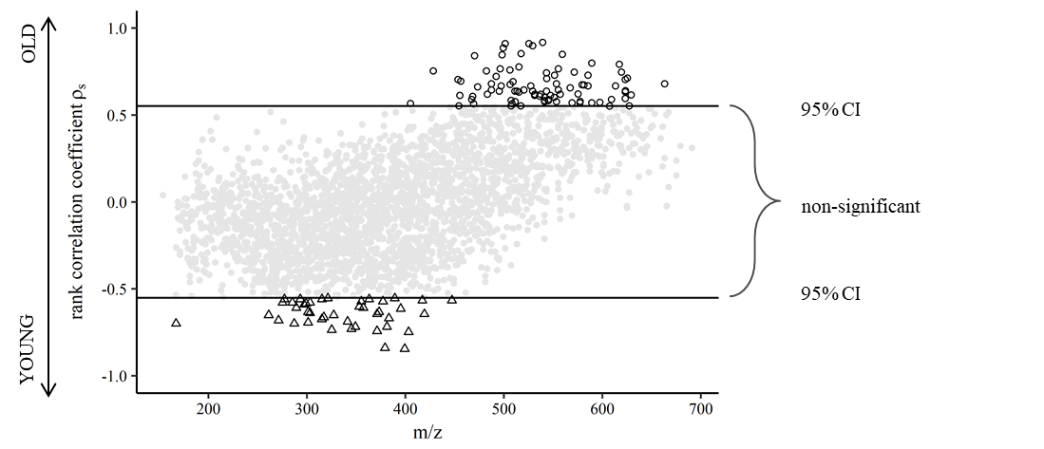

**Supplementary Figure S1.** Distribution of rank correlation strength values over the measured m/z range.

# Supplementary Tables

**Supplementary Table S1.** List of suggested compounds for sum formulae that were strongly associated with cal 14C age. Continued on following pages.



















**Supplementary Table S2.** List of ChEBI structure suggestions for negatively correlated sum formulae.

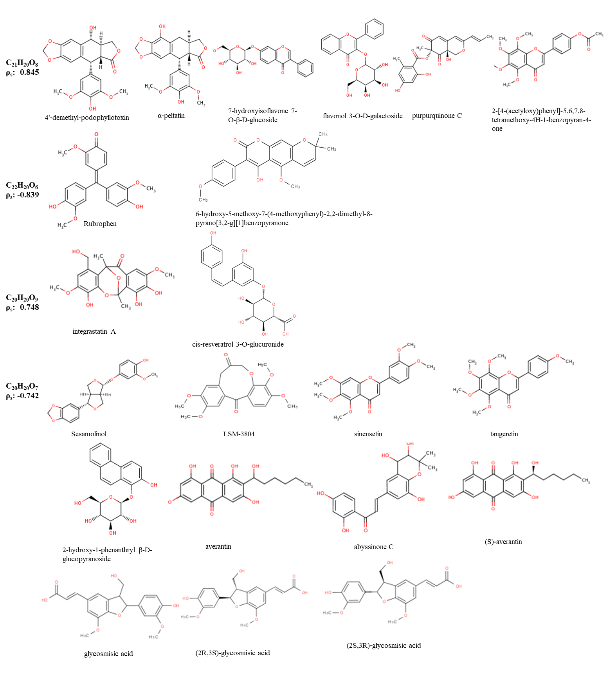

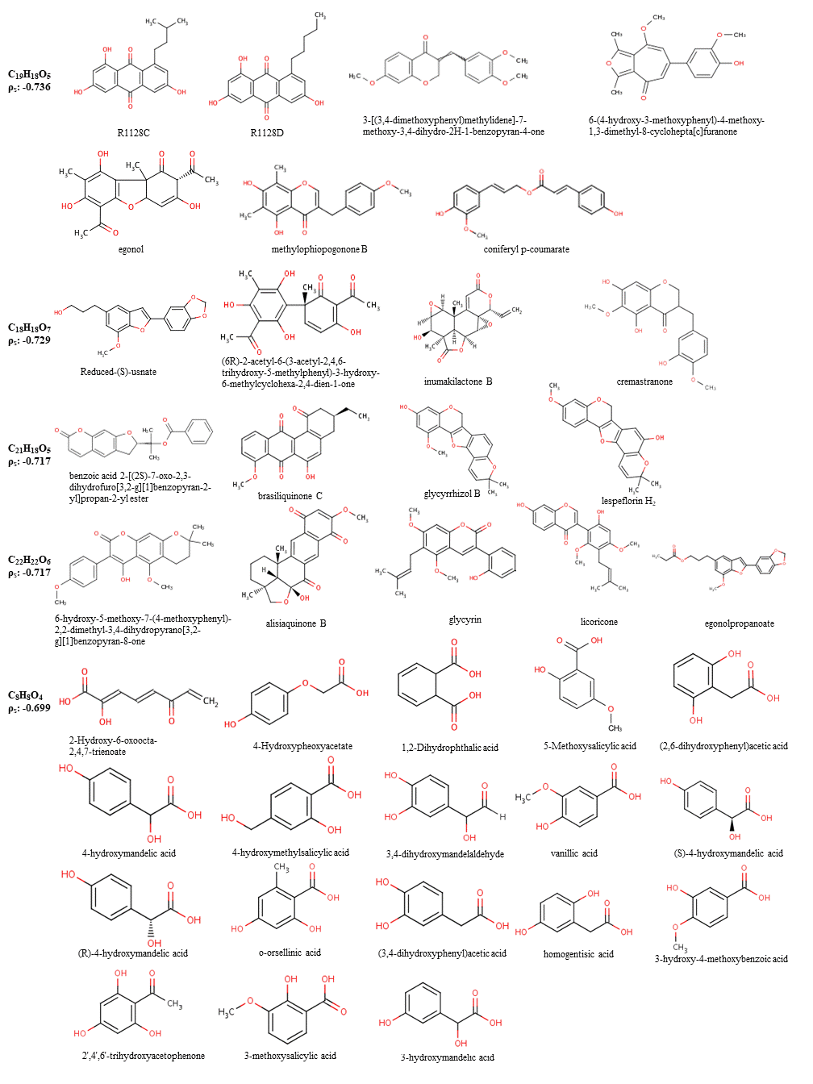

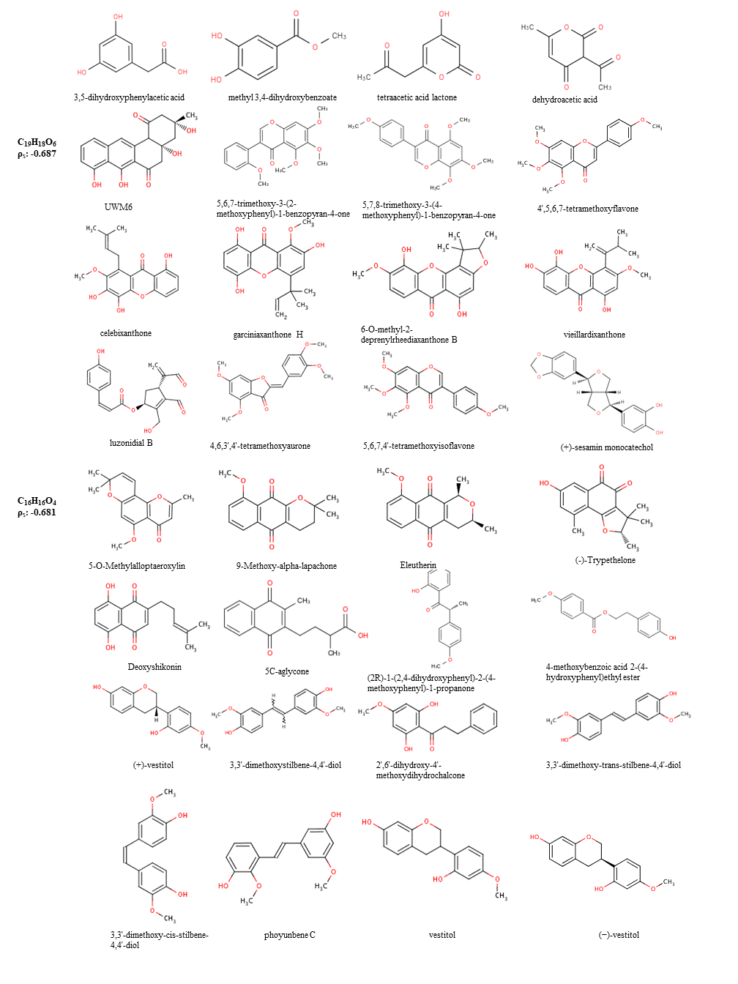

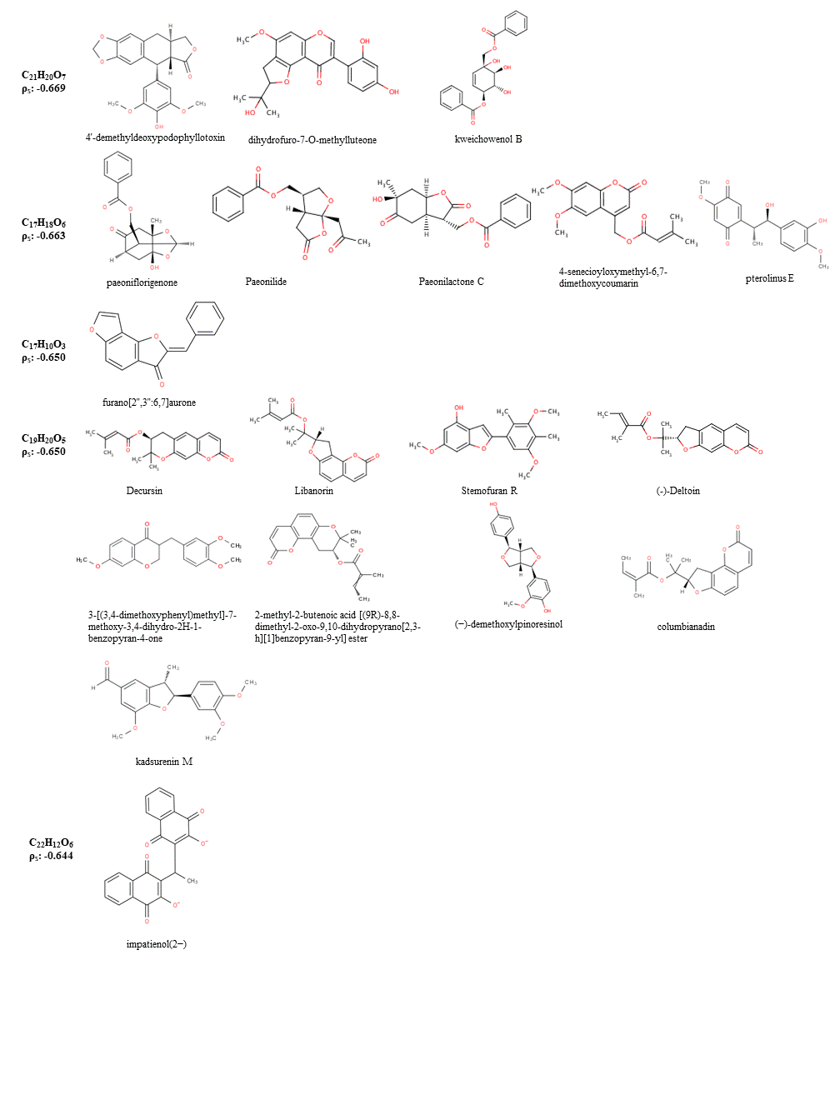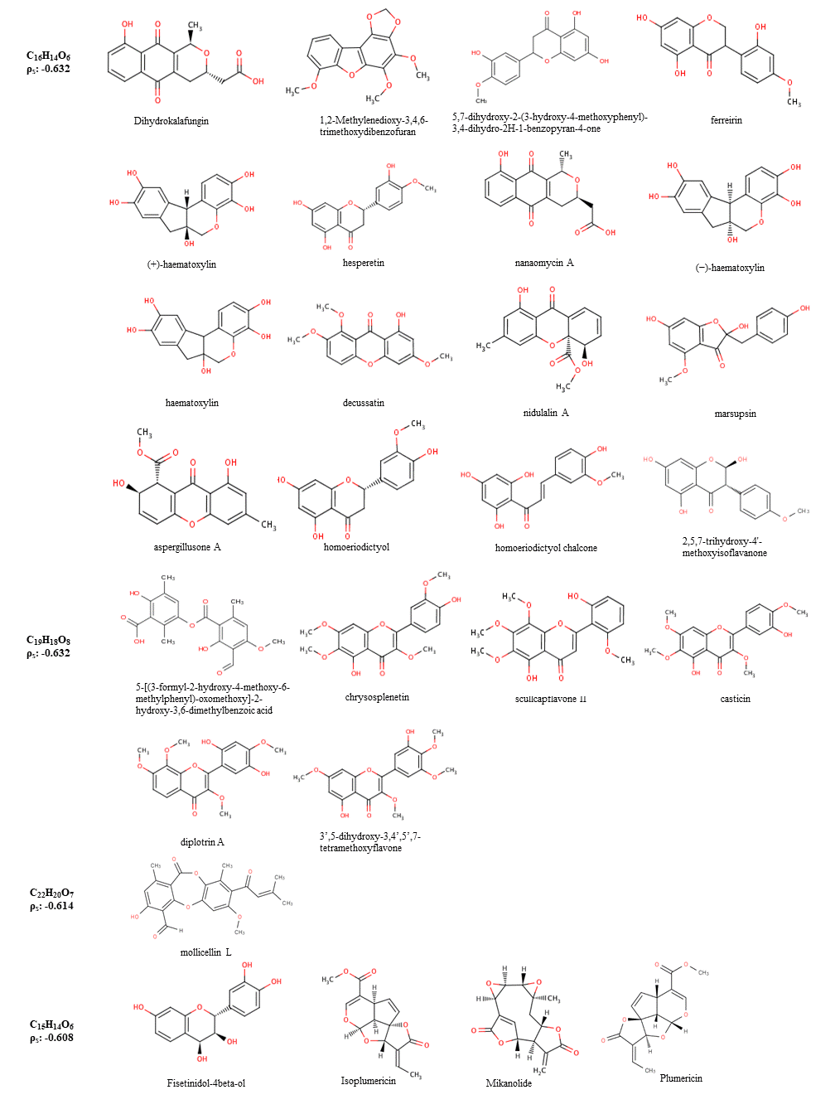

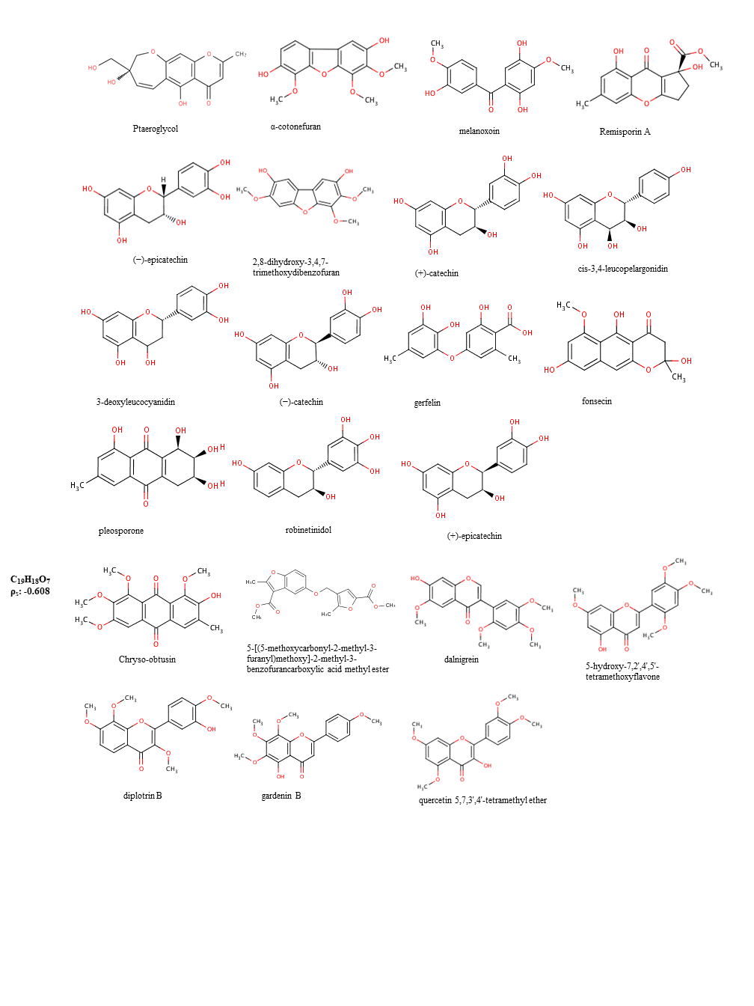

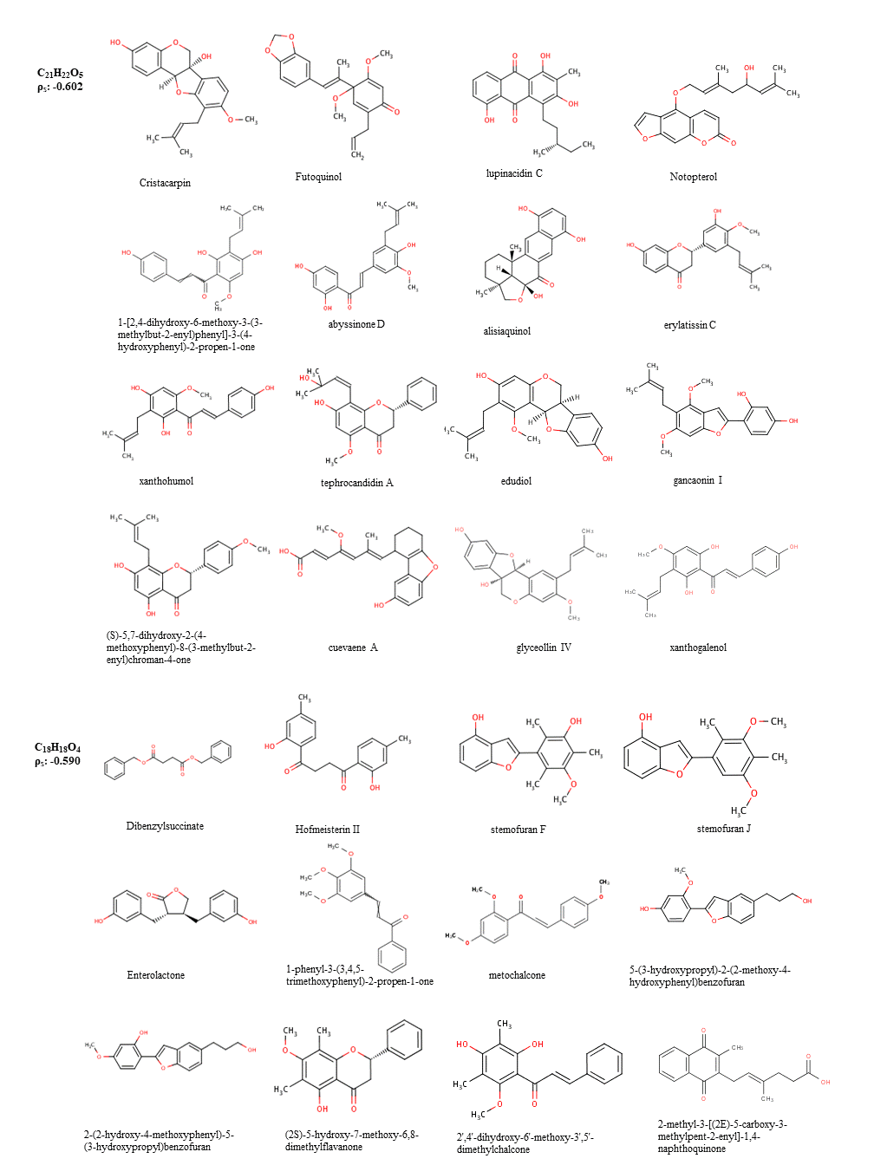

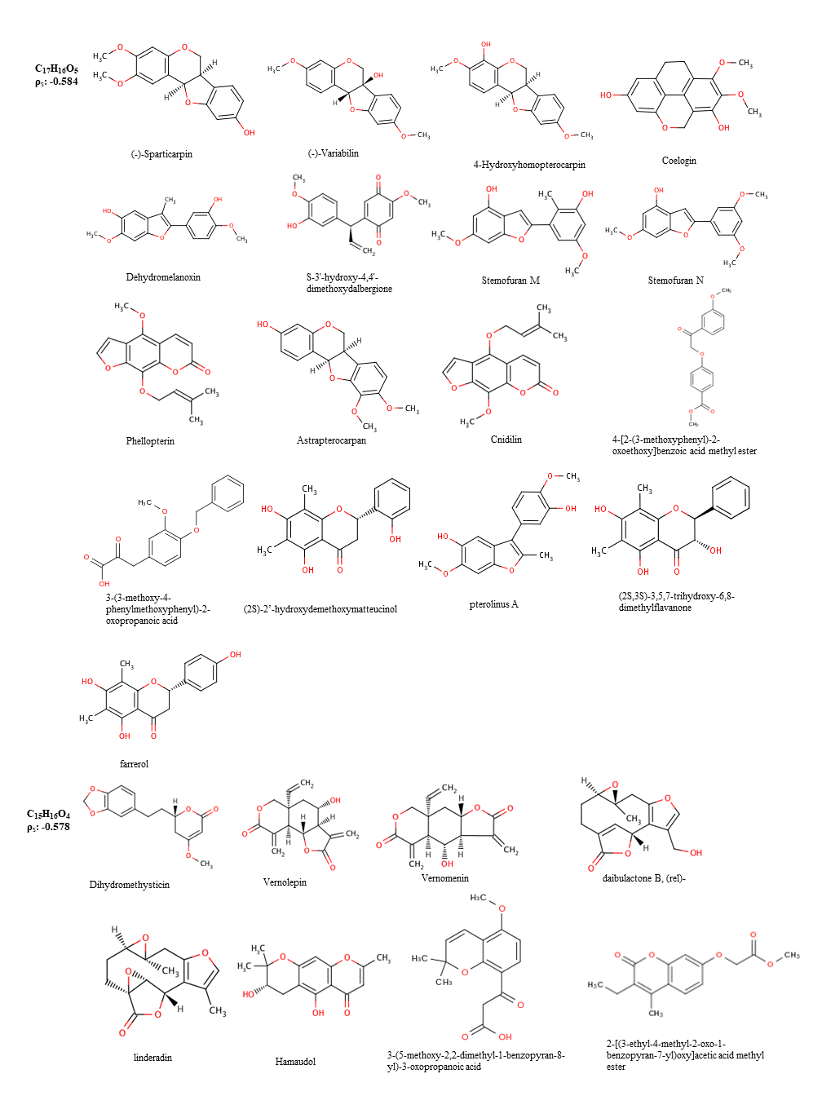

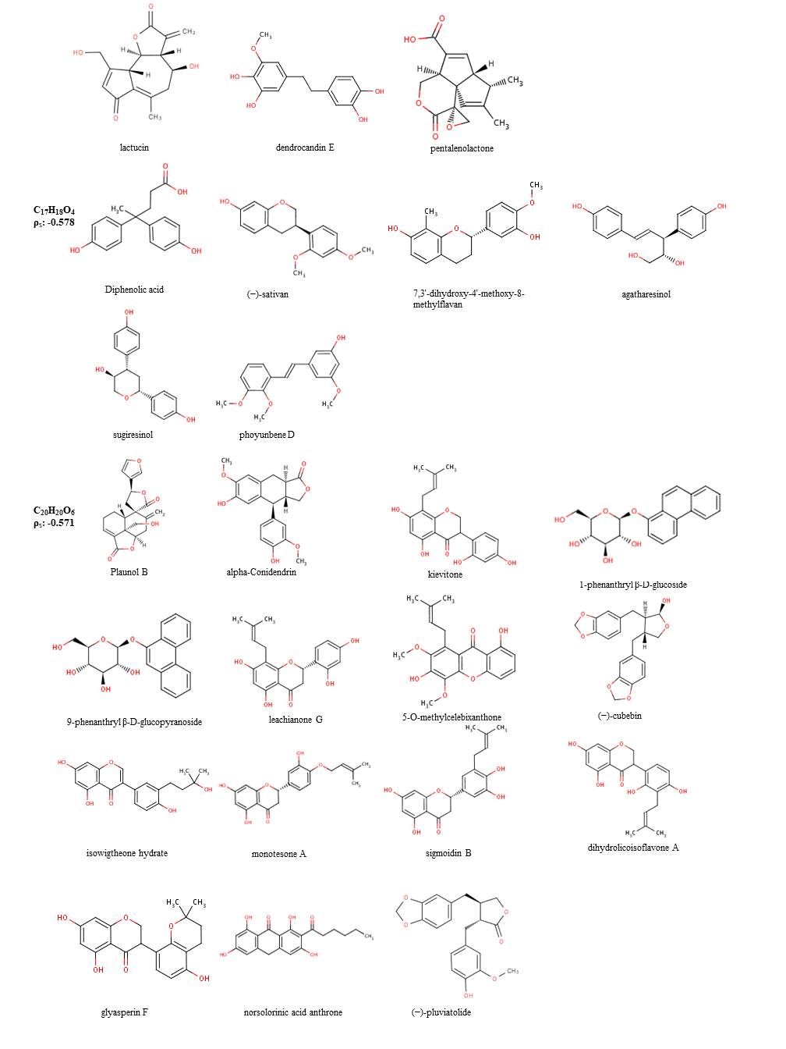

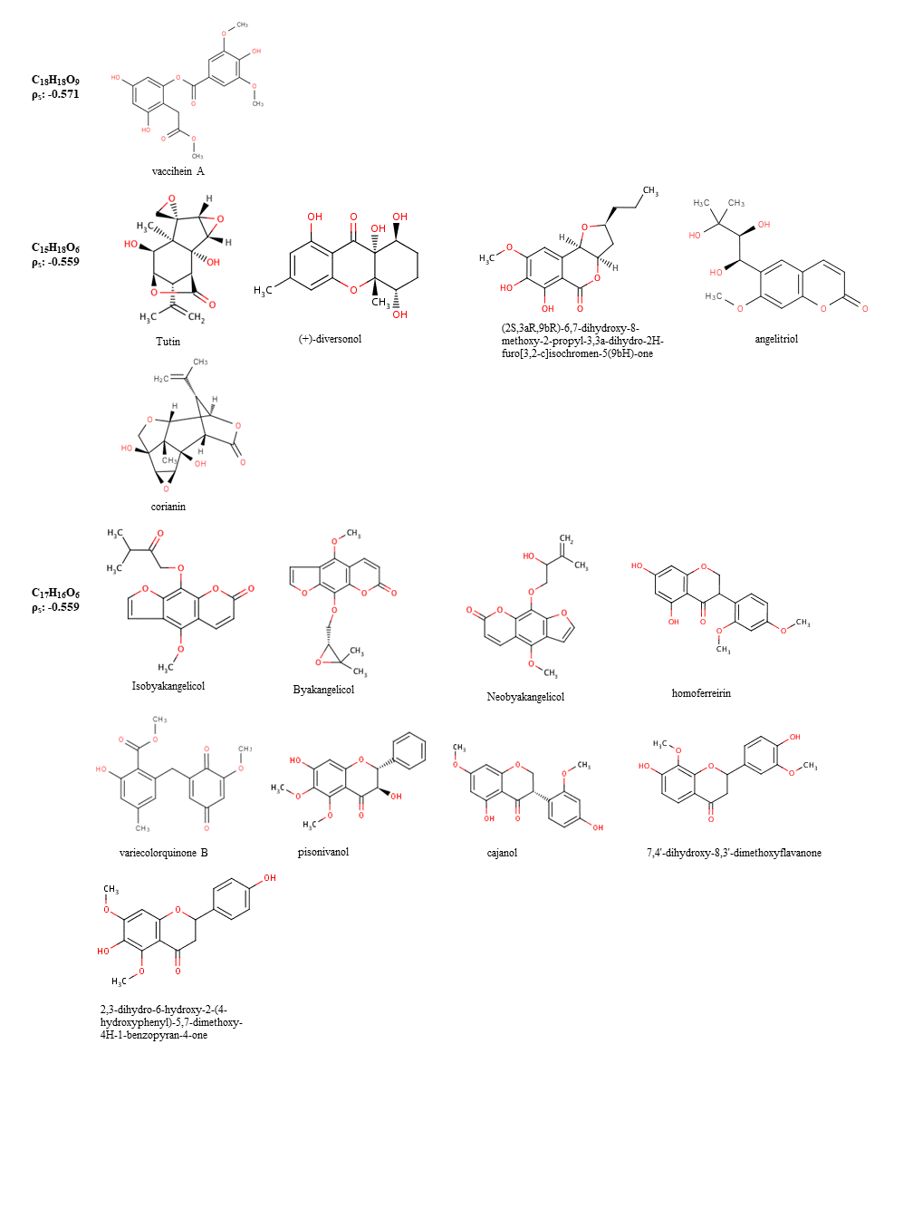

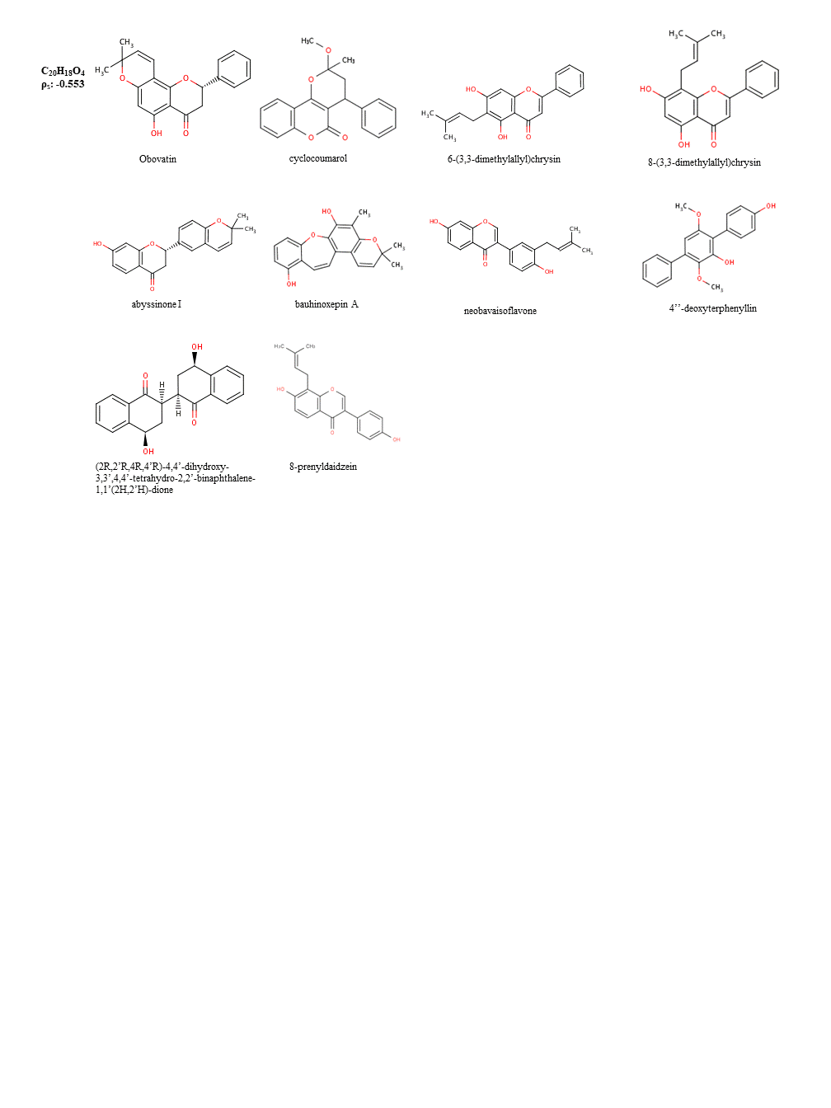**Supplementary Table S3.** List of ChEBI structure suggestions for positively correlated sum formulae.

