Supplemental Materials

Metagenomics insights into the contribution of phages to antibiotic resistance in water samples related to swine feedlot wastewater treatment

Mianzhi Wang^{1,2}, Wenguang Xiong^{1,2}, Peng Liu^{1,2}, Xiying Xie^{1,2}, Jiaxiong Zeng^{1,2}, Yongxue Sun^{1,2*}, Zhenling Zeng^{1,2*}

¹ National Risk Assessment Laboratory for Antimicrobial Resistance of Animal Original Bacteria, South China Agricultural University, Guangzhou, China
² Guangdong Provincial Key Laboratory of Veterinary Pharmaceutics Development and Safety Evaluation, College of Veterinary Medicine, South China Agricultural University, Guangzhou, China

Abbreviations: ARB (antimicrobial resistant bacteria), ARGs (antimicrobial resistance genes), HGT (horizontal gene transfer)

* Corresponding author
Tel: +86-2085284313
E-mail address:
sunyx@scau,edu.cn (YX.Sun)
zlzeng@scau.edu.cn (ZL.Zeng)

Pages: 4
Figure: 4
Tables: 1

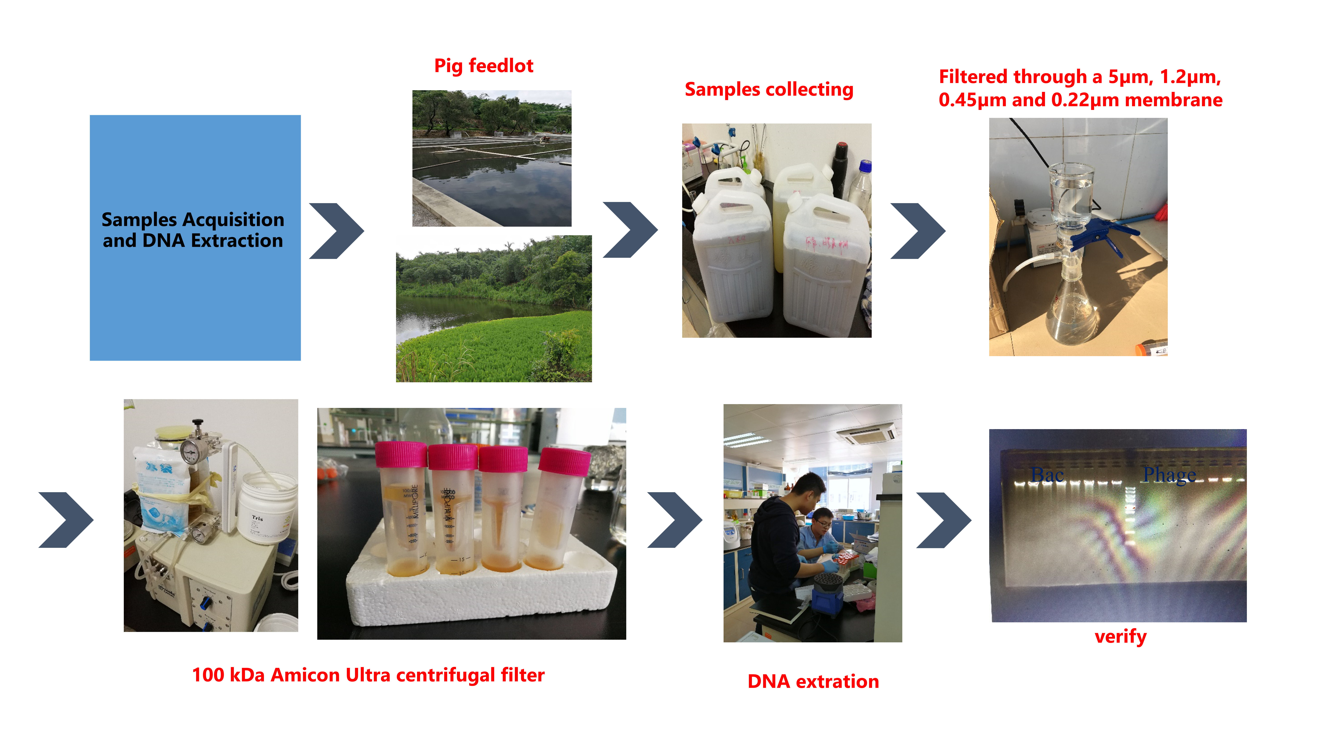
Fig S1: Schematic illustration of bacteriophage acquisition and DNA extraction.

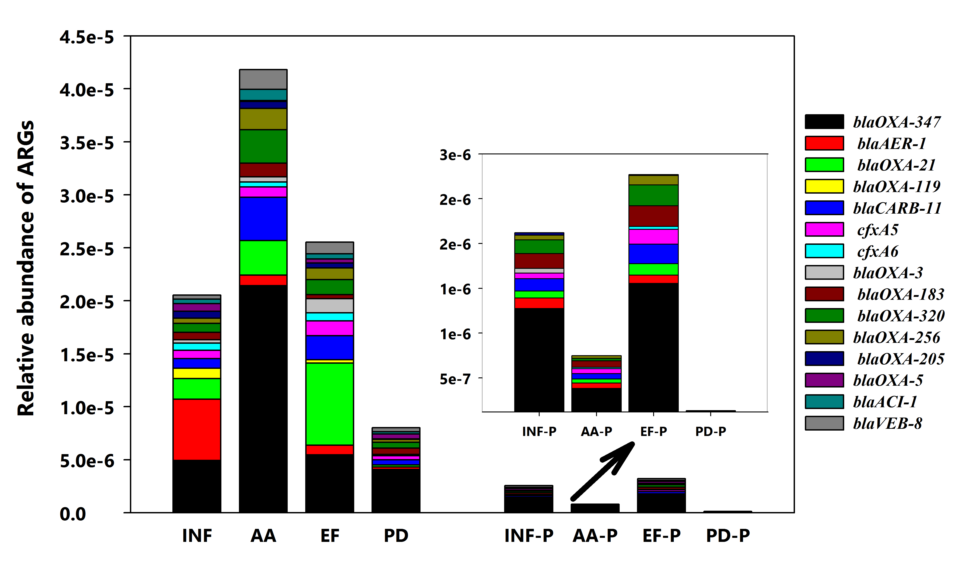
Fig S2：Distribution patterns of β-lactamases ARG types at different sampling locations.
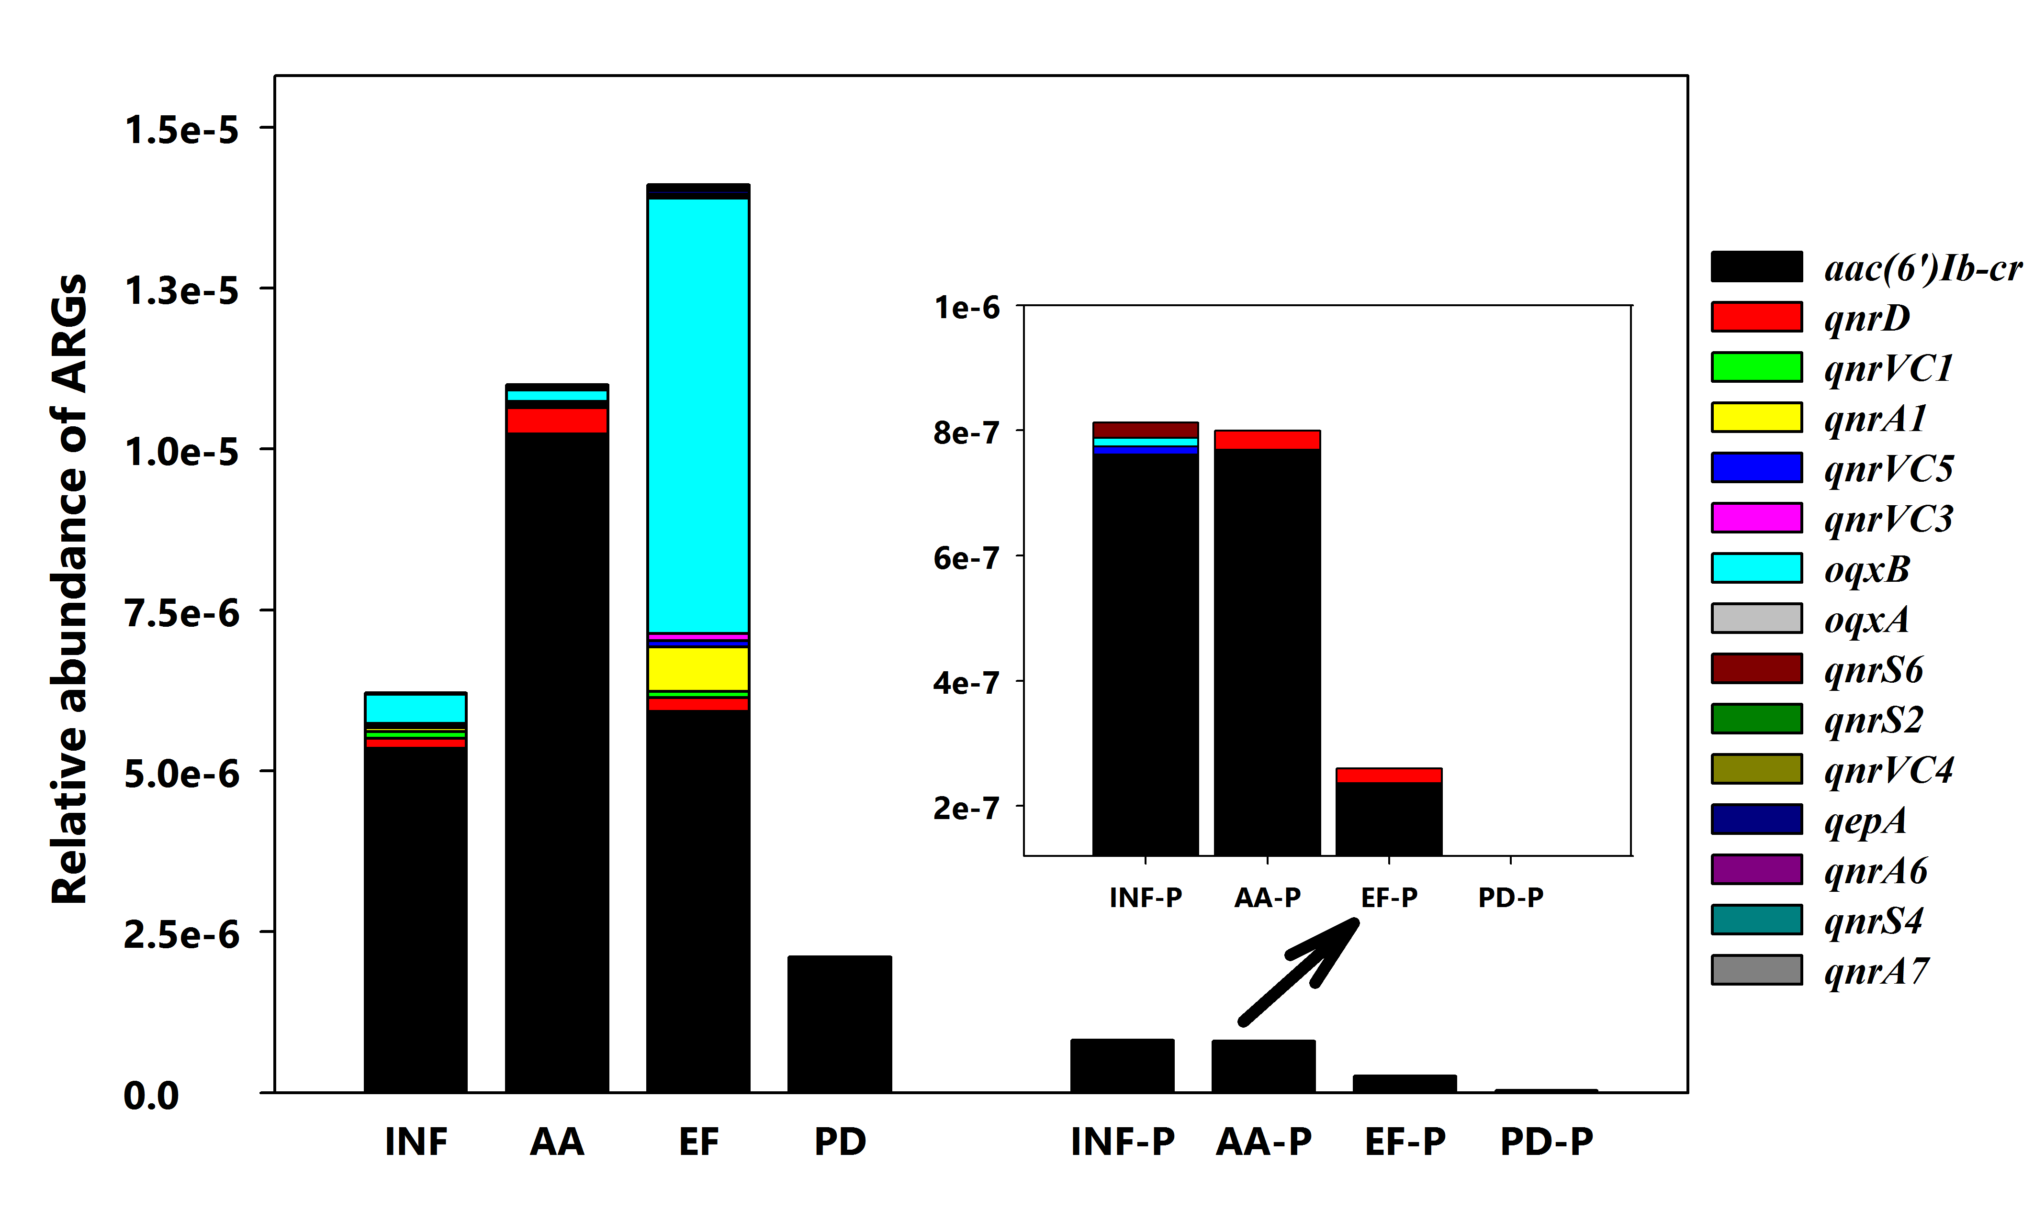
Fig S3：Distribution patterns of quinolone ARG types at different sampling locations

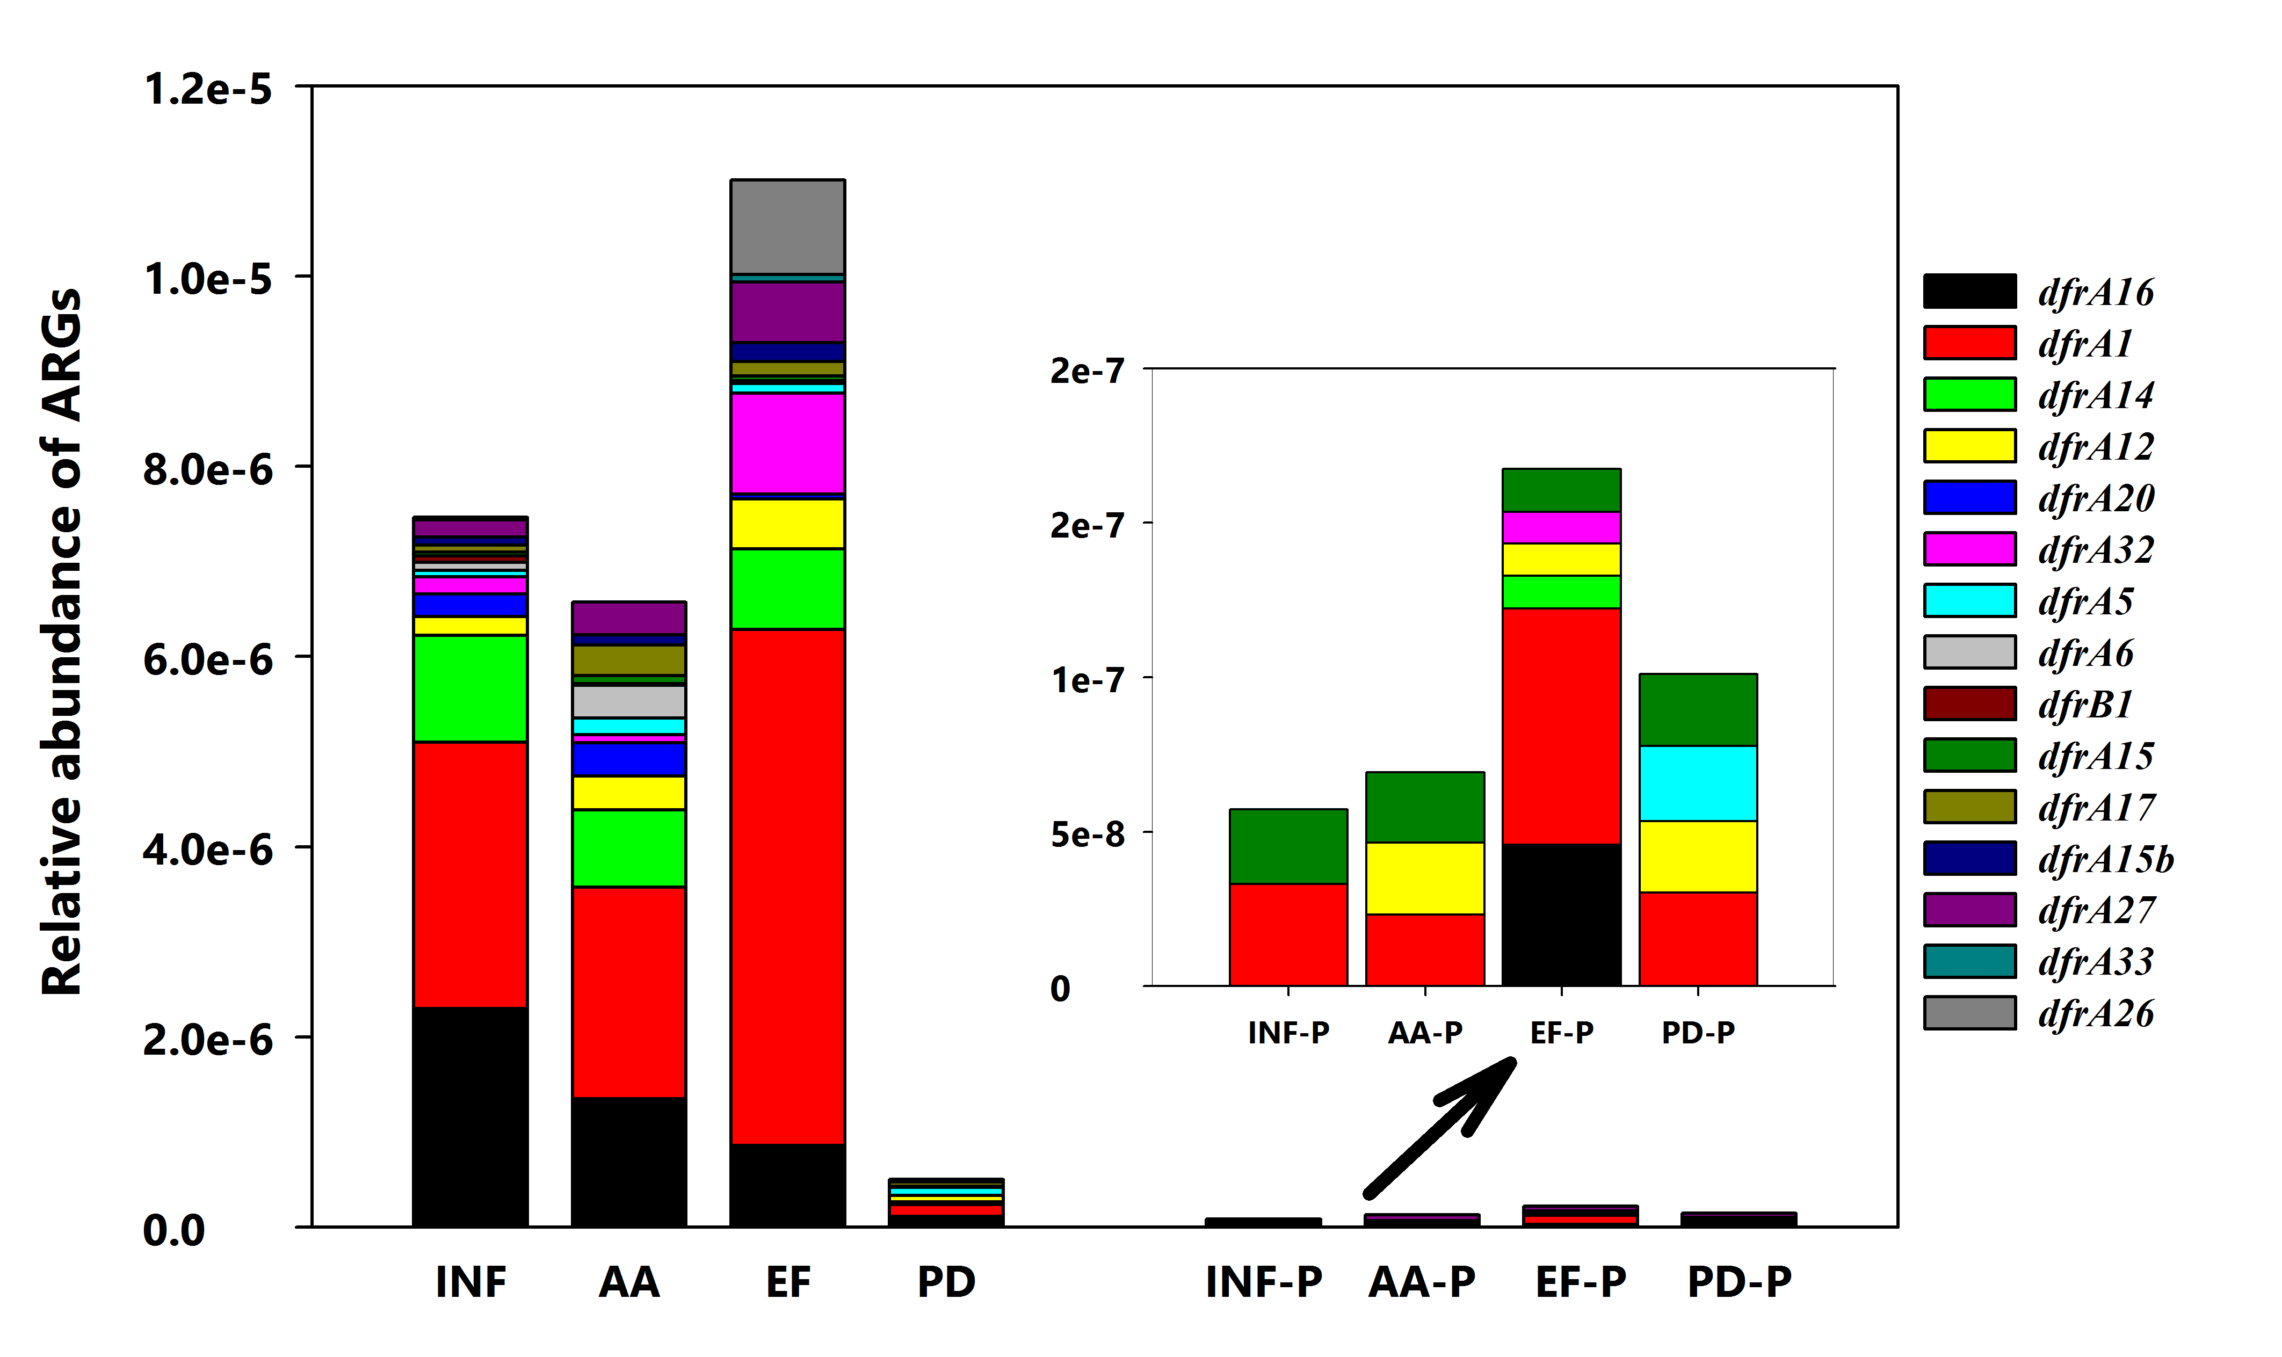
Fig S4：Distribution patterns of trimethoprim ARG types at different sampling locations

Table S1
Conditions for the detection of 16S rDNA (for conventional PCR).
Groups | Genes | Primer sequence(5’-3’) | MT^{b} | bp | Reference
16s rDNA | 16s-1 | F-GGTAGTCYAYGCMSTAAACG | Initial 95 °C denaturation for 5 min, followed by 35 cycles consisting of denaturation (95 °C for 30 s), annealing (61.7 °C for 30 s), extension (72 °C for 45 s); Final extension step (72 °C for10 min) | 263 | (Koike et al., 2010)
 | 16s-2 | R-GACARCCATGCASCACCTG
 | 28f | F-AAGAGTTTGATCCTGGCTCAGA | Initial 95 °C denaturation for 5 min, followed by 35 cycles consisting of denaturation (95 °C for 30 s), annealing (61.7 °C for 30 s), extension (72 °C for 45 s); Final extension step (72 °C for10 min) | 1503 | Colomer-Lluch et al., 2014
 | 1492r | R-TACGGCTACCTTGTTACGACTT

Table S2
Accession number and detailed information of 12 raw data in MG-RAST
Sample name | Duplication | Accession number
INF-B | B11 | mgm4801790.3
 | B12 | mgm4801786.3
EF-B | B21 | mgm4801792.3
 | B22 | mgm4801784.3
AA-B | B31 | mgm4801783.3
 | B32 | mgm4801794.3
PD-B | B41 | mgm4801791.3
 | B42 | mgm4801793.3
INF-P | P11 | mgm4801795.3
 | P12 | mgm4801789.3
EF-P | P21 | mgm4801787.3
 | P22 | mgm4801797.3
AA-P | P31 | mgm4801788.3
 | P32 | mgm4801785.3
PD-P | P41 | mgm4801798.3
 | P42 | mgm4801796.3

