Coupling between magmatic degassing and volcanic tremor

in basaltic volcanism

Giuseppe G. Salerno*, Mike Burton, Giuseppe Di Grazia, Tommaso Caltabiano, Clive Oppenheimer.

* Correspondence: Corresponding Author: Giuseppe G. Salerno, giuseppe.salerno@ingv.it

1 Supplementary Data

Volcanic tremor frequency analysis

The optimal tremor frequency content for each of the six case here studied was evaluated by carrying out a correlation analysis between the selected ΦSO₂ samples and Vt frequency bands between 0.025 and 10.5 Hz (1 Hz width). Correlation analyses express the strength of linkage or co-occurrence between two variables in a single value between -1 and +1, i.e. . The correlation coefficient, r, quantifies the direction and magnitude of correlation. When r is 1, there is a perfect positive correlation or direct correlation. That is, large values of the one variable, for example, X, are associated with large values of the other, for example, Y, and small values of the X variable are associated with small values of the Y variable. When the coefficient r is −1, there is a perfect negative correlation or indirect correlation. When the r is equal to zero, it means that there is no relationship or correlation. Correlations are limited to linear relationships between variables, and though correlation coefficient might be zero, a non-linear relationship can exist between two variables (Davis, 1986; McKillup and Dyar, 2010).

In this study the non-parametric Spearman’s Rank (ρ_{s}) correlation analysis was applied to investigate the strength between ΦSO₂ and Vt in the six intraday case studies, this method was selected due to the small sample size and no-normal distribution of the data (e.g., Zar, 1972; Davis, 1986; Swan and Sandilands, 1995). The Spearman's rank-order correlation ρ_{s} measures the monotonic relationship between two ranked variables x and y, and is expressed as follows:

Where 6 is a constant, n is the number of observations in each of the two data sets, d_{i} being the difference between each pair of ranks of corresponding values of the two variables x and y, and n the number of pairs of values in the sample. The likeness of correlation between two variates is measured as a scalar between 1 ≥ ρ ≥ -1 and correlation are considered reliable for value ≥ |0.6|. The significance of ρ is computed by using the Student’s t-distribution, with n-2 degrees of freedom of n number of observations.

References
- Davis, J.C., 1986. Statistics and data analysis in geology, Second edition, John Wiley & Sons, New York.
- McKillup, S., and Dyar, M.D., (2010). Geostatistics Explained An Introductory Guide for Earth Scientists. Cambridge University Press. ISBN-13: 9780521746564
- Swan, A.R.H., Sandilands, M., 1995. Introduction to geological data analysis. Blackwell Science.
- Zar, J.H., 1972. Significance testing of the Spearman Rank Correlation Coefficient. JASA 67, 339.
Supplementary Figure S1

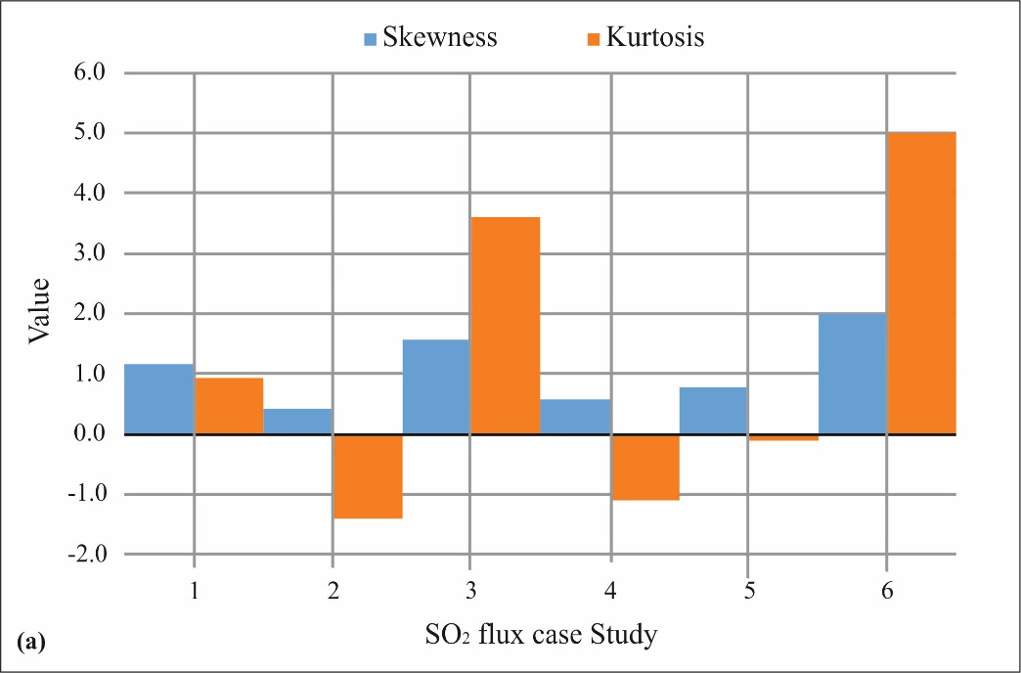

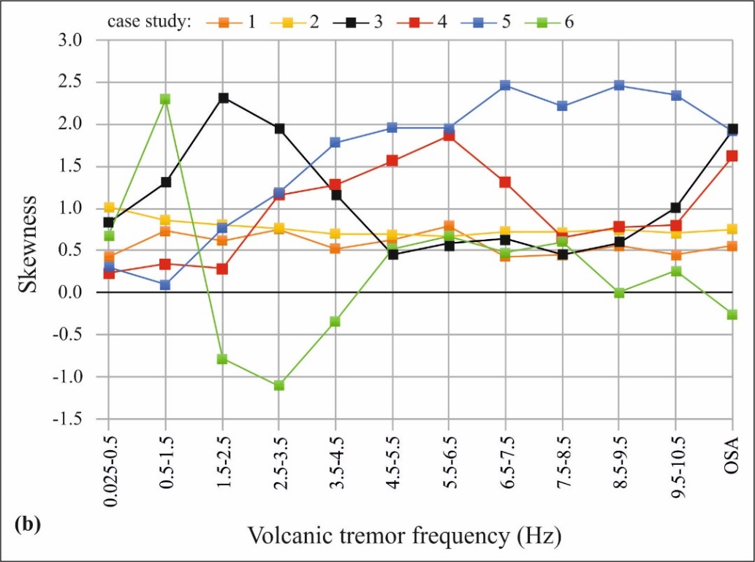
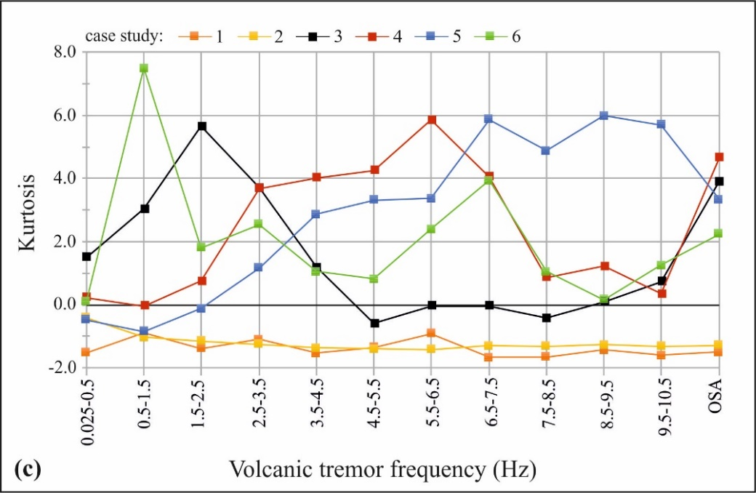

Figure S1.
Statistical proprieties of SO₂ flux (a) and volcanic seismic tremor (b and c) of the six intraday case studies explored for the short timescale investigation (Figure 3 and table 1). Both data records displayed mean skewness values of 1.1 and 0.9 (standard deviation of 0.6 and 0.5; a and b) which revealed lack of symmetry relative to a normal distribution of the data. Volcanic tremor showed isolated Gaussian distribution (skewness near and/or zero in b) for case study 4, 5 and 6 for frequency between 1.5 and 2.5 and for 9.5 - 10.5 Hz, respectively. Kurtosis in both SO₂ flux and volcanic tremor (a and c, respectively) show mean value of 1.2 and 1.1, respectively (standard deviation of 0.7 and 1.1). Data in each different case studies and for different frequency band was both heavily and light tailed (positive and negative kurtosis) and marked by outliers (positive and negative and high positive kurtosis values, respectively). The six case studies relate to different eruptive regimes, which ranged between explosive to predominantly effusive activity (case study 1- 3 and 4 – 6, respectively in figure 3 and table 1).

