Simultaneous supplementation of Bacillus Subtilis and Antibiotic Growth Promoters by Stages Improved Intestinal Function of Pullets by Altering Gut Microbiota
Xueyuan Li#, † , Shengru Wu #, *, †, Xinyi Li#, † ,Tao Yan#, Yongle Duan#, Xin Yang#, Yulan Duan#, Qingzhu Sun#, Xiaojun Yang^{#, 1}
Correspondence: Xiaojun Yang: yangxj@nwsuaf.edu.cn
Supplementary files
Supplementary Figure 1. The standard curve and equation of C. leptum, B. fragilis, E. coli, and S. enteritidis plasmids. Note: The abscissa represented lg vaules of copy numbers in the plasmids by dilutions (10⁻¹~10⁻⁶) and the ordinate represented the cycle threshold vaules, R² > 0.99.
Supplementary Figure 2 Abundance of the predicted gene related to KEGG pathways at level 1 and 2 at 3 week. Note: Yellow box: AGP samples, purple box: BA3 samples. The terms given on the left are KEGG pathways annotation at level 1 and level 2 (from left to right).
Supplementary Figure 3 Abundance of the predicted gene related to KEGG pathways at level 1 and 2 at 6 week. Note: Purple box: AGP samples, yellow box: BA3 samples, blue box: BA6 samples. The terms given on the left are KEGG pathways annotation at level 1 and level 2 (from left to right).
Supplementary Figure 4 Abundance of the predicted gene related to KEGG pathways at level 1 and 2 at 12 week. Note: Blue box: AGP samples, red box: BA3 samples, yellow box: BA6 samples,dark blue box: BA12 samples. The terms given on the left are KEGG pathways annotation at level 1 and level 2 (from left to right).
Supplementary Figure 5 Abundance of the predicted gene related to KEGG pathways at level 1 and 2 at 16 week. Note: Blue box: AGP samples, purple box: BA3 samples, yellow box: BA6 samples, dark blue box: BA12 samples, red box: BA16 samples. The terms given on the left are KEGG pathways annotation at level 1 and level 2 (from left to right).

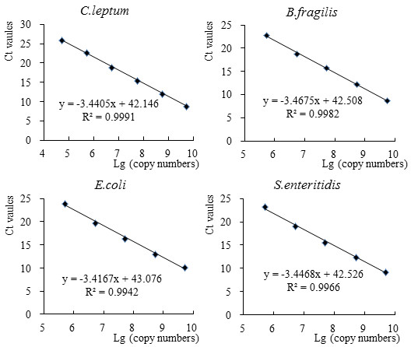
Supplementary Figure 1. The standard curve and equation of C.leptum, B.fragilis, E.coli, and S.enteritidis plasmids. The abscissa represented lg vaules of copy numbers in the plasmids by dilutions (10⁻¹~10⁻⁶) and the ordinate represented the cycle threshold vaules, R²>0.99.

Supplementary Figure 2. Abundance of the predicted gene related to KEGG pathways at level 1 and 2 at 3 week. Yellow box: AGP samples, purple box: BA3 samples. The terms given on the left are KEGG pathways annotation at level 1 and level 2 (from left to right).
Supplementary Figure 3. Abundance of the predicted gene related to KEGG pathways at level 1 and 2 at 6 week. Purple box: AGP samples, yellow box: BA3 samples, blue box: BA6 samples. The terms given on the left are KEGG pathways annotation at level 1 and level 2 (from left to right).
Supplementary Figure 4. Abundance of the predicted gene related to KEGG pathways at level 1 and 2 at 12 week. Blue box: AGP samples, red box: BA3 samples, yellow box: BA6 samples,dark blue box: BA12 samples. The terms given on the left are KEGG pathways annotation at level 1 and level 2 (from left to right).
Supplementary Figure 5. Abundance of the predicted gene related to KEGG pathways at level 1 and 2 at 16 week. Blue box: AGP samples, purple box: BA3 samples, yellow box: BA6 samples, dark blue box: BA12 samples, red box: BA16 samples. The terms given on the left are KEGG pathways annotation at level 1 and level 2 (from left to right).

