Supplementary Materials
Synthesis and Microwave Absorbing Properties of Porous One-Dimensional Nickel Sulfide Nanostructures
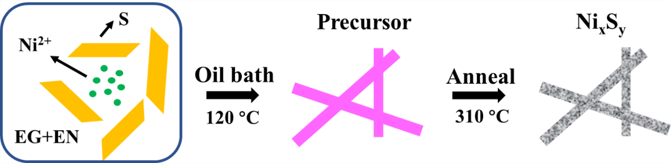
Figure S1 | Growth mechanism of porous 1D nanorods.
Figure S2 | SEM images of precursor of Ni_{x}S_{y} samples under different reaction times: (a) 2, (b) 4, (c) and (d) 6, (e) 8, (f)10 h. (scale bar = 1 μm).
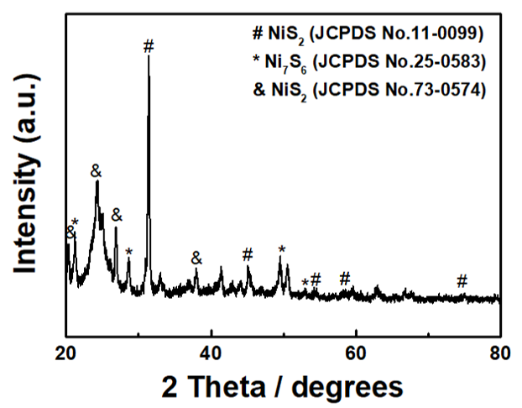
Figure S3 | XRD pattern of as-synthesized Ni_{x}S_{y} samples.

