**Supplementary Materials**

**Table S1.** Dynamic parameters calculated by the modified Gompertz model

|  |  |  |  |  |
| --- | --- | --- | --- | --- |
| Group | Maximum CH4 yield (mL/L) | Lag phase (h) | Maximum CH4 production rate (mL/L·h) | R2 |
| Control | 231.4±3.0 | 4.7±0.6 | 17.6±0.7 | 0.999 |
| Fe3O4 | 173.6±2.7 | 2.2±0.1 | 21.7±0.3 | 0.999 |

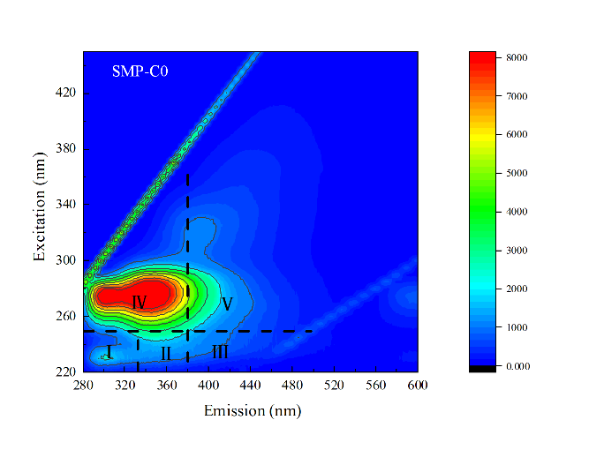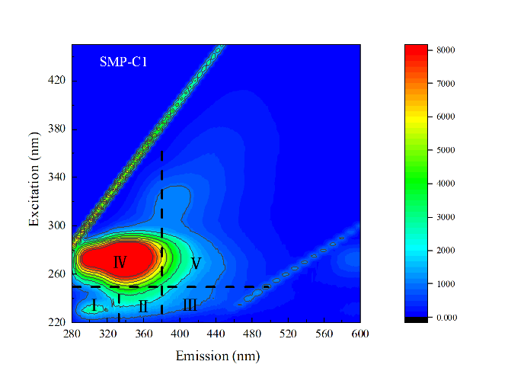

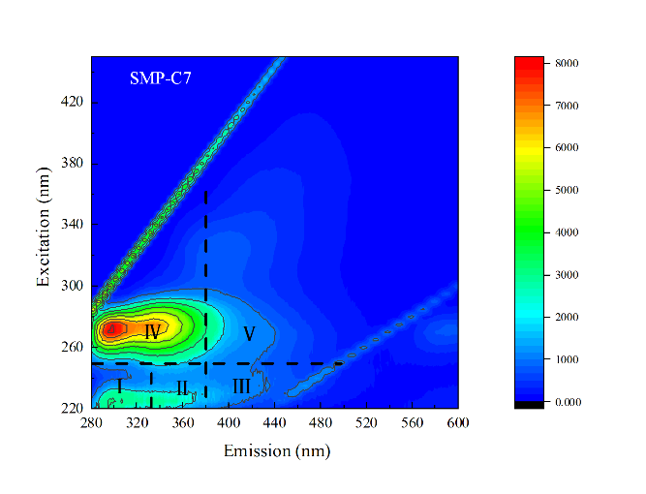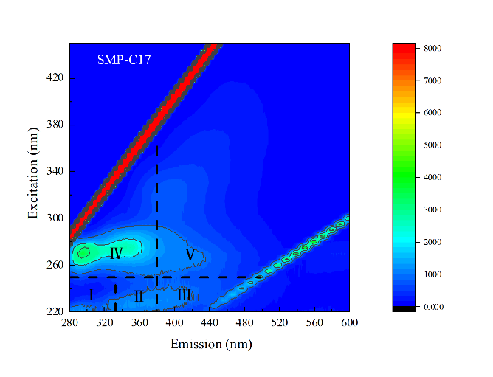

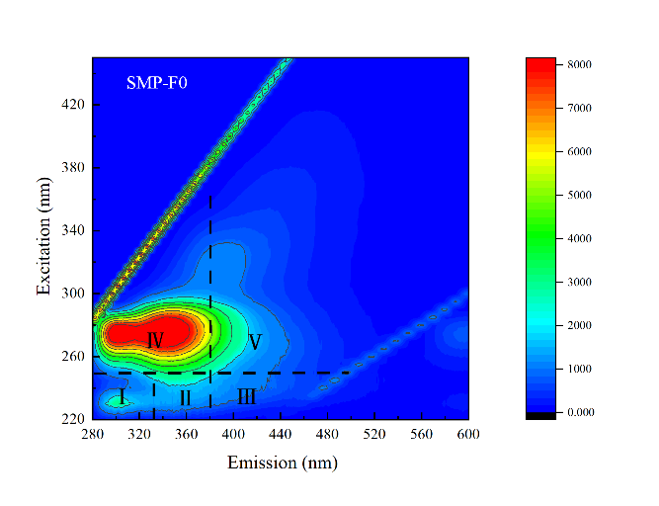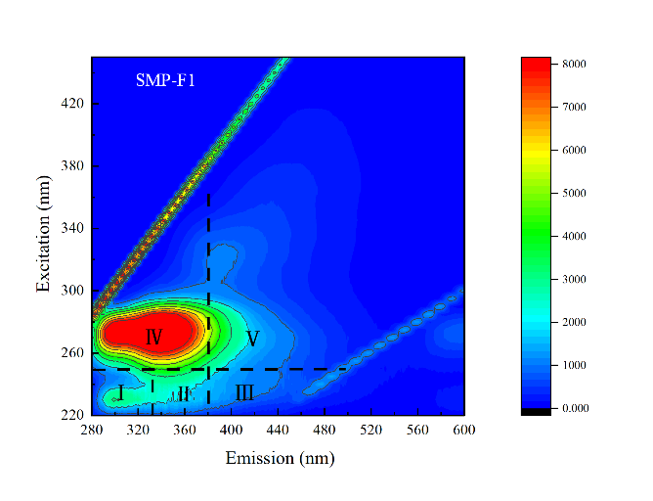

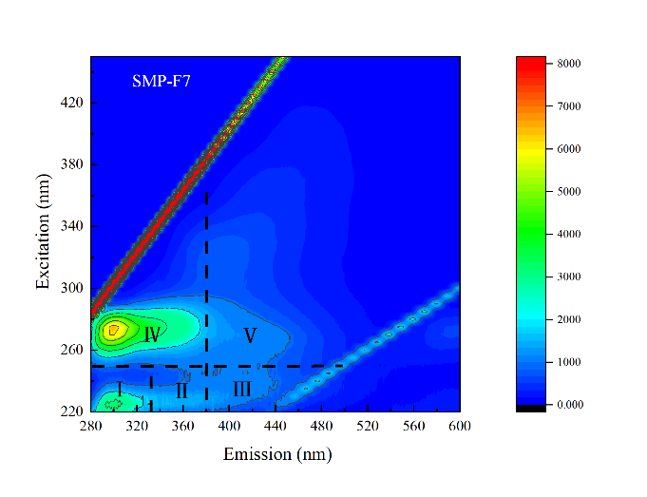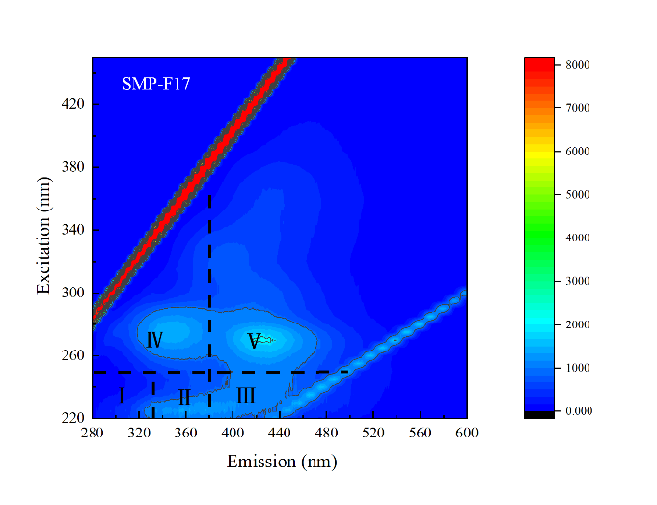

**Figure S1.** EEM fluorescence spectra result of SMP in the control and Fe3O4 reactors.

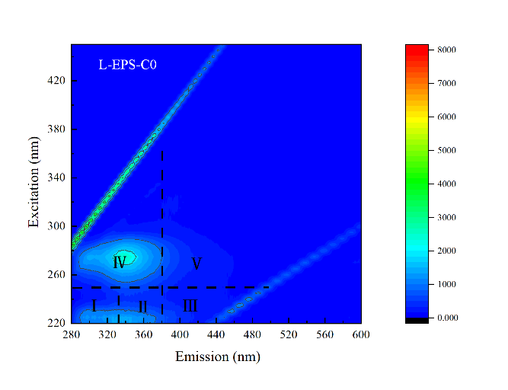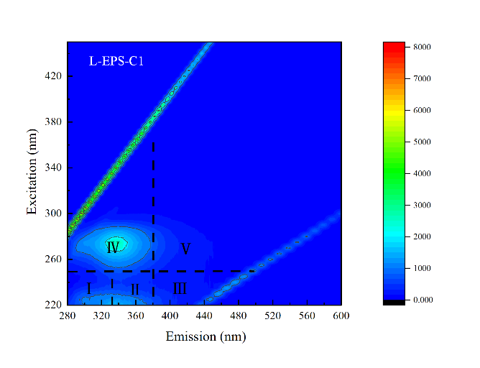

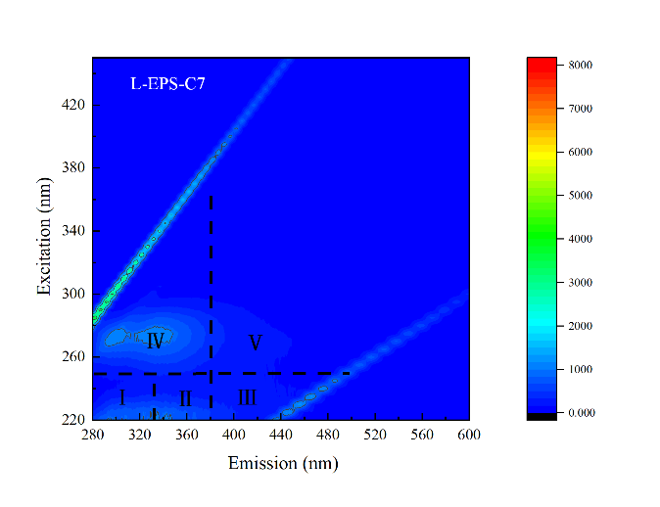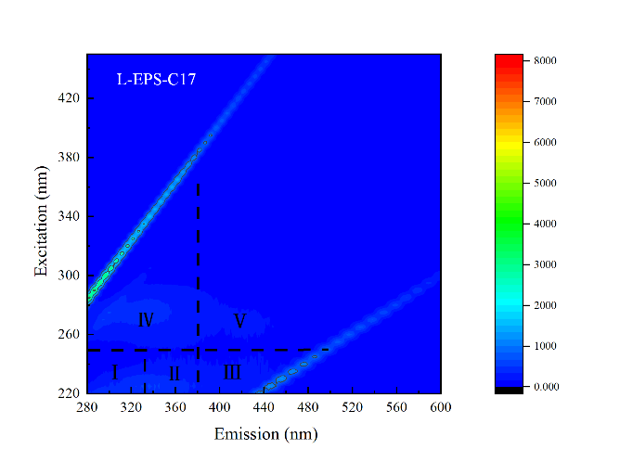

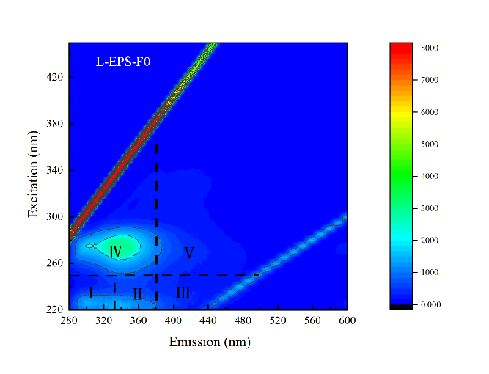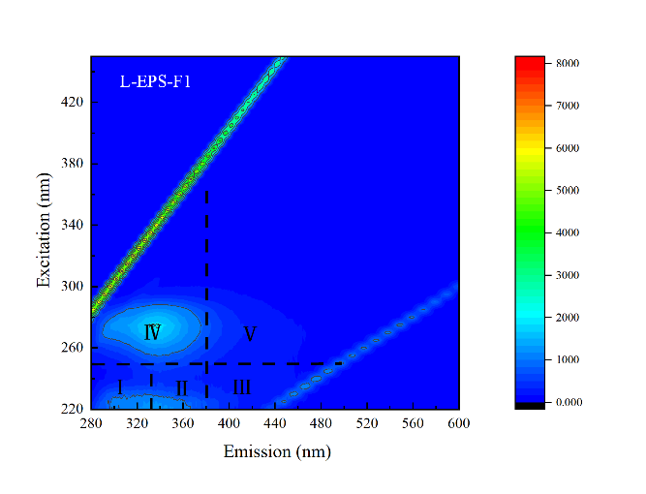

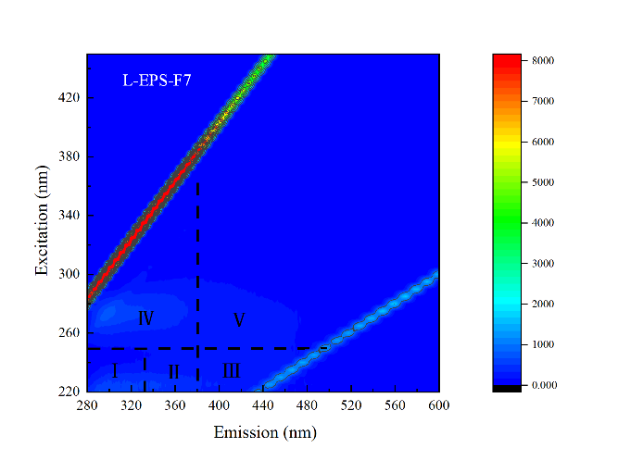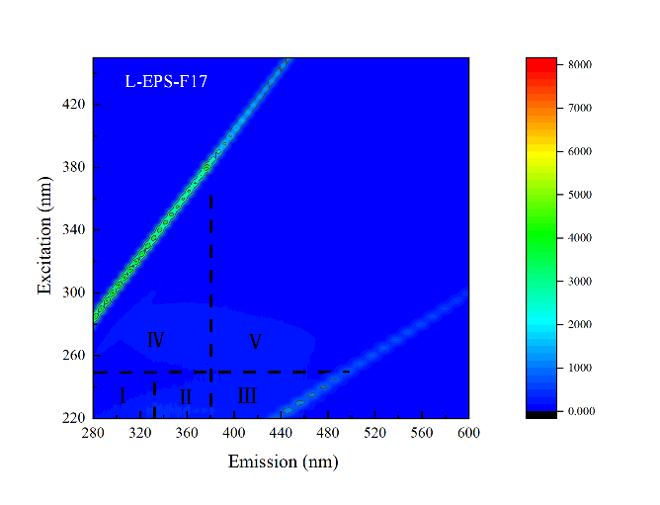

**Figure S2.** EEM fluorescence spectra result of L-EPS in the control and Fe3O4 reactors.

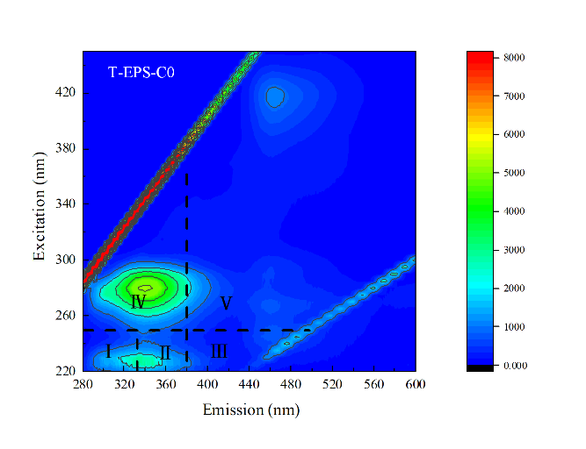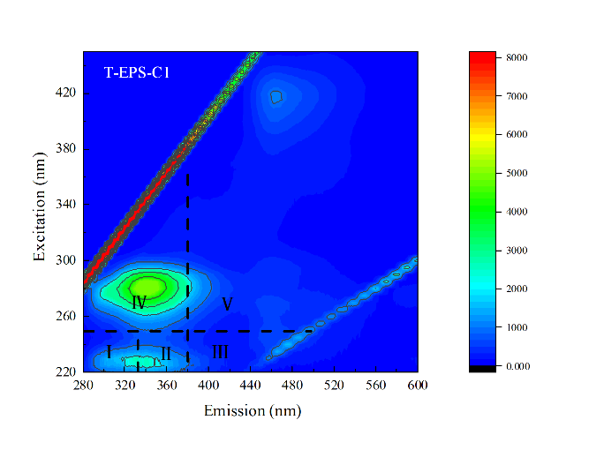

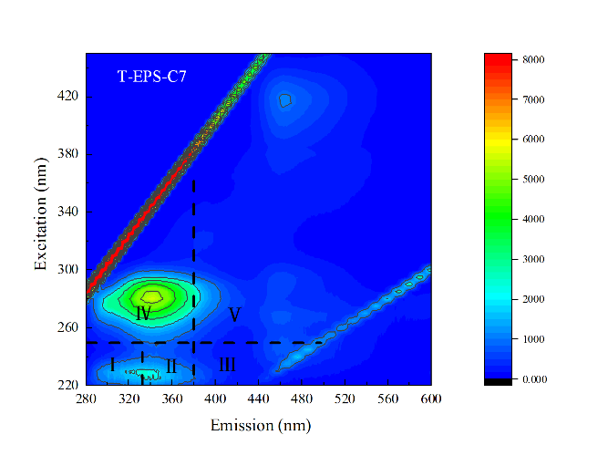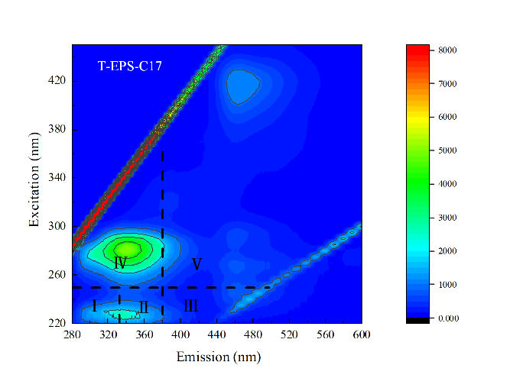

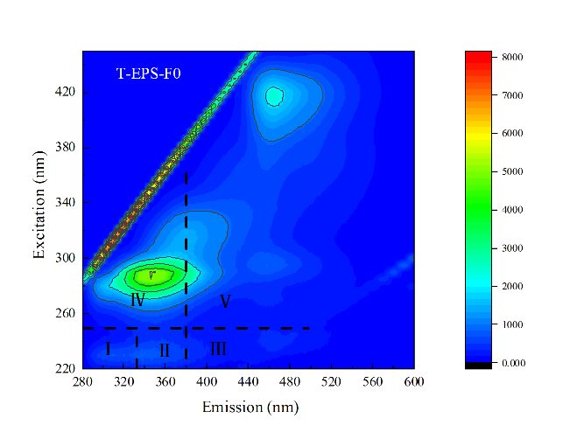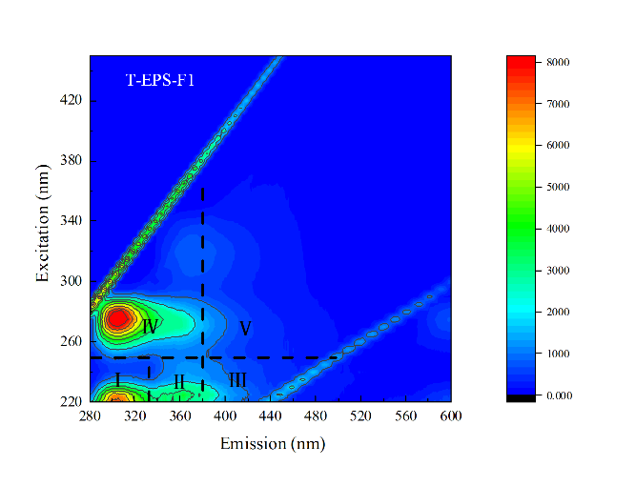

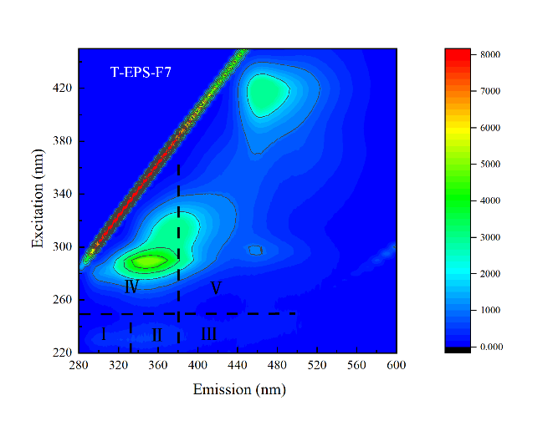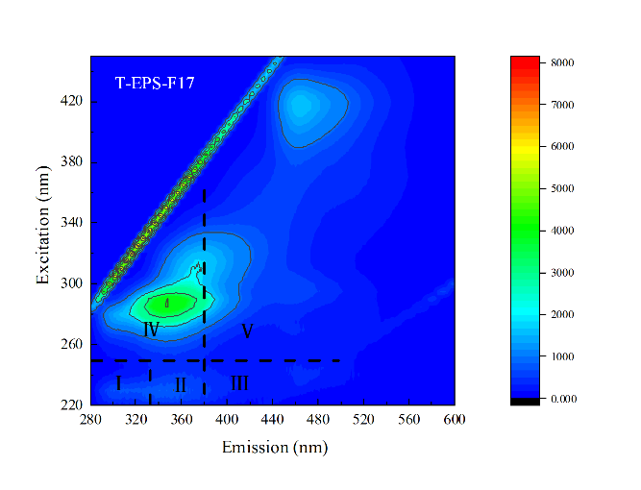

**Figure S3**. EEM fluorescence spectra result of T-EPS in the control and Fe3O4 reactors.

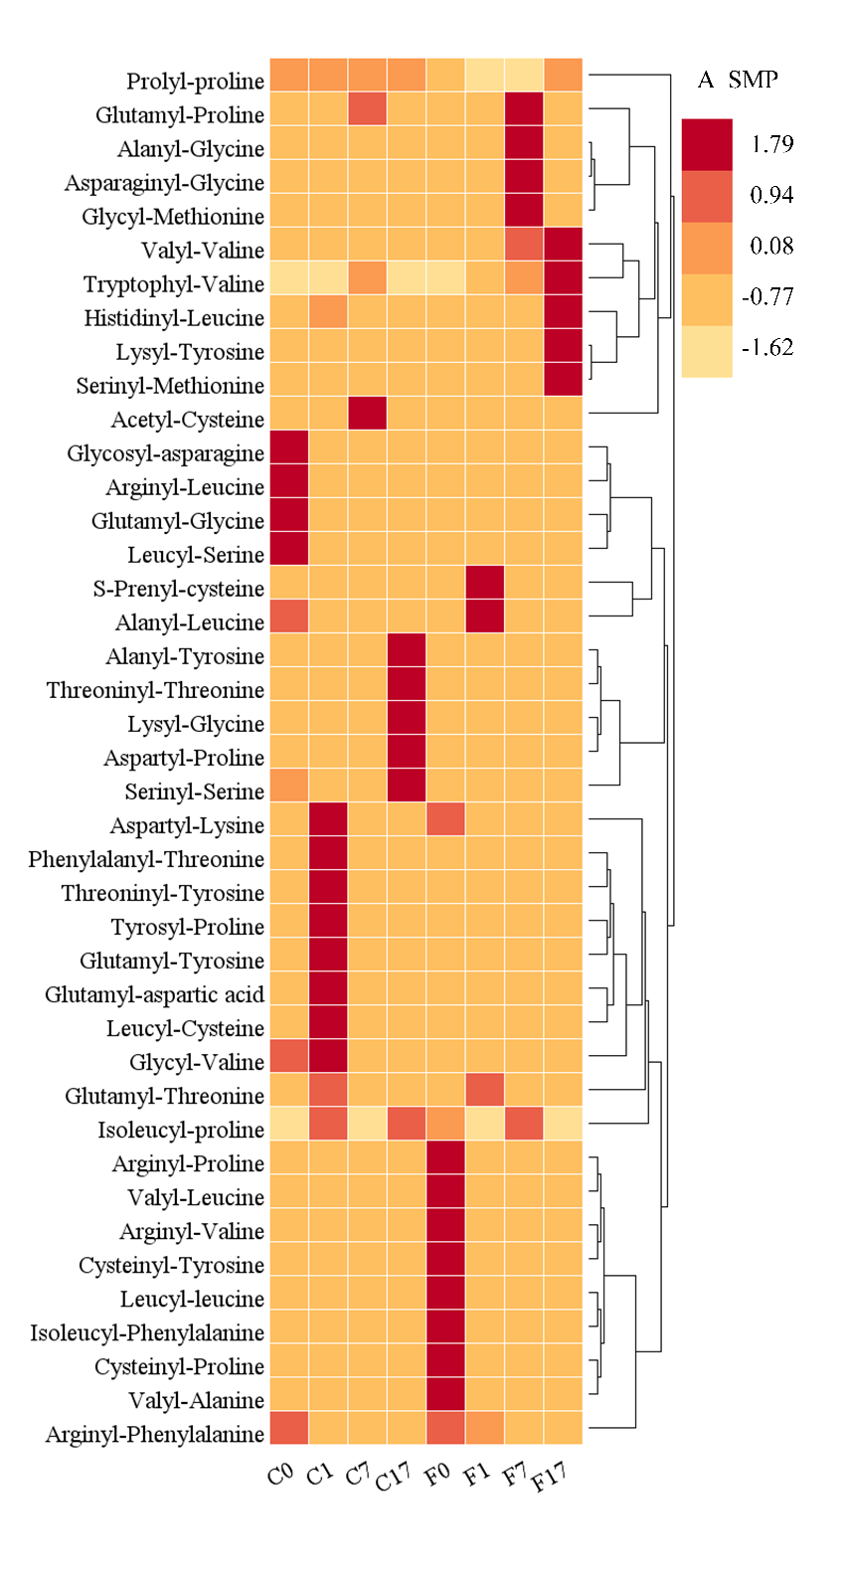

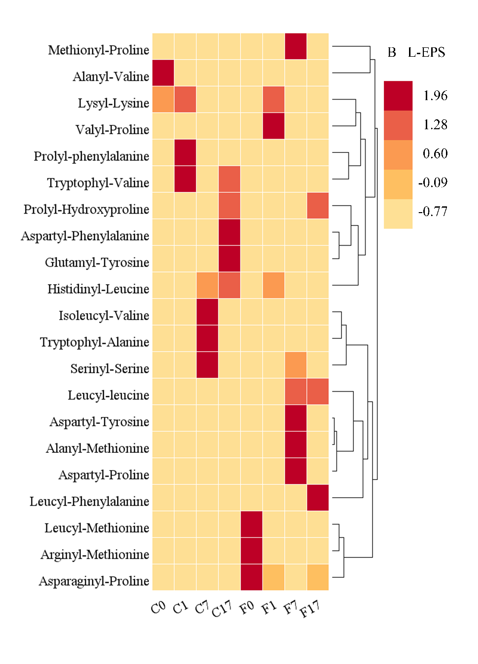

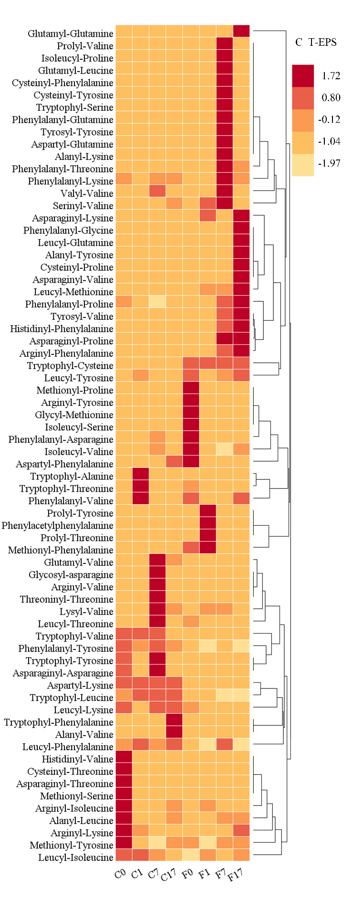

**Figure S4**. Distribution of dipeptides in (A) SMP, (B) L-EPS and (C) T-EPS at different steps in the control and Fe3O4 reactors.

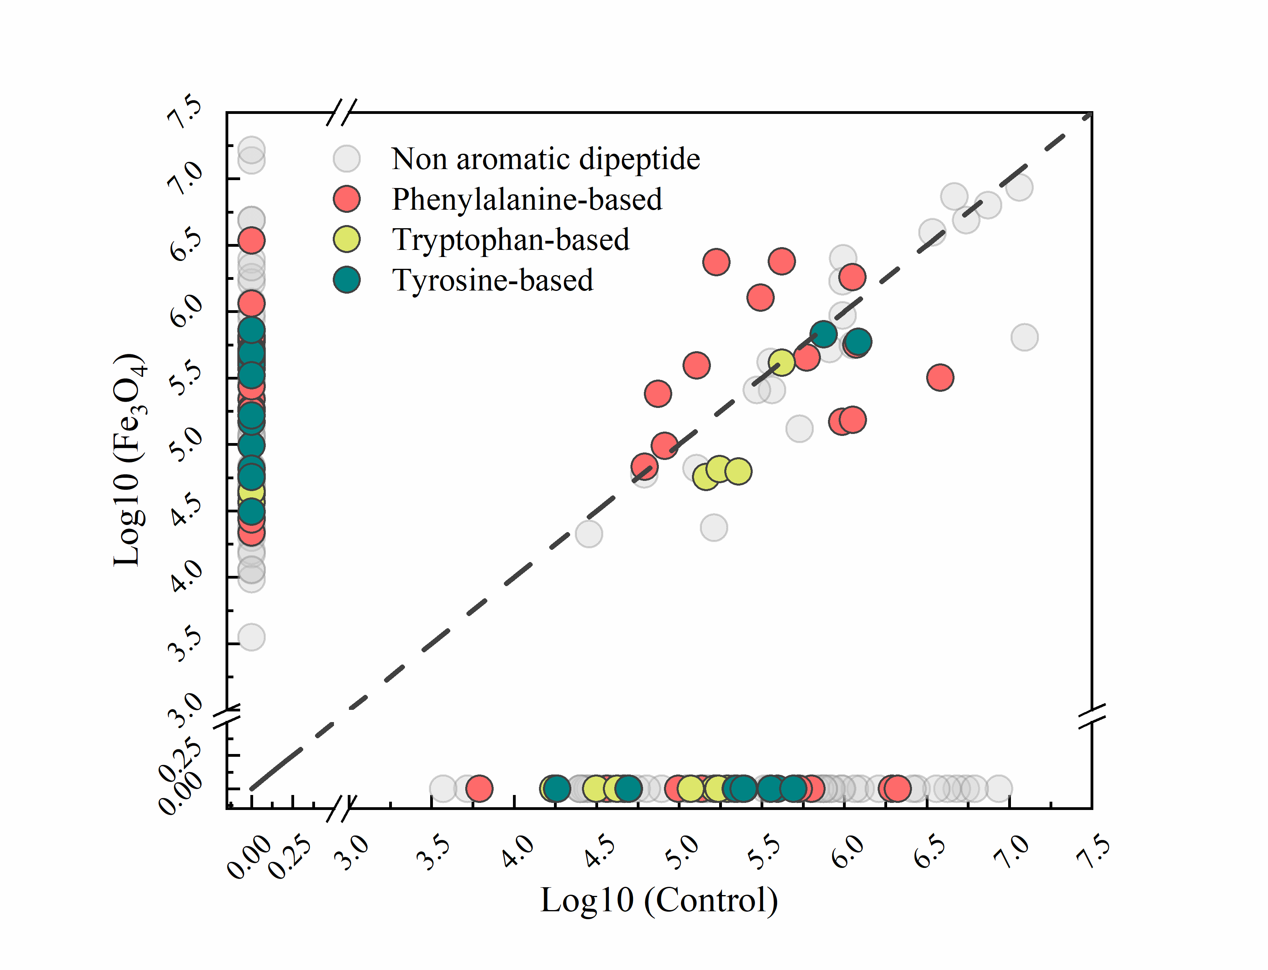

**Figure S5**. Distributed variation of aromatic dipeptides at different steps in the control and Fe3O4 reactors.

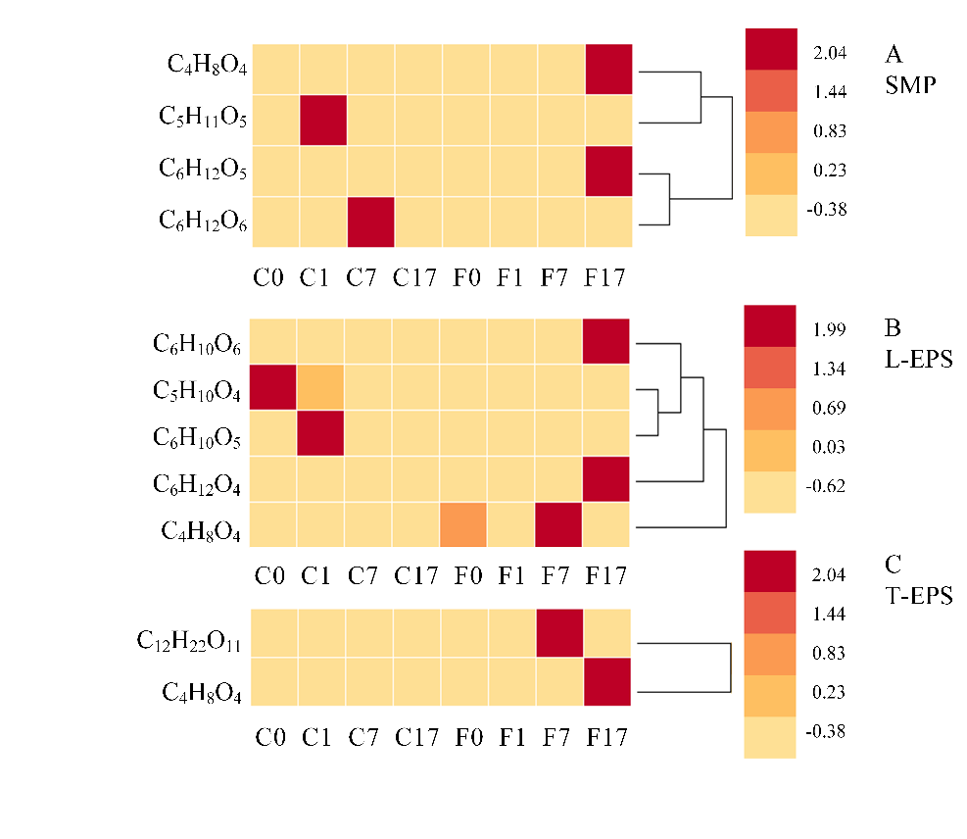

**Figure S6**. Distribution of monosaccharide, disaccharide and derivatives in (A) SMP, (B) L-EPS and (C) T-EPS at different steps in the control and Fe3O4 reactors.