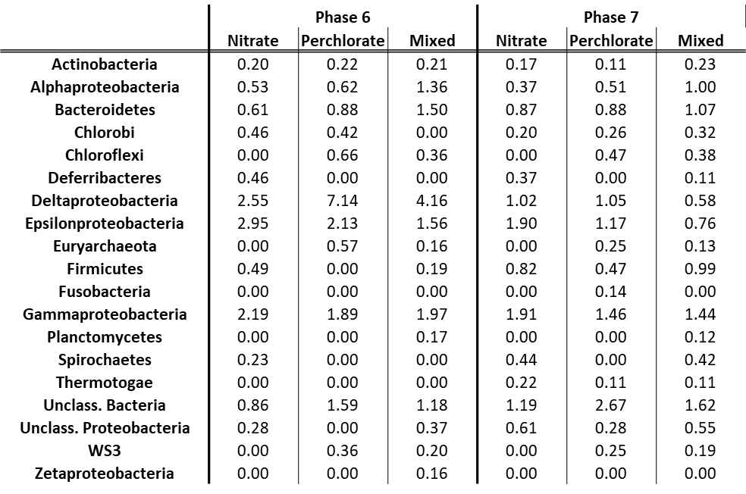

**Table S3:** Contributory percentages for each phylum or class (for Proteobacteria) for each treatment during treatment phases 6 and 7.