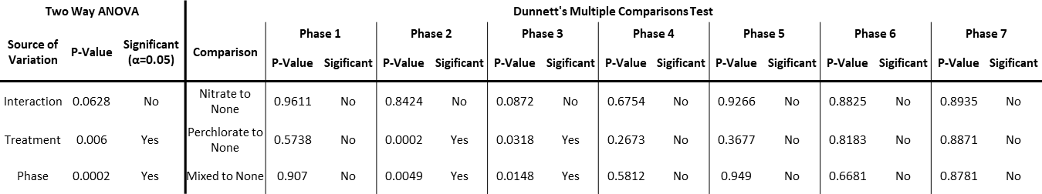

**Table S2:** Summary of the statistical tests and results for the sulfur data for all treatments.