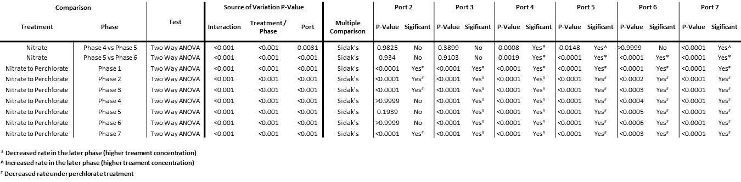

**Table S1:** Summary of the statistical tests and results for the sulfide production rate data for all treatments.