Supplementary Methods
Primers used in this study.
Primers for Chip-qPCR
Gene | Forward | Reverse
miR-146a | ATCCTCCTGCCTTAACCTC | CAGTGATACCTGCCATTCTC
Primers for RT-qPCR
Gene | Forward | Reverse
GAPDH | TGACCTCAACTACATGGTCTACA | CTTCCCATTCTCGGCCTTG
IL-1β | TTCAGGCAGGCAGTATCACTC | GAAGGTCCACGGGAAAGACAC
KDM6A | CATAGACTTGCATCAGATCCTCC | CGGGCGGACAAAAGAAGAAC
KDM6B | AGTGAGGAAGCCGTATGCTG | AGCCCCATAGTTCCGTTTGTG

Supplementary Figures
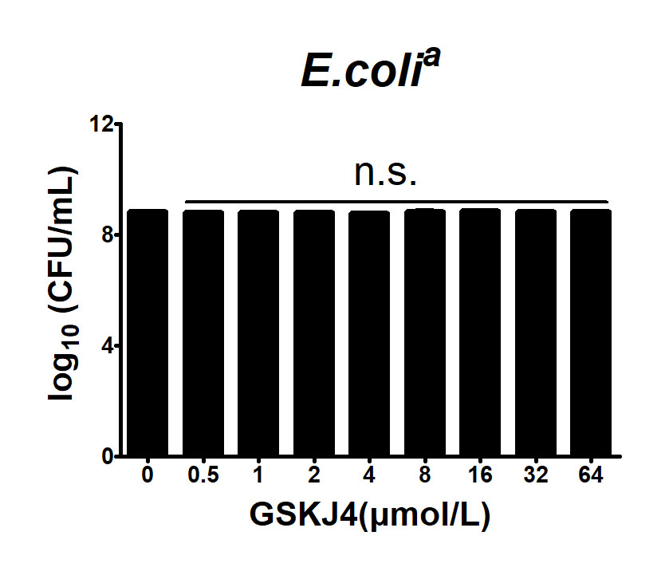

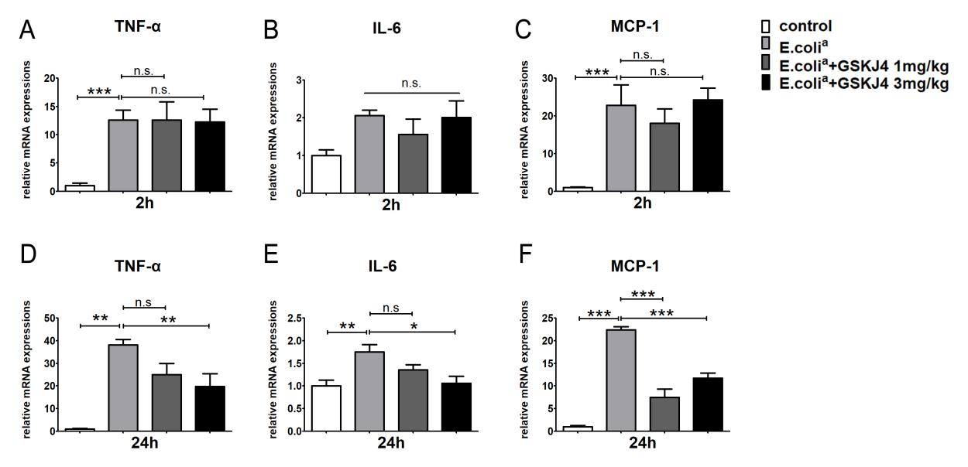
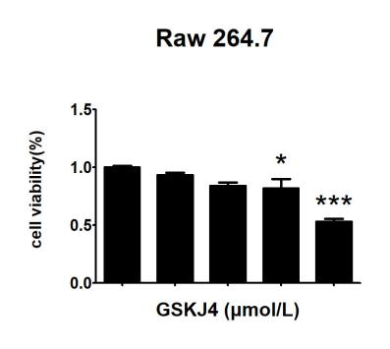
Figure legends
Supplementary Figure 1. Effect of GSKJ4 on the viability of Escherichia coli. Time-kill assays with GSKJ4 at different concentrations for 24 h using inocula of 1 × 10⁵ CFU/mL.
Supplementary Figure 2. GSKJ4 protects mice against septic death. ICR mice were administered intraperitoneally (i.p.) with GSKJ4 (1 or 3 mg/kg body weight) or normal saline 1h prior to bacterial infection intraperitoneally (i.p.) with viable clinical Escherichia coli (E. coliª) (1 × 10⁷ CFU/mouse). The mRNA expression levels of TNF-α (A), IL-6 (B) and MCP-1 (C) in peritoneal macrophage at 2 h post infection were determined by quantitative PCR (7 mice per group). The mRNA expression levels of TNF-α (D), IL-6 (E) and MCP-1 (F) in peritoneal macrophage at 24 h post infection were determined by quantitative PCR. Data are shown as mean ± SEM (n = 7). *P < 0.05; **P < 0.01; ***P < 0.001.
Supplementary Figure 3. Effect of GSKJ4 on the viability of macrophages. Raw264.7 cells were treated with GSKJ4 at different concentrations for 24 h. Cell viability was determined by CCK-8 assay. Data are shown as mean ± SEM (n = 7). *P < 0.05; **P < 0.01; ***P < 0.001.

