Supplementary materials
Induced resistance against western flower thrips by the Pseudomonas syringae-derived defense elicitors in tomato
Gang Chen^{1*}, Rocío Escobar-Bravo¹, Hye Kyong Kim¹, Kirsten A. Leiss², Peter G.L. Klinkhamer¹

¹Plant Science and Natural Products, Institute of Biology, Leiden University, The Netherlands
²Business Unit Horticulture, Wageningen University and Research Centre, Bleiswijk, The Netherlands
*Correspondence
Gang Chen
Email: g.chen@biology.leidenuniv.nl

1 Supplementary Methods

1.1 Supplementary Method 1 Gene expression analysis
The gene-specific primers used for the RT-qPCRs are listed below.
Wound inducible proteinase inhibitor II (Solyc01g095200)
WIPI II_F: 5´- GACAAGGTACTAGTAATCAATTATCC -3´
WIPI II_R: 5´- GGGCATATCCCGAACCAAGA -3´
Pathogenesis related-protein 6 (Solyc00g174340)
PR-P6_F: 5´- GTA CTG CAT CTT CTT GTT TCC A -3´
PR-P6_R: 5´- TAG ATAAGT GCT TGA TGT GCC -3´
Actin (Solyc03g078400)
SlActin_F: 5´- TTAGCACCTTCCAGCAGATGT -3´
SlActin_R: 5´- AACAGACAGGACACTCGCACT -3´

2 Supplementary Figures and Tables
2.1 Supplementary Figures
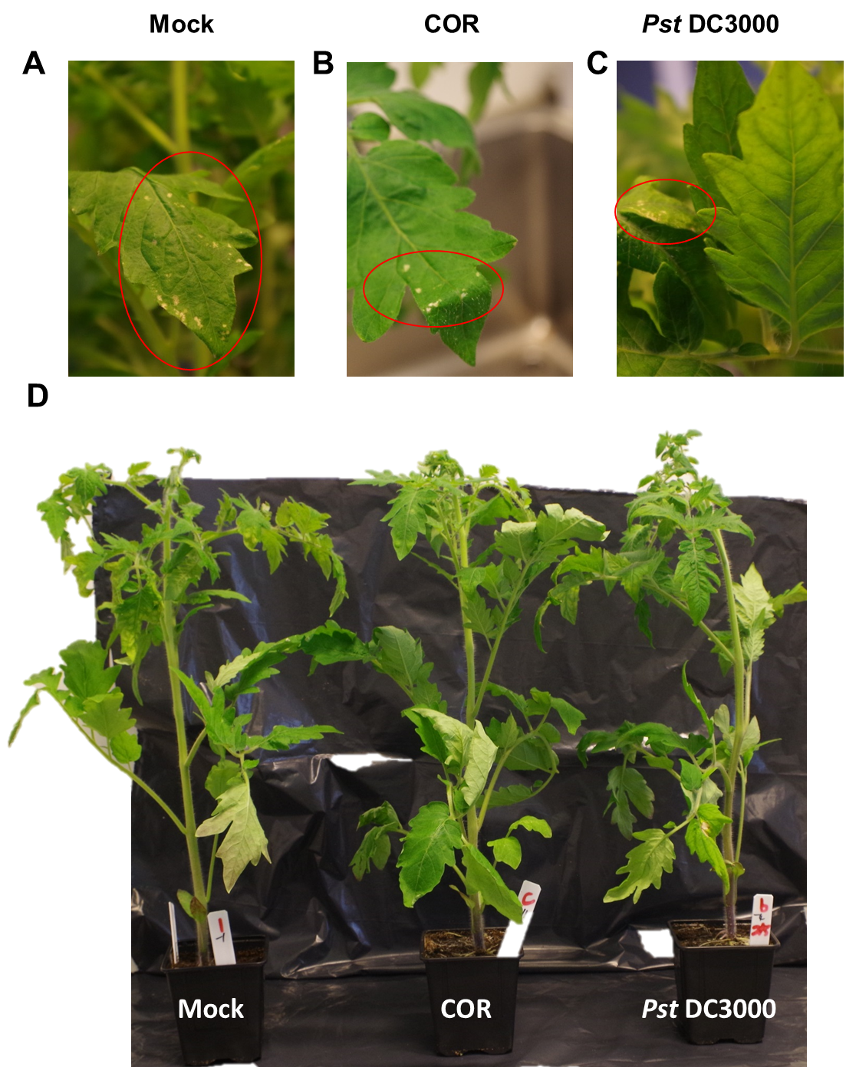

Supplementary Figure S1. Representative photographs of leaves from thrips-infested (A) Mock-, (B) coronatine (COR)- or (C) Pseudomonas syringae pv. tomato DC3000 (Pst DC 3000)-treated plants. The Red circles indicate the silver damage symptoms caused by western flower thrips (WFT) feeding. (D) Representative photographs of the WFT-infested plants subjected to mock-, COR- or Pst DC3000 treatments. Four leaflets of four-week old tomato plants were infiltrated with mock solution (water), 5 µM COR solution or 10⁸ cfu ml⁻¹ Pst DC3000. Seven days after treatments plants were subjected to non-choice whole plant thrips bioassays. Silver damage symptoms were determined at 7 days after infestation.

Supplementary Figure S2. Effect of COR and Pst DC3000 on tomato resistance against WFT. Silver damage symptoms (mean ± SEM, n = 15) were determined in (A) infiltrated and (B) non-infiltrated leaves of mock-, coronatine (COR)- and Pseudomonas syringae pv. tomato DC3000 (Pst DC3000)-treated tomato plants. Plants were infested with (western flower thrips) WFT at 7 days after the initial treatment and evaluated 7 days after WFT infestation. Different letters indicate significant differences among treatments tested by Fisher’s LSD test at P < 0.05.
B
A
Supplementary Figure S3. Important NMR signals that contributed to the metabolome differentiation among treatments. Heatmap of the 78 out of 80 signals detected by NMR and displaying VIP scores > 1 based on PLS-DA analysis. Each heatmap column displays the log₂ fold change of relative peak intensity of the compounds differentially induced in Mock, COR or Pst DC3000 samples in comparison to Mock. Log₂ fold change of compounds in the mock treatment was 0 (fold change = 1). The other 2 out of 80 NMR signals cannot be shown in the Heatmap, because the mean relative peak intensity of Mock was 0.

B
A
Supplementary Figure S4. Effect of Pst DC3000-derived medium on tomato resistance against WFT. Silver damage symptoms (mean ± SEM, n = 10) determined in (A) infiltrated and (B) non-infiltrated leaves of tomato plants treated with a mock solution (mock), blank medium, 0.68 µM coronatine (COR) dissolved in blank medium (blank medium + COR), Pseudomonas syringae pv. tomato DC3000 (Pst DC3000) suspension or Pst DC3000-derived medium (containing 0.68 µM of COR). Plants were infested with western flower thrips (WFT) at 7 days after the initial treatment and evaluated at 7 days after WFT infestation. Different letters indicate significant differences among treatments tested by Fisher’s LSD test at P < 0.05.

B
A
Supplemental Figure S5. Effect of COR and Pst DB29 medium on WFT resistance. Silver damage symptoms (mean ± SEM, n = 10) determined in (A) infiltrated and (B) non-infiltrated leaves of tomato plants treated with blank medium, 0.14 μM COR in blank medium, Pseudomonas syringae pv. tomato DB29 (Pst DB29)-derived medium diluted five-fold with blank medium or 0.14 μM COR in Pst DB29-derived medium diluted five-fold with blank medium. Plants were infested with western flower thrips (WFT) at 7 days after the initial treatment and evaluated 7 days after WFT infestation.

Supplementary Figure S6. Effect of mock solution, COR, or Pst DC3000 on plant growth. (A) Dry biomass of the above ground plant material and (B) stem height were determined in tomato plants infiltrated with a mock solution (mock), 5 µM of coronatine (COR) or 10⁸ cfu ml⁻¹ of Pseudomonas syringae pv. tomato DC3000 (Pst DC3000) suspension. Measurements were performed at 7 days after the initial treatments. Depicted are the average (± SEM) of fifteen replicates. Different letters indicate significant differences among treatments (One way ANOVA followed by Fisher’s LSD test, P < 0.05).

Supplementary Figure S7. Bacteria growth and symptoms of tomato plants infiltrated with COR, Pst DC3000 or Pst DC-3000 derived medium. Four leaflets of four-week old tomato plants were infiltrated with mock solution (water), 5 µM coronatine (COR) solution or 10⁸ cfu ml⁻¹ Pseudomonas syringae pv. tomato DC3000 (Pst DC3000) suspension for experiment 1; or with mock solution (water), blank medium, 0.68 µM COR + blank medium, 10⁸ cfu ml⁻¹ Pst DC3000 suspension or Pst DC3000-derived medium diluted five-fold with blank medium for experiment 2. (A) Pst DC3000 growth was determined in mock-, COR- and Pst DC3000-infiltrated (i.e. local) leaves and (B) in non-infiltrated systemic leaves at 7 days after the initial treatments in experiment 1. (C) Pst DC3000 growth was determined in mock-, blank medium, blank medium +COR, Pst-DC3000, and Pst DC3000-derived medium-infiltrated (i.e. local) leaves at 7 days after the initial treatment in experiment 2. Differences in bacteria growth among the treatments were tested by non-parametric Kruskal-Wallis rank-sum test followed by Wilcoxon rank-sum test for multiple comparisons. n.d.: not detected. Below each graph, representative photographs of the bacterial colonies visually detected in the 10,000x dilution are shown. D) Representative photographs of the symptoms in local leaves observed 7 days after infiltration in the experiment 2 are shown.

2.2 Supplementary tables
Supplementary Table S1. Results of the statistical analysis performed for each figure.
Figure | Panel | Statistical test | Factor and statistic value | df | P
Figure 1 | None | One-way ANOVA | COR or Pst DC3000; F = 8.610 | 2 | P = 0.001
Figure 2 | A | One-way ANOVA | COR or Pst DC3000; F = 25.494 | 2 | P < 0.001
 | B | One-way ANOVA | COR or Pst DC3000; F = 8.943 | 2 | P = 0.007
 | C | One-way ANOVA | COR or Pst DC3000; F = 7.038 | 2 | P = 0.014
Figure 3 | A | One-way ANOVA | COR or Pst DC3000; F = 2.927 | 2 | P = 0.071
 | B | One-way ANOVA | COR or Pst DC3000; F = 3.744 | 2 | P = 0.037
Figure 4 | D | Kruskal-Wallis test | COR or Pst DC3000; χ² = 7.385 | 2 | P = 0.025
 | E | Kruskal-Wallis test | COR or Pst DC3000; χ² = 8.000 | 2 | P = 0.018
 | F | Kruskal-Wallis test | COR or Pst DC3000; χ² = 7.731 | 2 | P = 0.021
 | G | Kruskal-Wallis test | COR or Pst DC3000; χ² = 7.538 | 2 | P = 0.023
 | H | Kruskal-Wallis test | COR or Pst DC3000; χ² = 8.769 | 2 | P = 0.012
Figure 5 | A | One-way ANOVA | COR, Pst DC3000 or Pst DC3000 medium; F = 9.790 | 4 | P < 0.001
 | B | One-way ANOVA | COR, Pst DC3000 or Pst DC3000 medium; F = 156.551 | 4 | P < 0.001
Figure 6 | A | GLM | Dilution; Wald χ² = 8.400 | 4 | P = 0.078
 |  |  | COR or Pst DC3000 medium; Wald χ² = 55.789 | 2 | P < 0.001
 |  |  | Interaction; Wald χ² = 8.537 | 8 | P = 0.383
 | B | GLM | Dilution; Wald χ² = 4.472 | 4 | P = 0.346
 |  |  | COR or Pst DC3000 medium; Wald χ² = 429.336 | 2 | P < 0.001
 |  |  | Interaction; Wald χ² = 17.691 | 8 | P = 0.024
Figure 7 | A | GLM | Pst DB29 medium; Wald χ² = 31.481 | 1 | P < 0.001
 |  |  | COR; Wald χ² < 0.001 | 1 | P = 0.994
 |  |  | Interaction; Wald χ² = 7.104 | 1 | P = 0.008
 | B | GLM | Pst DB29 medium; Wald χ² = 36.311 | 1 | P < 0.001
 |  |  | COR; Wald χ² = 14.623 | 1 | P < 0.001
 |  |  | Interaction; Wald χ² = 2.642 | 1 | P = 0.104

