An empirical comparison of human value models
Online Supplemental Materials

Supplemental Figures
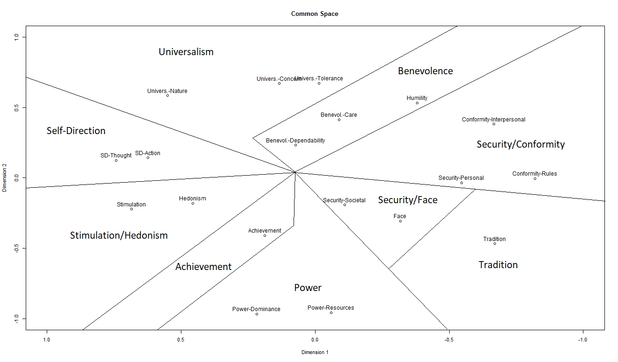
Figure S1. Common space plot of Schwartz’s revised 19-value type model.
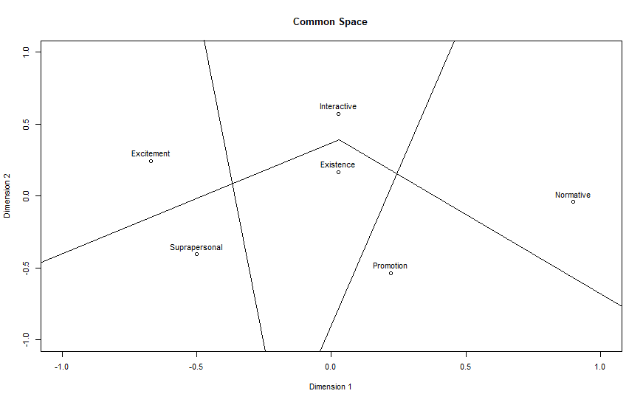
Figure S2. Common space plot of Gouveia’s functional theory model.
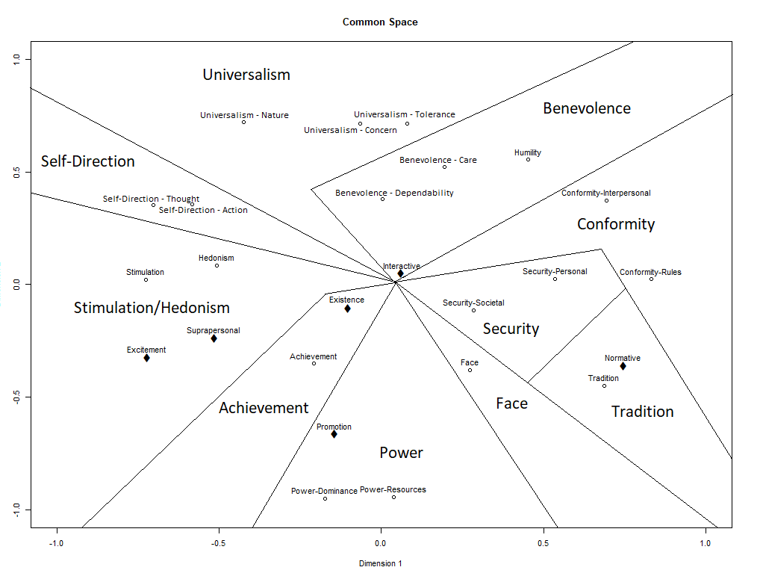
Figure S3. The two meaningful dimensions of the 3-dimensional MDS common space plot.

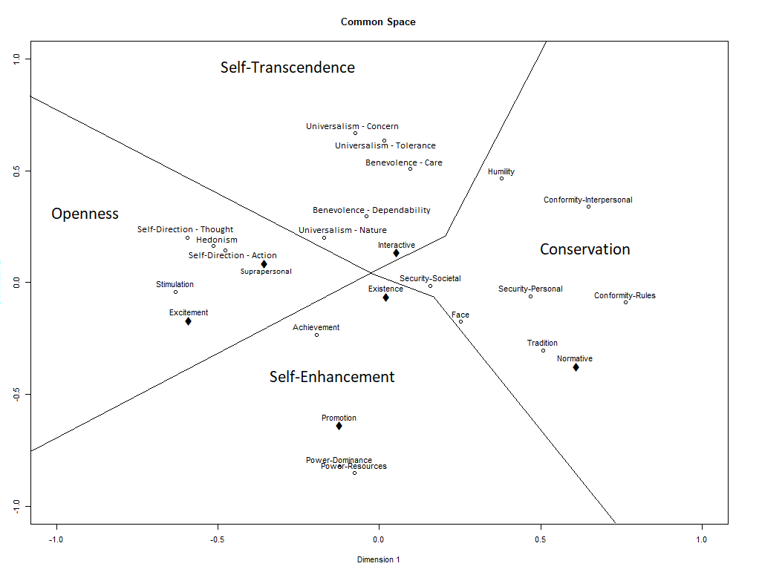
Figure S4. The two meaningful dimensions of the 4-dimensional MDS common space plot.

Hierarchical Regressions – Selective Inclusion

Table 1. Altruism predicted by PVQ + SVO + BVS. Hierarchical Regression
 | Adj. R² | Res.Df | RSS | Df | SSQ | F | p
PVQ + | .12 | 224 | 54.118
SVO | .12 | 223 | 54.079 | 1 | .04 | .16 | .69
SVO + BVS | .14 | 222 | 52.858 | 1 | 1.22 | 5.13 | .026*
Note. PVQ = Self Direction – Action, Stimulation, Power – Dominance, Security – Societal, Tradition, Humility, Universalism – Nature, Universalism – Concern, Universalism – Tolerance, Benevolence - Care, Benevolence - Dependability; SVO = SVO; BVS = Suprapersonal
Significance level: ^{t}p < .1, *p < .05, **p < .01, ***p < .001

Table 2. Altruism predicted by PVQ + BVS + SVO. Hierarchical Regression
 | Adj. R² | Res.Df | RSS | Df | SSQ | F | p
PVQ + | .12 | 224 | 54.118
BVS | .14 | 223 | 52.863 | 1 | 1.25 | 5.27 | .023*
BVS + SVO | .14 | 222 | 52.858 | 1 | .01 | .02 | .883
Note. PVQ = Self Direction – Action, Stimulation, Power – Dominance, Security – Societal, Tradition, Humility, Universalism – Nature, Universalism – Concern, Universalism – Tolerance, Benevolence - Care, Benevolence - Dependability; SVO = SVO; BVS = Suprapersonal
Significance level: ^{t}p < .1, *p < .05, **p < .01, ***p < .001

Table 3. Altruism predicted by SVO + PVQ + BVS. Hierarchical Regression
 | Adj. R² | Res.Df | RSS | Df | SSQ | F | p
SVO + | <.01 | 234 | 64.804
PVQ | .12 | 223 | 54.079 | 11 | 10.73 | 4.1 | < .001***
PVQ + BVS | .14 | 222 | 52.858 | 1 | 1.22 | 5.13 | .025*
Note. PVQ = Self Direction – Action, Stimulation, Power – Dominance, Security – Societal, Tradition, Humility, Universalism – Nature, Universalism – Concern, Universalism – Tolerance, Benevolence - Care, Benevolence - Dependability; SVO = SVO; BVS = Suprapersonal
Significance level: ^{t}p < .1, *p < .05, **p < .01, ***p < .001

Table 4. Altruism predicted by SVO + BVS + PVQ. Hierarchical Regression
 | Adj. R² | Res.Df | RSS | Df | SSQ | F | p
SVO + | <.01 | 234 | 64.804
BVS | .06 | 233 | 60.422 | 1 | 4.38 | 18.40 | < .001***
BVS + PVQ | .14 | 222 | 52.858 | 11 | 7.56 | 2.89 | .001**
Note. PVQ = Self Direction – Action, Stimulation, Power – Dominance, Security – Societal, Tradition, Humility, Universalism – Nature, Universalism – Concern, Universalism – Tolerance, Benevolence - Care, Benevolence - Dependability; SVO = SVO; BVS = Suprapersonal
Significance level: ^{t}p < .1, *p < .05, **p < .01, ***p < .001

Table 5. Altruism predicted by BVS + PVQ + SVO. Hierarchical Regression
 | Adj. R² | Res.Df | RSS | Df | SSQ | F | p
BVS + | .06 | 234 | 60.479
PVQ | .14 | 223 | 52.863 | 11 | 7.62 | 2.91 | .001**
PVQ + SVO | .14 | 222 | 52.858 | 1 | .01 | .02 | .883
Note. PVQ = Self Direction – Action, Stimulation, Power – Dominance, Security – Societal, Tradition, Humility, Universalism – Nature, Universalism – Concern, Universalism – Tolerance, Benevolence - Care, Benevolence - Dependability; SVO = SVO; BVS = Suprapersonal
Significance level: ^{t}p < .1, *p < .05, **p < .01, ***p < .001

Table 6. Altruism predicted by BVS + SVO + PVQ. Hierarchical Regression
 | Adj. R² | Res.Df | RSS | Df | SSQ | F | p
BVS + | .06 | 234 | 60.479
SVO | .06 | 233 | 60.422 | 1 | .06 | .24 | .627
SVO + PVQ | .14 | 222 | 52.858 | 11 | 7.56 | 2.89 | .001**
Note. PVQ = Self Direction – Action, Stimulation, Power – Dominance, Security – Societal, Tradition, Humility, Universalism – Nature, Universalism – Concern, Universalism – Tolerance, Benevolence - Care, Benevolence - Dependability; SVO = SVO; BVS = Suprapersonal
Significance level: ^{t}p < .1, *p < .05, **p < .01, ***p < .001

Table 7. General Health predicted by PVQ + SVO + BVS. Hierarchical Regression
 | Adj. R² | Res.Df | RSS | Df | SSQ | F | p
PVQ + | .1 | 232 | 50.805
SVO | .1 | 231 | 50.718 | 1 | .09 | .4 | .528
SOV + BVS | .11 | 230 | 50.066 | 1 | .65 | 2.99 | .085^{t}
Note. PVQ = Hedonism, Face, Conformity – Interpersonal; SVO = SVO; BVS = Suprapersonal
Significance level: ^{t}p < .1, *p < .05, **p < .01, ***p < .001

Table 8. General Health predicted by PVQ + BVS + SVO. Hierarchical Regression
 | Adj. R² | Res.Df | RSS | Df | SSQ | F | P
PVQ + | .1 | 232 | 50.805
BVS | .11 | 231 | 50.148 | 1 | .66 | 3.02 | .084^{t}
BVS + SVO | .11 | 230 | 50.066 | 1 | .08 | .37 | .542
Note. PVQ = Hedonism, Face, Conformity – Interpersonal; SVO = SVO; BVS = Suprapersonal
Significance level: ^{t}p < .1, *p < .05, **p < .01, ***p < .001

Table 9. General Health predicted by SVO + PVQ + BVS. Hierarchical Regression
 | Adj. R² | Res.Df | RSS | Df | SSQ | F | p
SVO + | <.01 | 234 | 57.163
PVQ | .09 | 231 | 50.718 | 3 | 6.45 | 9.87 | < .001***
PVQ + BVS | .11 | 230 | 50.066 | 1 | .65 | 2.99 | .085^{t}
Note. PVQ = Hedonism, Face, Conformity – Interpersonal; SVO = SVO; BVS = Suprapersonal
Significance level: ^{t}p < .1, *p < .05, **p < .01, ***p < .001

Table 10. General Health predicted by SVO + BVS + PVQ. Hierarchical Regression
 | Adj. R² | Res.Df | RSS | Df | SSQ | F | p
SVO + | <.01 | 234 | 57.163
BVS | .01 | 233 | 56.16 | 1 | 1 | 4.61 | .033*
BVS + PVQ | .11 | 230 | 50.066 | 3 | 6.09 | 9.33 | < .001***
Note. PVQ = Hedonism, Face, Conformity – Interpersonal; SVO = SVO; BVS = Suprapersonal
Significance level: ^{t}p < .1, *p < .05, **p < .01, ***p < .001

 | Table 11. General Health predicted by BVS + PVQ + SVO. Hierarchical Regression
 |  | Adj. R² | Res.Df |  | RSS |  | Df |  | SSQ |  | F |  | p
 | BVS + | .01 | 234 |  | 56.168
 | PVQ | .11 | 231 |  | 50.148 |  | 3 |  | 6.02 |  | 9.22 |  | < .001***
 | PVQ + SVO | .11 | 230 |  | 50.066 |  | 1 |  | .08 |  | .37 |  | .855
Note. PVQ = Hedonism, Face, Conformity – Interpersonal; SVO = SVO; BVS = Suprapersonal
Significance level: ^{t}p < .1, *p < .05, **p < .01, ***p < .001
 |  | Table 12. General Health predicted by BVS + SVO + PVQ. Hierarchical Regression
 |  | Adj. R² |  | Res.Df |  | RSS |  | Df |  | SSQ |  | F | p
BVS + |  | .01 |  | 234 |  | 56.168
SVO |  | .01 |  | 233 |  | 56.16 |  | 1 |  | .01 |  | .03 | .848
SVO + PVQ |  | .11 |  | 230 |  | 50.066 |  | 3 |  | 6.09 |  | 9.33 | < .001***
Note. PVQ = Hedonism, Face, Conformity – Interpersonal; SVO = SVO; BVS = Suprapersonal
Significance level: ^{t}p < .1, *p < .05, **p < .01, ***p < .001

Table 13. Environmentalism predicted by PVQ + SVO + BVS. Hierarchical Regression
 | Adj. R² | Res.Df | RSS | Df | SSQ | F | p
PVQ + | .25 | 228 | 66.993
SVO | .26 | 227 | 65.579 | 1 | 1.41 | 4.98 | .027*
SVO + BVS | .27 | 226 | 64.19 | 1 | 1.39 | 4.89 | .028*
Note. PVQ = Self-Direction – Thought, Self-Direction – Action, Conformity – Interpersonal, Humility, Universalism – Nature, Universalism – Concern, Universalism - Tolerance; SVO = SVO; BVS = Suprapersonal
Significance level: ^{t}p < .1, *p < .05, **p < .01, ***p < .001

Table 14. Environmentalism predicted by PVQ + BVS + SVO. Hierarchical Regression
 | Adj. R² | Res.Df | RSS | Df | SSQ | F | p
PVQ + | .25 | 228 | 66.993
BVS | .26 | 227 | 65.906 | 1 | 1.09 | 3.83 | .052^{t}
BVS + SVO | .27 | 226 | 64.19 | 1 | 1.72 | 6.04 | .014*
Note. PVQ = Self-Direction – Thought, Self-Direction – Action, Conformity – Interpersonal, Humility, Universalism – Nature, Universalism – Concern, Universalism - Tolerance; SVO = SVO; BVS = Suprapersonal
Significance level: ^{t}p < .1, *p < .05, **p < .01, ***p < .001

Table 15. Environmentalism predicted by SVO + PVQ + BVS. Hierarchical Regression
 | Adj. R² | Res.Df | RSS | Df | SSQ | F | p
SVO + | .02 | 234 | 89.141
PVQ | .26 | 227 | 65.579 | 7 | 23.56 | 11.85 | < .001***
PVQ + BVS | .27 | 226 | 64.19 | 1 | 1.39 | 4.89 | .028*
Note. PVQ = Self-Direction – Thought, Self-Direction – Action, Conformity – Interpersonal, Humility, Universalism – Nature, Universalism – Concern, Universalism - Tolerance; SVO = SVO; BVS = Suprapersonal
Significance level: ^{t}p < .1, *p < .05, **p < .01, ***p < .001

Table 16. Environmentalism predicted by SVO + BVS + PVQ. Hierarchical Regression
 | Adj. R² | Res.Df | RSS | Df | SSQ | F | p
SVO + | .02 | 234 | 89.141
BVS | .09 | 233 | 82.17 | 1 | 6.97 | 24.54 | < .001***
BVS + PVQ | .27 | 226 | 64.19 | 7 | 17.98 | 9.04 | < .001***
Note. PVQ = Self-Direction – Thought, Self-Direction – Action, Conformity – Interpersonal, Humility, Universalism – Nature, Universalism – Concern, Universalism - Tolerance; SVO = SVO; BVS = Suprapersonal
Significance level: ^{t}p < .1, *p < .05, **p < .01, ***p < .001

Table 17. Environmentalism predicted by BVS + PVQ + SVO. Hierarchical Regression
 | Adj. R² | Res.Df | RSS | Df | SSQ | F | p
BVS + | .07 | 234 | 84.962
PVQ | .26 | 227 | 65.906 | 7 | 19.06 | 9.58 | < .001***
PVQ + SVO | .27 | 226 | 64.19 | 1 | 1.72 | 6.04 | .015*
Note. PVQ = Self-Direction – Thought, Self-Direction – Action, Conformity – Interpersonal, Humility, Universalism – Nature, Universalism – Concern, Universalism - Tolerance; SVO = SVO; BVS = Suprapersonal
Significance level: ^{t}p < .1, *p < .05, **p < .01, ***p < .001

Table 18. Environmentalism predicted by BVS + SVO + PVQ. Hierarchical Regression
 | Adj. R² | Res.Df | RSS | Df | SSQ | F | p
BVS + | .07 | 234 | 84.962
SVO | .09 | 233 | 82.17 | 1 | 2.79 | 9.83 | .002**
SVO + PVQ | .27 | 226 | 64.19 | 7 | 17.98 | 9.04 | < .001***
Note. PVQ = Self-Direction – Thought, Self-Direction – Action, Conformity – Interpersonal, Humility, Universalism – Nature, Universalism – Concern, Universalism - Tolerance; SVO = SVO; BVS = Suprapersonal
Significance level: ^{t}p < .1, *p < .05, **p < .01, ***p < .001

