Supporting Information

Synthesis and Thermoelectric Characterization of Lead Telluride Hollow Nanofibers
Miluo Zhang¹, Su-Dong Park², Jiwon Kim³, Michael Nalbandian⁴, Seil Kim^{3,5}, Yongho Choa⁵, Jaehong Lim³, and Nosang V. Myung^{1,}*
¹Department of Chemical and Environmental Engineering and Winston Chung Global Energy Center, University of California-Riverside, Riverside, CA, USA
²Advanced Materials and Application Research Division, Korea Electrotechnology Research Institute, Changwon, South Korea
³Electrochemistry Department, Korea Institute of Materials Science, Changwon 641-831, Korea
⁴Department of Civil Engineering and Construction Management, California Baptist University, Riverside, CA, USA
⁵Department of Fusion Chemical Engineering, Hanyang University, Ansan, South Korea

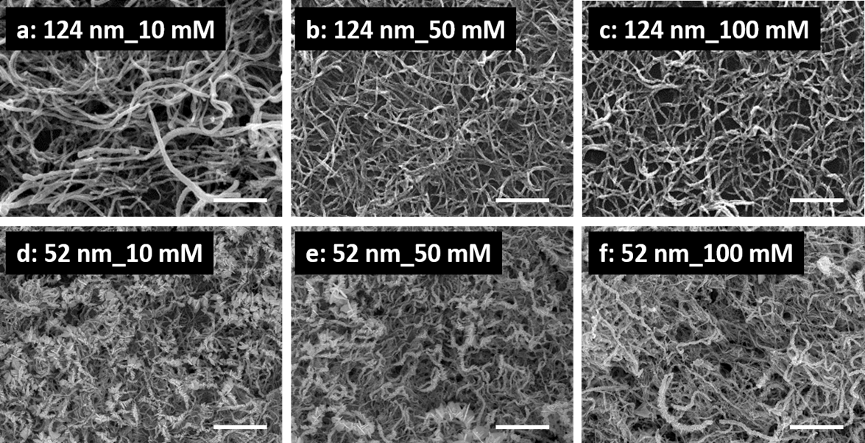

Figure S1. Low magnification SEM images of synthesized Pb_{x}Te_{y} hollow nanofibers using 124 nm (top row) and 52 nm (bottom row) Co nanofibers as sacrificial materials. The electrolytes contain a fixed concentration of 0.1 mM HTeO₂⁺ and 0.1 M HNO₃ with various concentration of Pb²⁺ of 10 mM (left column), 50 mM (middle column), and 100 mM (right column). The reactions were conducted at room temperature for 30 min. The scale bar represents 1 micron.
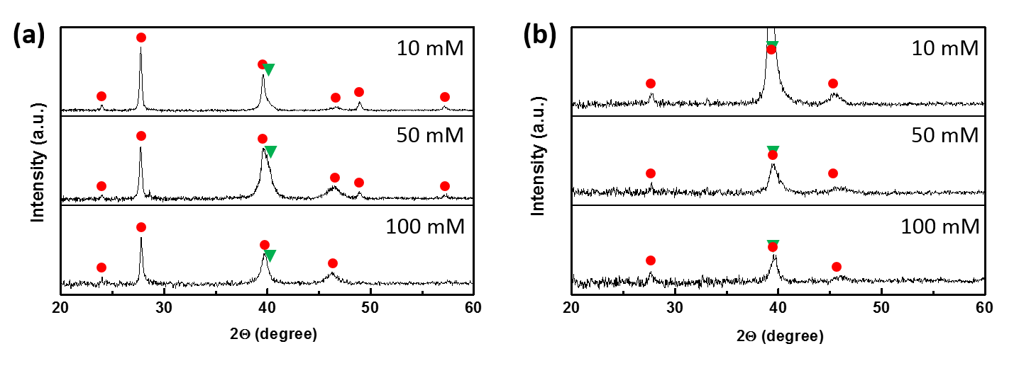
Figure S2. XRD pattern of PbTe hollow nanofibers using (a) 124 nm and (b) 52 nm Co nanofibers as sacrificial materials. The electrolytes contain a fixed concentration of 0.1 mM HTeO₂⁺ and 0.1 M HNO₃ with various concentration of Pb⁺ of 10 Mm, 50 mM, and 100 mM, as labelled. The peaks with red dots and green triangles belong to PbTe and Pt, respectively.

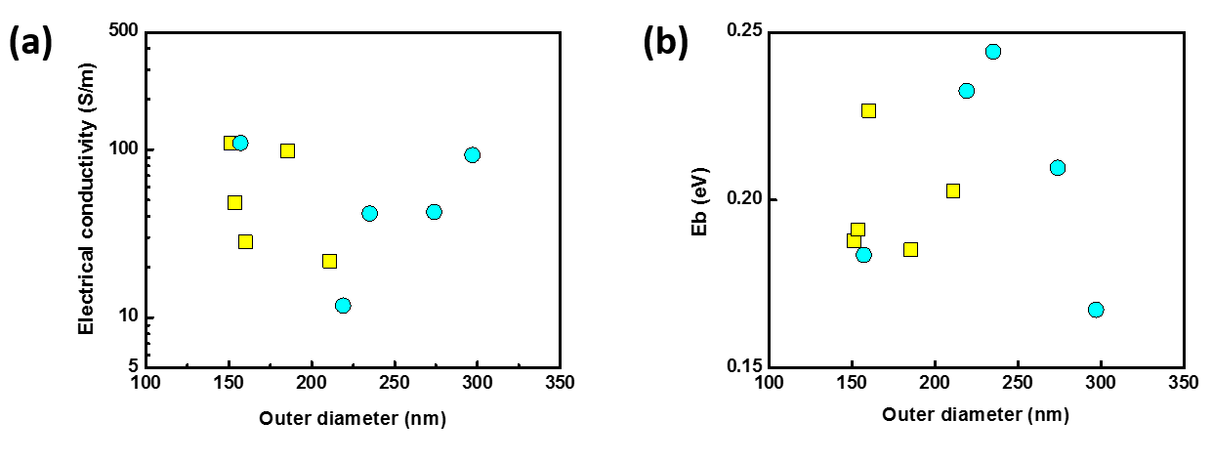
Figure S3. (a) Electrical conductivity and (b) energy barrier height E_{b} of PbTe single nanofibers as a function of outer diameter. Yellow squares and blue circles indicate Pb_{x}Te_{y} from 52 nm and 124 nm Co nanofibers, respectively.

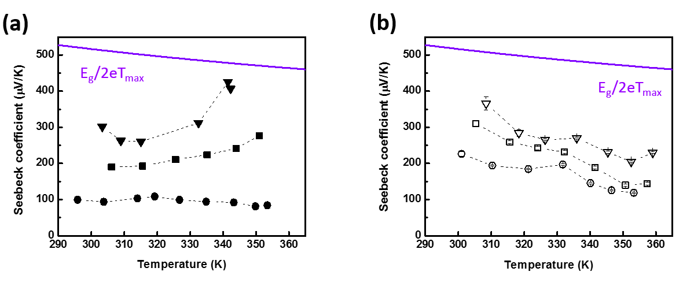
Figure S4. (a) Temperature dependent Seebeck coefficient of Pb₄₃Te₅₇ (solid triangles), Pb₄₂Te₅₈ (solid squares), and Pb₃₇Te₆₃ (solid circles) nanofiber mats reacted from 52 nm Co nanofiber mats. (b) Temperature dependent Seebeck coefficient of Pb₄₃Te₅₇ (open triangles), Pb₃₉Te₆₁ (open squares), and Pb₄₄Te₅₆ (open circles) nanofiber mats reacted from 124 nm Co nanofiber mats. The electrolytes contain a fixed concentration of 0.1 mM HTeO₂⁺ and 0.1 M HNO₃ with various concentration of Pb⁺ of 10 mM (triangle), 50 mM (square), and 100 mM (circle). The maximum Seebeck coefficient S_{max}=E_{g}/2eT_{max} is predicted and plotted in the purple lines.

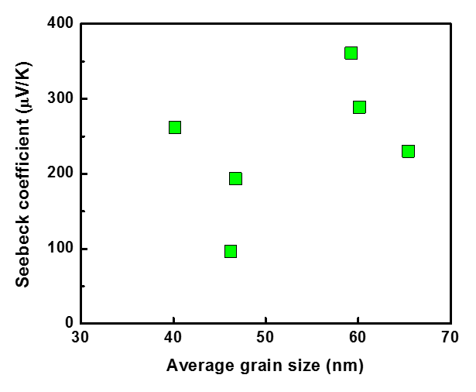
Figure S5. Seebeck coefficient of PbTe nanofiber mats as a function of average grain size.

