Supp. Table 1: Subject Demographics and Individual Antibody Data
ID | Group | Age | WB #ARA IgG | ~23kD Band¥ | No Ag IgM§ | Recov IgM | No Ag IgG | Recov IgG | No Ag IgG1 | Recov IgG1
A001 | AIR | 60-65 | 5 | Y | 0.078±0.019 | 0.196±0.019 | 0.108±0.055 | 0.161±0.055 | 0.132±0.028 | 0.172±0.009
A048 | AIR | 70-75 | 3* | Y | 0.117±0.031 | 0.212±0.057 | 0.364±0.012 | 0.340±0.237 | 0.163±0.017 | 0.404±0.022
A052 | AIR | 70-75 | 7 | Y | 0.068±0.012 | 0.385±0.033 | 0.110±0.007 | 0.456±0.012 | 0.087±0.007 | 0.193±0.008
A061 | AIR | 65-70 | 4 | N | 0.061±0.002 | 0.106±0.013 | 0.112±0.007 | 0.260±0.017 | 0.110±0.016 | 0.290±0.036
A070 | AIR | 55-60 | 6 | N | 0.099±0.007 | 0.463±0.020 | 0.138±0.007 | 0.606±0.021 | 0.161±0.004 | 0.198±0.005
A125 | AIR | 70-75 | 9 | Y | 0.078±0.003 | 0.123±0.036 | 0.176±0.030 | 0.451±0.040 | 0.178±0.036 | 0.484±0.025
A132 | AIR | 55-60 | 4 | N | 0.088±0.019 | 0.152±0.017 | 0.111±0.026 | 0.775±0.079 | 0.256±0.081 | 0.733±0.128
A134 | AIR | 50-55 | 5* | N | 0.076±0.004 | 0.350±0.051 | 0.130±0.033 | 0.589±0.071 | 0.372±0.069 | 0.462±0.023
A135 | AIR | 55-60 | 3 | N | 0.077±0.008 | 0.344±0.076 | 0.129±0.042 | 0.677±0.072 | 0.231±0.007 | 0.697±0.046
A145 | AIR | 60-65 | 3 | Y | 0.062±0.004 | 0.078±0.008 | 0.373±0.040 | 0.819±0.053 | 0.126±0.007 | 0.171±0.010
A166 | AIR | 25-30 | 4 | N | 0.109±0.008 | 0.467±0.038 | 0.137±0.037 | 0.650±0.019 | 0.135±0.003 | 0.202±0.022
A178 | AIR | 40-45 | 8* | N | 0.145±0.038 | 0.189±0.048 | 0.319±0.019 | 0.493±0.025 | 0.154±0.013 | 0.300±0.029
A213 | AIR | 55-60 | 5 | Y | 0.102±0.010 | 0.089±0.013 | 0.336±0.077 | 0.308±0.006 | 0.167±0.007 | 0.360±0.021
A277 | AIR | 45-50 | 2* | N | 0.293±0.044 | 0.097±0.045 | 0.080±0.021 | 0.586±0.148 | 0.103±0.002 | 0.160±0.009
A286 | AIR | 40-45 | 9* | Y | 0.056±0.002 | 0.211±0.102 | 0.210±0.089 | 0.739±0.181 | 0.184±0.024 | 0.387±0.005
R152 | RP | 20-25 | 2 | N | 0.064±0.008 | 0.168±0.052 | 0.093±0.003 | 0.557±0.036 | 0.116±0.006 | 0.164±0.009
R172 | RP | 20-25 | 2 | N | 0.053±0.006 | 0.065±0.010 | 0.230±0.028 | 0.256±0.019 | 0.206±0.031 | 0.266±0.026
R188 | RP | 55-60 | 0 | N | 0.145±0.034 | 0.336±0.020 | 0.114±0.011 | 0.425±0.020 | 0.122±0.006 | 0.160±0.006
R201 | RP | 65-70 | 3 | Y | 0.057±0.004 | 0.176±0.093 | 0.075±0.025 | 0.727±0.161 | 0.137±0.017 | 0.187±0.008
R215 | RP | 35-40 | 1 | N | 0.156±0.033 | 0.100±0.021 | 0.211±0.017 | 0.470±0.015 | 0.151±0.018 | 0.292±0.022
R223 | RP | 55-60 | 2 | Y | 0.138±0.016 | 0.137±0.045 | 0.171±0.038 | 0.428±0.031 | 0.138±0.004 | 0.191±0.005
R237 | RP | 55-60 | 2 | N | 0.142±0.026 | 0.275±0.042 | 0.177±0.041 | 0.748±0.066 | 0.070±0.002 | 0.159±0.012
R242 | RP | 60-65 | 3 | N | 0.101±0.023 | 0.101±0.011 | 0.067±0.015 | 0.480±0.096 | 0.062±0.005 | 0.133±0.006
R245 | RP | 30-35 | 0 | N | 0.076±0.011 | 0.127±0.061 | 0.110±0.016 | 0.400±0.032 | 0.100±0.005 | 0.139±0.003
R253 | RP | 45-50 | 0 | N | 0.094±0.033 | 0.140±0.049 | 0.108±0.044 | 0.292±0.075 | 0.106±0.005 | 0.142±0.009
R261 | RP | 75-80 | 1 | N | 0.073±0.018 | 0.080±0.006 | 0.095±0.047 | 0.662±0.036 | 0.067±0.003 | 0.292±0.009
R271 | RP | 35-40 | 3 | N | 0.144±0.059 | 0.101±0.011 | 0.261±0.137 | 0.300±0.164 | 0.169±0.008 | 0.404±0.035
R281 | RP | 35-40 | 2 | N | 0.081±0.037 | 0.536±0.119 | 0.112±0.047 | 0.560±0.056 | 0.362±0.028 | 0.318±0.055
R294 | RP | 70-75 | 2 | N | 0.083±0.032 | 0.396±0.017 | 0.052±0.005 | 0.971±0.177 | 0.093±0.003 | 0.201±0.016
R300 | RP | 35-40 | 3 | Y | 0.144±0.015 | 0.126±0.047 | 0.134±0.053 | 0.248±0.027 | 0.055±0.007 | 0.068±0.001
C010 | HC | 50-55 | 1 | N | 0.054±0.006 | 0.228±0.018 | 0.061±0.018 | 0.500±0.124 | 0.126±0.022 | 0.305±0.021
C230 | HC | 50-55 | 0 | N | 0.084±0.008 | 0.077±0.012 | 0.097±0.017 | 0.143±0.039 | 0.110±0.017 | 0.130±0.011
C249 | HC | 35-40 | 0 | N | 0.066±0.005 | 0.235±0.070 | 0.111±0.064 | 0.422±0.047 | 0.125±0.005 | 0.236±0.033
C272 | HC | 50-55 | 0 | N | 0.059±0.008 | 0.164±0.049 | 0.053±0.007 | 0.704±0.087 | 0.184±0.024 | 0.276±0.009
C273 | HC | 50-55 | 2 | N | 0.070±0.021 | 0.094±0.072 | 0.052±0.006 | 0.586±0.034 | 0.203±0.030 | 0.255±0.031
C275 | HC | 55-60 | 2 | N | 0.054±0.006 | 0.149±0.047 | 0.078±0.002 | 0.503±0.028 | 0.101±0.006 | 0.154±0.012
C319 | HC | 65-70 | 0 | N | 0.097±0.012 | 0.409±0.056 | 0.063±0.015 | 0.555±0.102 | 0.175±0.018 | 0.305±0.040
C323 | HC | 65-70 | 0 | N | 0.078±0.025 | 0.083±0.051 | 0.089±0.037 | 0.373±0.023 | 0.097±0.006 | 0.175±0.012
C324 | HC | 55-60 | 1 | N | 0.097±0.047 | 0.182±0.039 | 0.110±0.059 | 0.330±0.078 | 0.159±0.008 | 0.261±0.010
C360 | HC | 65-70 | 0 | N | 0.117±0.021 | 0.209±0.050 | 0.072±0.012 | 0.417±0.053 | 0.291±0.050 | 0.440±0.059
C361 | HC | 60-65 | 0 | N | 0.064±0.004 | 0.156±0.018 | 0.072±0.006 | 0.393±0.046 | 0.130±0.024 | 0.348±0.015
C362 | HC | 55-60 | 0 | N | 0.082±0.005 | 0.208±0.006 | 0.069±0.005 | 0.348±0.063 | 0.105±0.033 | 0.170±0.035
C363 | HC | 50-55 | 1 | N | 0.056±0.002 | 0.093±0.005 | 0.071±0.003 | 0.454±0.095 | 0.091±0.022 | 0.152±0.009
C364 | HC | 55-60 | 2 | N | 0.078±0.013 | 0.148±0.063 | 0.087±0.009 | 0.231±0.053 | 0.151±0.020 | 0.112±0.002
nd = ARA WB not done for this person
*Some Western blots had very faint bands or areas of smeared signals making it difficult to count more bands than listed.
~Recoverin is a 23 kilodalton retinal protein that was not positively detected on every Western blot.
§Numeric values for antibody levels are mean absorbance at 450 nm ± standard deviation of triplicates.

Supp. Table 2: Most Differentially Expressed Genes (AIR vs Healthy Controls)
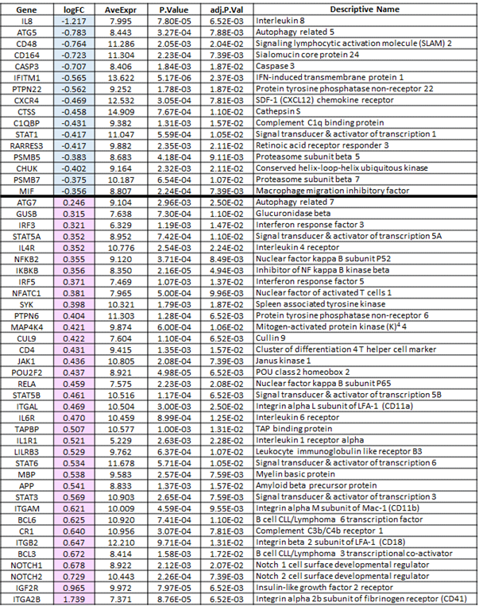
The 16 genes listed at the top (blue logFC column) were lower in AIR patients than in healthy controls.
The 36 genes listed on the bottom (pink logFC column) were higher in AIR patients than in healthy controls.
Average expression values are exponents of log(2) transformation of copy number data for all samples.

