Supplementary Material

Landscape Structures affect risk of Canine Distemper in Urban Wildlife
Pierre Gras ^{1,2,}*, Sarah Knuth ^{3,1}, Konstantin Börner ⁴, Lucile Marescot ⁴, Sarah Benhaiem ¹, Angelika Aue ⁵, Ulrich Wittstatt ⁵, Birgit Kleinschmit ³, Stephanie Kramer-Schadt ^{1,2,}*
* Correspondence:

Dr. Pierre Gras
gras@izw-berlin.de
Dr. Stephanie Kramer-Schadt
kramer@izw-berlin.de

Inhalt
1 Supplementary Data 3
1.1 S13 Fox carcass locations 3
2 Supplementary Description, Figures, Tables and Lists 3
2.1 Supplementary Description 3
2.1.1 Supplementary Description S1 - Description of lab methods 3
2.1.2 Supplementary Description S2 - Model formulas of the single variable models 4
2.2 Supplementary Tables 5
2.2.1 Supplementary Table S4a – AICc of all single predictor models for the data from 2009-2013 5
2.2.2 Supplementary Table S4b – AICc of all single predictor models for the data from 2012-2013 7
2.2.3 Supplementary Table S11 – Summary of the estimated effect of the landscape metrics models 8
2.2.4 Supplementary Figure S12 – Figure 5 with interaction term for time and land-use variables 10
2.3 Supplementary Figures 11
2.3.1 Supplementary Figure S7 – Temporal pattern of seropositive cases by age categories from 2008 – 2013 11
Supplementary Figure S8 – Temporal pattern of seropositive cases all carcasses from 2008 – 2013 11
2.3.2 Supplementary Figure S9 – Spatial distribution of all used landscape variables across Berlin and 4km of Brandenburg area 13
2.3.3 Supplementary Figure S10 – Number of found carcasses for each sex/age category 14
2.4 Supplementary Lists 15
2.4.1 Supplementary List S6a – Candidate model formulas in R syntax for the data from 2009-2013 15
2.4.2 Supplementary List S6b – Candidate model formulas in R syntax for the data from 2012-2013 18

Supplementary Data

S13 Fox carcass locations
Data of fed fox carcass locations with attributes sex, age and cause of death (see file: data sheet 1.csv).

Supplementary Descriptions, Figures, Tables and Lists

Supplementary Description

Supplementary Description S1 - Description of lab methods
Canine distemper virus (CDV) quickly spreads through wildlife populations via aerosols of respiratory exudate (Williams and Barker, 2008) and impairs individual health condition by affecting integumentary systems, gastrointestinal, respiratory and central nervous most severely (Deem et al., 2000). Typical symptoms are fever, diarrhoea, anorexia/emaciation, ocular exudates, seizures and ataxia (Martella et al., 2002; Woo et al., 2010).
In order to detect CDV antibodies in red foxes a direct immunofluorescence test was applied by the state laboratory of Berlin and Brandenburg. For this purpose, impression smears or frozen sections of spleen, bowel, lung, brain and lymph node were prepared and object holders were fixed with anhydrous acetone (15-20 minutes at -12 till -20°C). The conjugate (e.g. CDVGAMACON) to demonstrate the presence of CDV antibodies was applied as specified in the user requirements by the producer. For background contrast Evans blue (0,01% dilution) was added. Incubation was carried out in a wet chamber at 37°C (incubation time dependent on the particular conjugate). Afterwards the conjugate was removed and first flushed three times with PBS buffer and second one time with distilled water. Then the air-dried object holders were covered by a cover slip with phosphate-buffered glycerol and microscoped with a fluorescence-free immersion oil. For verification control preparations were microscoped and evaluated.

The age of the foxes was determined based on dental appearance, and individuals were classified as ‘juvenile’ (age < 12 month) or ‘adult’ (age > 12 month) based on dentition changes and abrasion.

The cause of death is defined as follows:
Roadkill: the corpus was found close to a road and the examination showed signs of traumas with resulting internal and external injuries
Deliberately killed: the animal was shot
Perished from disease or trauma: the corpus was not found close to a street, the examination of the carcass showed signs of traumas with resulting internal and external injuries or clear signs of a disease or consecutive tests such as parasitology, histology, CDV antibody detection were positive and severe enough to be lethal.

Supplementary Description S2 - Model formulas of the single variable models

Single variable model formula:
glmer( cdv ~ ( age+sex ) * e + cod + scale(obsday_int) + scale(I( obsday_int^2 )) + ( 1|district_fac ) , data = df_train, family = binomial(), control = glmerControl( optimizer="bobyqa" ) )
In each model the variable “e” was replaced with one of the following 15 variables:
(1) Share of arable land, (2) share of inner-city blocks, (3) share of forest, (4) share of private green space, (5) share of industrial area, (6) share of public building, (7) share of urban green space, (8) share of streets, (9) share of detached houses, (10) share of water bodies, (11) railway tracks, (12) brownfields (13) Shannon index, (14) Pielou's evenness, (15) richness

Null model:
glmer( cdv ~ 1 + ( 1|district_fac ) , data = df_train, family = binomial(), control = glmerControl( optimizer="bobyqa" ) )

Model having only the factors specified:
glmer( cdv ~ age+sex + cod + scale(obsday_int) + scale(I( obsday_int^2 )) + ( 1|district_fac ) , data = df_train, family = binomial(), control = glmerControl( optimizer="bobyqa" ) )

Supplementary Tables

Supplementary Table S4a – AICc of all single predictor models for the data from 2009-2013
Tables S4a.1 – S4a.3: AICc of all single predictor models for the data from 2009-2013. Res. indicates the resolution (the diameter of the buffer) at which the landscape variables were calculated. Fixed Eff shows the estimated effect size a predictor, AICc: the small-sample-size corrected version of Akaike information criterion, delta: difference to the model with the lowest AICc, the comparison was done only between models having the same resolution, the column predictor names the landscape variable included in the model, model type indicates the ecological group to which the landscape variable was assigned and Number indicates the number in a ranking due to AICc within each model type group.
Table S4a.1
Res. | Fixed. Eff | AICc | delta | Predictor | Model type | Number
300 | 0.28 | 237.38 | 0 | LU evenness | Landscape metrics | 1
300 | 0.54 | 240.84 | 3.46 | public building | Grey model | 1
300 | 0.12 | 241.42 | 4.04 | LU Shannon index | Landscape metrics | 2
300 | NA | 242.62 | 5.24 | Age sex and cod only | Control only | -
300 | -0.18 | 243.2 | 5.82 | private green space | Green/blue model | 1
300 | -0.31 | 244.23 | 6.85 | industrial area | Grey model | 2
300 | -0.03 | 245.08 | 7.7 | LU richness | Landscape metrics | 3
300 | -0.04 | 245.25 | 7.87 | detached houses | Grey model | 3
300 | -0.11 | 245.39 | 8.01 | water bodies | Green/blue model | 2
300 | 0.28 | 245.56 | 8.18 | forest | Green/blue model | 3
300 | 0.01 | 246.05 | 8.67 | brownfields | Green/blue model | 4
300 | -0.17 | 246.4 | 9.02 | inner-city blocks | Grey model | 4
300 | 0.15 | 247.06 | 9.68 | streets | Grey model | 5
300 | 0.11 | 247.64 | 10.26 | urban green space | Green/blue model | 5
300 | -0.26 | 247.9 | 10.53 | railway tracks | Green/blue model | 6
300 | -0.14 | 247.91 | 10.53 | arable land | Green/blue model | 7
300 | NA | 334.57 | 97.19 | Null model | Null model | -
Table S4a.2
Res. | Fixed. Eff | AICc | delta | Predictor | Model type | Number
500 | -0.08 | 266.85 | 0 | LU evenness | Landscape metrics | 1
500 | -0.25 | 267.07 | 0.22 | LU Shannon index | Landscape metrics | 2
500 | -0.28 | 267.91 | 1.07 | LU richness | Landscape metrics | 3
500 | -0.04 | 270.39 | 3.54 | urban green space | Green/blue model | 1
500 | 0.03 | 271.05 | 4.21 | detached houses | Grey model | 1
500 | 0.32 | 272.76 | 5.92 | public building | Grey model | 2
500 | -0.25 | 272.9 | 6.06 | industrial area | Grey model | 3
500 | 0.07 | 272.97 | 6.13 | brownfields | Green/blue model | 2
500 | -0.33 | 273.26 | 6.41 | arable land | Green/blue model | 3
500 | 0.01 | 273.44 | 6.6 | private green space | Green/blue model | 4
500 | -0.13 | 274.46 | 7.62 | water bodies | Green/blue model | 5
500 | 0.11 | 274.8 | 7.96 | streets | Grey model | 4
500 | 0.03 | 275.78 | 8.93 | railway tracks | Green/blue model | 6
500 | 0.12 | 275.99 | 9.15 | forest | Green/blue model | 7
500 | -0.12 | 276.13 | 9.28 | inner-city blocks | Grey model | 5
500 | NA | 307.92 | 41.07 | Age sex and cod only | Control only | -
500 | NA | 324 | 57.16 | Null model | Null model | -
Table S4a.3
Res. | Fixed. Eff | AICc | delta | Predictor | Model type | Number
1000 | 0 | 260.05 | 0 | LU evenness | Landscape metrics | 1
1000 | NA | 260.78 | 0.73 | Age sex and cod only | Control only | -
1000 | 0.05 | 262.26 | 2.2 | detached houses | Grey model | 1
1000 | 0.24 | 262.28 | 2.22 | brownfields | Green/blue model | 1
1000 | -0.1 | 262.39 | 2.34 | LU Shannon index | Landscape metrics | 2
1000 | 0.03 | 263.14 | 3.08 | public building | Grey model | 2
1000 | 0.21 | 263.83 | 3.77 | arable land | Green/blue model | 2
1000 | 0.11 | 263.89 | 3.83 | water bodies | Green/blue model | 3
1000 | -0.02 | 264.15 | 4.09 | private green space | Green/blue model | 4
1000 | -0.09 | 264.46 | 4.41 | railway tracks | Green/blue model | 5
1000 | 0.2 | 264.75 | 4.7 | urban green space | Green/blue model | 6
1000 | -0.29 | 265.1 | 5.05 | inner-city blocks | Grey model | 3
1000 | -0.11 | 265.9 | 5.85 | industrial area | Grey model | 4
1000 | -0.18 | 266.06 | 6.01 | LU richness | Landscape metrics | 3
1000 | -0.14 | 266.15 | 6.1 | streets | Grey model | 5
1000 | 0.03 | 266.4 | 6.35 | forest | Green/blue model | 7
1000 | NA | 348.78 | 88.72 | Null model | Null model | -

Supplementary Table S4b – AICc of all single predictor models for the data from 2012-2013
Tables S4b.1 – S4b.3: AICc of all single predictor models for the data from 2012-2013. Res. indicates the resolution (the diameter of the buffer) at which the landscape variables were calculated. Fixed Eff shows the estimated effect size a predictor, AICc: the small-sample-size corrected version of Akaike information criterion, delta: difference to the model with the lowest AICc, the comparison was done only between models having the same resolution, the column predictor names the landscape variable included in the model, model type indicates the ecological group to which the landscape variable was assigned and Number indicates the number in a ranking due to AICc within each model type group.
Table S4b.1
Scale | Fixed. Eff | AIC | delta | Predictor | Model type | Number
300 | NA | 141.24 | 2.45 | Age, sex and cod only | Control only | -
300 | 1.11 | 140.58 | 1.79 | water bodies | Green/blue model | 1
300 | 1.41 | 141.16 | 2.36 | forest | Green/blue model | 2
300 | -0.6 | 141.77 | 2.98 | arable land | Green/blue model | 3
300 | 0.32 | 142.05 | 3.26 | private green space | Green/blue model | 4
300 | 0.29 | 143.14 | 4.35 | railway tracks | Green/blue model | 5
300 | 0.45 | 144.7 | 5.91 | brownfields | Green/blue model | 6
300 | -0.01 | 146.11 | 7.32 | urban green space | Green/blue model | 7
300 | -0.44 | 141.97 | 3.17 | inner-city blocks | Grey model | 1
300 | -0.21 | 143.06 | 4.27 | streets | Grey model | 2
300 | -0.21 | 143.38 | 4.59 | public building | Grey model | 3
300 | 0.17 | 144.05 | 5.26 | detached houses | Grey model | 4
300 | -0.23 | 145.26 | 6.47 | industrial area | Grey model | 5
300 | 0.4 | 138.79 | 0 | LU evenness | Landscape metrics | 1
300 | -0.15 | 140.15 | 1.35 | LU richness | Landscape metrics | 2
300 | 0 | 140.71 | 1.92 | LU Shannon index | Landscape metrics | 3
300 | NA | 155.91 | 17.12 | Null model | Null model | -
Table S4b.2
Res. | Fixed. Eff | AICc | delta | Predictor | Model type | Number
500 | NA | 164.97 | 30.71 | Age, sex and cod only | Control only | -
500 | 0.84 | 134.26 | 0 | water bodies | Green/blue model | 1
500 | -0.27 | 137.58 | 3.32 | railway tracks | Green/blue model | 2
500 | 0.75 | 139.92 | 5.66 | brownfields | Green/blue model | 3
500 | -0.36 | 141.35 | 7.09 | arable land | Green/blue model | 4
500 | -0.53 | 141.73 | 7.47 | urban green space | Green/blue model | 5
500 | -0.05 | 141.93 | 7.68 | private green space | Green/blue model | 6
500 | 0.61 | 142.77 | 8.51 | forest | Green/blue model | 7
500 | -0.36 | 138.9 | 4.64 | streets | Grey model | 1
500 | 0.89 | 140.08 | 5.82 | detached houses | Grey model | 2
500 | -0.9 | 140.99 | 6.73 | industrial area | Grey model | 3
500 | -0.43 | 141.57 | 7.31 | inner-city blocks | Grey model | 4
500 | 0.21 | 143.85 | 9.59 | public building | Grey model | 5
500 | -0.2 | 137.38 | 3.13 | LU evenness | Landscape metrics | 1
500 | -0.08 | 138.8 | 4.55 | LU richness | Landscape metrics | 2
500 | -0.13 | 142.65 | 8.4 | LU Shannon index | Landscape metrics | 3
500 | NA | 166.49 | 32.23 | Null model | Null model | -
Table S4b.3
Res. | Fixed. Eff | AICc | delta | Predictor | Model type | Number
1000 | NA | 148.49 | 14.92 | Age, sex and cod only | Control only | -
1000 | 0.85 | 133.57 | 0 | brownfields | Green/blue model | 1
1000 | -1.24 | 147.11 | 13.54 | railway tracks | Green/blue model | 2
1000 | 0.72 | 148.58 | 15.01 | water bodies | Green/blue model | 3
1000 | -0.38 | 150.07 | 16.5 | arable land | Green/blue model | 4
1000 | 0.69 | 150.65 | 17.08 | private green space | Green/blue model | 5
1000 | -0.09 | 152.7 | 19.13 | urban green space | Green/blue model | 6
1000 | 0.29 | 154.13 | 20.56 | forest | Green/blue model | 7
1000 | -0.49 | 148.3 | 14.73 | industrial area | Grey model | 1
1000 | -0.53 | 149.92 | 16.34 | streets | Grey model | 2
1000 | 0.45 | 152.41 | 18.84 | detached houses | Grey model | 3
1000 | -0.4 | 152.96 | 19.39 | inner-city blocks | Grey model | 4
1000 | -0.11 | 154.01 | 20.44 | public building | Grey model | 5
1000 | -0.31 | 151.14 | 17.57 | LU Shannon index | Landscape metrics | 1
1000 | -0.07 | 151.77 | 18.19 | LU richness | Landscape metrics | 2
1000 | -0.36 | 152.42 | 18.85 | LU evenness | Landscape metrics | 3
1000 | NA | 160.86 | 27.28 | Null model | Null model | -

Supplementary Table S11 – Summary of the estimated effect of the landscape metrics models
Table S11 Summary of the estimated effect of the landscape metrics models (a) Jan 2009 - July 2013 and (b) Apr 2012 - July 2013. Output as derived in R. The column “Variable” name of the variable level estimated in the row. The row “(Intercept)” indicates values if the factor levels are: age = adult, sex = male, cod (Cause of death) = perished from unknown disease or trauma, and the value 0 for all numeric variables (Evenness, Richness, Study_day, Share_close-to-nature). The other rows show ether the relative change in intercept for factors or the slope for numeric variables. Estimate shows estimated effect size values. “Std. Error” the standard error, z value and Pr(>|z|) indicate the statistical significant difference (intercept)-row.
(a)
Variable Estimate Std. Error z value Pr(>|z|)
(Intercept) -0.172 0.349 -0.492 0.623
agejuvenile -1.688 0.467 -3.611 0.000
coddeliberately_killed 0.747 0.486 1.538 0.124
codroad_kill -2.295 0.446 -5.146 0.000
scale(Evenness) 0.081 0.214 0.380 0.704
scale(Richness) -0.019 0.228 -0.082 0.935
scale(Study_day) -8.701 1.030 -8.449 0.000
scale(Share_close-to-nature) 0.058 0.211 0.277 0.782
scale(I(Study_day^2)) 9.653 1.091 8.845 0.000
sexfemale 0.248 0.347 0.714 0.475
agejuvenile:
scale(Share_close-to-nature) 1.228 0.423 2.903 0.004
scale(Richness):
sexfemale 0.609 0.338 1.803 0.071

(b)
Variable Estimate Std. Error z value Pr(>|z|)
(Intercept) 1.248 0.715 1.745 0.081
agejuvenile -0.728 0.668 -1.089 0.276
coddeliberately_killed 0.351 0.830 0.422 0.673
codroad_kill -2.382 0.785 -3.036 0.002
scale(Evenness) 0.444 0.362 1.227 0.220
scale(Richness) -0.076 0.282 -0.268 0.789
scale(Study_day) 1.326 0.314 4.220 0.000
scale(Share_close-to-nature) -0.278 0.351 -0.792 0.429
sexfemale 1.388 0.651 2.131 0.033
Agejuvenile:
sexfemale -2.801 1.205 -2.323 0.020
Agejuvenile:
scale(lu_evenness) 0.512 0.694 0.738 0.461
Agejuvenile:
scale(Share_close-to-nature) 1.577 0.596 2.648 0.008

Supplementary Figure S12 – Figure 5 with interaction term for time and land-use variables
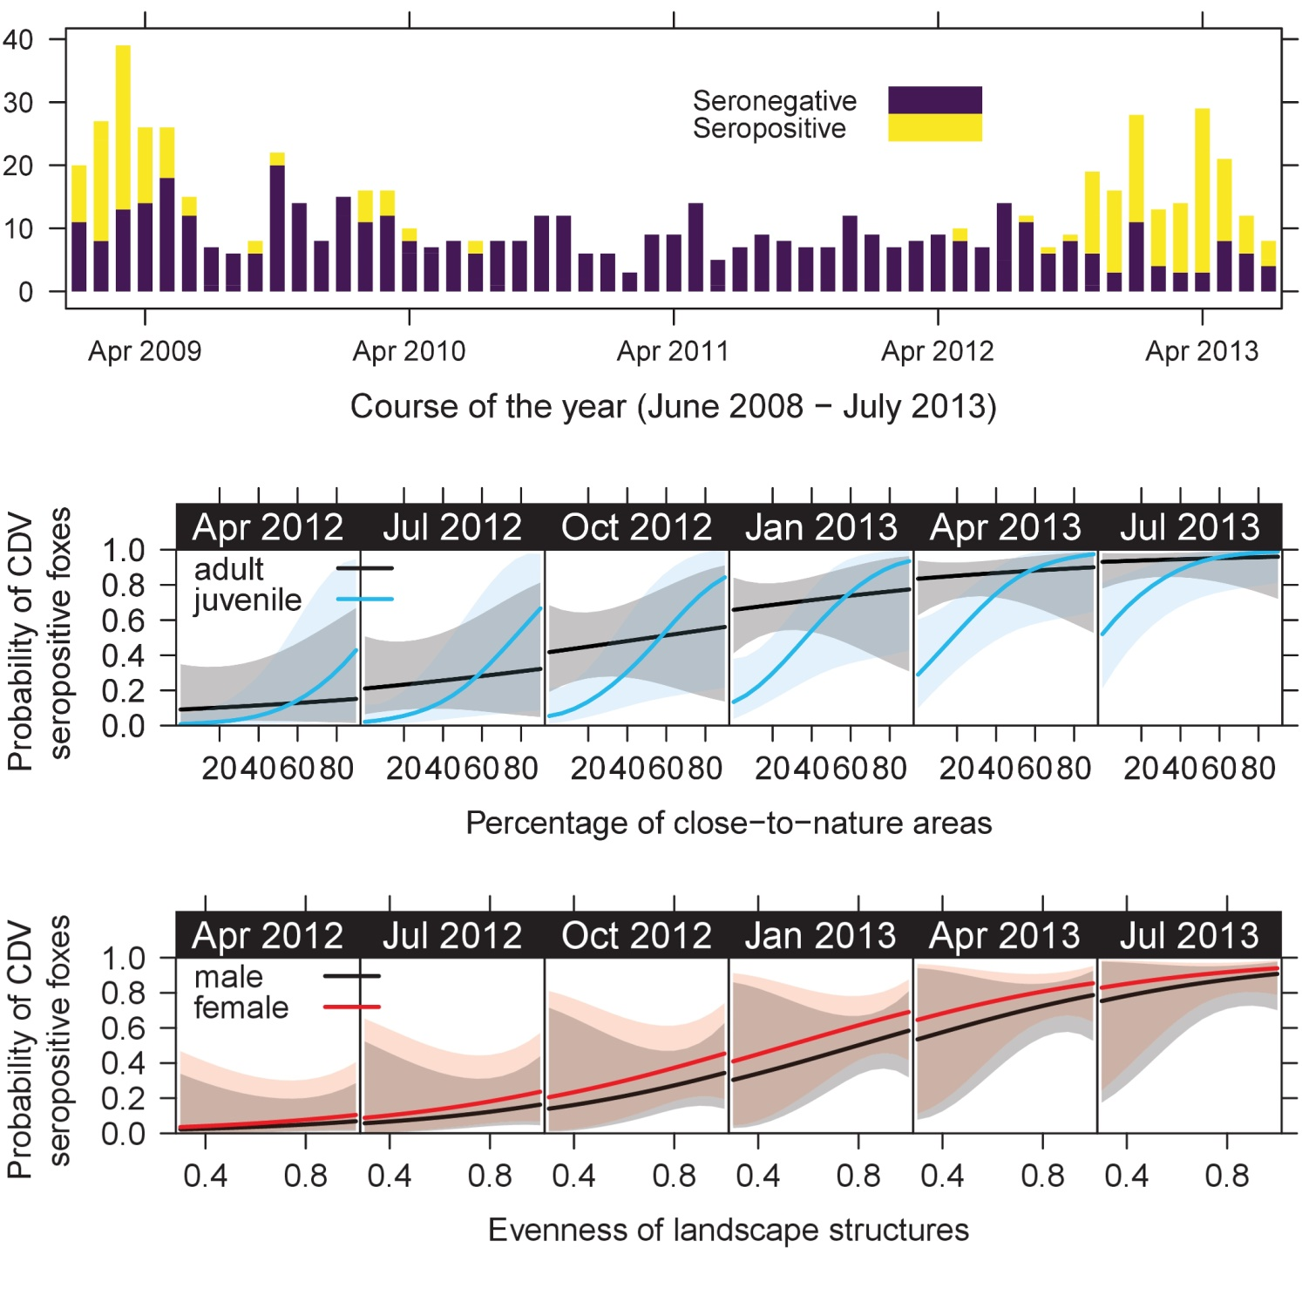
Supplementary Figure S12. Landscape - seroprevalence relationship from April 2012 till July 2013. Top: bar plot on showing the number of analyzed fox carcasses and the proportion of CDV seropositive foxes. Middle: relationships between the probability of CDV seroprevalence (y-axis) and the share of close-to-nature areas (x-axis) in April of each analyzed year. Bottom: bottom row shows the modeled relationship of probability of CDV seroprevalence (y-axis) and the landscape structure richness in April of each analyzed year (x-axis).

Supplementary Figures

Supplementary Figure S7 – Temporal pattern of seropositive cases by age categories from 2008 – 2013
´
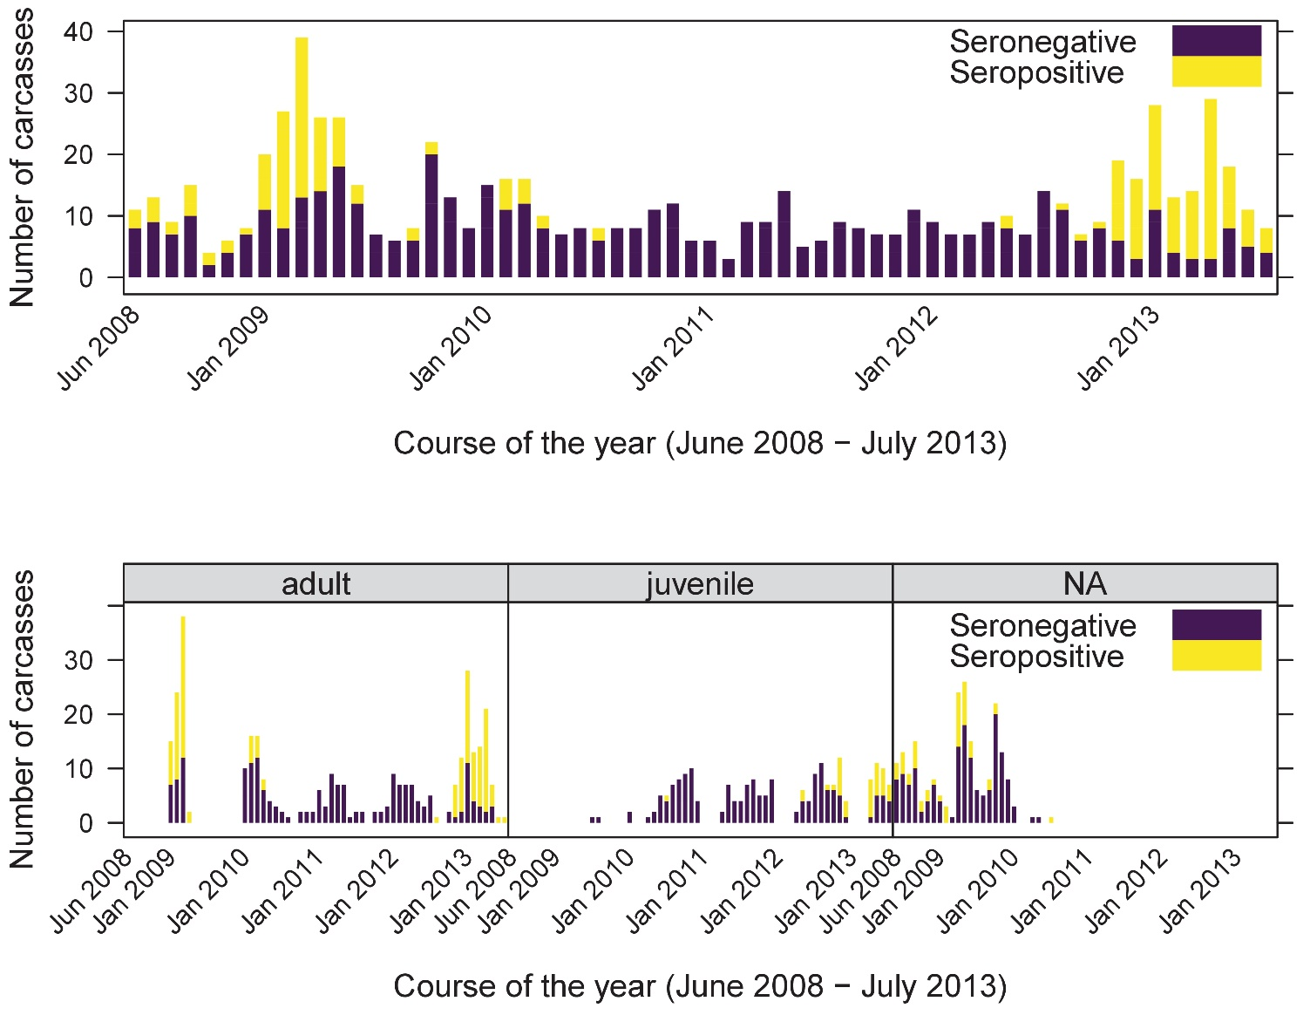
Supplementary Figure S7. Top: shows the number of all discovered carcasses over the course of the study from June 2008 to July 20013. Yellow indicates carcasses tested seropositive for canine distemper. Bottom: shows the number of discovered carcasses over the course of the study from June 2008 to July 20013. The data is separated for adults, juveniles and unknown sex (NA). Yellow indicates carcasses tested seropositive for canine distemper.

Supplementary Figure S8 – Sex and age specific temporal pattern of all carcasses found from 2008 – 2013

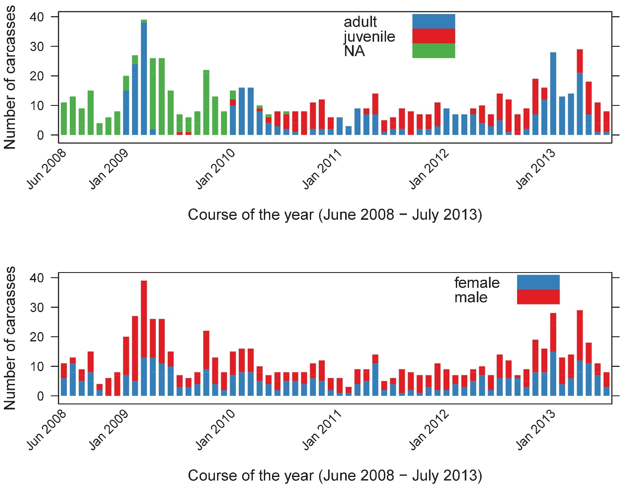Supplementary Figure S8. Top: shows the abundance of discovered carcasses over the course of the years. Different colours indicate different age classes. Bottom: shows the abundance of discovered carcasses over the course of the years. Different colours indicate different sexes.

Supplementary Figure S9 – Spatial distribution of all used landscape variables across Berlin and 4km of Brandenburg area

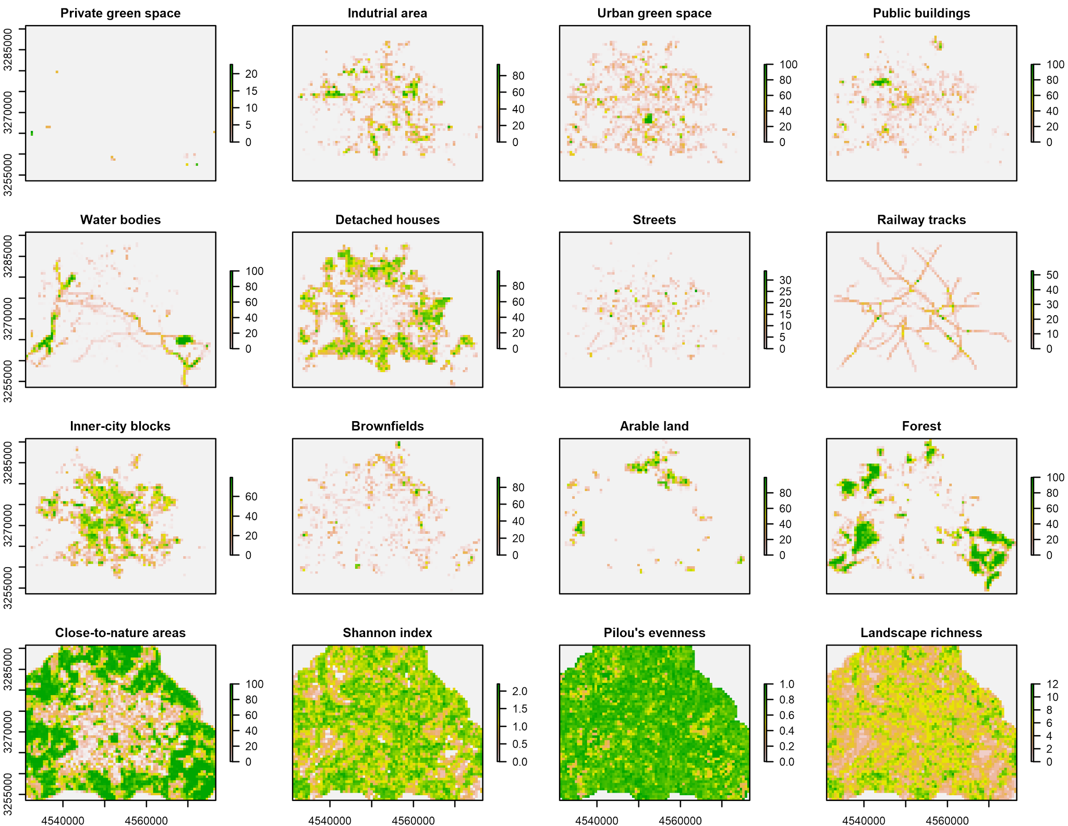
Supplementary Figure S9. Spatial distribution of all used landscape variables across Berlin and 4km of Brandenburg area. Each panel shows the spatial pattern of one landscape variable. The variable is named above each panel. The y axis shows the latitude and the x axis the longitude values using the spatial reference ETRS89 / ETRS-LAEA (EPSG 3035). Except for Shannon index, Pilou’s evenness, and landscape richness the color values of a pixel (res. 600m) indicates the local share of the landscape type in percentage (Grey indicates ‘zero’ and ’NA’).

Supplementary Figure S10 – Number of found carcasses for each sex/age category
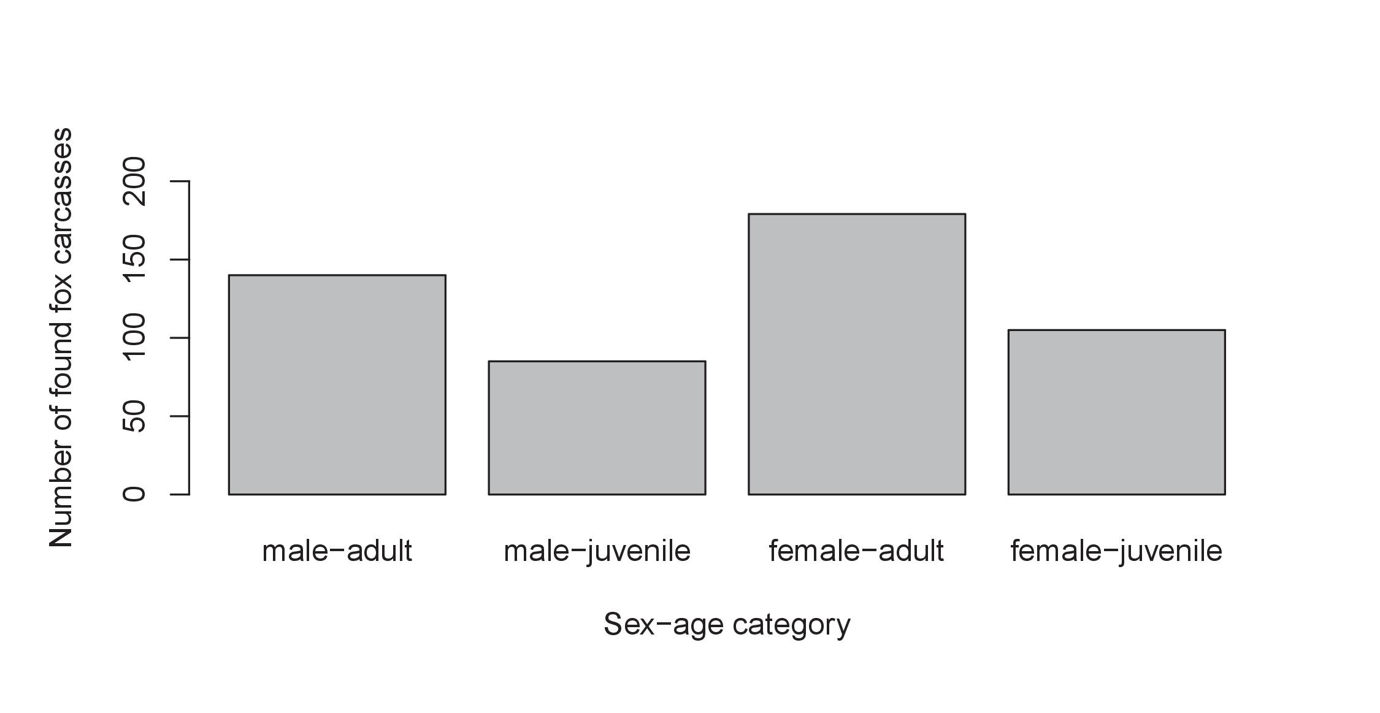
Supplementary Figure S10. Number of found fox carcasses by sex-age category.

Supplementary Lists

Supplementary List S6a – Candidate model formulas in R syntax for the data from 2009-2013
Models are written in line with the R-Package “lme4” function “glmer” to fit nested logistic –regressions. Here we report the full models.

Scale 300m

Land use metrics model
glmer(cdv ~ (age + sex+ lu_richness.sc+lu_evenness.sc+ perc_suitable.sc)^3 +scale(I(lu_richness^2))+scale(I(lu_evenness^2))+ scale(I(perc_suitable^2))+ cod + obsday_int.sc +scale(I(obsday_int^2)) + (1|district_fac) , data = df_train, family = binomial(), control = glmerControl(optimizer = "bobyqa"), na.action = na.fail)

Green/blue infrastructure model
glmer(cdv ~ (age+sex)* (perc_lu_area_garden.sc+ perc_lu_area_pblc_green.sc+ perc_lu_area_water.sc+ perc_lu_area_wasteland.sc)+ scale(I(perc_lu_area_garden^2))+ scale(I(perc_lu_area_pblc_green^2))+ scale(I(perc_lu_area_water^2))+ scale(I(perc_lu_area_wasteland^2)) + cod + obsday_int.sc +scale(I(obsday_int^2)) + (1|district_fac) , data = df_train, family = binomial(), control = glmerControl(optimizer = "bobyqa"), na.action = na.fail)

Grey infrastructure model
glmer(cdv ~ (age+sex)* (perc_lu_area_pblc_building.sc+ perc_lu_area_buildings_small.sc+ perc_lu_area_industry.sc+ perc_lu_area_street.sc)+ scale(I(perc_lu_area_pblc_building^2))+ scale(I(perc_lu_area_buildings_small^2))+ scale(I(perc_lu_area_industry^2))+ scale(I(perc_lu_area_street^2)) + cod + obsday_int.sc +scale(I(obsday_int^2)) + (1|district_fac) , data = df_train, family = binomial(), control = glmerControl(optimizer = "bobyqa"), na.action = na.fail)

Combined model
glmer(cdv ~ (age+sex)* lu_evenness.sc + perc_lu_area_garden.sc + perc_lu_area_pblc_building.sc + scale(I(lu_evenness^2))+ scale(I(perc_lu_area_garden^2))+ scale(I(perc_lu_area_pblc_building^2))+ cod + obsday_int.sc +scale(I(obsday_int^2)) + (1|district_fac) , data = df_train, family = binomial(), control = glmerControl(optimizer = "bobyqa"), na.action = na.fail)

Scale 500m

LU metrics model
glmer(cdv ~ (age + sex+ lu_richness.sc+lu_evenness.sc+ perc_suitable.sc)^3 +scale(I(lu_richness^2))+scale(I(lu_evenness^2))+ scale(I(perc_suitable^2))+ cod + obsday_int.sc +scale(I(obsday_int^2)) + (1|district_fac) , data = df_train, family = binomial(), control = glmerControl(optimizer = "bobyqa"), na.action = na.fail)

Green/blue infrastructure model
glmer(cdv ~ (age+sex)* (perc_lu_area_pblc_green.sc+ perc_lu_area_garden.sc+ perc_lu_area_water.sc+ perc_lu_area_wasteland.sc)+ scale(I(perc_lu_area_pblc_green^2))+ scale(I(perc_lu_area_garden^2))+ scale(I(perc_lu_area_water^2))+ scale(I(perc_lu_area_wasteland^2)) + cod + obsday_int.sc +scale(I(obsday_int^2)) + (1|district_fac) , data = df_train, family = binomial(), control = glmerControl(optimizer = "bobyqa"), na.action = na.fail)

Grey infrastructure model
glmer(cdv ~ (age+sex)* (perc_lu_area_buildings_small.sc+ perc_lu_area_industry.sc+ perc_lu_area_pblc_building.sc+ perc_lu_area_street.sc)+ scale(I(perc_lu_area_buildings_small^2))+ scale(I(perc_lu_area_industry^2))+ scale(I(perc_lu_area_pblc_building^2))+ scale(I(perc_lu_area_street^2)) + cod + obsday_int.sc +scale(I(obsday_int^2)) + (1|district_fac) , data = df_train, family = binomial(), control = glmerControl(optimizer = "bobyqa"), na.action = na.fail)

Combined model
glmer(cdv ~ (age+sex)* (lu_richness.sc + perc_lu_area_pblc_green.sc + perc_lu_area_buildings_small.sc)+ scale(I(lu_richness^2))+ scale(I(perc_lu_area_pblc_green^2))+ scale(I(perc_lu_area_buildings_small^2))+ cod + obsday_int.sc +scale(I(obsday_int^2)) + (1|district_fac) , data = df_train, family = binomial(), control = glmerControl(optimizer = "bobyqa"), na.action = na.fail)

Scale 1000m

LU metrics model
glmer(cdv ~ (age + sex+ lu_richness.sc+lu_evenness.sc+ perc_suitable.sc)^3 +scale(I(lu_richness^2))+scale(I(lu_evenness^2))+ scale(I(perc_suitable^2))+ cod + obsday_int.sc+scale(I(obsday_int^2)) + (1|district_fac) , data = df_train, family = binomial(), control = glmerControl(optimizer = "bobyqa"), na.action = na.fail)

Green/blue infrastructure model
glmer(cdv ~ (age+sex)* (perc_lu_area_wasteland.sc+ perc_lu_area_agriculture.sc+ perc_lu_area_water.sc+ perc_lu_area_garden.sc)+ scale(I(perc_lu_area_wasteland^2))+ scale(I(perc_lu_area_agriculture^2))+ scale(I(perc_lu_area_water^2))+ scale(I(perc_lu_area_garden^2)) + cod + obsday_int.sc +scale(I(obsday_int^2)) + (1|district_fac) , data = df_train, family = binomial(), control = glmerControl(optimizer = "bobyqa"), na.action = na.fail)

Grey infrastructure model
glmer(cdv ~ (age+sex)* (perc_lu_area_industry.sc+ perc_lu_area_buildings_small.sc+ perc_lu_area_pblc_building.sc+ perc_lu_area_street.sc)+ scale(I(perc_lu_area_industry^2))+ scale(I(perc_lu_area_buildings_small^2))+ scale(I(perc_lu_area_pblc_building^2))+ scale(I(perc_lu_area_street^2)) + cod + obsday_int.sc +scale(I(obsday_int^2)) + (1|district_fac) , data = df_train, family = binomial(), control = glmerControl(optimizer = "bobyqa"), na.action = na.fail)

Combined model
glmer(cdv ~ (age+sex)* (lu_evenness.sc + perc_lu_area_wasteland.sc + perc_lu_area_industry.sc)+ scale(I(lu_evenness^2))+ scale(I(perc_lu_area_wasteland^2))+ scale(I(perc_lu_area_industry^2))+ cod + obsday_int.sc +scale(I(obsday_int^2)) + (1|district_fac) , data = df_train, family = binomial(), control = glmerControl(optimizer = "bobyqa"), na.action = na.fail)

Supplementary List S6b – Candidate model formulas in R syntax for the data from 2012-2013
Models are written in line with the R-Package “lme4” function “glmer” to fit nested logistic –regressions. Here we report the full models.

Scale 300m

Land use metrics model
glmer(cdv ~ (age + sex+ lu_richness.sc+lu_evenness.sc+ perc_suitable.sc)^3 +scale(I(lu_richness^2))+scale(I(lu_evenness^2))+ scale(I(perc_suitable^2))+ cod + obsday_int.sc +scale(I(obsday_int^2)) + (1|district_fac) , data = df_train, family = binomial(), control = glmerControl(optimizer = "bobyqa"), na.action = na.fail)

Green/blue infrastructure model
glmer(cdv ~ (age+sex)* (perc_lu_area_garden.sc+ perc_lu_area_pblc_green.sc+ perc_lu_area_water.sc+ perc_lu_area_wasteland.sc)+ scale(I(perc_lu_area_garden^2))+ scale(I(perc_lu_area_pblc_green^2))+ scale(I(perc_lu_area_water^2))+ scale(I(perc_lu_area_wasteland^2)) + cod + obsday_int.sc +scale(I(obsday_int^2)) + (1|district_fac) , data = df_train, family = binomial(), control = glmerControl(optimizer = "bobyqa"), na.action = na.fail)

Grey infrastructure model
glmer(cdv ~ (age+sex)* (perc_lu_area_pblc_building.sc+ perc_lu_area_buildings_small.sc+ perc_lu_area_industry.sc+ perc_lu_area_street.sc)+ scale(I(perc_lu_area_pblc_building^2))+ scale(I(perc_lu_area_buildings_small^2))+ scale(I(perc_lu_area_industry^2))+ scale(I(perc_lu_area_street^2)) + cod + obsday_int.sc +scale(I(obsday_int^2)) + (1|district_fac) , data = df_train, family = binomial(), control = glmerControl(optimizer = "bobyqa"), na.action = na.fail)

Combined model
glmer(cdv ~ (age+sex)* lu_evenness.sc + perc_lu_area_garden.sc + perc_lu_area_pblc_building.sc + scale(I(lu_evenness^2))+ scale(I(perc_lu_area_garden^2))+ scale(I(perc_lu_area_pblc_building^2))+ cod + obsday_int.sc +scale(I(obsday_int^2)) + (1|district_fac) , data = df_train, family = binomial(), control = glmerControl(optimizer = "bobyqa"), na.action = na.fail)

Scale 500m

LU metrics model
glmer(cdv ~ (age + sex+ lu_richness.sc+lu_evenness.sc+ perc_suitable.sc)^3 +scale(I(lu_richness^2))+scale(I(lu_evenness^2))+ scale(I(perc_suitable^2))+ cod + obsday_int.sc +scale(I(obsday_int^2)) + (1|district_fac) , data = df_train, family = binomial(), control = glmerControl(optimizer = "bobyqa"), na.action = na.fail)

Green/blue infrastructure model
glmer(cdv ~ (age+sex)* (perc_lu_area_pblc_green.sc+ perc_lu_area_garden.sc+ perc_lu_area_water.sc+ perc_lu_area_wasteland.sc)+ scale(I(perc_lu_area_pblc_green^2))+ scale(I(perc_lu_area_garden^2))+ scale(I(perc_lu_area_water^2))+ scale(I(perc_lu_area_wasteland^2)) + cod + obsday_int.sc +scale(I(obsday_int^2)) + (1|district_fac) , data = df_train, family = binomial(), control = glmerControl(optimizer = "bobyqa"), na.action = na.fail)

Grey infrastructure model
glmer(cdv ~ (age+sex)* (perc_lu_area_buildings_small.sc+ perc_lu_area_industry.sc+ perc_lu_area_pblc_building.sc+ perc_lu_area_street.sc)+ scale(I(perc_lu_area_buildings_small^2))+ scale(I(perc_lu_area_industry^2))+ scale(I(perc_lu_area_pblc_building^2))+ scale(I(perc_lu_area_street^2)) + cod + obsday_int.sc +scale(I(obsday_int^2)) + (1|district_fac) , data = df_train, family = binomial(), control = glmerControl(optimizer = "bobyqa"), na.action = na.fail)

Combined model
glmer(cdv ~ (age+sex)* (lu_richness.sc + perc_lu_area_pblc_green.sc + perc_lu_area_buildings_small.sc)+ scale(I(lu_richness^2))+ scale(I(perc_lu_area_pblc_green^2))+ scale(I(perc_lu_area_buildings_small^2))+ cod + obsday_int.sc +scale(I(obsday_int^2)) + (1|district_fac) , data = df_train, family = binomial(), control = glmerControl(optimizer = "bobyqa"), na.action = na.fail)

Scale 1000m

LU metrics model
glmer(cdv ~ (age + sex+ lu_richness.sc+lu_evenness.sc+ perc_suitable.sc)^3 +scale(I(lu_richness^2))+scale(I(lu_evenness^2))+ scale(I(perc_suitable^2))+ cod + obsday_int.sc+scale(I(obsday_int^2)) + (1|district_fac) , data = df_train, family = binomial(), control = glmerControl(optimizer = "bobyqa"), na.action = na.fail)

Green/blue infrastructure model
glmer(cdv ~ (age+sex)* (perc_lu_area_wasteland.sc+ perc_lu_area_agriculture.sc+ perc_lu_area_water.sc+ perc_lu_area_garden.sc)+ scale(I(perc_lu_area_wasteland^2))+ scale(I(perc_lu_area_agriculture^2))+ scale(I(perc_lu_area_water^2))+ scale(I(perc_lu_area_garden^2)) + cod + obsday_int.sc +scale(I(obsday_int^2)) + (1|district_fac) , data = df_train, family = binomial(), control = glmerControl(optimizer = "bobyqa"), na.action = na.fail)

Grey infrastructure model
glmer(cdv ~ (age+sex)* (perc_lu_area_industry.sc+ perc_lu_area_buildings_small.sc+ perc_lu_area_pblc_building.sc+ perc_lu_area_street.sc)+ scale(I(perc_lu_area_industry^2))+ scale(I(perc_lu_area_buildings_small^2))+ scale(I(perc_lu_area_pblc_building^2))+ scale(I(perc_lu_area_street^2)) + cod + obsday_int.sc +scale(I(obsday_int^2)) + (1|district_fac) , data = df_train, family = binomial(), control = glmerControl(optimizer = "bobyqa"), na.action = na.fail)

Combined model
glmer(cdv ~ (age+sex)* (perc_lu_area_industry.sc+ perc_lu_area_buildings_small.sc+ perc_lu_area_pblc_building.sc+ perc_lu_area_street.sc)+ scale(I(perc_lu_area_industry^2))+ scale(I(perc_lu_area_buildings_small^2))+ scale(I(perc_lu_area_pblc_building^2))+ scale(I(perc_lu_area_street^2)) + cod + obsday_int.sc +scale(I(obsday_int^2)) + (1|district_fac) , data = df_train, family = binomial(), control = glmerControl(optimizer = "bobyqa"), na.action = na.fail)

