Supplementary Material
Combined Multistate and Kohn-Sham Density Functional Theory Studies of the elusive mechanism of N-dealkylation of N,N-dimethylanilines Mediated by the biomimetic nonheme oxidant Fe^{IV}(O)(N4Py)(ClO₄)₂
Lili Yang, Xin Chen, Zexing Qu*, Jiali Gao
* Correspondence: Zexing Qu: zxqu@jlu.edu.cn

Supplementary Figures
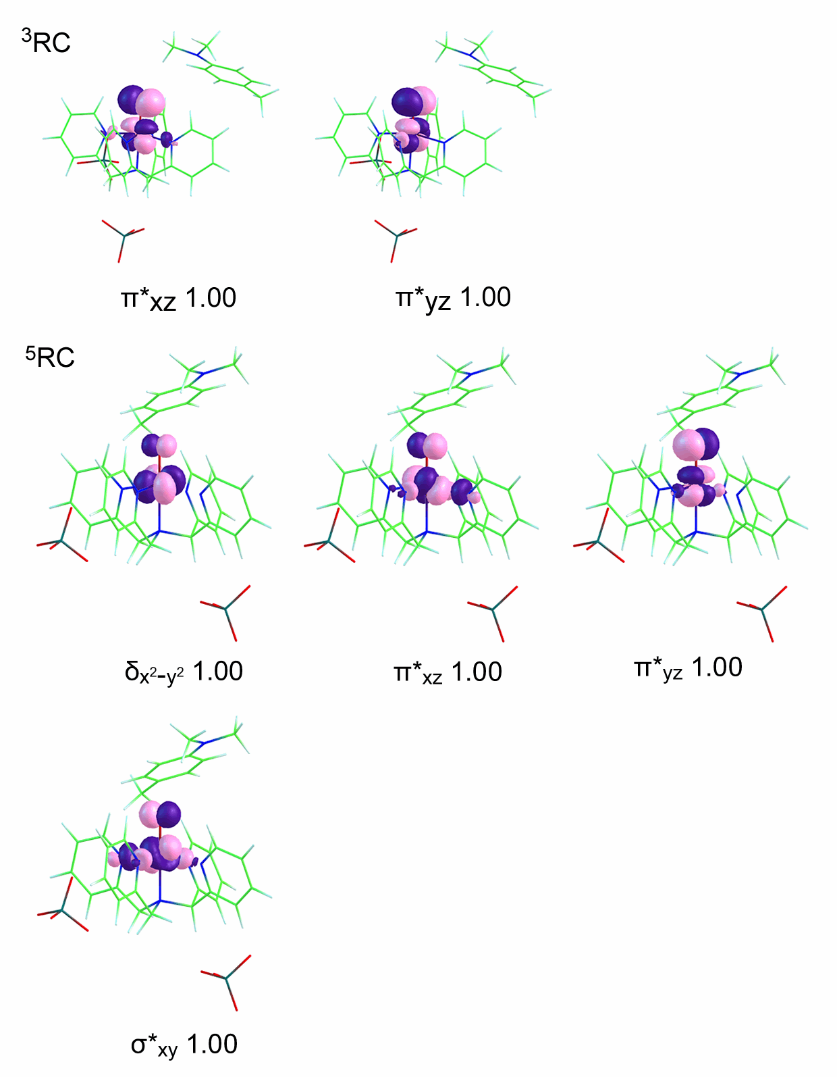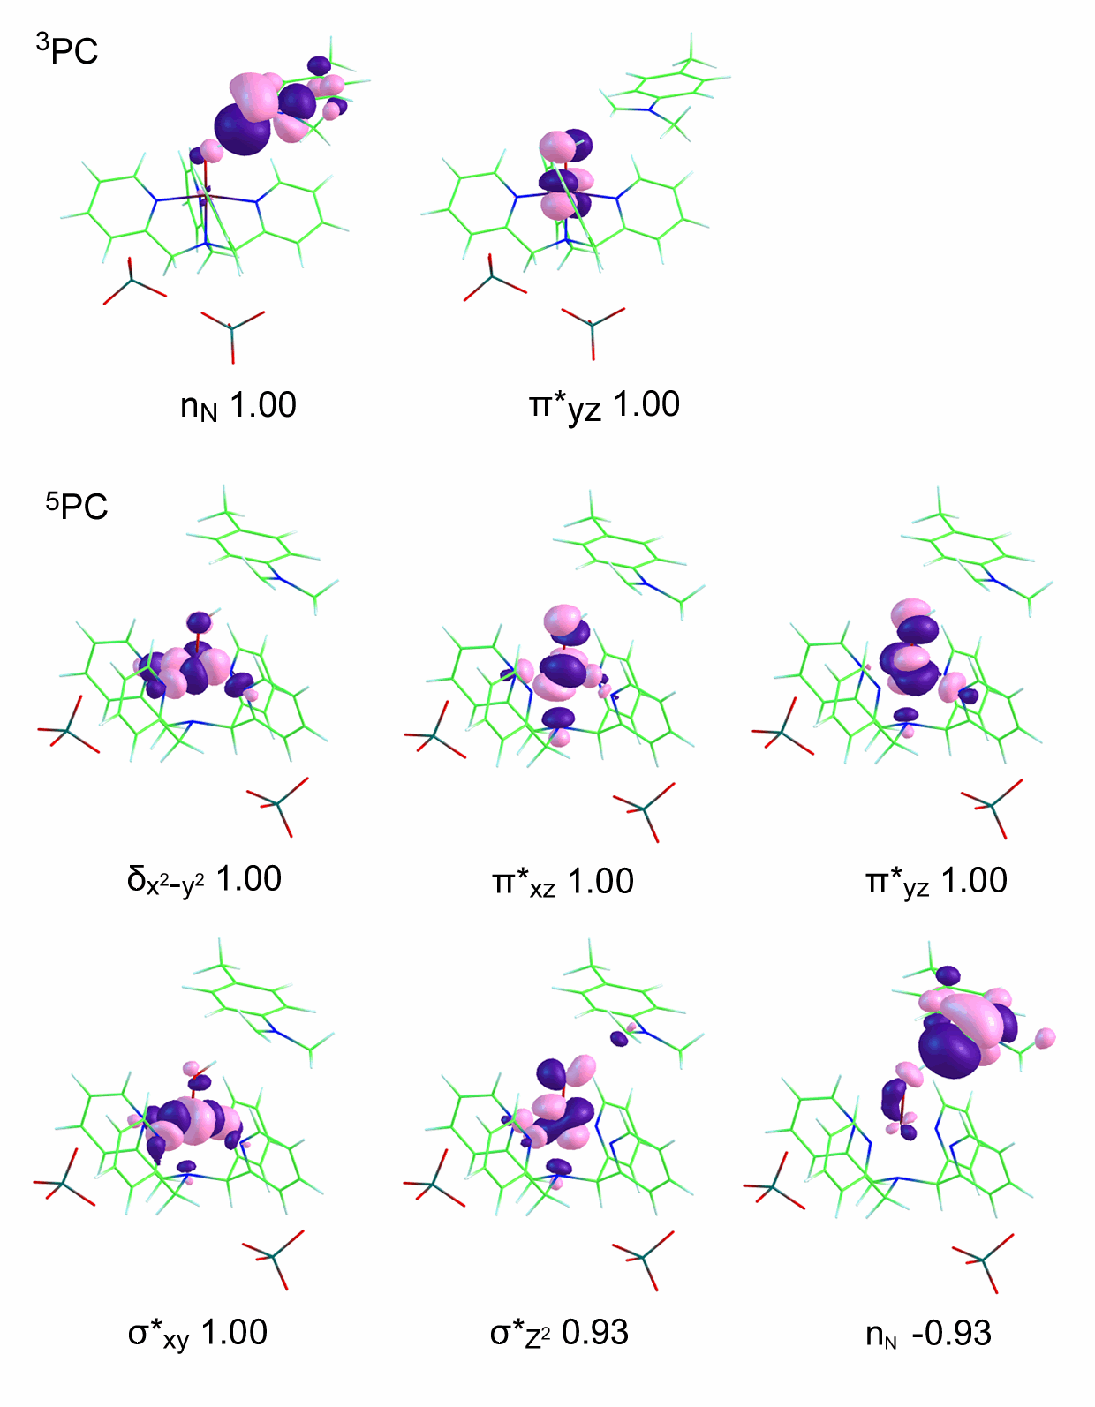
Supplementary Figure 1. Spin natural orbitals (SNO) and their occupation numbers of reactant and product in the H-transfer reaction of para-substituted N,N-dimethylanilines mediated by [(N4Py)-Fe^{IV}=O] (ClO₄)₂. A negative occupation number corresponds to spin β.

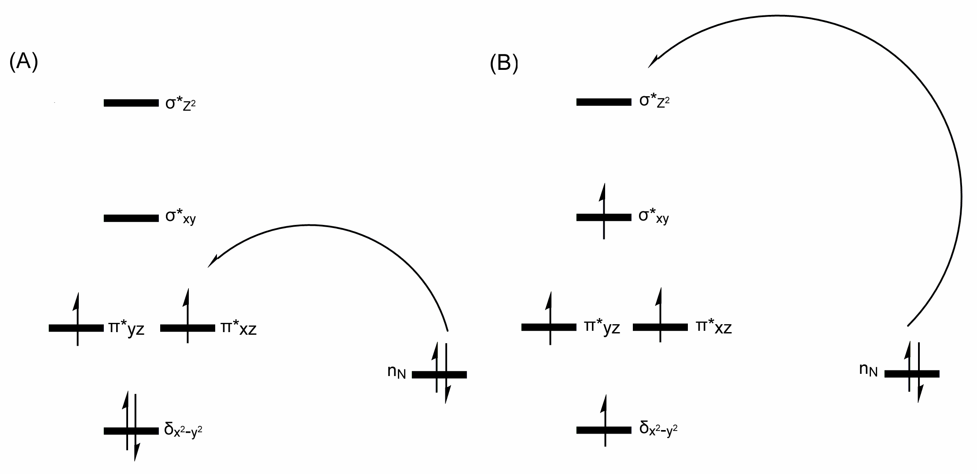
Supplementary Figure 2. The schematic diagram of electron transfer during the C-H bond activation of para-substituted N,N-dimethylanilines mediated by [(N4Py)-Fe^{IV}=O](ClO₄)₂ for (A)triplet and (B)quintet pathways.

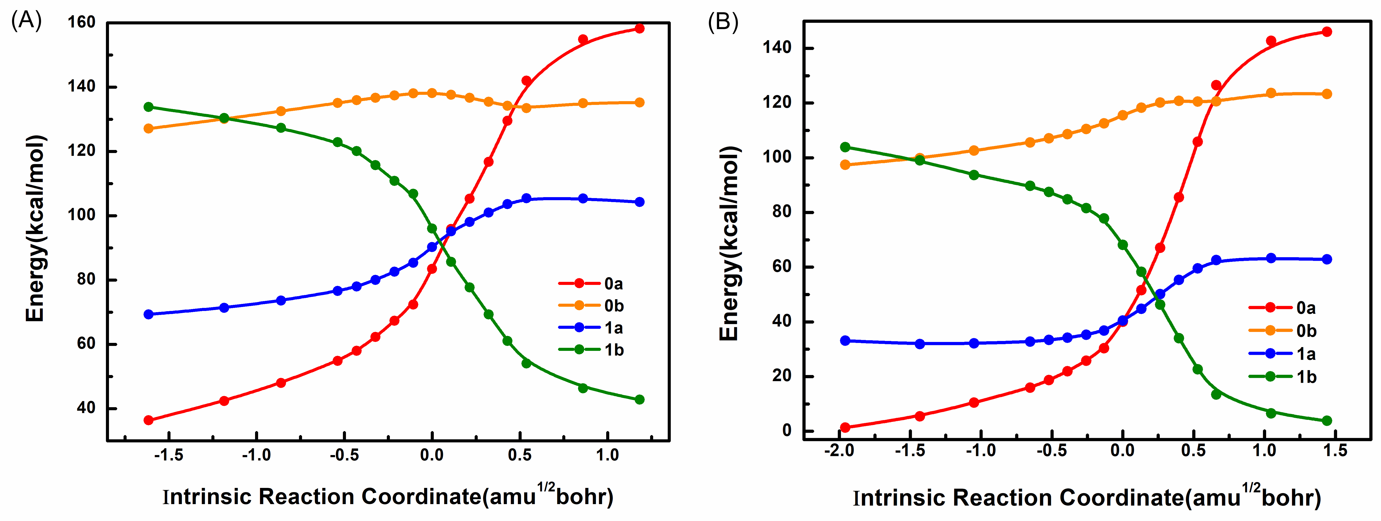
Supplementary Figure 3. Diabatic potential energy surfaces for the triplet(A) and quintet(B) high-valent oxoiron (IV) complexes along IRC in the C-H bond activation reactions. 0a (red line), 0b (orange line), 1a (blue line) and 1b (green line) represent for reactant state, proton transfer state, electron transfer state and product state respectively. Use the lowest energy of the quintet ground state as the zero-point energy. The abscissa and ordinate stand for reaction coordinate from IRC (amu^{1/2}bohr) and energy (kcal mol⁻¹) respectively.

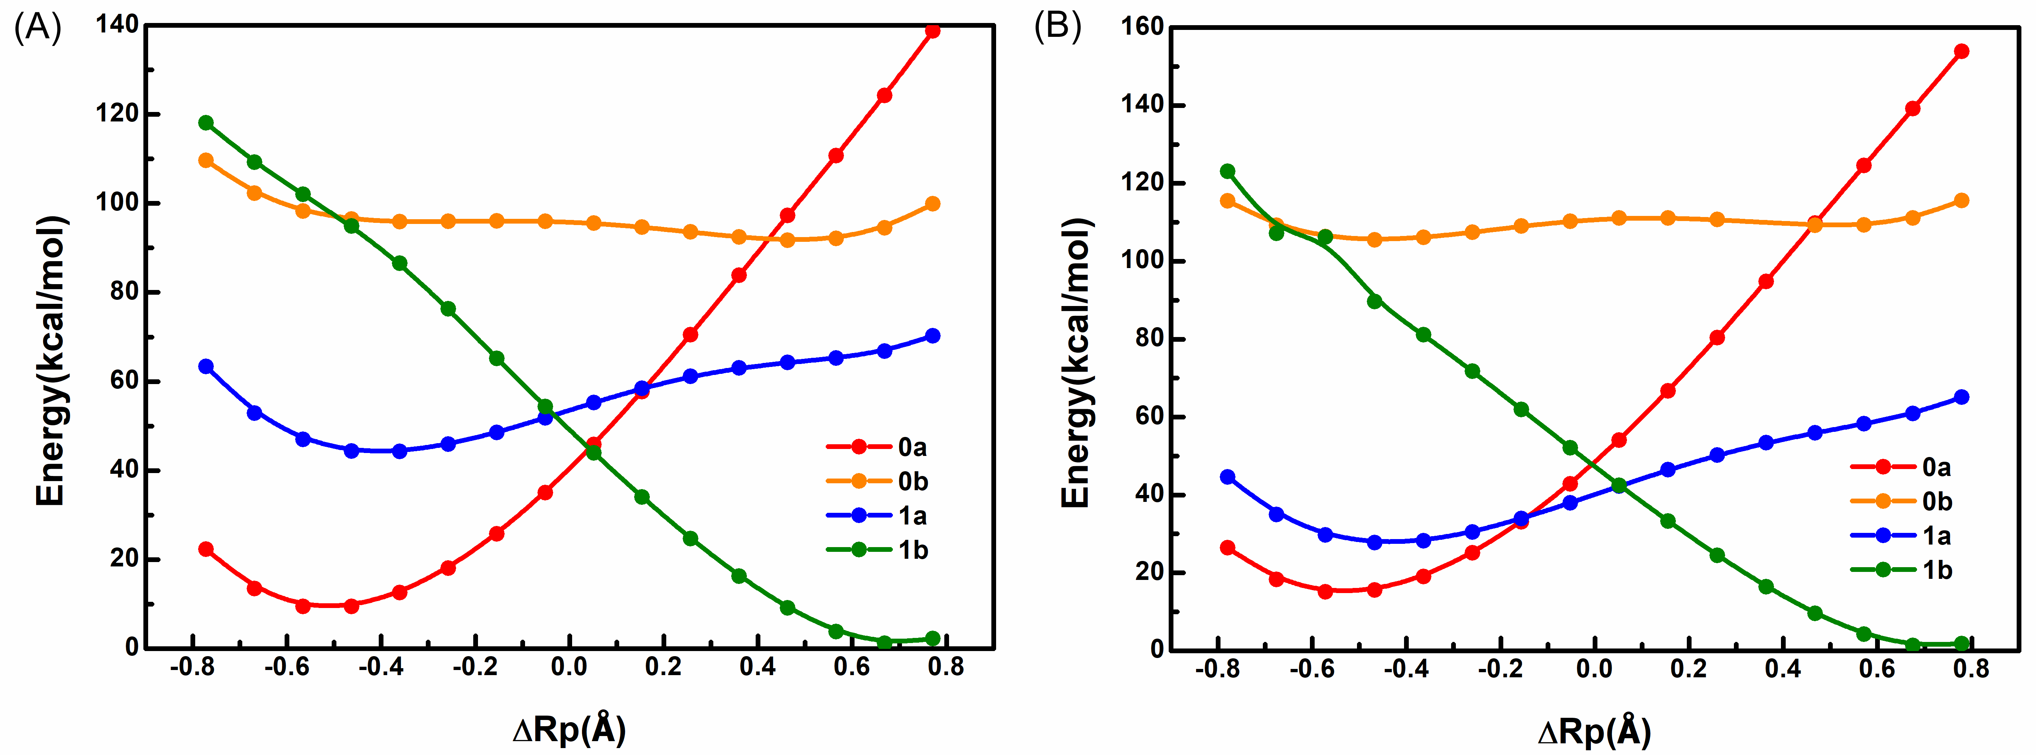
Supplementary Figure 4. Diabatic potential energy surfaces for the triplet(A) and quintet(B) high-valent oxoiron (IV) complexes along ΔRp in the C-H bond activation reactions. 0a (red line), 0b (orange line), 1a (blue line) and 1b (green line) represent for reactant state, proton transfer state, electron transfer state and product state respectively. Use the lowest energy of the quintet ground state as the zero-point energy. The abscissa and ordinate stand for the distance of the migrating hydrogen from the donor atom C and from the acceptor atom O (Å) in C-H bond activation step and energy (kcal mol⁻¹) respectively.

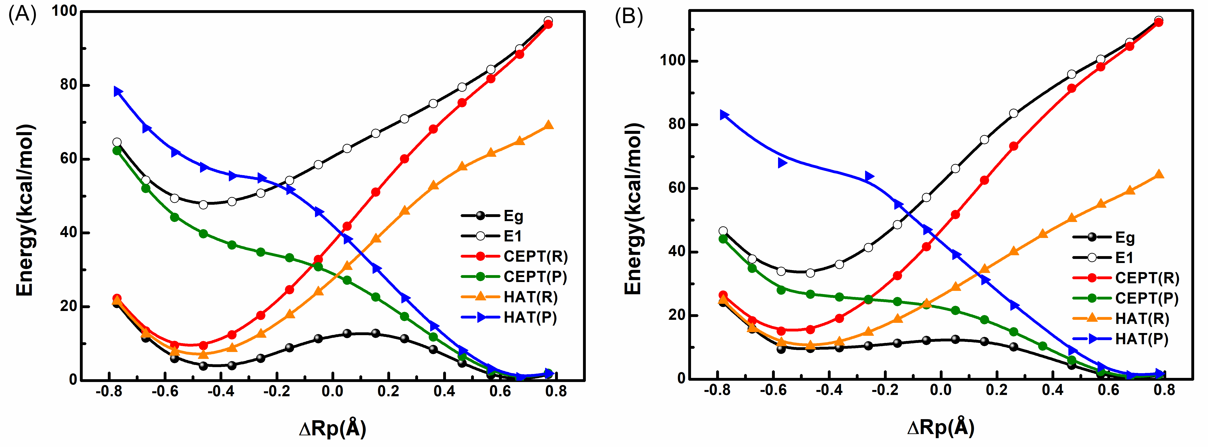
Supplementary Figure 5. The effective diabatic and adiabatic potential energy surfaces for the triplet(A) and quintet(B) high-valent oxoiron (IV) complexes along ΔRp in the C-H bond activation reactions. CEPT(R) (red line) and CEPT(P) (green line) represent the effective reactant state and product state of CEPT reaction mechanism, HAT(R) (orange line) and HAT(P) (blue line) mean the effective reactant state and product state of HAT reaction mechanism. The two black lines stand for the ground state and excited state. Use the lowest energy of the quintet ground state as the zero-point energy. The abscissa and ordinate stand for the distance of the migrating hydrogen from the donor atom C and from the acceptor atom O (Å) in C-H bond activation step and energy (kcal mol⁻¹) respectively.

Supplementary Tables
Supplementary Table 1. Energy of diabatic states for triplet high-valent oxoiron (IV) complexes along the intrinstic reaction coordinate(IRC) in C-H bond activation step.
IRC | ³RC | ³PT | ³ET | ³PC
-1.61524 | -4427.209 | -4427.06443 | -4427.1565 | -4427.0539
-1.18425 | -4427.1994 | -4427.05967 | -4427.15322 | -4427.0591
-0.86095 | -4427.1905 | -4427.05574 | -4427.1497 | -4427.064
-0.53781 | -4427.1795 | -4427.05169 | -4427.1449 | -4427.07116
-0.43019 | -4427.1746 | -4427.05036 | -4427.1427 | -4427.0755
-0.32259 | -4427.1677 | -4427.04911 | -4427.1394 | -4427.0825
-0.215 | -4427.1597 | -4427.04801 | -4427.1353 | -4427.09027
-0.1078 | -4427.15161 | -4427.04691 | -4427.1309 | -4427.09675
0 | -4427.13399 | -4427.04681 | -4427.1231 | -4427.1139
0.1078 | -4427.11415 | -4427.04761 | -4427.1153 | -4427.13044
0.21386 | -4427.09912 | -4427.04916 | -4427.1107 | -4427.14308
0.32141 | -4427.08092 | -4427.05111 | -4427.106 | -4427.15651
0.42908 | -4427.06057 | -4427.05308 | -4427.1018 | -4427.16964
0.53681 | -4427.04062 | -4427.05421 | -4427.0989 | -4427.18087
0.85928 | -4427.02007 | -4427.05182 | -4427.0991 | -4427.19314
1.1822 | -4427.01474 | -4427.05144 | -4427.1008 | -4427.19878

Supplementary Table 2. Energy of diabatic states for quintet high-valent oxoiron (IV) complexes along the intrinstic reaction coordinate(IRC) in C-H bond activation step.
IRC | ⁵RC | ⁵PT | ⁵ET | ⁵PC
-1.9593 | -4427.2648 | -4427.1117 | -4427.214 | -4427.1014
-1.4312 | -4427.2582 | -4427.1079 | -4427.216 | -4427.1091
-1.04921 | -4427.2502 | -4427.1034 | -4427.216 | -4427.1177
-0.65395 | -4427.2416 | -4427.0987 | -4427.215 | -4427.1239
-0.52184 | -4427.2372 | -4427.0963 | -4427.214 | -4427.1276
-0.38988 | -4427.232 | -4427.0938 | -4427.213 | -4427.1318
-0.25858 | -4427.2258 | -4427.0908 | -4427.211 | -4427.137
-0.13218 | -4427.2186 | -4427.0876 | -4427.208 | -4427.1429
0 | -4427.2032 | -4427.0828 | -4427.202 | -4427.1583
0.13218 | -4427.1848 | -4427.0785 | -4427.196 | -4427.1741
0.26413 | -4427.1601 | -4427.0755 | -4427.187 | -4427.1932
0.39627 | -4427.1307 | -4427.0745 | -4427.179 | -4427.2128
0.52841 | -4427.0983 | -4427.0749 | -4427.172 | -4427.2308
0.66055 | -4427.0653 | -4427.0748 | -4427.167 | -4427.2455
1.04704 | -4427.0394 | -4427.0699 | -4427.166 | -4427.2565
1.4422 | -4427.0341 | -4427.0705 | -4427.167 | -4427.2609

Supplementary Table 3. Energy of the effective diabatic and adiabatic states for triplet high-valent oxoiron (IV) complexes along the intrinstic reaction coordinate(IRC) in C-H bond activation step.
IRC | CEPT(R) | CEPT(P) | HAT(R) | HAT(P) | Eg | E1
-1.61524 | -4427.20953 | -4427.15649 | -4427.21107 | -4427.07467 | -4427.21231 | -4427.15408
-1.18425 | -4427.2005 | -4427.15743 | -4427.20249 | -4427.07959 | -4427.20507 | -4427.15246
-0.86095 | -4427.19188 | -4427.156 | -4427.19493 | -4427.08282 | -4427.19907 | -4427.14842
-0.53781 | -4427.18087 | -4427.15491 | -4427.18576 | -4427.08886 | -4427.19305 | -4427.14247
-0.43019 | -4427.17587 | -4427.1549 | -4427.18173 | -4427.09277 | -4427.19118 | -4427.1394
-0.32259 | -4427.16901 | -4427.15515 | -4427.17609 | -4427.09851 | -4427.18894 | -4427.13506
-0.215 | -4427.16119 | -4427.15482 | -4427.16944 | -4427.10273 | -4427.18531 | -4427.13034
-0.1078 | -4427.15362 | -4427.1541 | -4427.16246 | -4427.10604 | -4427.18098 | -4427.12617
0 | -4427.13826 | -4427.15648 | -4427.14972 | -4427.11898 | -4427.17666 | -4427.11665
0.1078 | -4427.12245 | -4427.16076 | -4427.13637 | -4427.13308 | -4427.17437 | -4427.10705
0.21386 | -4427.1118 | -4427.16601 | -4427.12802 | -4427.14482 | -4427.17583 | -4427.10016
0.32141 | -4427.10031 | -4427.17266 | -4427.11874 | -4427.15758 | -4427.17884 | -4427.09263
0.42908 | -4427.08923 | -4427.18018 | -4427.10999 | -4427.17027 | -4427.18355 | -4427.08485
0.53681 | -4427.07962 | -4427.18743 | -4427.10387 | -4427.18125 | -4427.18921 | -4427.07719
0.85928 | -4427.06918 | -4427.19697 | -4427.10208 | -4427.19336 | -4427.19789 | -4427.06781
1.1822 | -4427.06705 | -4427.20191 | -4427.10332 | -4427.19897 | -4427.20264 | -4427.06591

Supplementary Table 4. Energy of the effective diabatic and adiabatic states for quintet high-valent oxoiron (IV) complexes along the intrinstic reaction coordinate(IRC) in C-H bond activation step.
IRC | CEPT(R) | CEPT(P) | HAT(R) | HAT(P) | Eg | E1
-1.9593 | -4427.26484 | -4427.21532 | -4427.26666 | -4427.1235 | -4427.26693 | -4427.21268
-1.4312 | -4427.25822 | -4427.21773 | -4427.2613 | -4427.12746 | -4427.26188 | -4427.21333
-1.04921 | -4427.25019 | -4427.21865 | -4427.25537 | -4427.13471 | -4427.25679 | -4427.21103
-0.65395 | -4427.24171 | -4427.21901 | -4427.24973 | -4427.14033 | -4427.25236 | -4427.20705
-0.52184 | -4427.23732 | -4427.21907 | -4427.2471 | -4427.14408 | -4427.25071 | -4427.20417
-0.38988 | -4427.23228 | -4427.21908 | -4427.24427 | -4427.14836 | -4427.24925 | -4427.20036
-0.25858 | -4427.22618 | -4427.21918 | -4427.24107 | -4427.15366 | -4427.24803 | -4427.19523
-0.13218 | -4427.21921 | -4427.21931 | -4427.23768 | -4427.1594 | -4427.24714 | -4427.18876
0 | -4427.20484 | -4427.2203 | -4427.23096 | -4427.17258 | -4427.24639 | -4427.17429
0.13218 | -4427.1886 | -4427.22193 | -4427.22349 | -4427.1846 | -4427.24542 | -4427.15812
0.26413 | -4427.16827 | -4427.22614 | -4427.21416 | -4427.19973 | -4427.24555 | -4427.1389
0.39627 | -4427.14559 | -4427.23338 | -4427.20274 | -4427.21637 | -4427.24718 | -4427.12126
0.52841 | -4427.12246 | -4427.24247 | -4427.19007 | -4427.23261 | -4427.25067 | -4427.10664
0.66055 | -4427.10193 | -4427.25148 | -4427.1781 | -4427.24638 | -4427.2556 | -4427.09411
1.04704 | -4427.08692 | -4427.25975 | -4427.17255 | -4427.25693 | -4427.2619 | -4427.08294
1.4422 | -4427.08529 | -4427.26347 | -4427.17204 | -4427.26122 | -4427.26514 | -4427.08222

Supplementary Table 5. Energy of diabatic states for triplet high-valent oxoiron (IV) complexes along the distance of the migrating hydrogen from the donor atom C and from the acceptor atom O (ΔRp)in C-H bond activation step.
ΔRp | ³RC | ³PT | ³ET | ³PC
-0.8744 | -4427.1916 | -4427.0574 | -4427.124 | -4427.0433
-0.77152 | -4427.216 | -4427.0768 | -4427.1505 | -4427.0633
-0.66866 | -4427.2301 | -4427.0885 | -4427.1672 | -4427.0774
-0.56578 | -4427.2364 | -4427.0949 | -4427.1767 | -4427.0889
-0.46292 | -4427.2364 | -4427.0978 | -4427.1808 | -4427.1003
-0.36004 | -4427.2315 | -4427.0987 | -4427.181 | -4427.1136
-0.25718 | -4427.2227 | -4427.0986 | -4427.1784 | -4427.1299
-0.1543 | -4427.2105 | -4427.0984 | -4427.1741 | -4427.1476
-0.05144 | -4427.1957 | -4427.0985 | -4427.1689 | -4427.1649
0.05144 | -4427.1785 | -4427.0992 | -4427.1634 | -4427.1815
0.1543 | -4427.1595 | -4427.1006 | -4427.1583 | -4427.1973
0.25718 | -4427.1391 | -4427.1024 | -4427.1541 | -4427.2122
0.36004 | -4427.1179 | -4427.1042 | -4427.1511 | -4427.2256
0.46292 | -4427.0965 | -4427.1053 | -4427.1491 | -4427.237
0.56578 | -4427.0751 | -4427.1047 | -4427.1475 | -4427.2454
0.66866 | -4427.0535 | -4427.1009 | -4427.145 | -4427.2496
0.77152 | -4427.0304 | -4427.0923 | -4427.1395 | -4427.248
0.8744 | -4427.0033 | -4427.0763 | -4427.1281 | -4427.238

Supplementary Table 6. Energy of diabatic states for quintet high-valent oxoiron (IV) complexes along the distance of the migrating hydrogen from the donor atom C and from the acceptor atom O (ΔRp) in C-H bond activation step.
ΔRp | RC | PT | ET | PC
-0.88324 | -4427.1911 |  | -4427.16 | -4427.0409
-0.77932 | -4427.214 | -4427.072 | -4427.185 | -4427.06
-0.67542 | -4427.2269 | -4427.082 | -4427.2004 | -4427.0854
-0.5715 | -4427.2321 | -4427.0867 | -4427.2088 | -4427.0868
-0.4676 | -4427.2313 | -4427.088 | -4427.2119 | -4427.1133
-0.36368 | -4427.2257 | -4427.087 | -4427.2111 | -4427.1268
-0.25978 | -4427.2161 | -4427.0849 | -4427.2075 | -4427.1417
-0.15586 | -4427.2034 | -4427.0824 | -4427.2021 | -4427.1574
-0.05196 | -4427.1878 | -4427.0804 | -4427.1956 | -4427.1731
0.05196 | -4427.1699 | -4427.0791 | -4427.1888 | -4427.1884
0.15586 | -4427.1498 | -4427.079 | -4427.1821 | -4427.2031
0.25978 | -4427.128 | -4427.0797 | -4427.1761 | -4427.2171
0.36368 | -4427.105 | -- | -4427.171 | -4427.2299
0.4676 | -4427.0812 | -4427.082 | -4427.1669 | -4427.2409
0.5715 | -4427.0576 | -4427.0819 | -4427.1633 | -4427.2494
0.67542 | -4427.0343 | -4427.0791 | -4427.1591 | -4427.254
0.77932 | -4427.0108 | -4427.0719 | -4427.1524 | -4427.2532

Supplementary Table 7. Energy of the effective diabatic and adiabatic states for triplet high-valent oxoiron (IV) complexes along the distance of the migrating hydrogen from the donor atom C and from the acceptor atom O (ΔRp) in C-H bond activation step.
ΔRp | CEPT(R) | CEPT(P) | HAT(R) | HAT(P) | Eg | E1
-0.8744 | -4427.1916 | -4427.1252 | -4427.1925 | -4427.1035 | -4427.1932 | -4427.1227
-0.77152 | -4427.216 | -4427.1522 | -4427.2173 | -4427.1266 | -4427.2183 | -4427.1486
-0.66866 | -4427.2301 | -4427.1686 | -4427.2315 | -4427.1424 | -4427.2332 | -4427.165
-0.56578 | -4427.2364 | -4427.1811 | -4427.2393 | -4427.1528 | -4427.2421 | -4427.1728
-0.46292 | -4427.2365 | -4427.1881 | -4427.2407 | -4427.1594 | -4427.2453 | -4427.1756
-0.36004 | -4427.2318 | -4427.193 | -4427.2377 | -4427.1631 | -4427.2451 | -4427.1742
-0.25718 | -4427.2234 | -4427.1961 | -4427.2316 | -4427.164 | -4427.242 | -4427.1706
-0.1543 | -4427.2123 | -4427.1985 | -4427.2232 | -4427.169 | -4427.2374 | -4427.1651
-0.05144 | -4427.1992 | -4427.2024 | -4427.2133 | -4427.1786 | -4427.2335 | -4427.1583
0.05144 | -4427.1849 | -4427.2082 | -4427.2023 | -4427.1903 | -4427.2312 | -4427.1513
0.1543 | -4427.1701 | -4427.2155 | -4427.1904 | -4427.203 | -4427.2311 | -4427.1448
0.25718 | -4427.1558 | -4427.2239 | -4427.1784 | -4427.2158 | -4427.2335 | -4427.1385
0.36004 | -4427.1429 | -4427.2327 | -4427.1675 | -4427.2279 | -4427.2381 | -4427.1319
0.46292 | -4427.1315 | -4427.241 | -4427.1593 | -4427.2385 | -4427.244 | -4427.1248
0.56578 | -4427.1212 | -4427.2474 | -4427.1534 | -4427.2464 | -4427.2491 | -4427.1172
0.66866 | -4427.1106 | -4427.2506 | -4427.1484 | -4427.2503 | -4427.2515 | -4427.1083
0.77152 | -4427.0977 | -4427.2484 | -4427.1415 | -4427.2484 | -4427.2489 | -4427.0962
Supplementary Table 8. Energy of the effective diabatic and adiabatic states for quintet high-valent oxoiron (IV) complexes along the distance of the migrating hydrogen from the donor atom C and from the acceptor atom O (ΔRp) in C-H bond activation step.
 | CEPT(R) | CEPT(P) | HAT(R) | HAT(P) | Eg | E1
-0.88324 |  | -4427.1606 | -4427.1929
-0.77932 | -4427.214 | -4427.1859 | -4427.2166 | -4427.1236 | -4427.2177 | -4427.1818
-0.67542 | -4427.2269 | -4427.2006 | -4427.2308 | -- | -4427.231 | -4427.1959
-0.5715 | -4427.2321 | -4427.2115 | -4427.2378 | -4427.1477 | -4427.2411 | -4427.2021
-0.4676 | -4427.2313 | -4427.2135 | -4427.2395 | -- | -4427.2407 | -4427.2029
-0.36368 | -4427.2257 | -4427.215 | -4427.2375 | -- | -4427.2404 | -4427.1986
-0.25978 | -4427.2164 | -4427.2161 | -4427.2327 | -4427.1544 | -4427.2394 | -4427.1902
-0.15586 | -4427.2042 | -4427.2172 | -4427.2262 | -4427.1684 | -4427.2381 | -4427.1787
-0.05196 | -4427.1897 | -4427.2188 | -4427.2185 | -4427.1811 | -4427.2367 | -4427.1651
0.05196 | -4427.1736 | -4427.2217 | -4427.2101 | -4427.1936 | -4427.2362 | -4427.1506
0.15586 | -4427.1564 | -4427.2263 | -4427.2012 | -4427.2063 | -4427.2372 | -4427.1361
0.25978 | -4427.1393 | -4427.2324 | -4427.1923 | -4427.219 | -4427.2399 | -4427.1229
0.36368 | -- | -4427.2395 | -4427.1836 | -- | -- | --
0.4676 | -4427.1103 | -4427.2465 | -4427.1756 | -4427.2416 | -4427.2492 | -4427.1033
0.5715 | -4427.0996 | -4427.2523 | -4427.1685 | -4427.2498 | -4427.2537 | -4427.0958
0.67542 | -4427.0893 | -4427.2555 | -4427.1619 | -4427.2543 | -4427.2561 | -4427.0874
0.77932 | -4427.0773 | -4427.2538 | -4427.1538 | -4427.2533 | -4427.2541 | -4427.0763

Supplementary Cartesian Coordinates
³RC
Fe 0.145927 -0.019852 0.832843
N -1.436347 -0.400308 -0.439924
N -0.528829 -1.702652 1.690468
N 1.087379 -1.240548 -0.466824
N -1.206218 1.011832 1.826435
N 0.451277 1.507174 0.377096
O 1.398680 0.258858 1.838523
C -0.393540 -2.087001 2.966791
C -0.965700 -3.271286 3.420691
C -1.696528 -4.056074 2.526798
C -1.835308 -3.651965 1.197848
C -1.227621 -2.460595 0.817461
C -1.212032 -1.883406 -0.589016
C 0.208297 -2.056946 -1.087686
C 0.613823 -2.982607 -2.040680
C 1.975007 -3.058172 -2.347438
C 2.875226 -2.213839 -1.698024
C 2.393470 -1.306044 -0.756269
C -0.915266 1.838315 2.848972
C -1.896958 2.577637 3.486470
C -3.214744 2.473532 3.038129
C -3.506615 1.622587 1.980851
C -2.476318 0.895803 1.386279
C -2.728995 -0.050563 0.244321
C -1.243126 0.372727 -1.709627
C -0.321083 1.544949 -1.482288
C -0.244280 2.612897 -2.372816
C 0.641370 3.650772 -2.111796
C 1.440066 3.594121 0.969585
C 1.310071 2.509834 0.117094
H 0.186353 -1.428325 3.603201
H -0.841643 -3.564086 4.457224
H -2.165320 -4.975515 2.862529
H -2.417140 -4.206179 0.468500
H -1.936655 -2.357667 -1.248803
H -0.125754 -3.615962 -2.519199
H 2.325592 -3.768933 -3.089168
H 3.938990 -2.240535 -1.904508
H 3.046914 -0.624807 -0.224195
H 0.129904 1.883236 3.130257
H -1.625793 3.243169 4.297742
H -4.000790 3.069298 3.488910
H -4.509416 1.548285 1.577827
H -0.916027 2.649881 -3.221651
H 0.683671 4.507574 2.774902
H 2.128569 4.393251 0.720432
H 1.881482 2.409117 0.797394
H -3.412320 0.413194 -0.466859
H -3.220027 -0.968006 0.584142
H -2.203132 0.726759 -2.086483
H -0.817337 -0.290935 -2.468072
Cl -2.763509 4.066393 0.471120
O -2.404898 4.994005 -1.580745
O -3.129689 2.718241 -1.058377
O -3.914334 4.581674 0.318434
O -1.574233 3.880325 0.432169
Cl -4.360799 -3.101258 1.536251
O -4.568764 -2.796340 -0.076276
O -5.595702 -3.631277 -2.146500
O -3.238286 -4.115382 -1.646301
O -3.909093 -1.844082 -2.230692
N 5.644774 -0.834348 1.923691
C 5.770889 -0.334237 0.632680
C 5.970563 0.659867 2.051572
C 6.491566 -1.033307 -0.364801
C 5.173811 0.888308 0.249139
C 6.579903 -0.541704 -1.664330
C 5.274329 1.358346 1.060220
C 6.519061 -1.913915 2.352822
C 5.027452 -0.004248 2.947363
C 6.064853 1.170618 3.469846
H 6.999110 -1.959574 -0.124853
H 4.639494 1.486162 0.976862
H 7.154365 -1.107490 -2.394885
H 4.800467 2.305171 1.309268
H 7.586890 -1.655591 2.280859
H 6.351051 -2.820743 1.760442
H 6.297466 -2.159629 3.392186
H 5.585546 0.925452 3.142155
H 4.976803 -0.570148 3.878912
H 4.002015 0.259887 2.667333
H 5.397133 0.622608 4.146979
H 5.791522 2.227977 3.530648
H 7.079566 1.066098 3.868351
³TS
Fe -0.589828 0.953901 -0.504737
N -0.314380 0.416825 1.454331
N 1.409983 1.048962 -0.456719
N -0.370497 -1.012002 -0.774147
N -0.704497 2.790080 0.250049
N -2.512827 0.718015 -0.067404
O -0.876057 1.445735 -2.148295
C 2.221708 1.836615 -1.176341
C 3.595317 1.853946 -0.956184
C 4.124264 1.044848 0.050218
C 3.278089 0.239164 0.814929
C 1.917071 0.268192 0.525042
C 0.839953 -0.542460 1.234109
C 0.329427 -1.574304 0.237441
C 0.536368 -2.947378 0.317786
C -0.001610 -3.747412 -0.692620
C -0.725740 -3.161893 -1.731835
C -0.898671 -1.780541 -1.736699
C -1.083649 3.877279 -0.447759
C -1.189729 5.123488 0.150766
C -0.911372 5.238997 1.515643
C -0.529962 4.111021 2.230994
C -0.422544 2.889617 1.564103
C 0.038038 1.633459 2.262071
C -1.569256 -0.232692 1.964147
C -2.765008 0.229586 1.165069
C -4.069848 0.129190 1.648299
C -5.120954 0.512887 0.822971
C -4.848933 0.994079 -0.459919
C -3.526808 1.095335 -0.867151
H 1.739007 2.454510 -1.924444
H 4.229312 2.497083 -1.556673
H 5.190764 1.042892 0.251598
H 3.658222 -0.389542 1.617325
H 1.204550 -1.018815 2.150332
H 1.100715 -3.351335 1.151072
H 0.141912 -4.822777 -0.659815
H -1.156073 -3.755513 -2.530646
H -1.455712 -1.264761 -2.509279
H -1.292649 3.697068 -1.496355
H -1.498761 5.980152 -0.437613
H -1.009806 6.195013 2.019522
H -0.347051 4.154025 3.297890
H -4.239590 -0.177196 2.674607
H -6.141807 0.457398 1.186868
H -5.643954 1.307695 -1.127319
H -3.227657 1.479937 -1.835831
H -0.409199 1.571180 3.260250
H 1.124526 1.669822 2.388973
H -1.702832 -0.020533 3.029468
H -1.469045 -1.317085 1.858029
Cl -2.983984 1.949504 4.685050
O -4.151268 1.015860 4.713406
O -1.713572 1.149688 4.892133
O -3.104196 2.989418 5.731301
O -2.896415 2.593373 3.321872
Cl 3.460025 -2.925069 2.708215
O 4.078321 -1.649262 3.206476
O 4.154451 -4.102261 3.270754
O 3.526433 -2.931972 1.203346
O 1.999056 -2.936168 3.105303
N 0.598752 -0.570291 -4.596493
C -0.490958 -1.206375 -5.202080
C -2.702459 -2.488775 -6.456933
C -0.357152 -2.485362 -5.778488
C -1.759208 -0.589081 -5.246645
C -1.445137 -3.101945 -6.389838
C -2.830732 -1.224389 -5.865689
C 1.795397 -1.342068 -4.277249
C 0.532332 0.781956 -4.203703
C -3.865522 -3.151216 -7.153663
H 0.597680 -2.997001 -5.769081
H -1.914625 0.369278 -4.765453
H -1.306844 -4.085496 -6.831436
H -3.796366 -0.725198 -5.879281
H 2.358060 -1.599423 -5.183242
H 1.540129 -2.266994 -3.750986
H 2.440513 -0.747722 -3.630907
H -0.010909 1.402007 -4.921230
H 1.528743 1.183043 -4.019404
H -0.125233 0.999579 -3.122532
H -4.817658 -2.887251 -6.683580
H -3.927155 -2.842703 -8.204852
H -3.772886 -4.241005 -7.140868
³IM
Fe -0.028322 0.714073 -0.728704
N 0.277501 0.050308 1.155637
N 1.969379 0.815246 -0.743831
N 0.219721 -1.243965 -1.156402
N -0.120055 2.487566 0.134160
N -1.934861 0.443711 -0.305073
O -0.335516 1.332702 -2.389353
C 2.761370 1.621377 -1.465706
C 4.1427630 1.603219 -1.304824
C 4.700812 0.732254 -0.367082
C 3.875078 -0.098234 0.392263
C 2.502585 -0.020062 0.175075
C 1.441085 -0.868449 0.861713
C 0.955697 -1.840651 -0.192397
C 1.248400 -3.199225 -0.217029
C 0.749458 -3.957760 -1.278135
C -0.018644 -3.338056 -2.265582
C -0.269221 -1.970631 -2.170334
C -0.498358 3.617982 -0.491620
C -0.553394 4.830465 0.177695
C -0.216875 4.865567 1.534007
C 0.166627 3.693437 2.172470
C 0.213684 2.506273 1.440037
C 0.634305 1.198791 2.061445
C -0.960900 -0.662162 1.632339
C -2.170721 -0.180247 0.868507
C -3.471238 -0.378305 1.328836
C -4.532661 0.081063 0.556855
C -4.274968 0.711888 -0.662034
C -2.956999 0.883054 -1.060373
H 2.258518 2.272603 -2.171623
H 4.762835 2.263888 -1.900674
H 5.775328 0.705707 -0.216019
H 4.255339 -0.775610 1.150112
H 1.798829 -1.379303 1.753102
H 1.845527 -3.629178 0.580724
H 0.952632 -5.022876 -1.327898
H -0.423261 -3.894892 -3.103179
H -0.856614 -1.436235 -2.907878
H -0.744722 3.501116 -1.540814
H -0.866527 5.724068 -0.350370
H -0.271452 5.795214 2.091071
H 0.392885 3.673591 3.231610
H -3.626048 -0.812714 2.308874
H -5.548781 -0.029794 0.919637
H -5.078469 1.087735 -1.285643
H -2.669809 1.370609 -1.985066
H 0.125378 1.084867 3.019885
H 1.709536 1.176503 2.267615
H -1.117702 -0.511943 2.704573
H -0.830907 -1.736674 1.473660
Cl -2.978694 1.419791 4.192443
O -4.387593 1.457833 3.700720
O -2.536587 -0.019185 4.319516
O -2.846749 2.115451 5.492960
O -2.081728 2.084179 3.166231
Cl 3.292123 -1.521081 3.766087
O 3.541569 -0.067948 3.453121
O 3.998881 -1.924578 4.997359
O 3.777864 -2.340536 2.583888
O 1.809993 -1.737181 3.887625
N 1.142275 -0.830911 -5.330327
C -0.093439 -1.359217 -5.739900
C -2.599424 -2.419368 -6.580760
C -0.172358 -2.608443 -6.385468
C -1.293772 -0.656503 -5.505518
C -1.403611 -3.117525 -6.790785
C -2.511591 -1.184342 -5.924541
C 2.306181 -1.709069 -5.266319
C 1.289605 0.496221 -4.971835
C -3.923003 -2.963534 -7.060519
H 0.724436 -3.179575 -6.594982
H -1.278608 0.278255 -4.957075
H -1.429448 -4.081674 -7.292436
H -3.420101 -0.621869 -5.723887
H 2.696968 -1.935447 -6.266061
H 2.054342 -2.649221 -4.767391
H 3.091591 -1.214350 -4.694539
H 0.611772 1.208621 -5.427467
H 2.306339 0.817560 -4.784966
H 0.270935 0.961858 -3.063497
H -4.135696 -2.644847 -8.088702
H -3.933841 -4.057545 -7.052727
H -4.750437 -2.613551 -6.436160
³PC
Fe -0.231225 -0.321838 0.617210
N 1.649814 0.182756 -0.291908
N 0.302739 1.171841 1.860683
N -0.849362 1.226380 -0.744709
N 0.964247 -1.605820 1.716085
N -0.321043 -1.671521 -0.855493
O -2.351800 -0.762919 1.321300
C 0.003520 1.374181 3.154340
C 0.528321 2.436338 3.882266
C 1.407945 3.313005 3.246726
C 1.749111 3.096572 1.911793
C 1.179209 2.009022 1.251913
C 1.462051 1.667640 -0.208411
C 0.205951 2.031465 -0.992887
C 0.132561 3.116021 -1.865609
C -1.085134 3.364266 -2.499925
C -2.175473 2.530719 -2.248902
C -2.013558 1.467556 -1.365249
C 0.535050 -2.586453 2.530976
C 1.403701 -3.460741 3.164676
C 2.771761 -3.329226 2.923314
C 3.213484 -2.323301 2.074246
C 2.282137 -1.469365 1.482475
C 2.742483 -0.351851 0.559821
C 1.631882 -0.391425 -1.661265
C 0.646896 -1.539027 -1.790792
C 0.759333 -2.440436 -2.849305
C -0.131052 -3.500444 -2.948105
C -1.115695 -3.644340 -1.971574
C -1.162060 -2.720551 -0.940738
H -0.661111 0.649070 3.611913
H 0.257029 2.561624 4.924829
H 1.838438 4.150492 3.786341
H 2.445673 3.736331 1.380307
H 2.327975 2.220125 -0.577456
H 1.013099 3.727184 -2.035342
H -1.175978 4.199363 -3.187384
H -3.135386 2.691506 -2.727360
H -2.835025 0.795144 -1.139694
H -0.540901 -2.662881 2.657463
H 1.013966 -4.244841 3.803914
H 3.481237 -4.020959 3.364111
H 4.263186 -2.226199 1.823279
H 1.579297 -2.336716 -3.549869
H -0.029464 -4.226502 -3.746834
H -1.808843 -4.477600 -1.982372
H -1.870415 -2.832906 -0.126077
H 3.551347 -0.744240 -0.060693
H 3.159951 0.464413 1.158109
H 2.620178 -0.769963 -1.932947
H 1.375812 0.394219 -2.378391
Cl 2.960963 -4.277520 -0.851817
O 2.804469 -5.001702 -2.144794
O 3.446118 -2.869954 -1.134369
O 3.942237 -4.958704 0.036633
O 1.628151 -4.192599 -0.159626
Cl 3.659098 4.474996 -1.114341
O 4.224741 3.546917 -0.068948
O 4.650918 5.502903 -1.495727
O 2.415653 5.113917 -0.546940
O 3.255857 3.648682 -2.308452
N -4.197009 0.763045 1.760444
C -5.198888 0.427186 0.825100
C -7.247652 -0.228878 -1.058758
C -5.930114 1.429271 0.160446
C -5.508912 -0.913588 0.513288
C -6.928348 1.098262 -0.754003
C -6.511501 -1.222087 -0.403510
C -3.781384 2.157341 1.884497
C -3.348815 -0.249317 2.270923
C -8.349677 -0.575941 -2.030319
H -5.730893 2.475527 0.355293
H -4.990206 -1.737803 0.992536
H -7.471311 1.903334 -1.242724
H -6.720100 -2.268353 -0.612325
H -4.604222 2.774634 2.259657
H -3.436605 2.579192 0.932207
H -2.960343 2.221919 2.599106
H -3.930856 -1.104891 2.622320
H -2.761460 0.140937 3.098756
H -2.838040 -1.125497 0.566450
H -9.302599 -0.738059 -1.511527
H -8.508785 0.225203 -2.757849
H -8.123069 -1.492429 -2.583531
⁵RC
Fe 0.1865340 0.832144 -0.563936
N 0.3007020 0.024712 1.355405
N 2.339141 0.800882 -0.238575
N 0.531045 -1.259165 -1.001079
N 0.110999 2.605169 0.504676
N -1.828523 0.422492 -0.299177
O 0.104284 1.475504 -2.051877
C 3.297318 1.550246 -0.799350
C 4.632563 1.413506 -0.431002
C 4.966763 0.475319 0.547261
C 3.969019 -0.306094 1.133592
C 2.658423 -0.107231 0.707025
C 1.467843 -0.923197 1.180827
C 1.121025 -1.873168 0.047809
C 1.431153 -3.228943 0.037748
C 1.107639 -3.958627 -1.109696
C 0.496016 -3.322259 -2.189463
C 0.216996 -1.959974 -2.099894
C -0.195533 3.802695 -0.028196
C -0.357413 4.930283 0.759800
C -0.217389 4.805237 2.143258
C 0.094818 3.565872 2.689126
C 0.252360 2.474102 1.838730
C 0.598428 1.104696 2.363661
C -0.975465 -0.706947 1.683751
C -2.130380 -0.221895 0.845493
C -3.453638 -0.443925 1.218750
C -4.472088 0.014561 0.391372
C -4.147838 0.676009 -0.794657
C -2.811254 0.871049 -1.101807
H 2.971528 2.260190 -1.552641
H 5.388850 2.031106 -0.902665
H 5.999784 0.350251 0.856205
H 4.178345 -1.049807 1.895664
H 1.672626 -1.449922 2.110843
H 1.909353 -3.676825 0.902964
H 1.332729 -5.019728 -1.153266
H 0.230857 -3.855750 -3.094826
H -0.260811 -1.416383 -2.907785
H -0.313181 3.819473 -1.105987
H -0.617025 5.877483 0.301347
H -0.379703 5.657540 2.793825
H 0.157771 3.426886 3.761523
H -3.673673 -0.913280 2.169774
H -5.507816 -0.116470 0.684808
H -4.916367 1.062340 -1.454182
H -2.486269 1.396383 -1.992649
H 0.029188 0.927106 3.277005
H 1.660557 1.056652 2.620263
H -1.219742 -0.574508 2.738219
H -0.814503 -1.775224 1.513770
Cl -3.200283 2.517507 3.035093
O -4.591676 2.007326 3.172582
O -2.235161 1.446714 3.506697
O -2.987832 3.748277 3.845392
O -2.909322 2.809623 1.587994
Cl 2.887316 -3.039103 3.664993
O 3.005411 -1.569360 3.981342
O 3.358768 -3.863862 4.795628
O 3.702669 -3.311514 2.422172
O 1.443837 -3.333193 3.344814
N 0.698688 -0.035795 -6.104445
C -0.346842 -0.873419 -5.757557
C -2.517034 -2.606320 -5.041045
C -0.322048 -2.254654 -6.062306
C -1.487832 -0.387492 -5.075817
C -1.383511 -3.085345 -5.710305
C -2.535025 -1.240422 -4.733502
C 1.833720 -0.558696 -6.840736
C 0.664013 1.365220 -5.721990
C -3.679615 -3.509548 -4.703798
H 0.526874 -2.685477 -6.579075
H -1.558851 0.660313 -4.811901
H -1.326281 -4.139685 -5.972855
H -3.394058 -0.824298 -4.211503
H 1.528664 -1.013540 -7.792990
H 2.388575 -1.317851 -6.269919
H 2.521620 0.256491 -7.067633
H -0.173671 1.900340 -6.192022
H 1.587844 1.846442 -6.045635
H 0.577229 1.489356 -4.633743
H -4.194730 -3.179469 -3.796112
H -4.424971 -3.526269 -5.509245
H -3.354083 -4.542632 -4.546364
⁵TS
Fe -0.302021 0.796027 -0.619951
N -0.146210 0.158809 1.528322
N 1.885344 0.688748 -0.235689
N -0.031534 -1.408836 -0.708862
N -0.258063 2.675739 0.376801
N -2.346501 0.490439 -0.107638
O -0.433568 1.275711 -2.255534
C 2.865908 1.342760 -0.872583
C 4.198393 1.217050 -0.491880
C 4.509055 0.388001 0.587228
C 3.490159 -0.291055 1.256650
C 2.182108 -0.108733 0.809681
C 0.977896 -0.828273 1.405155
C 0.570665 -1.894229 0.395743
C 0.843515 -3.251536 0.558852
C 0.466381 -4.120292 -0.466003
C -0.161596 -3.616621 -1.605972
C -0.394608 -2.247089 -1.690207
C -0.518202 3.838473 -0.250881
C -0.605629 5.040172 0.432268
C -0.438438 5.031673 1.818459
C -0.175151 3.830473 2.463488
C -0.090770 2.658531 1.711288
C 0.205476 1.333827 2.379825
C -1.430498 -0.474503 1.947573
C -2.604027 -0.007156 1.115795
C -3.910546 -0.109959 1.592216
C -4.960046 0.316982 0.788748
C -4.683258 0.832604 -0.478706
C -3.361405 0.913158 -0.884397
H 2.558062 1.974887 -1.699664
H 4.969293 1.759860 -1.028031
H 5.538313 0.271261 0.911949
H 3.682839 -0.939737 2.104815
H 1.225035 -1.277615 2.367487
H 1.334052 -3.596308 1.463193
H 0.660999 -5.183965 -0.369600
H -0.468372 -4.267415 -2.417558
H -0.877842 -1.798288 -2.551898
H -0.660730 3.766288 -1.323645
H -0.829689 5.954891 -0.104761
H -0.542948 5.945012 2.394013
H -0.092866 3.782850 3.542762
H -4.087791 -0.459532 2.601983
H -5.977545 0.282075 1.162071
H -5.473160 1.199381 -1.124403
H -3.070325 1.335867 -1.839797
H -0.351832 1.301999 3.318043
H 1.269168 1.284587 2.633066
H -1.640371 -0.261294 2.997808
H -1.334807 -1.560385 1.853523
Cl -3.524254 3.006966 3.049938
O -4.932805 2.570353 3.266308
O -2.592235 1.944805 3.596384
O -3.246258 4.297283 3.740116
O -3.263762 3.156149 1.576384
Cl 2.550150 -2.843781 4.008890
O 2.744954 -1.361542 4.200016
O 3.060881 -3.596732 5.174402
O 3.275663 -3.250799 2.748833
O 1.079819 -3.103263 3.804263
N -0.064067 0.438017 -5.570246
C -0.995539 -0.595454 -5.695915
C -2.911596 -2.676807 -5.974987
C -0.789799 -1.651272 -6.607220
C -2.168874 -0.609313 -4.911482
C -1.734989 -2.662717 -6.736661
C -3.098249 -1.632375 -5.057050
C 1.294247 0.246915 -6.068663
C -0.367184 1.611384 -4.841712
C -3.946074 -3.760311 -6.148891
H 0.095854 -1.677134 -7.230662
H -2.326517 0.151609 -4.157129
H -1.553620 -3.459564 -7.452889
H -3.987575 -1.623731 -4.432394
H 1.328246 0.312994 -7.163065
H 1.688012 -0.727437 -5.764647
H 1.935676 1.026608 -5.659056
H -1.382263 1.965922 -5.037193
H 0.361191 2.396101 -5.048027
H -0.340747 1.427798 -3.639345
H -4.480304 -3.958406 -5.215150
H -4.696165 -3.472581 -6.896182
H -3.493603 -4.696567 -6.487773
⁵IM
Fe -0.191848 -0.658763 0.782097
N 1.459020 0.519942 -0.204885
N -0.054663 1.227700 1.966392
N -1.234110 0.720014 -0.619121
N 1.518277 -1.333404 1.848786
N 0.264643 -1.881860 -0.888495
O -1.509060 -1.574686 1.584170
C -0.412621 1.422984 3.243493
C -0.231320 2.648322 3.877245
C 0.346674 3.693855 3.154694
C 0.728536 3.492659 1.827856
C 0.510532 2.233431 1.269117
C 0.833585 1.884287 -0.179038
C -0.498360 1.810107 -0.916506
C -0.954201 2.799047 -1.787127
C -2.214204 2.631492 -2.363692
C -2.970395 1.498055 -2.061086
C -2.440650 0.557889 -1.181822
C 1.471992 -2.389237 2.684685
C 2.613919 -2.913095 3.268182
C 3.846276 -2.335430 2.956965
C 3.889914 -1.248848 2.092501
C 2.700323 -0.766103 1.548464
C 2.698292 0.430855 0.622514
C 1.669288 0.002088 -1.589300
C 1.171134 -1.415895 -1.766291
C 1.624031 -2.206953 -2.821324
C 1.132321 -3.498839 -2.957885
C 0.190246 -3.972683 -2.042806
C -0.211660 -3.135836 -1.014860
H -0.847795 0.569266 3.754252
H -0.529385 2.773275 4.912624
H 0.507416 4.660955 3.620819
H 1.190503 4.272520 1.231444
H 1.485202 2.635833 -0.627079
H -0.328475 3.660138 -1.996484
H -2.596511 3.381609 -3.049082
H -3.950885 1.335347 -2.495073
H -2.983243 -0.342397 -0.913034
H 0.484746 -2.802576 2.862057
H 2.541699 -3.772256 3.925292
H 4.766444 -2.745993 3.358178
H 4.834851 -0.814138 1.789869
H 2.395676 -1.830775 -3.481949
H 1.504896 -4.139438 -3.749683
H -0.201324 -4.981572 -2.105498
H -0.921417 -3.445502 -0.255147
H 3.580908 0.369569 -0.017127
H 2.793144 1.344565 1.217503
H 2.729505 0.025609 -1.848769
H 1.148851 0.656957 -2.294815
Cl 4.285935 -3.137300 -0.799647
O 4.411379 -3.885751 -2.081532
O 4.256545 -1.651925 -1.099526
O 5.430887 -3.422967 0.109539
O 2.997086 -3.511247 -0.121117
Cl 2.118976 5.087159 -1.392147
O 2.935133 4.502834 -0.267885
O 2.771222 6.292269 -1.946541
O 0.749928 5.420650 -0.849359
O 1.953715 4.029426 -2.452993
N -4.747206 -0.024315 1.868132
C -5.393726 -0.642776 0.777343
C -6.705954 -1.903086 -1.401751
C -6.444172 0.001692 0.102071
C -4.993306 -1.919160 0.337737
C -7.080037 -0.625615 -0.966738
C -5.646441 -2.528369 -0.728918
C -4.804023 1.430994 2.000207
C -4.030156 -0.748865 2.786511
C -7.423421 -2.588798 -2.538600
H -6.785242 0.981116 0.417067
H -4.139788 -2.406553 0.795042
H -7.894219 -0.108312 -1.467365
H -5.311836 -3.509712 -1.055230
H -5.753822 1.755887 2.441183
H -4.684902 1.905412 1.023504
H -3.990556 1.760005 2.647687
H -4.319412 -1.783539 2.933496
H -3.672786 -0.197111 3.647249
H -2.350323 -1.280699 2.026796
H -6.735567 -3.186967 -3.143934
H -8.199527 -3.268251 -2.165050
H -7.913168 -1.866419 -3.197497
⁵PC
Fe -0.431142 -0.230009 0.525021
N 1.604850 0.089463 -0.167472
N 0.319269 1.440593 1.940105
N -0.667030 1.520692 -0.846093
N 0.578374 -1.615044 1.798307
N -0.437689 -1.589528 -1.175786
O -2.538613 -0.487263 1.014648
C 0.022467 1.800042 3.197788
C 0.725434 2.782912 3.888170
C 1.790163 3.412969 3.244028
C 2.124036 3.036694 1.943528
C 1.363614 2.040123 1.328631
C 1.640497 1.588304 -0.104013
C 0.520994 2.147589 -0.974688
C 0.693773 3.254484 -1.806859
C -0.407335 3.708490 -2.532297
C -1.633449 3.052681 -2.410378
C -1.718760 1.959550 -1.554483
C -0.002462 -2.546522 2.578469
C 0.724980 -3.500225 3.269807
C 2.113958 -3.504832 3.127612
C 2.714513 -2.551269 2.317193
C 1.917551 -1.613468 1.658661
C 2.559471 -0.560745 0.774572
C 1.721905 -0.443886 -1.554249
C 0.708990 -1.528335 -1.881438
C 0.974664 -2.424385 -2.918793
C 0.041630 -3.403150 -3.232035
C -1.142781 -3.468293 -2.496950
C -1.328449 -2.553349 -1.474480
H -0.801431 1.271439 3.670127
H 0.445567 3.038410 4.904537
H 2.364650 4.182719 3.749768
H 2.955359 3.483686 1.407732
H 2.604619 1.971640 -0.437226
H 1.667435 3.729317 -1.873553
H -0.303522 4.563964 -3.192444
H -2.506394 3.374471 -2.967833
H -2.649974 1.415334 -1.426115
H -1.087154 -2.516576 2.626829
H 0.215277 -4.240156 3.876365
H 2.717863 -4.262425 3.614803
H 3.783755 -2.562632 2.142768
H 1.929266 -2.383368 -3.429341
H 0.252223 -4.127767 -4.010652
H -1.886624 -4.233862 -2.686126
H -2.214007 -2.601402 -0.845514
H 3.366984 -1.043687 0.220362
H 3.018600 0.207255 1.404786
H 2.721204 -0.851657 -1.722597
H 1.596603 0.383040 -2.259856
Cl 2.506383 -4.499485 -0.569228
O 2.437499 -5.263051 -1.846810
O 3.200062 -3.177496 -0.821478
O 3.262831 -5.254407 0.469351
O 1.113796 -4.219241 -0.073618
Cl 4.467631 3.678252 -1.097220
O 4.759292 2.787053 0.082817
O 5.690331 4.379846 -1.542404
O 3.404644 4.667992 -0.680753
O 3.902110 2.827340 -2.203780
N -4.298836 1.102262 1.559775
C -5.382137 0.786589 0.708074
C -7.588587 0.176258 -1.002218
C -6.132130 1.804293 0.092033
C -5.753544 -0.546675 0.437260
C -7.208059 1.495840 -0.738273

