STRENGTH -ENDURANCE 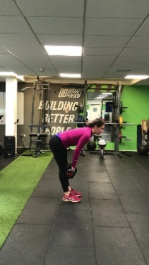 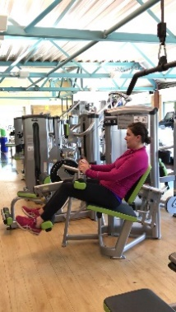
PROGRAM Straight leg deadlift hamstring curl
 | Session 1 | Session 2 | Session 3
Week 1 | Test 15RM write down the result for hams curl:_________  Dead lift:__________ | 3 x 12 repetitions at 15RM  1min30 recovery | 3 x 12 repetitions at 15RM  1min30 recovery
Week 2 | 3 x 15 repetitions at 15RM  1min30 recovery | 3 x 15 repetitions at 15RM 1min30 recovery | 3 x 15 repetitions at 15RM 1min30 recovery
Week 3 | 3 x 18 repetitions at 15RM  1min30 recovery | 3 x 20 repetitions at 15RM 1min30 recovery | 3 x 20 repetitions at 15RM 1min30 recovery
Week 4 | 3 x 12-18 repetitions  With only 1min recovery  Write down the number of reps performed and keep the same all week | 3 x 12-18 repetitions  1min recovery | 3 x 12-18 repetitions  1min recovery
Week 5 | 3 x 15-20 repetitions  With only 1min recovery  As close as 20 reps as possible, while keeping a short recovery period.  If you can go over 20reps, increase the load. write down the result for hams curl:_________  Dead lift:__________ | 3 x 15-20 repetitions  With only 1min recovery  As close as 20 reps as possible, while keeping a short recovery period.  If possible to increase from 1st session of this week, do so.  If you can go over 20reps, increase the load. | 3 x 15-20 repetitions  With only 1min recovery
Week 6 | 3 x 12-18 repetitions  With only 45s recovery  Write down the number of reps performed and keep the same all week | 3 x 12-18 repetitions  45s recovery | 3 x 12-18 repetitions  45s recovery
Week 7 | 3 x 12 repetitions  45s recovery | 3 x 12 repetitions  45s recovery | 3 x 12 repetitions  45s recovery

