### 

### Figure S-1. Linear time-independent or background I-V relationships for Na+, K+, and Cl- in a human chondrocyte. Individual ion selective conductances are shown as: Na+ (red), K+ (blue) and Cl- (green). The combined net background current is scaled to yield the experimentally determined value of chondrocyte input resistance at approximately -40 mV.

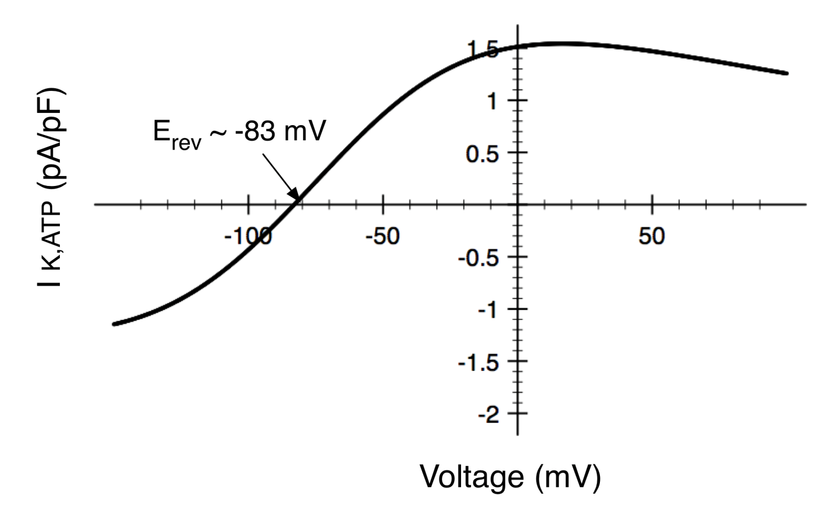

**Figure S-2.**ATP-sensitive K+ current, IK-ATP, in an isolated chondrocyte. Panel A shows a typical I-V relationship for this K+ current, scaled to provide an outward current density that would be consistent with those for IK-DR and IK-Ca in human chondrocytes. This I-V curve was computed using a standard mathematical formulation for this current that is described in the text.