Supplementary Material
Lipidomics reveals tissue-specific organization of lipids
Irene Pradas,¹ Kevin Huynh,² Rosanna Cabré,¹ Victòria Ayala,¹ Peter J Meikle,² Mariona Jové,¹* and Reinald Pamplona¹*
¹Department of Experimental Medicine, University of Lleida-Institute for Research in Biomedicine of Lleida (UdL-IRBLleida), E-25198 Lleida, Spain
²Baker Heart and Diabetes Institute, Melbourne VIC 3004, Australia
* Correspondence:
Dr. Mariona Jové, Departament de Medicina Experimental, Universitat de Lleida-Institut de Recerca Biomedica de Lleida (IRBLleida), Edifici Biomedicina 1, Av. Alcalde Rovira Roure-80, Lleida 25198, Catalonia, Spain. Phone: (+34)973702442
mariona.jove@udl.cat
Prof. Dr. Reinald Pamplona, Departament de Medicina Experimental, Universitat de Lleida-Institut de Recerca Biomedica de Lleida (IRBLleida), Edifici Biomedicina 1, Av. Alcalde Rovira Roure-80, Lleida 25198, Catalonia, Spain. Phone: (+34)973702442
reinald.pamplona@mex.udl.cat

Supplementary Figure 2. Extracted chromatogram of 770.4 / 184.1 corresponding to PC(35:3), PC(O-36:3) and PC(P-36:2). Sequential examination of normal pooled plasma lipid extracts (Black trace) and acid treated lipid extracts (red trace) was used to extensively determine plasmalogen species from other isomer and isobaric compounds. Identify of each species was further characterised in a combination of other fragmentation experiments.
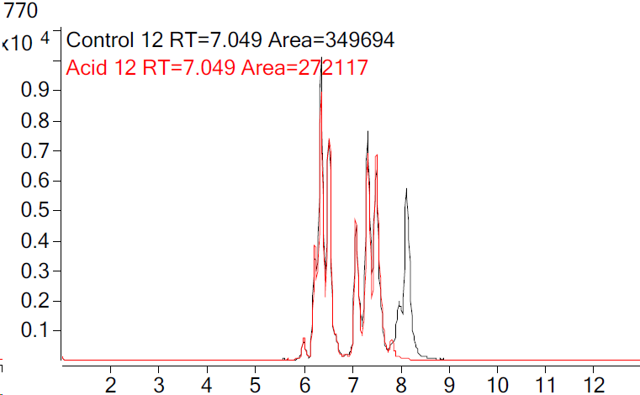
Retention time (minute)
Q1 – 770.4
Q3 – 184.1
Control QC sample
Acid treated QC sample
PC(35:3)
PC(O-36:3)
PC(P-36:2)
Intensity
a
b
c
d
e
f
g
h
Subsequent identification
a) PC(17:1_18:2)
b) PC(15:0_20:3)
c) +1 isotope of SM(39:3) + other
d) +2 isotope of PC(O-36:4)
e) PC(O-18:1/18:2)
f ) PC(O-16:0/20:3)
g) PC(P-18:1/18:1)
h) PC(P-18:0/18:2)

