Supplementary materials

FIGURE S1

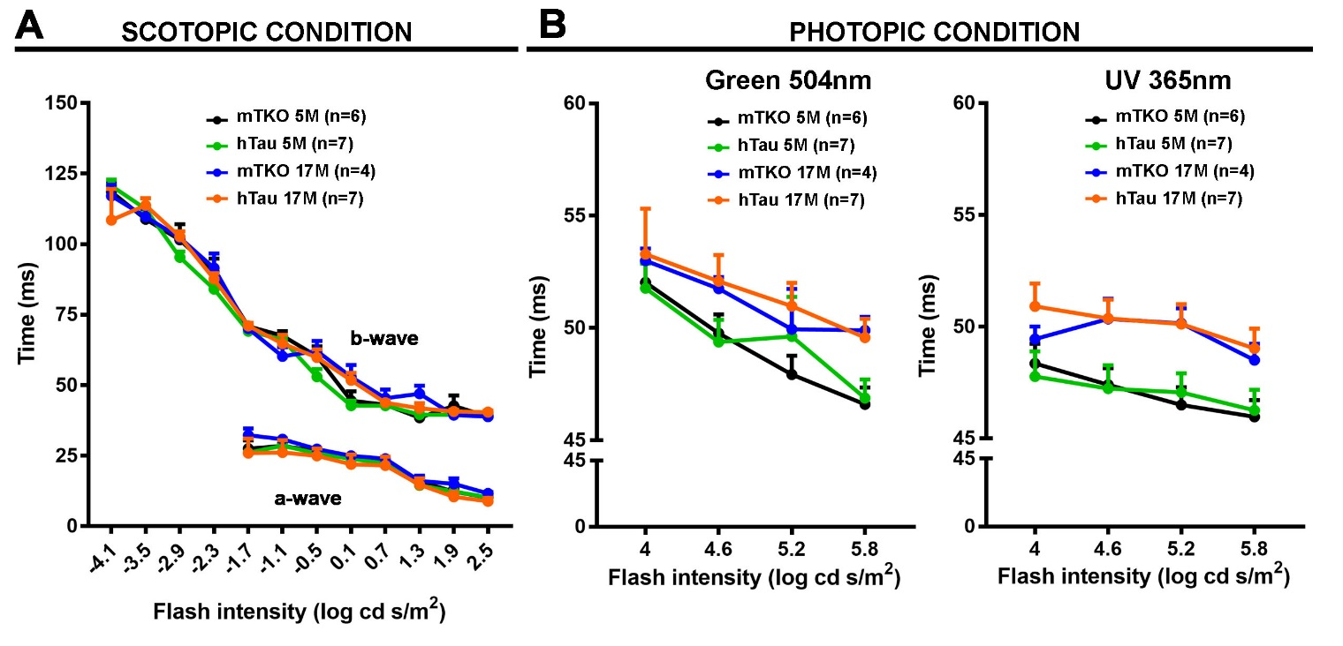

Figure S1. hTau does not influence ERG peak times in scotopic and photopic conditions.
Peak times of ERG a-waves and b-waves presented in Figures 2 and 3 were analyzed.
A. Quantitatively, luminance-peak time function curves showed no significant difference between mTKO and hTau b-wave latencies at 5 or 17 months in scotopic condition.
B. Quantitatively, luminance-peak time function curves showed no difference between mTKO and hTau b-wave latencies at 5 or 17 months in photopic conditions (green and UV).
Each dot represents mean values ± SEM. n = 4-7 mice per group.

FIGURE S2
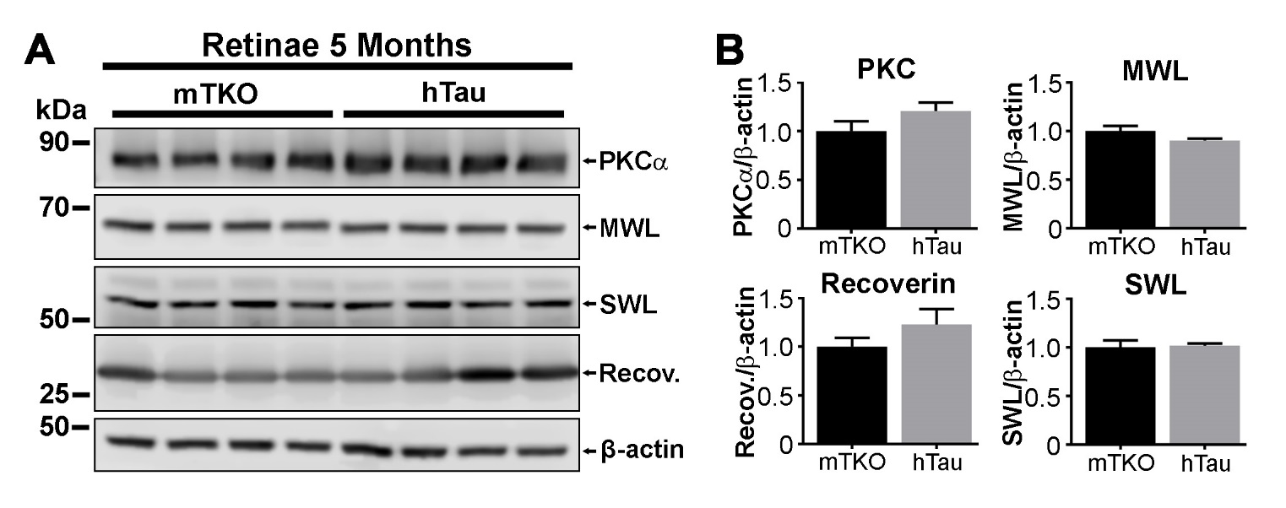

Figure S2. hTau does not influence the level of constitutively expressed retinal proteins.
A. Western blot analysis of cell-specific markers in 5-month-old mTKO and hTau retinae, PKCα (bipolar cells), MWL (M-cones), SWL (S-cones), Recoverin (rods).
B. Quantitative measurements of Western blot signals with the image J software (NIH). The level of constitutively expressed proteins did not vary between the 2 experimental groups.
Each bar represents mean values ± SEM. n = 4 mice per group.
FIGURE S3

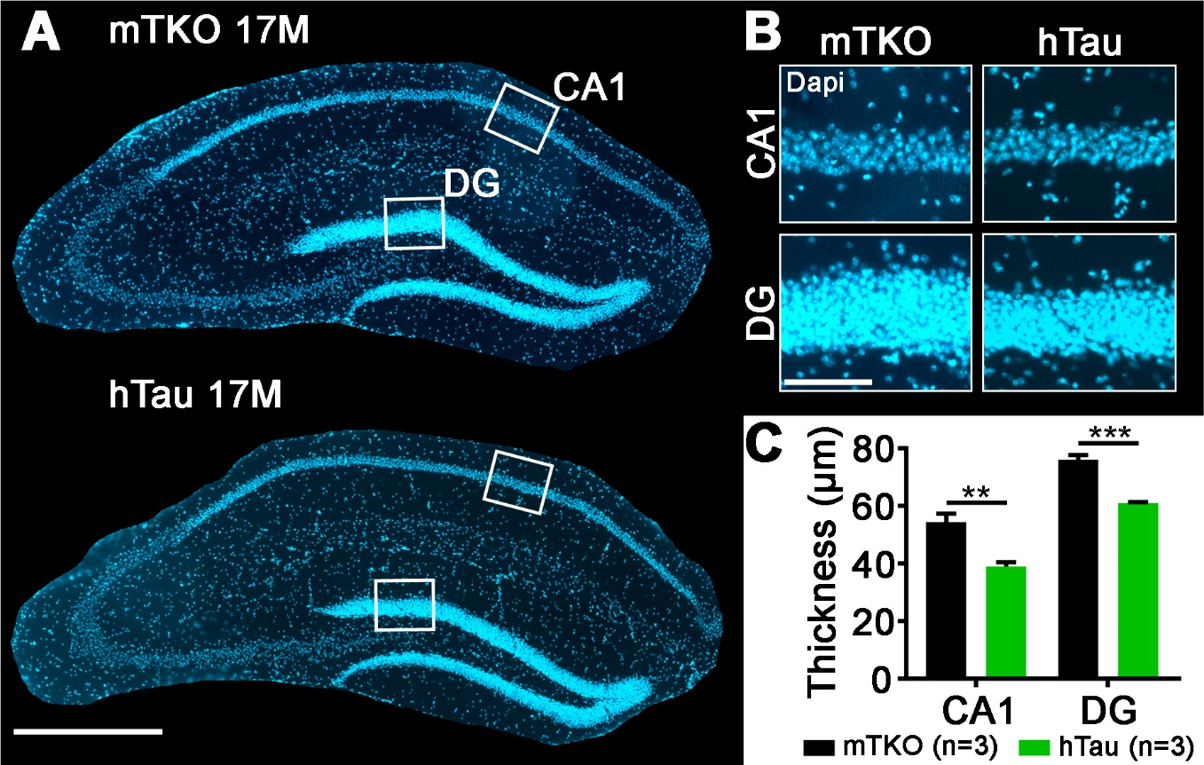

Figure S3. hTau expression induces hippocampal neurodegeneration in 17-month-old mice.
A. Representative images of 17-month-old mTKO vs hTau mouse brain sections stained with Dapi.
B. Close-up of CA1 and DG cell layers of mTKO and hTau mice.
C. Thickness analysis of CA1 and DG in 17-month-old mTKO vs hTau mouse hippocampal sections.
Data represent mean values ± S.E.M. n = 3 mice per group.
Statistics: non-parametric unpaired t-test, **: P < 0.01; ***: P < 0.001.
Scale bars: A = 500 µm and B = 100 µm.

