Supplementary Material

The effect of co-infection of food-borne pathogenic bacteria on the progression of Campylobacter jejuni infection in mice
Gang Wang, Yufeng He, Xing Jin, Yonghua Zhou*, Xiaohua Chen, Jianxin Zhao, Hao Zhang, Wei Chen*
* Correspondence: Yonghua Zhou & Wei Chen
zhouyonghua@jipd.com & chenwei66@jiangnan.edu.cn

Supplementary Figures and Tables

Supplementary Figures 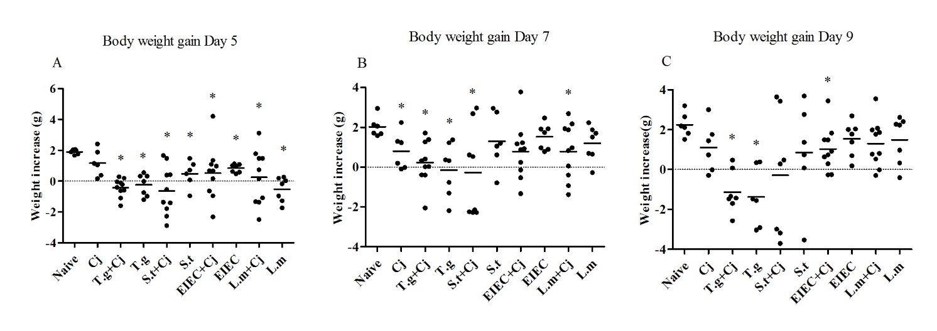
Supplementary Figure 1. Body weight gain of mice over the course of infection. (A) Day 5. (B) Day 7. (C) Day 9. Asterisk (*) indicates means that differ significantly from the naive group (P < 0.05).

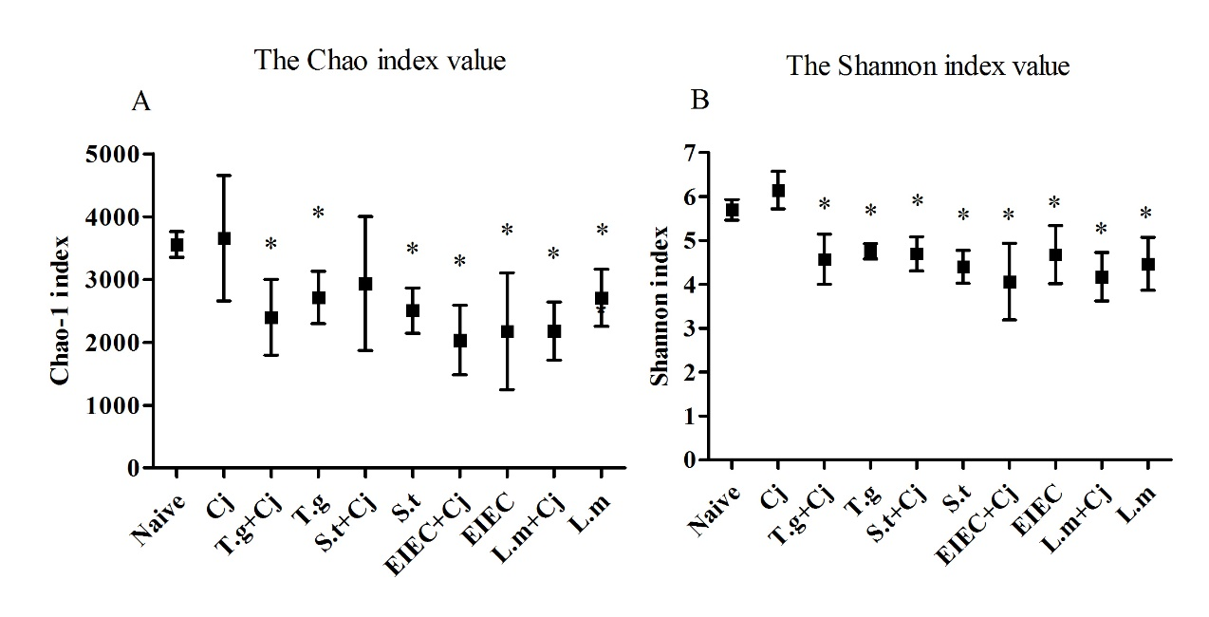
Supplementary Figure 2. Diversity of gut microbiota in each experimental groups. (A) Chao-1 index. (B) Shannon index. Asterisk (*) indicates means that differ significantly from the naive group (P < 0.05).
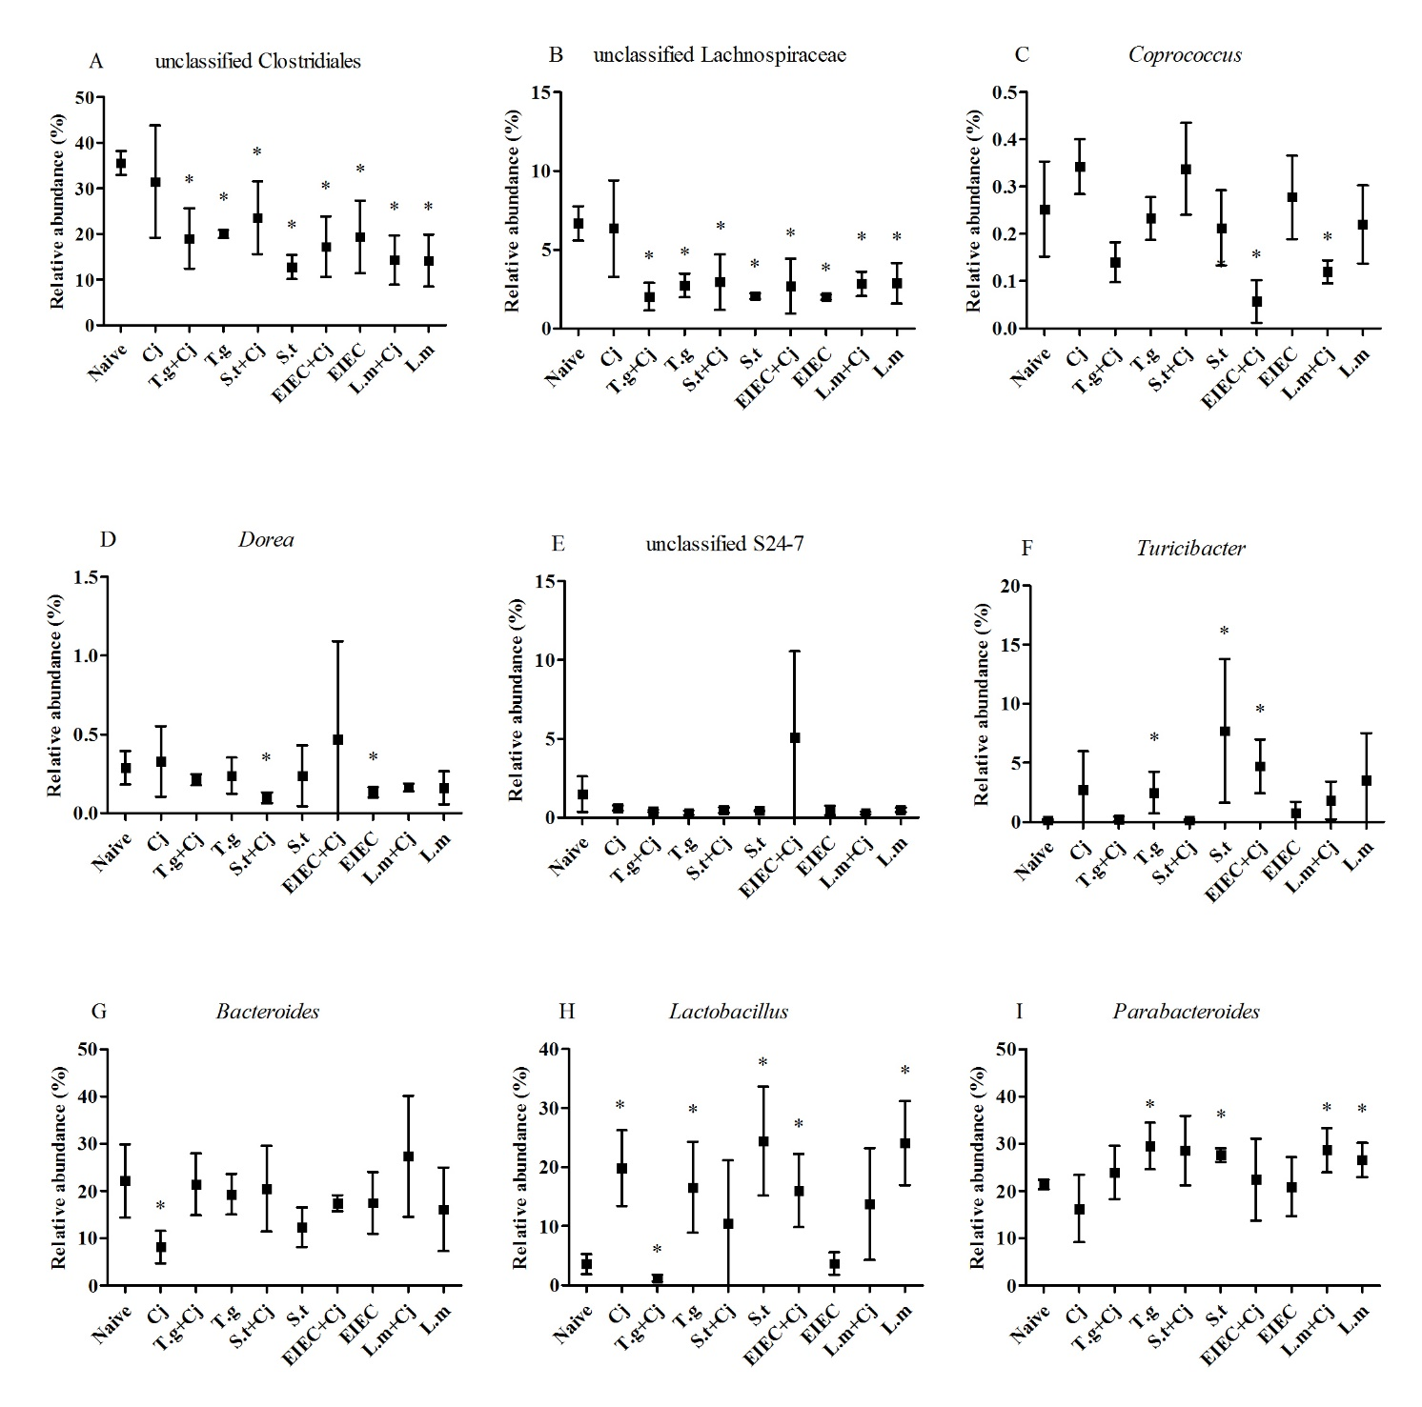
Supplementary Figure 3. Microbial composition at genus level in different groups. Asterisk (*) indicates means that differ significantly from the naive group (P < 0.05).

Supplementary Tables
Supplementary Table 1. Body weight of each individual mouse over the course of infection.
Group / Number |  | Body weight (g) |  |  |  | Group / Number |  | Body weight (g)
 |  | Day1 | Day5 | Day7 | Day9 |  |  | Day1 | Day5 | Day7 | Day9
Naive | A | 13.16 | 15.17 | 14.87 | 14.98 | Cj | A | 13.07 | 14.95 | 12.97 | 14.83
 | B | 14.49 | 16.55 | 16.62 | 16.68 |  | B | 13.10 | 14.25 | 14.33 | 13.83
 | C | 14.73 | 16.49 | 16.41 | 16.85 |  | C | 14.72 | 14.88 | 14.91 | 14.42
 | D | 14.08 | 16.08 | 15.66 | 15.59 |  | D | 12.85 | 15.26 | 15.09 | 15.85
 | E | 12.00 | 13.89 | 14.06 | 14.65 |  | E | 12.41 | 13.46 | 13.70 | 13.85
 | F | 12.14 | 13.81 | 15.08 | 15.34 |  | F | 15.32 | 15.70 | 15.30 | 15.31
T.g+Cj | A | 11.97 | 11.86 | 12.29 | 10.63 | S.t+Cj | A | 13.91 | 12.51 | 11.67 | 10.92
 | B | 14.68 | 13.08 | 12.63 | × |  | B | 12.22 | 9.95 | × | ×
 | C | 13.01 | 11.91 | 13.04 | 11.58 |  | C | 11.00 | 12.47 | 13.96 | 14.64
 | D | 11.13 | 11.09 | 12.39 | 11.21 |  | D | 13.08 | 11.72 | 10.80 | ×
 | E | 11.34 | 11.62 | 13.05 | 11.81 |  | E | 13.70 | 10.81 | × | ×
 | F | 11.62 | 11.82 | 13.00 | × |  | F | 11.14 | 12.80 | 13.82 | 14.57
 | G | 13.52 | 12.89 | 13.54 | 11.82 |  | G | 14.71 | 14.16 | 12.57 | 11.53
 | H | 13.60 | 13.20 | 14.00 | 12.13 |  | H | 13.96 | 14.38 | 14.57 | 14.44
 | I | 14.00 | 13.41 | 13.60 | × |  | I | 13.00 | 11.22 | 10.72 | 9.29
 | J | 13.19 | 12.97 | 12.80 | 10.62 |  | J | 14.23 | 14.62 | 14.76 | 14.51
T.g | A | 12.71 | 12.70 | 13.03 | 11.15 | S.t | A | 11.68 | 13.16 | 14.44 | 14.44
 | B | 14.77 | 14.03 | 14.00 | 11.86 |  | B | 14.49 | 15.20 | 15.54 | 15.23
 | C | 13.68 | 14.00 | 14.04 | 12.20 |  | C | 14.91 | × | × | ×
 | D | 14.98 | 13.78 | 12.79 | × |  | D | 12.31 | 13.39 | 15.26 | 16.00
 | E | 10.45 | 11.00 | 11.82 | 10.79 |  | E | 12.92 | 13.00 | 13.53 | 13.00
 | F | 14.34 | 13.37 | 13.03 | 11.30 |  | F | 13.31 | 13.79 | 14.51 | 14.67
 | G | 11.45 | 11.77 | 12.67 | 11.83 |  | G | 15.89 | 14.94 | 15.10 | 12.35
EIEC+  Cj | A | 12.22 | 12.88 | 13.44 | 13.71 | L.m+Cj | A | 13.80 | 12.72 | 13.40 | 14.60
 | B | 11.51 | 15.72 | 15.28 | 14.95 |  | B | 12.48 | 13.95 | 14.65 | 14.55
 | C | 14.21 | 13.57 | 13.68 | 14.5 |  | C | 13.03 | 13.77 | 14.00 | 13.81
 | D | 14.14 | 13.19 | 14.00 | 14.78 |  | D | 11.70 | 13.48 | 13.63 | 13.69
 | E | 12.80 | 13.47 | 13.97 | 14.28 |  | E | 14.20 | 12.83 | 14.26 | 14.73
 | F | 12.56 | 12.72 | 13.48 | 13.48 |  | F | 13.22 | 13.37 | 14.05 | 15.08
 | G | 12.83 | 14.18 | 13.07 | 12.56 |  | G | 11.16 | 14.27 | 13.84 | 14.71
 | H | 12.70 | 13.67 | 14.34 | 14.53 |  | H | 14.68 | 13.35 | 13.75 | 14.38
 | I | 13.65 | 14.74 | 14.52 | 14.39 |  | I | 12.99 | 14.46 | 14.86 | 14.76
 | J | 14.07 | 11.76 | 12.74 | 13.82 |  | J | 14.09 | 11.60 | 12.71 | 14.07
EIEC | A | 14.48 | 14.95 | 15.44 | 15.86 | L.m | A | 11.45 | 11.70 | 13.68 | 14.07
 | B | 12.18 | 13.26 | 13.92 | 14.22 |  | B | 15.02 | 13.74 | 15.67 | 15.35
 | C | 14.64 | 15.22 | 15.42 | 14.83 |  | C | 15.23 | 13.49 | 14.95 | 14.82
 | D | 11.98 | 12.94 | 14.44 | 14.67 |  | D | 11.18 | 11.38 | 12.68 | 13.45
 | E | 11.99 | 13.11 | 13.91 | 14.00 |  | E | 13.48 | 12.52 | 14.17 | 14.45
 | F | 13.60 | 14.23 | 14.49 | 14.30 |  | F | 11.93 | 11.75 | 13.80 | 14.34
 | G | 13.00 | 14.02 | 14.91 | 14.78 |  | G | 13.65 | 13.68 | 15.35 | 15.88
Mice died during infection are represented by X mark.

Supplementary Table 2. Infection symptoms associated with different pathogens treatment.
Group | Infection symptoms
 | Culturable Cj |  | Body weight |  |  | Bloody stool |  | Colonic damage
 | Day7 | Day9 | Day5 | Day7 | Day9 | Day7 | Day9
Naive | ND | ND | - | - | - | - | - | -
Cj | 2 | 1 | - | - | - | - | - | -
T.g+Cj | 3 | 4 | ↓ | ↓ | ↓ | ++ | ++ | ++
T.g | ND | ND | ↓ | ↓ | ↓ | ++ | ++ | ++
S.t+Cj | 3 | 3 | ↓ | ↓ | ↓ | ++ | ++ | +
S.t | ND | ND | - | - | - | + | + | ++
EIEC+Cj | 3 | 1 | ↓ | ↓ | - | + | ++ | -
EIEC | ND | ND | - | - | - | + | + | -
L.m+Cj | 2 | 1 | ↓ | ↓ | - | + | + | +
L.m | ND | ND | ↓ | - | - | + | + | ++

Culturable C. jejuni in mice feces are shown in different scores: score 1 indicates less than 10⁵ CFU/g, score 2 between 10⁵ CFU/g and 10⁶ CFU/g, score 3 between 10⁶ CFU/g and 10⁷ CFU/g, score 4 indicates more than 10⁷ CFU/g, ND means not detected. For body weight assay, groups which show no significance compared with naive group are represented by “-”. Groups which significantly lower than naive group are represented by “↓”. For bloody stool assay, groups which only contain Grade 0 are represented by “-”, groups which contain Grade 1 but not Grade 2 are represented by “+”, groups which contain Grade 2 are represented by “++”. For colonic damage, groups which contain score 0-2 are represented by “-”, groups which contain score 2-4 are represented by “+”, groups which contain score 4-6 are represented by “++”.
Supplementary Table 3. Cytokines level associated with different pathogens treatment.
Group | Cytokines
 | IFN-γ | TNF-α | IL-6 | IL-10 | IL-1α
Naive | - | - | - | - | -
Cj | - | - | - | - | -
T.g+Cj | ↑ | ↑ | ↑ | ↑ | ↓
T.g | - | - | - | - | -
S.t+Cj | - | - | - | ↑ | -
S.t | - | - | - | - | -
EIEC+Cj | - | - | - | - | -
EIEC | - | - | - | - | -
L.m+Cj | - | - | - | - | -
L.m | - | - | - | - | -

For cytokines assay, groups which show no significance compared with naive group are represented by “-”, groups which significantly lower than naive group are represented by “↓”, groups which significantly higher than naive group are represented by “↑”.

Supplementary Table 4. SCFAs level associated with different pathogens treatment.
Group | SCFAs
 | Acetic acid | Propionic acid | Butyric acid
Naive | - | - | -
Cj | - | - | -
T.g+Cj | - | - | ↓
T.g | - | - | ↓
S.t+Cj | ↓ | - | ↓
S.t | - | - | ↓
EIEC+Cj | - | - | -
EIEC | ↓ | ↓ | ↓
L.m+Cj | ↓ | ↓ | ↓
L.m | ↓ | ↓ | ↓

For SCFAs s assay, groups which show no significance compared with naive group are represented by “-”, groups which significantly lower than naive group are represented by “↓”, groups which significantly higher than naive group are represented by “↑”.
Supplementary Table 5. Diversity and relative phylum abundance of gut microbiota associated with different pathogens treatment.
Group | Diversity and relative phylum abundance of gut microbiota
 | Chao-1  index | Shannon  index | Firmicutes | Bacteroidetes | Proteobacteria
Naive | - | - | - | - | -
Cj | - | - | - | - | -
T.g+Cj | ↓ | ↓ | ↓ | - | ↑
T.g | ↓ | ↓ | - | - | -
S.t+Cj | - | ↓ | - | - | ↑
S.t | ↓ | ↓ | - | - | ↑
EIEC+Cj | ↓ | ↓ | - | - | -
EIEC | ↓ | ↓ | ↓ | - | ↑
L.m+Cj | ↓ | ↓ | - | - | -
L.m | ↓ | ↓ | - | - | ↑

For gut microbiota assay, groups which show no significance compared with naive group are represented by “-”, groups which significantly lower than naive group are represented by “↓”, groups which significantly higher than naive group are represented by “↑”.

Supplementary Table 6. Relative genus abundance of gut microbiota associated with different pathogens treatment.
Group | Relative genus abundance of gut microbiota
 | UEnt | UClo | ULach | Cop | Dor | US24 | Tur | Bac | Lact | Par
Naive | - | - | - | - | - | - | - | - | - | -
Cj | - | - | - | - | - | - | - | ↓ | ↑ | -
T.g+Cj | ↑ | ↓ | ↓ | - | - | - | - | - | ↓ | -
T.g | - | ↓ | ↓ | - | - | - | ↑ | - | ↑ | ↑
S.t+Cj | ↑ | ↓ | ↓ | - | ↓ | - | - | - | - | -
S.t | ↑ | ↓ | ↓ | - | - | - | ↑ | - | ↑ | ↑
EIEC+Cj | - | ↓ | ↓ | ↓ | - | - | ↑ | - | ↑ | -
EIEC | ↑ | ↓ | ↓ | - | ↓ | - | - | - | - | -
L.m+Cj | - | ↓ | ↓ | ↓ | - | - | - | - | - | ↑
L.m | ↑ | ↓ | ↓ | - | - | - | - | - | ↑ | ↑

Relative abundance of genus unclassified Enterobacteriaceae (UEnt), unclassified Clostridiales (UClo), unclassified Lachnospiraceae (ULach), Coprococcus (Cop), Dorea (Dor), unclassified S24-7 (US24), Turicibacter (Tur), Bacteroides (Bac), Lactobacillus (Lact), Parabacteroidesa (Par) were shown. Groups which show no significance compared with naive group are represented by “-”, groups which significantly lower than naive group are represented by “↓”, groups which significantly higher than naive group are represented by “↑”.

