Annex 1. Details of the risk of bias assessment.
Study | Year | Jadad score | PEDro score | Randomization | Blinding | Description of withdrawals | Allocation concealment
Aubrun | 2008 | 5(5) | 11(11) | Random number table | Double blind | Yes | Sealed envelopes
Ganne | 2005 | 5(5) | 10(11) | Random number table | Double blind | Yes | Sealed envelopes
Guignard | 2012 | 5(5) | 10(11) | Computer-generated | Double blind | Yes | Unclear
Haidi | 2013 | 4(5) | 9(11) | Just mentioned random | Double blind | Yes | Unclear
Hadi | 2010 | 4(5) | 8(11) | Just mentioned random | Double blind | Yes | Unclear
Jaksch | 2002 | 4(5) | 9(11) | Just mentioned random | Double blind | Yes | Sealed envelopes
Joly | 2005 | 5(5) | 10(11) | Random number table | Double blind | Yes | Sealed envelopes
Leal, 2015 | 2015 | 5(5) | 10(11) | Computer-generated | Double blind | Yes | Sealed envelopes
Lee | 2014 | 3(5) | 8(11) | Computer-generated | Observer-random | Yes | Unclear
Sahin | 2004 | 4(5) | 9(11) | Just mentioned random | Double blind | Yes | Unclear
Van Elstraete, | 2004 | 4(5) | 9(11) | Random number table | Double blind | Yes | Unclear
Yalcin | 2012 | 3(5) | 9(11) | Computer-generated | Just mentioned blinded | Yes | Unclear

Annex 2. Influence graphics.
Subgroup | Influence graphics
1: VAS 0-2H MINOR SURGERY | 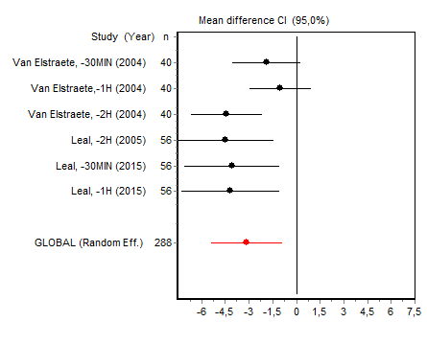
2:  VAS 0-2H MAJOR SURGERY | 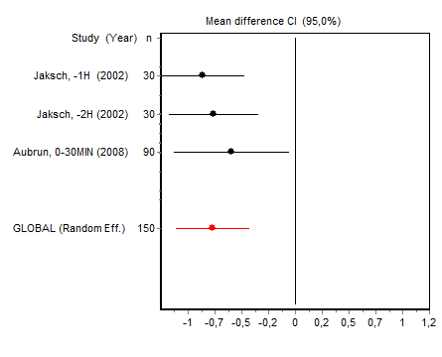
3: VAS 4H MINOR SURGERY | *
4: VAS 4H MAYOR SURGERY | 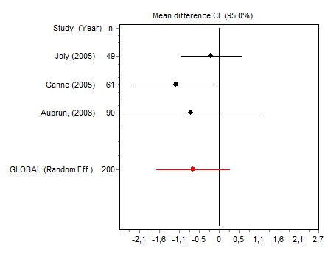
5: VAS 12H MINOR SURGERY | 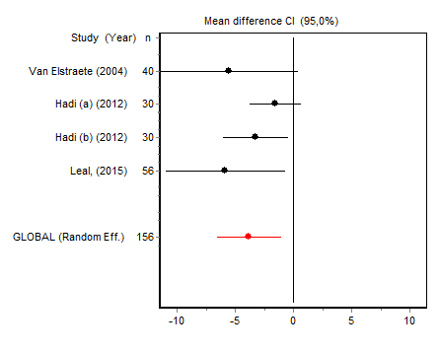
6: VAS 12H MAJOR SURGERY | 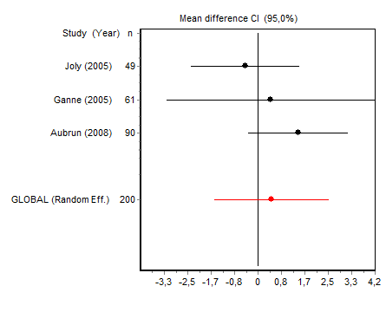
7: VAS 24H MINOR SURGERY | 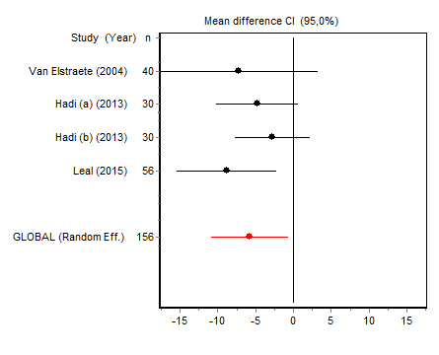
8: VAS 24H MAJOR SURGERY | 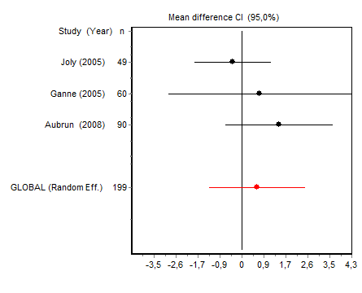
9: MORPHINE CONSUMPTION MAJOR SURGERY | 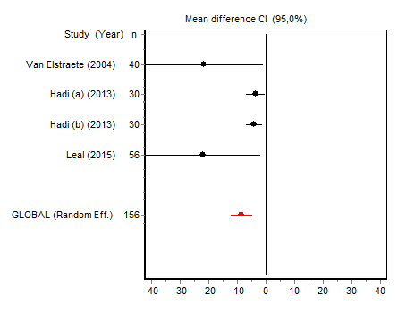
10: MORPHINE CONSUMPTION MAJOR SURGERY | 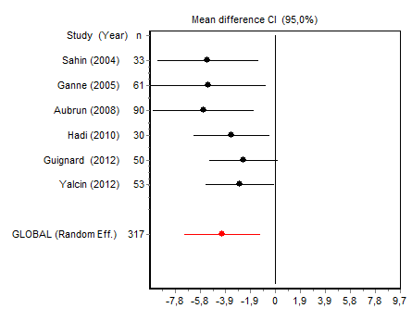
11: TIME TO FIRST RESCUE ANALGESIA  MINOR SURGERY | 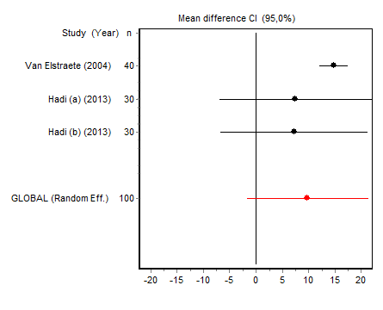
12: TIME TO FIRST RESCUE ANALGESIA MAYOR SURGERY | 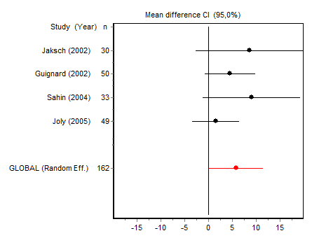
13: INCIDENCE OF PONV  MINOR SURGERY | 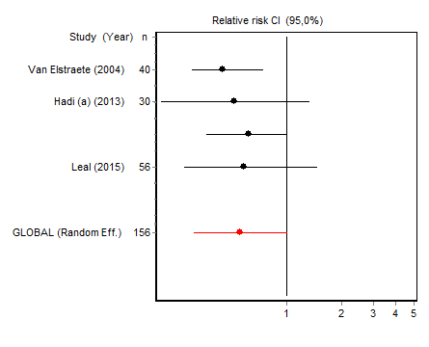
14: INCIDENCE OF PONV  MAJOR SURGERY | 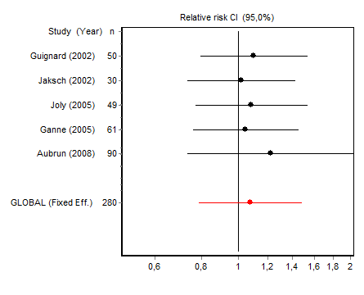
15: INCIDENCE OF PSYCOTIC EVENTS  MAJOR SURGERY | *
*Results not shown for subgroups with only two studies. PONV, postoperative nausea and vomiting; VAS, visual analog scale.
** Results not shown for subgroup 15, which was not included in the meta-analysis.
15

