Supplementary Material

Transcriptome analyses reveal metabolic syndrome of adulthood with intrauterine growth restriction in a pig model
Linyuan Shen, Mailin Gan, Shunhua Zhang, Jideng Ma, Guoqing Tang, Yanzhi Jiang, Mingzhou Li, Jinyong Wang, Xuewei Li, Lianqiang Che, & Li Zhu
* Correspondence: Lianqiang Che, email: clianqiang@hotmail.com
Li Zhu, zhuli7508@163.com
Supplementary Table S1. Fornula milk
Ingredients | Percent(%)
Whole milk powder | 58.00
Whey protein concentrate | 25.00
Casein | 5.70
Coconut oil | 10.00
CaH2PO4 (22%P) | 0.10
Choline chloride | 0.10
Vitamin mixture¹ | 0.10
Mineral mixture² | 0.50
L-Arg | 0.06
DL-Met | 0.06
L-Lys.HCl | 0.30
L-Thr | 0.03
L-Trp | 0.05
Total | 100.00
Nutrient content³ | Content
Crude protein, % | 25.30
Digestible energy, MJ/kg | 18.39
Calcium, % | 1.02
Total phosphorus, % | 0.81
Available phosphorus, % | 0.67
Digestive-Lysine, % | 1.93
Digestive -Methionine, % | 0.63
Digestive -Arginine, % | 0.86
Note 1: Contents per kg of diet: vitamin A, 0.94 mg; vitamin E, 20 mg; vitamin D3,10 μg; vitamin B1, 1.50 mg; vitamin B2, 5 mg; vitamin B6, 2 mg; vitamin B12, 40 μg; vitamin K3, 1 mg; folic acid, 1.50 mg; nicottinic acid, 20 mg; pantothenic acid, 15 mg; biotin, 0.1 mg. Note 2: contents per kg of diet: Zn, 90 mg; Mn, 4.0 mg; Fe, 90 mg; Cu, 6.0 mg; Se, 0.3 mg; I, 0.2 mg. Note 3: Nutrient levels were calculated values.

Supplementary Table S2. Ingredient composition and nutrient levels of expreimental diets (as fed basis,%)
Ingredients | 7-11kg | 11-25kg | 25-50kg | 50-75kg | 75-100kg
Corn grain | 27.19 | 35.00 | 68.57 | 75.13 | 78.03
Expand corn | 25.00 | 23.68 | 0.00 | 0.00 | 0.00
Soybean oil | 2.50 | 1.80 | 3.00 | 3.00 | 3.00
Sucrose | 2.00 | 2.00 | 2.00 | 0.00 | 0.00
Wheat bran | 0.00 | 0.00 | 3.00 | 3.00 | 5.00
Whey powder | 12.00 | 7.00 | 0.00 | 0.00 | 0.00
Soybean meal | 8.00 | 12.00 | 18.20 | 15.50 | 10.90
Full-fat soybean | 5.00 | 8.00 | 0.00 | 0.00 | 0.00
Soy protein concentrate | 5.00 | 3.00 | 0.00 | 0.00 | 0.00
Whole milk powder | 3.00 | 0.00 | 0.00 | 0.00 | 0.00
Fishmeal (CP 62.5 %) | 4.00 | 3.00 | 2.00 | 0.00 | 0.00
Plasma protein powder | 3.00 | 1.00 | 0.00 | 0.00 | 0.00
L-Lys·Hcl | 0.45 | 0.46 | 0.42 | 0.44 | 0.40
DL-Met | 0.15 | 0.16 | 0.14 | 0.12 | 0.10
L-Thr | 0.15 | 0.16 | 0.14 | 0.15 | 0.14
L-Try | 0.01 | 0.02 | 0.03 | 0.03 | 0.03
Choline chloride 50% | 0.15 | 0.10 | 0.10 | 0.10 | 0.10
CaCO3 | 1.00 | 0.92 | 0.90 | 0.89 | 0.80
CaHPO4 | 0.10 | 0.40 | 0.70 | 0.84 | 0.70
NaCl | 0.30 | 0.30 | 0.30 | 0.30 | 0.30
Premix¹ | 1.00 | 1.00 | 0.50 | 0.50 | 0.50
Total | 100.00 | 100.00 | 100.00 | 100.00 | 100.00
Nutrient levels²
DE（Kcal/kg） | 3.58 | 3.48 | 3.39 | 3.40 | 3.39
CP（%） | 19.55 | 18.35 | 15.68 | 13.73 | 12.18
Ca（%） | 0.79 | 0.71 | 0.66 | 0.59 | 0.52
STTD P（%） | 0.39 | 0.34 | 0.31 | 0.27 | 0.25
SID Lys（%） | 1.36 | 1.23 | 0.98 | 0.85 | 0.73
SID Met+cys（%） | 0.74 | 0.69 | 0.55 | 0.55 | 0.42
SID Thr（%） | 0.80 | 0.73 | 0.58 | 0.52 | 0.46
SID Trp（%） | 0.22 | 0.20 | 0.17 | 0.15 | 0.13
Note 1: Contents per kg of diet for 7-25 kg BW Period: Fe, 150 mg; Cu, 195 mg; Zn, 150 mg; Mn, 30 mg; I, 0.3 mg; Se, 0.3 mg; vitamin A, 12000 IU; vitamin D, 3200 IU; vitamin E, 80 mg; vitamin K3, 32.50 mg; vitamin B1, 2.30 mg; vitamin B2, 6.50 mg; vitamin B6, 5 mg; vitamin B12, 50 μg; nicotinic acid, 45 mg; pantothenic acid, 20 mg, folic acid, 1.50 mg; biotin, 0.15 mg; enzyme preparation and preservatives. Contents per kg of diet for 7-25 kg BW Period: Fe, 120 mg; Cu, 17 mg; Zn, 100 mg; Mn, 25 mg; I, 0.3 mg; Se, 0.2 mg; vitamin A, 5512 IU; vitamin D, 2250 IU; vitamin E, 24 mg; vitamin K3, 3 mg; vitamin B2, 6 mg; vitamin B6, 3 mg; vitamin B12, 24 μg;pantothenic acid, 15 mg, folic acid, 1.20 mg; biotin, 0.15 mg; enzyme preparation and preservatives. Note 2: Nutrient levels were calculated values.

Supplementary Table S3. Information of primers used to perfrom Q-PCR
Gene symbol | Forword primer | Reverse primer
ATP6 | AAGCAAGGGTTCTCAAACTCG | CGGCGCAAACTAAACCAACTC
COX2 | GCACCCCGACATAGAGAGC | CTGCGGAGTGCAGTGTTCT
GCG | GAATCAACACCATCGGTCAAAT | CTCCACCCATAGAATGCCCAGT
HSD17B2 | TCTTCTCGGTGTCATGCTTCC | CAAAACTCCGGCAAATACCGT
IGFBP2 | GACAATGGCGATGACCACTCA | CAGCTCCTTCATACCCGACTT
HGD | CCCGTCGTCATGGATCTCAC | GCTGACAATCTCCCTGTGGA
NNMT | GAGATCGTCGTCACTGACTACT | CACACACATAGGTCACCACTG
DAO | AATCTCGGGCTACAACCTCTT | TCAGCTTCCGAAATCCCAGAA
GNMT | CTGGGGTGGACTCCATTATGC | GATGACCCACTTGTCGAAGGC
FOXO1 | GCGTGCCCTACTTCAAGGATAA | TCCCACTCTTGCCTCCCTCT
GSR | TGACTATGGCTTTCAGAGTTGTG | GCCGTGGATGATTTCTATGTG
TOP2A | CGAAATGACAAGCGAGAAGT | CTGACCAATGGGCTGTAAGA
TCN1 | TCAGAGGGAACTATTCAATCA | GTCAGAGCAAGAACAGCCAC
KCNIP3 | CTTCCTGTTCAATGCCTTCG | TAGCCATCCTTGTTAATGTCGTAG
HAMP | TCTCCCATCCCAGACAAGACAG | GACAGCAGCCGCAGCAGAAG
ACTB | TCTGGCACCACACCTTCT | TGATCTGGGTCATCTTCTCAC
TBP | GATGGACGTTCGGTTTAGG | AGCAGCACAGTACGAGCAA
TOP2B | AACTGGATGATGCTAATGATGCT | TGGAAAAACTCCGTATCTGTCTC
ATP6: ATP synthase F0 subunit 6; COX2: cytochrome c oxidase subunit I; GCG: glucagon; HSD17B2: hydroxysteroid 17-beta dehydrogenase 2; IGFBP2: insulin like growth factor binding protein 2; HGD: homogentisate 1,2-dioxygenase; NNMT: nicotinamide N-methyltransferase; DAO: D-amino acid oxidase; GNMT: glycine N-methyltransferase; FOXO1: forkhead box O1; GSR: glutathione-disulfide reductase; TOP2A: DNA topoisomerase II alpha; TCN1: transcobalamin 1; KCNIP3: potassium voltage-gated channel interacting protein 3; HAMP: hepcidin antimicrobial peptide; ACTB: actin beta; TBP: TATA-box binding protein; TOP2B: DNA topoisomerase II beta.

Supplementary Table S4. Distuibutuion of genes expression (FPKM)
Sample | 0-0.1 | 0.1-0.3 | 0.3-3.57 | 3.57-15 | 15-60 | >60
Normal-1 | 18183  (15.02%) | 17054  (14.09%) | 65447  (54.06%) | 12987  (10.73%) | 4897  (4.05%) | 2487  (2.05%)
Normal-2 | 15005  (12.40%) | 14286  (11.80%) | 71180  (58.80%) | 14207  (11.74%) | 4325  (3.57%) | 2052  (1.70%)
Normal-3 | 14361  (11.86%) | 13047  (10.78%) | 73879  (61.03%) | 13879  (11.47%) | 3989  (3.30%) | 1900  (1.57%)
IUGR-1 | 15329  (12.66%) | 14830  (12.25%) | 70836  (58.52%) | 13462  (11.12%) | 4455  (3.68%) | 2143  (1.77%)
IUGR-2 | 17844  (14.74%) | 17732  (14.65%) | 65521  (54.12%) | 12808  (10.58%) | 4766  (3.94%) | 2384  (1.97%)
IUGR-3 | 17283  (14.28%) | 16802  (13.88%) | 66627  (55.04%) | 13383  (11.06%) | 4614  (3.81%) | 2346  (1.94%)
Note, FPKM: Reads Per Kilobase of exon model per Million mapped reads

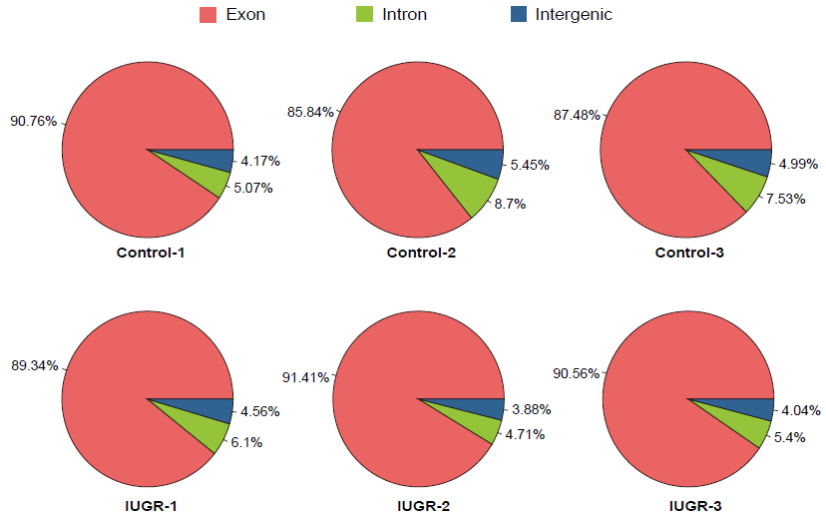

Supplementary Figure S1. The distribution of reads in genome sites.

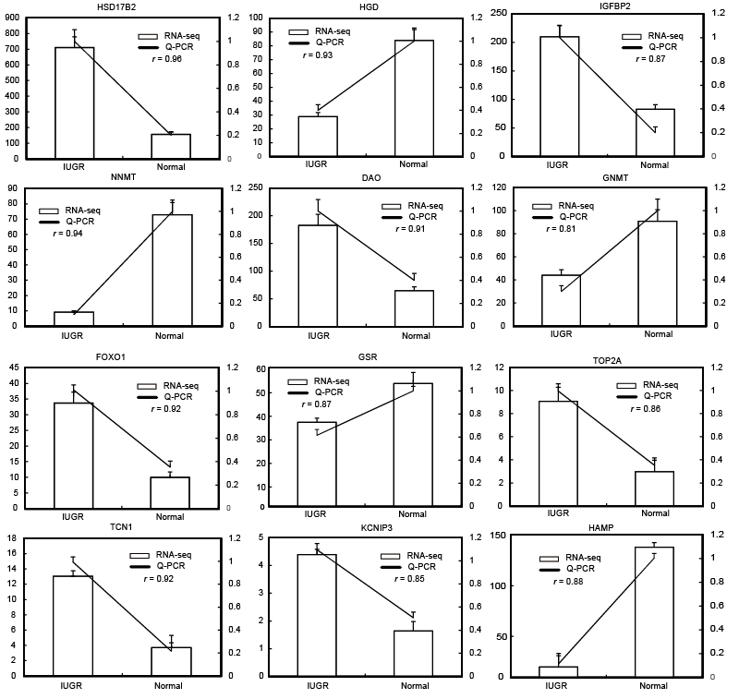
Supplementary Figure S2. Validation of DEGs by qPCR. The r value represents the Pearson correlation coefficient between two methods

