Supplementary Materials

TCP Transcription Factors Interact with NPR1 and Contribute Redundantly to Systemic Acquired Resistance
Min Li^{1,2}, Huan Chen^{1,2}, Jian Chen^{1,2}, Ming Chang^{1,2}, Ian Palmer¹, Walter Gassmann³, Fengquan Liu^{2,4}*, and Zheng Qing Fu¹*
¹Department of Biological Sciences, University of South Carolina, Columbia, SC, United States,
²Institute of Plant Protection, Jiangsu Academy of Agricultural Sciences, Nanjing, China,
³Division of Plant Sciences, C.S. Bond Life Sciences Center and Interdisciplinary Plant Group, University of Missouri, Columbia, MO, United States,
⁴Jiangsu Key Laboratory for Food Quality and Safety-State Key Laboratory Cultivation Base of Ministry of Science and Technology, Nanjing, China

* Correspondence:
Fengquan Liu
fqliu20011@sina.com
Zheng Qing Fu
zfu@mailbox.sc.edu
Keywords: plant immunity₁, systemically acquired resistance₂, transcriptional regulation₃, NON-EXPRESSER OF PR GENES 1₄, TCP transcription factors₅, PATHOGENESIS-RELATED genes₆.

Supplementary Tables
Supplemental Table 1. Primers used in this study
Primer Name | Primer Sequence (5'-3')
GW_F (attB1) | ggggACAAGTTTGTACAAAAAAGCAGGCTTC
GW_R (attB2) | gggcACCACTTTGTACAAGAAAGCTGGGTC
TCP8_GW_F | GW_F_ATGGATCTCTCCGACATCCG
TCP8_GW_R | GW_R_TCACTCAGAGCTATTTGAGTTCTCCT
TCP14_GW_F | GW_F_ATGCAAAAGCCAACATCAAGTATC
TCP14_GW_R | GW_R_CTAATCTTGCTGATCCTCCTCATCA
TCP15_GW_F | GW_F_ATGGATCCGGATCCGGATC
TCP15_GW_R | GW_R_CTAGGAATGATGACTGGTGCTTCC
PR1_p2380_GW_F | GW_F_ACAAAGAATATATATAACGATCATTG
PR1_p2380_GW_R | GW_R_AAAAATCGAGAATAGCCAGT
PR2_p1513_GW_F | GW_F_GCCGAACCAATATTCTATCAAG
PR2_p1513_GW_R | GW_R_TTTCTTGATTTTTCTATGATTCTGTG
PR5_p1000_GW_F | GW_F_GGTTCAATTTATGAACCAGTTTCTAC
PR5_p500_GW_F | GW_F_CAACAGTCAACAAACACATCTATCTG
PR5_p_GW_R | GW_R_ATTTTTTTATGGGTTTTTTGTGTG
NPR1_p1000_GW_F | GW_F_CCAAGAGGTGATTATGCAGA
NPR1_p1000_GW_R | GW_R_CAACAGGTTCCGATGAATTG
PR5_a_F | CTGTTGTTACACACACACACACCC
PR5_a_R | CCCCCTAATGAAGCATTCATCT
PR5_b_F | TCAACTATGTTCTAGACTTCTAGAAGCC
PR5_b_R | CTAAACAGGTATAAAATCTGGTTATAAACG
PR5_c_F | GGATCTCATAGTCGCGGATCA
PR5_c_R | CATGGCTGATGCACACTACACT
PR5_p1000_m_F | AACCCCCAGACAATAATATTTTATCGGTCA
PR5_p1000_m_R | TGACCGATAAAATATTATTGTCTGGGGGTT

Supplementary Figures

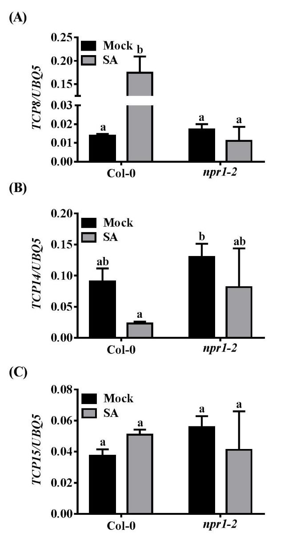
Supplementary Figure 1. SA-induced expression of TCP8 requires NPR1.
Four-week-old plants were sprayed with water (Mock) or 0.5 mM SA (SA) for 24 hours. The mRNA levels of TCP8 (A), TCP14 (B), and TCP15 (C) in Col-0 and npr1-2 were examined by RT-qPCR. Primers used in this study were described in (Wang et al., 2015). Relative mRNA levels were normalized to the UBQ5 mRNA levels. Error bars represent SD of three biological repeats. Statistical analysis was studied by two-way ANOVA following multiple comparisons with turkey test (95% confidence interval) using GraphPad Prism 7. Different small letters above the bars means significant difference

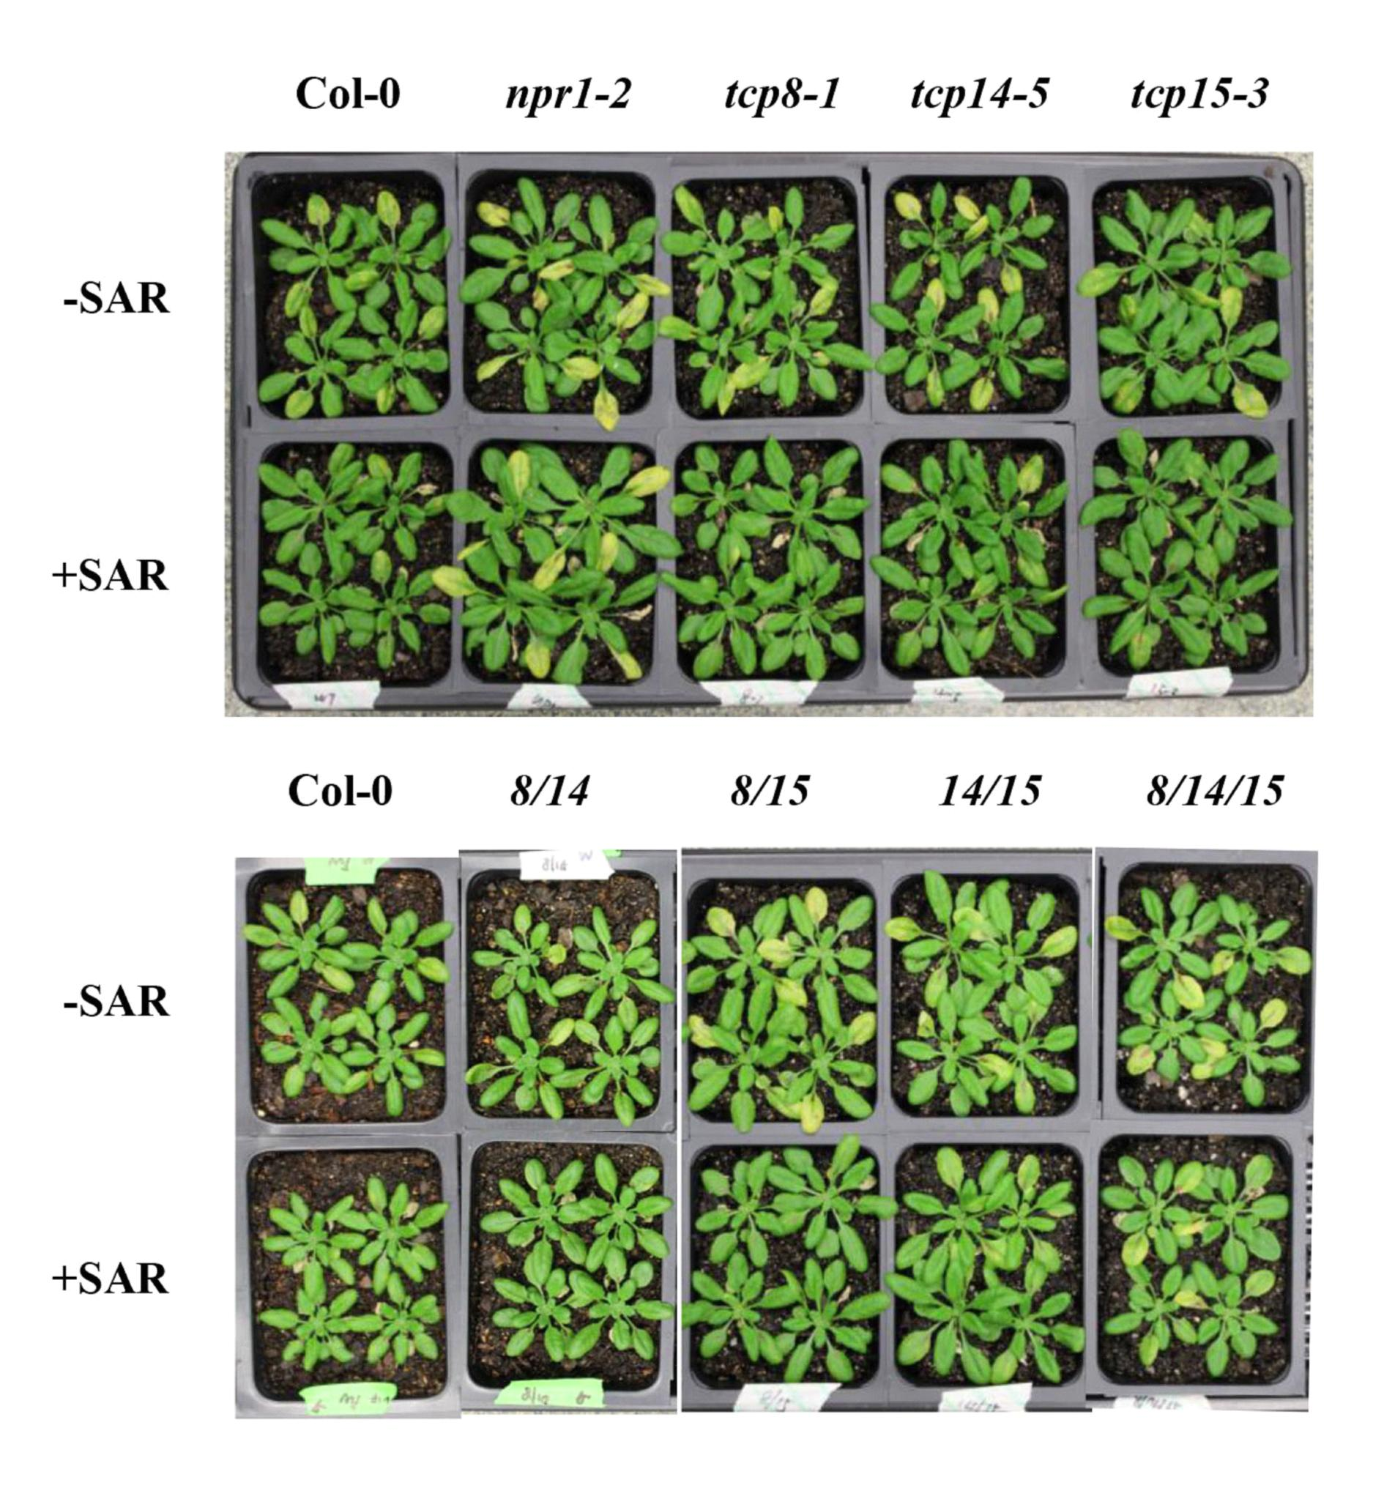
Supplementary Figure 2. The disease symptoms of plants subjected to SAR test.
Two lower leaves of three-week-old plants were infiltrated with 10 mM MgCl₂ (-SAR) or Psm ES4326 with avrRpt2 (OD₆₀₀ = 0.02) (+SAR). Three days later, two upper leaves were infiltrated with Psm ES4326 (OD₆₀₀ = 0.001). Photographs were taken three days post the second infection.

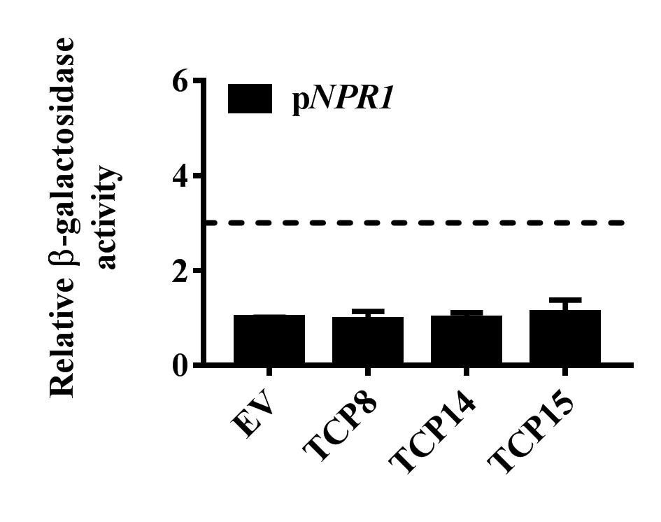
Supplementary Figure 3. TCP8, TCP14, and TCP15 did not bind to the NPR1 promoter
The binding ability of TCP8, TCP14, and TCP15 to the NPR1 promoter was studied by Y1H.

